
School of Computing, Creative Technology and Engineering
Student Name
Student ID
Module Name | Intelligent Computer Vision
Level | 6
Assignment name | Coursework in Image Video Processing

I know that it is Academic Unfair Practice to use the work and ideas of others, such as the work generated by a "Generative AI", without fully acknowledging it.
I have completed this piece of coursework solely on my own, original work and have used all sources, summaries, paraphrases and quotes correctly as required by the LBU Academic Regulations.
DECLARATION OF GENERATIVE AI USE
I DID use Generative AI technology in the creation, composition or modification of this assignment. All content has been reviewed and proof edited by the student and all image evidence is from provided coursework files.

Table of Contents
1. Introduction 4
2. Image and Video processing of the Coursework Files 5
2.1 Discuss and evaluate the step-by-step analysis and processing of Image1.jpg 7
2.2 Discuss and evaluate the step-by-step analysis and processing of Image2.jpg 10
2.3 Discuss and evaluate the step-by-step analysis and processing of Image3.bmp 13
2.4 Discuss and evaluate the step-by-step analysis and processing of Image4.jpg 16
2.5 Discuss and evaluate the step-by-step analysis and processing of Image5.jpg 19
2.6 Discuss and evaluate the step-by-step analysis and processing of Image6.jpg 22
2.7 Discuss and evaluate the step-by-step analysis and processing of image sequence 24
2.8 Discuss and evaluate the step-by-step analysis and processing of video1.avi 31
2.9 Discuss and evaluate the step-by-step analysis and processing of video2.avi 34
3. References 36

List of Figures
Figure 1 Input file Image1.jpg showing a strong green colour cast. 9
Figure 2 MATLAB code screenshot for Image1 colour balancing and contrast adjustment. 10
Figure 3 Final balanced and contrast-adjusted output for Image1.jpg. 11
Figure 4 Original input Image2.jpg before resizing and restoration. 13
Figure 5 Resized original image saved by MATLAB for comparison. 13
Figure 6 Deblurred and enhanced output produced using deconvolution, smoothing, contrast adjustment and sharpening. 14
Figure 7 Side-by-side MATLAB comparison of the original and deblurred enhanced image. 14
Figure 8 MATLAB code screenshot for Image2 deblurring and enhancement. 15
Figure 9 Input Image3.bmp showing the full greyscale vehicle scene and number plate region. 16
Figure 10 Original cropped number plate region from Image3.bmp. 17
Figure 11 Light denoising and contrast-adjusted number plate crop. 17
Figure 12 Best visible plate output after sharpening and enhancement. 17
Figure 13 MATLAB code screenshot for Image3 plate cropping, denoising, upscaling and sharpening. 18
Figure 14 Input Image4.jpg showing the underexposed backlit scene. 20
Figure 15 MATLAB code screenshot for Image4 gamma correction and adaptive histogram equalisation. 21
Figure 16 Enhanced output for Image4.jpg after per-channel gamma correction and CLAHE. 22
Figure 17 Input Image5.jpg showing directional motion blur. 23
Figure 18 MATLAB code screenshot for Image5 motion deblurring, sharpening and bilateral filtering. 23
Figure 19 Final deblurred output for Image5.jpg. 24
Figure 20 Input Image6.jpg showing haze and low contrast. 25
Figure 21 MATLAB code screenshot for Image6 channel-wise contrast stretching. 26
Figure 22 Contrast-stretched output for Image6.jpg. 26
Figure 23 MATLAB code screenshot 1 for loading, sorting and preparing the Vespa frame sequence. 28
Figure 24 MATLAB code screenshot 2 for sequence processing and stabilisation setup. 28
Figure 25 MATLAB code screenshot 3 showing template matching and stabilised-frame storage. 29
Figure 26 MATLAB code screenshot 4 showing cropped plate enhancement steps. 30
Figure 27 MATLAB code screenshot 5 showing output display, saving and helper function logic 31
Figure 28 Stabilised RGB frame selected from the Vespa image sequence. 31
Figure 29 Original extracted number plate region from the stabilised Vespa frame. 32
Figure 30 Zoomed original extracted Vespa plate area before final enhancement. 32
Figure 31 Histogram-equalised greyscale plate frame from the Vespa sequence. 32
Figure 32 Higher-resolution contrast-enhanced Vespa plate output. 33
Figure 33 Final side-by-side comparison of the Vespa original extracted frame and enhanced plate. 33
Figure 34 MATLAB code screenshot for video1.avi frame differencing and number plate enhancement. 35
Figure 35 Motion detection output comparing frame 20 against frame 2. 36
Figure 36 Original cropped number plate from video1.avi 36
Figure 37 Enhanced number plate output from video1.avi. 36
Figure 38 MATLAB code screenshot for video2.avi frame extraction and number plate enhancement. 39
Figure 39 Original cropped plate from extracted frame 0029 of video2.avi. 39
Figure 40 Enhanced number plate from frame 0029 of video2.avi. 39

List of Tables
Table 1 Summary of artefacts, selected MATLAB methods and expected improvement. 7

1. Introduction
This coursework report will use MATLAB R2024b, the Computer Vision Toolbox, and the Image Processing Toolbox to analyse the provided image, video and image-sequence files. It seeks to determine the primary visual artefact in each file, select a suitable image or video analysis workflow and assess the impact of the resulting artefacts on visual interpretation. The files include colour cast, defocus blur, low resolution plate crops, under-exposure, motion blur, haze, unstable frame sequences, and motion detection and video frame extraction. The report thus takes the approach of not simply being an editing job, but a technical diagnostic endeavor.
Digital image processing plays a key role in computer vision since the visual signal quality is important to recognition, measurement, etc. tasks. The most common use of such operations is enhancing features and local structures of the image, including intensity transformation, contrast stretching, histogram equalisation, spatial filtering, deconvolution and sharpening (Gonzalez and Woods, 2018; Jain, 1989). Enhancements, however, should be controlled so that when processing is too aggressive, the resulting image can have false edges, colour changes, enhancement of noise, which can reduce later vision processing performance (Shapiro and Stockman, 2001; Szeliski, 2022).
This report follows the coursework requirement 1:1. The artefact identified in each subsection is explained in the MATLAB processing stages followed by original or extracted image evidence, a code screen shot for the corresponding section of MATLAB and an evaluation of the output from the processing. The comments on the evaluation emphasize the suitability of the method, improvement made and areas of need. This is an important method for bolstering the submission as it will explain both what is done in MATLAB and why each method was chosen and what it can or cannot reliably demonstrate.

2. Image and Video processing of the Coursework Files
The following code sequences have been performed on the supplied coursework files, and were performed in the same sequence: Input Reading, Artefact Diagnosis, Parameter Selection, Artwork Enhancement/ANALYSIS, Output Saving and Visual Evaluation. Chromatic adaptation, gamma correction, stretching of contrast, adaptive histogram equalisation, median/gaussian/bilateral filtering, Canny edge detection, frame differencing, template-based stabilisation, bicubic upscaling and video frame extraction are the main techniques. The techniques are suitable because they target various types of degradation instead of using the same approach to all the files (Gonzalez and Woods, 2018; Szeliski, 2022).
The relationship between the visual defect and the algorithm chosen should be explained in a high-quality image processing solution. Colour cast, for instance, can be corrected with colour balancing or chromatic adaptation; defocus and motion blur can be corrected with a point-spread function and restoration method; unstable video can be stabilized with frame alignment; and number-plate crops require special local contrast enhancement and upscaling (MathWorks, n.d.-a; MathWorks, n.d.-c; Zuiderveld, 1994). Each file will thus be considered on its own merits, and the processing decisions made will be directly related to the evidence presented in the images and videos provided.

Table 1 Summary of artefacts, selected MATLAB methods and expected improvement.
File/task | Primary artefact or issue | Selected processing method
Image1.jpg | Green colour cast and weak contrast | Adjustment of illumination, chromatic adaptation, contrast adjustment
Image2.jpg | Defocus blur | To remove artifacts from the PSF, disk PSF and Lucy-Richardson deconvolution with smoothing/sharpening were implemented.
Image3.bmp | Small, noisy low-resolution number plate | The image was processed with the following operations: ROI crop, median filter, bicubic upscaling, contrast adjustment.
Image4.jpg | Underexposed foreground/high dynamic range | Channels: Gamma correction and CLAHE per channel.
Image5.jpg | Directional motion blur | Motion PSF, Lucy-Richardson deconvolution and bilateral filtering.
Image6.jpg | Haze and low contrast | Contrast stretching each channel separately (stretchlim/imadjust)
Image sequence | Camera instability and small Vespa plate | Template matching stabilisation and local plate enhancement
video1.avi | Vehicle movement and small plate crop | Frame differencing, thresholding and plate enhancement
video2.avi | Plate extraction from selected video frame | Full frame extraction, crop, upscaling, CLAHE and sharpening

2.1 Discuss and evaluate the step-by-step analysis and processing of Image1.jpg
Diagnosis of Artefacts: Image1.jpg has a dominant green colour cast and has a very slight loss of global contrast. The green illumination still shows in the scene but changes the colour balance to make it less natural, and makes colour cues less effective for visual interpretation. It is a colour constancy problem, rather than a sharpening or denoising problem, and thus is best addressed by channel balancing and chromatic adaptation, as opposed to sharpening or denoising (Shapiro and Stockman, 2001; Szeliski, 2022).
Running the MATLAB processing steps: The MATLAB script reads in the image called Image1.jpg, then converts it to double precision, computes the mean RGB channel values and estimates the illuminant. The green channel is deliberately lowered in order to compensate for the colour bias with red and blue. The image is then corrected using the chromadapt function in the linear RGB space, converted to sRGB space using the lin2rgb function and enhanced with the imadjust and stretchlim functions for spreading out intensity values (MathWorks, n.d.-b; MathWorks, n.d.-d).
Critical evaluation: The output at the end is better due to the minimized green cast and balanced colour appearance of the scene. Contrast adjustment also helps to make the subject and other details visible. The one big downside is that saturated or overly bright colors can't be recovered from the original image since there is no information left when they are clipped. Despite this constraint, the chosen workflow is suitable as it aims at the defect and does not affect the image content in any way other than the defect itself.
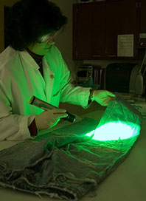
Figure 1 Input file Image1.jpg showing a strong green colour cast.

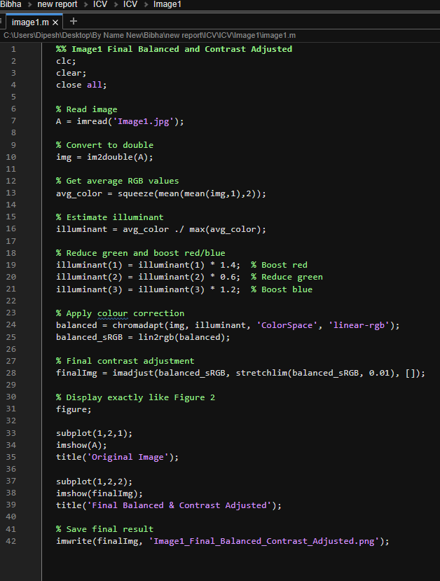
Figure 2 MATLAB code screenshot for Image1 colour balancing and contrast adjustment.

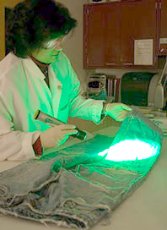
Figure 3 Final balanced and contrast-adjusted output for Image1.jpg.

2.2 Discuss and evaluate the step-by-step analysis and processing of Image2.jpg
Artefact diagnosis: The following steps will be used for the artefact diagnosis of Image2.jpg The person/background can be identified but the edge/detail of the face is blurred due to the spread of high frequencies between neighbouring pixels. The blur is not simply low contrast, but rather an optical defocus; this means that it cannot simply be compensated for by brightness adjustment; restoration needs to assume an optical defocus function, in addition to brightness adjustment (Gonzalez and Woods, 2018; Szeliski, 2022).
MATLAB processing steps: The first MATLAB line reduces the size of the source image to 400 × 600 pixels, the second line converts the source image to a double precision image, and the third line defines a disk point-spread function with fspecial('disk', 6). Lucy-Richardson deconvolution is then performed for 20 iterations, then a mild sharpening, light Gaussian smoothing, and contrast adjustment (imadjust and stretchlim) are performed. This sequence can be technically used as deconvolution provides a sharper image from a blurred observation and the subsequent smoothing and sharpening stages reduce noise and local detail in the image, as described in the works by Lucy (1974) and Richardson (1972) and in MathWorks (n.d.-c).
Processed output: Critical evaluation improves edges separation and the subject is more interpretable. It can, however, only form a "best estimate" of what it could not clearly see in the original frame. The result is not exaggerated in the report, therefore: The restoration is for enhancement and demonstration, but not as a forensic representation of detail. This is a more firm technical decision due to the fact that deblurring techniques have intrinsic limitations in terms of the accuracy of the blur model used and in the presence of noise.
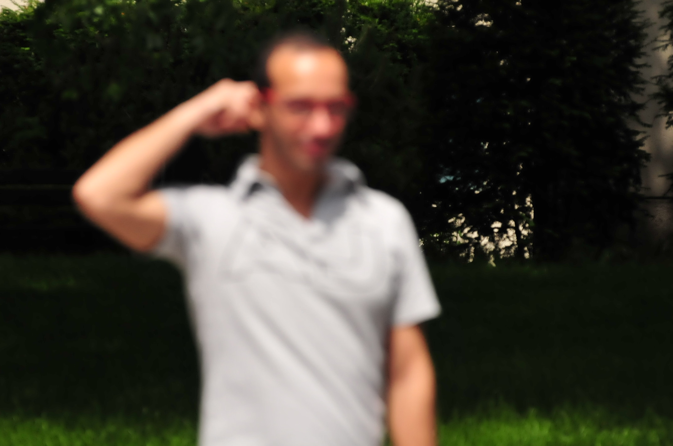
Figure 4 Original input Image2.jpg before resizing and restoration.

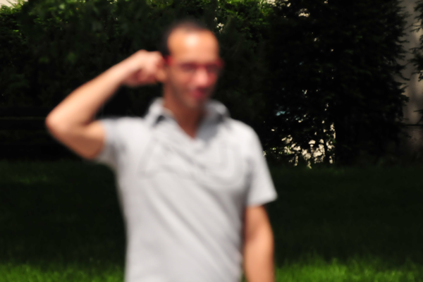
Figure 5 Resized original image saved by MATLAB for comparison.

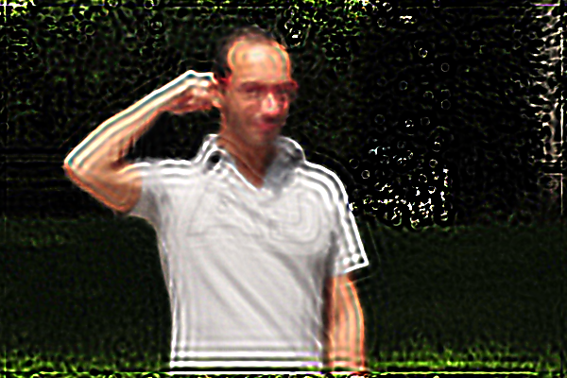
Figure 6 Deblurred and enhanced output produced using deconvolution, smoothing, contrast adjustment and sharpening.

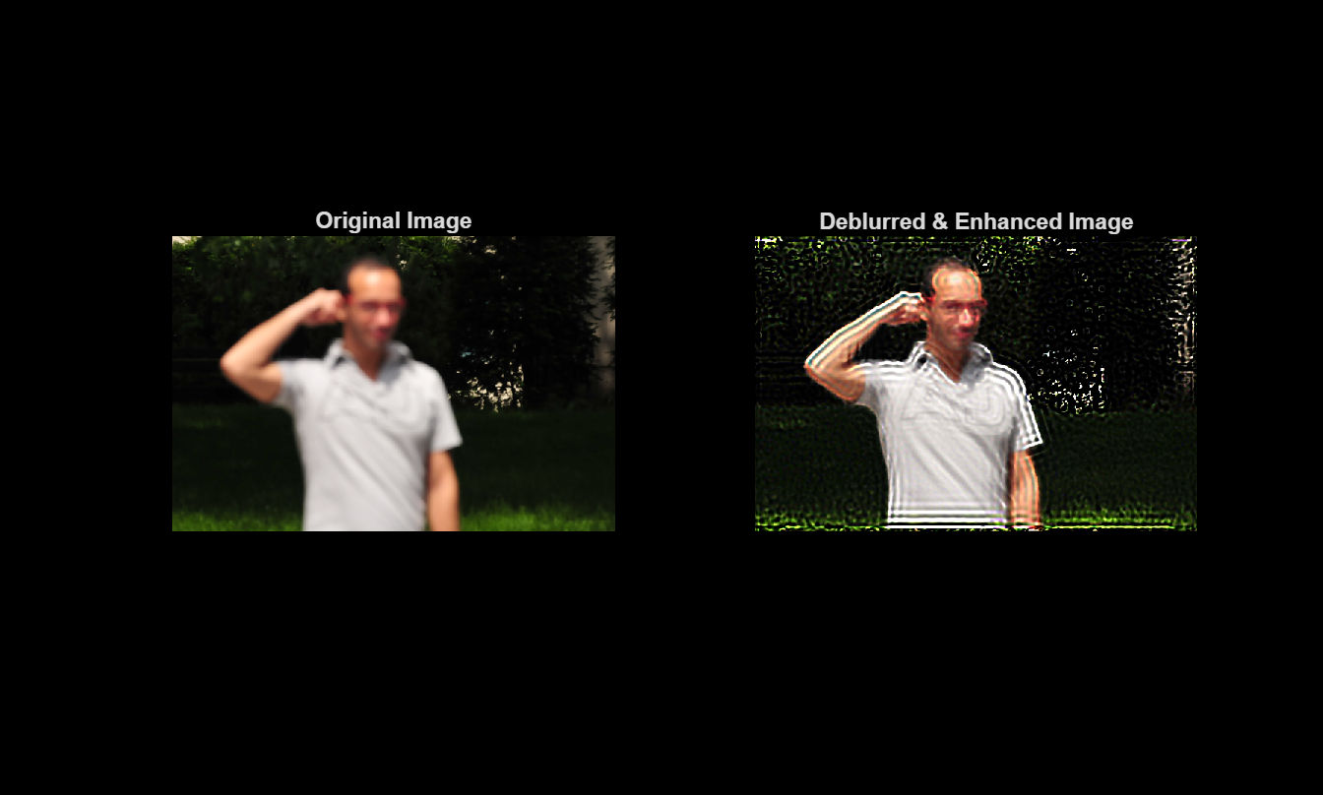
Figure 7 Side-by-side MATLAB comparison of the original and deblurred enhanced image.

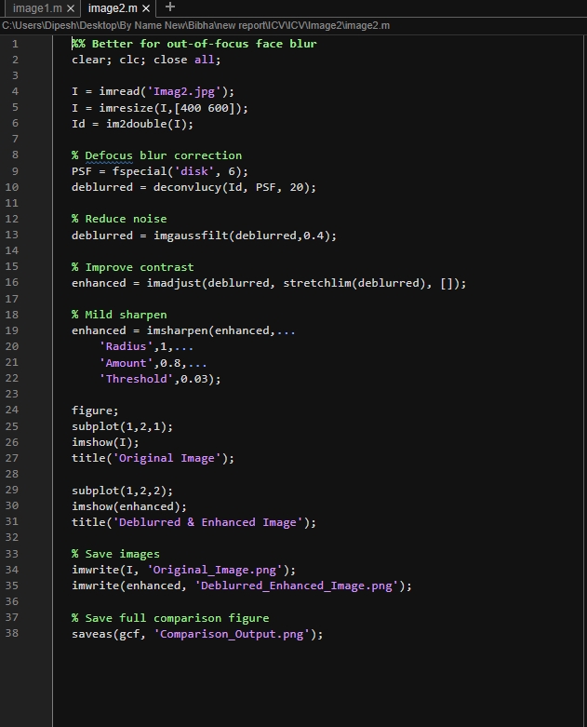
Figure 8 MATLAB code screenshot for Image2 deblurring and enhancement.

2.3 Discuss and evaluate the step-by-step analysis and processing of Image3.bmp
Artefact diagnosis: The vehicle image is a low-resolution, grey-scale image of a vehicle, with a small and/or pixellated number plate region. The primary issues are consequently poor spatial resolution and local noise and low character contrast. The information is found in a narrow area of interest so a whole-image enhancement would be wasteful, and might even detract from the plate evidence.
MATLAB processing steps: The processing steps are greyscales the image (if necessary), normalises the image intensity values, and sets a plate box with dimensions [82 74 90 34]. This image is cropped, denoised with a median filter of size 2×2, bicubic interpolated 3 times, stretched to range 0.03 – 0.97 with stretchlim and slightly sharpened. Small noisy regions can be enhanced using median filtering and local intensity adjustment that can enhance the visibility of the scene without altering the overall scene (Gonzalez and Woods, 2018; Jain, 1989).
Critical evaluation: The cropped and enhanced plate is clearly visible to be better than the original crop, especially after resizing and contrast adjusting. The drawback is that the bicubic interpolation will increase the size of the display, but it will not generate new plate info. Thus the output will be useful as an inspection aid, rather than a certainty of reconstruction. This difference is significant for the purpose of high-quality computer vision evaluation, in that the goal of the enhancement should be to understand and be technically honest, rather than to claim recovery of any kind that isn't possible (Szeliski, 2022).
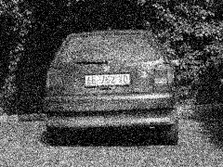
Figure 9 Input Image3.bmp showing the full greyscale vehicle scene and number plate region.

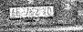
Figure 10 Original cropped number plate region from Image3.bmp.

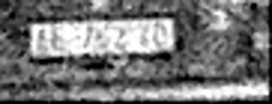
Figure 11 Light denoising and contrast-adjusted number plate crop.

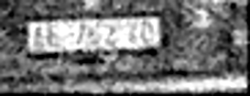
Figure 12 Best visible plate output after sharpening and enhancement.

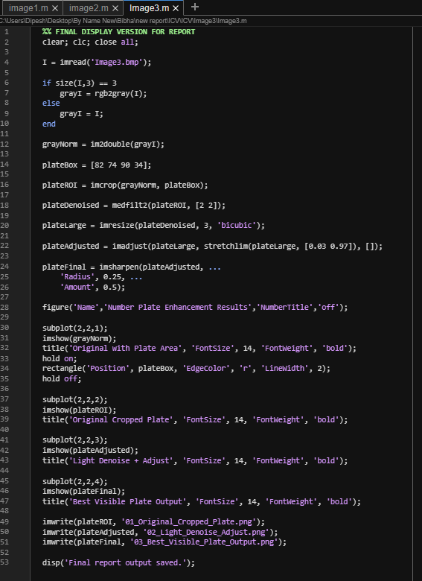
Figure 13 MATLAB code screenshot for Image3 plate cropping, denoising, upscaling and sharpening.

2.4 Discuss and evaluate the step-by-step analysis and processing of Image4.jpg
Artefact diagnosis: Image4.jpg is highly underexposed in the foreground and has a high dynamic range scene (much brighter sky or reflective areas). The subject is thus challenging to examine as there is less detail in the darker intensities. It's not a matter of blurriness, so the chosen technique ought not to be too saturated, but to enhance the shadows and boost local contrast.
There are processing steps in MATLAB: The script is going to work with each RGB channel individually. Each channel is scaled to double precision, gamma of 0.6 is applied to brighten the dark part of the image, contrast limited adaptive histogram equalisation is applied with 0.01 contrast limit and 8 × 8 tiles. In this case, CLAHE has been used as it enhances local contrast and minimizes the amplification of background noise, or clipping (Zuiderveld, 1994; MathWorks, n.d.-a).
Improved output: Critical evaluation of the enhanced output: More foreground structure & subject easier to analyse. This has the advantage of having a brighter overall image than a mere brightness enhancement, while at the same time enhancing the perceived contrast in various portions of the photograph. One drawback of having a channel-wise process is that there could be a slight colour shift, and it can enhance texture in lighter parts of the image. The overall method is appropriate as the principal objective is to preserve high intensity background without losing the visible information in the darker areas.
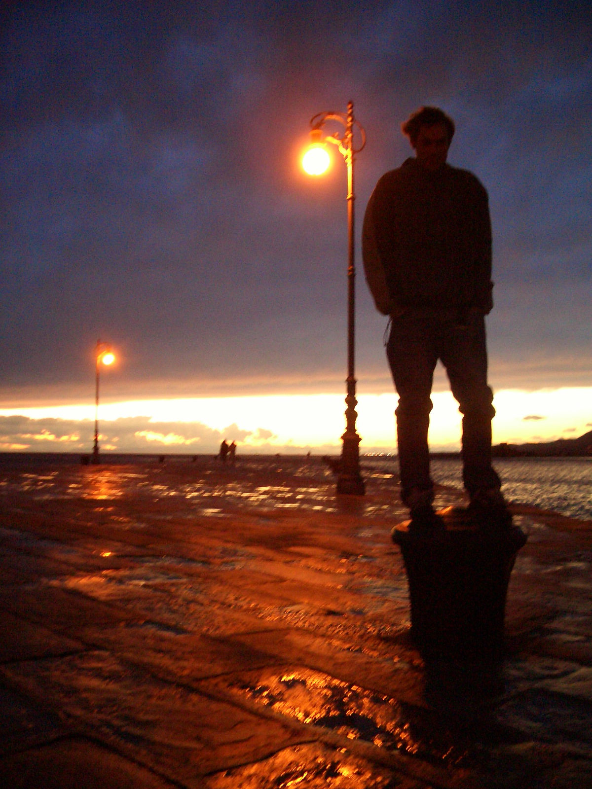
Figure 14 Input Image4.jpg showing the underexposed backlit scene.

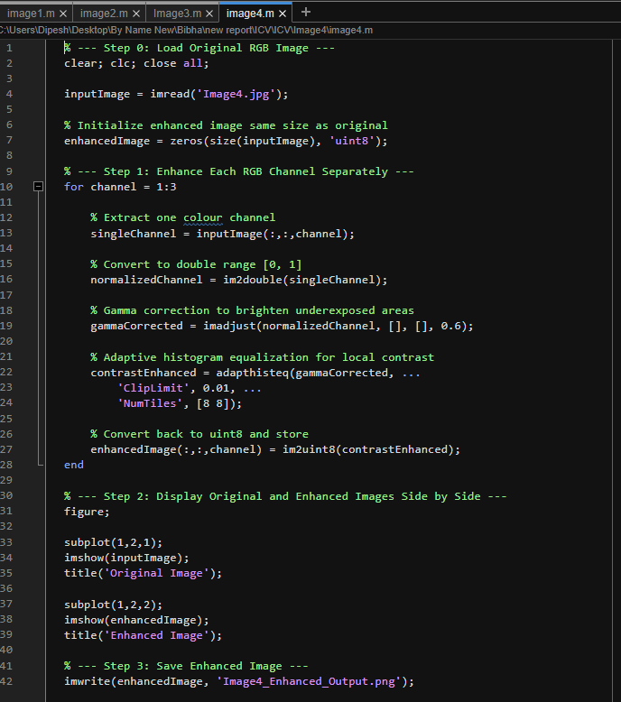
Figure 15 MATLAB code screenshot for Image4 gamma correction and adaptive histogram equalisation.

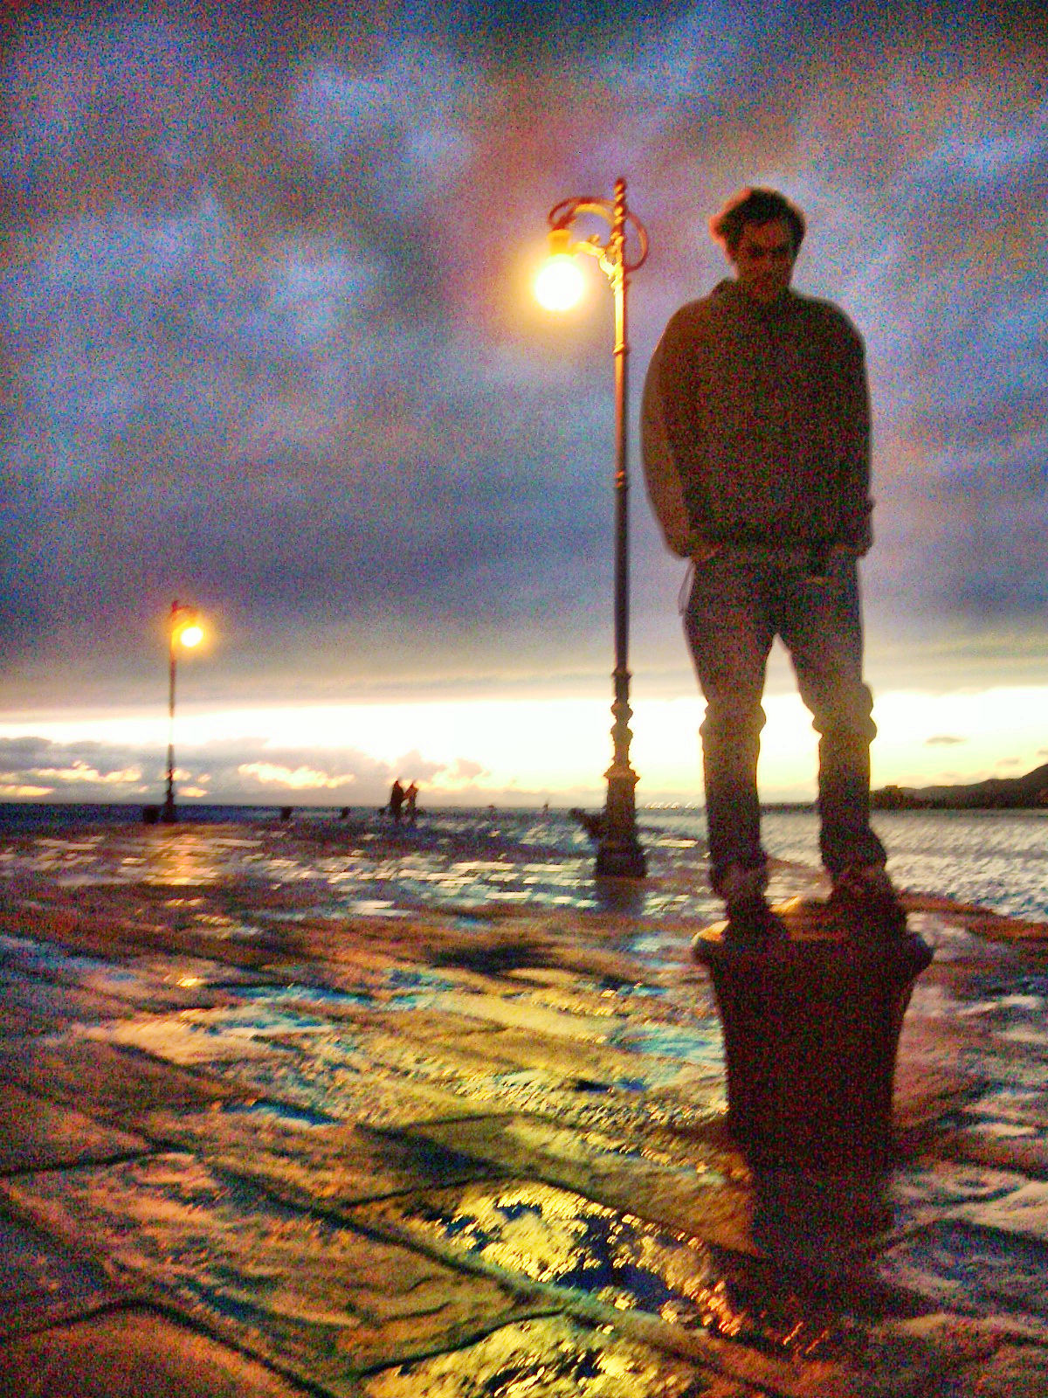
Figure 16 Enhanced output for Image4.jpg after per-channel gamma correction and CLAHE.

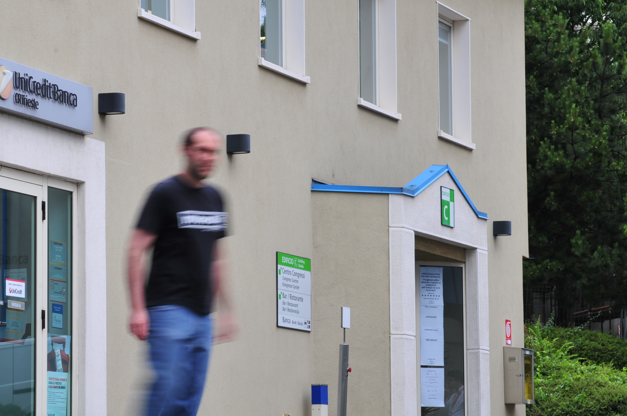
Figure 17 Input Image5.jpg showing directional motion blur.

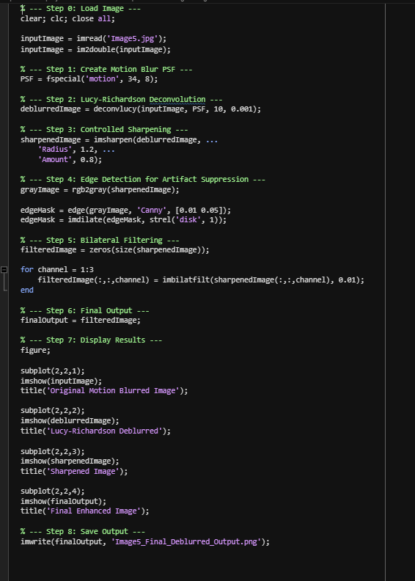
Figure 18 MATLAB code screenshot for Image5 motion deblurring, sharpening and bilateral filtering.

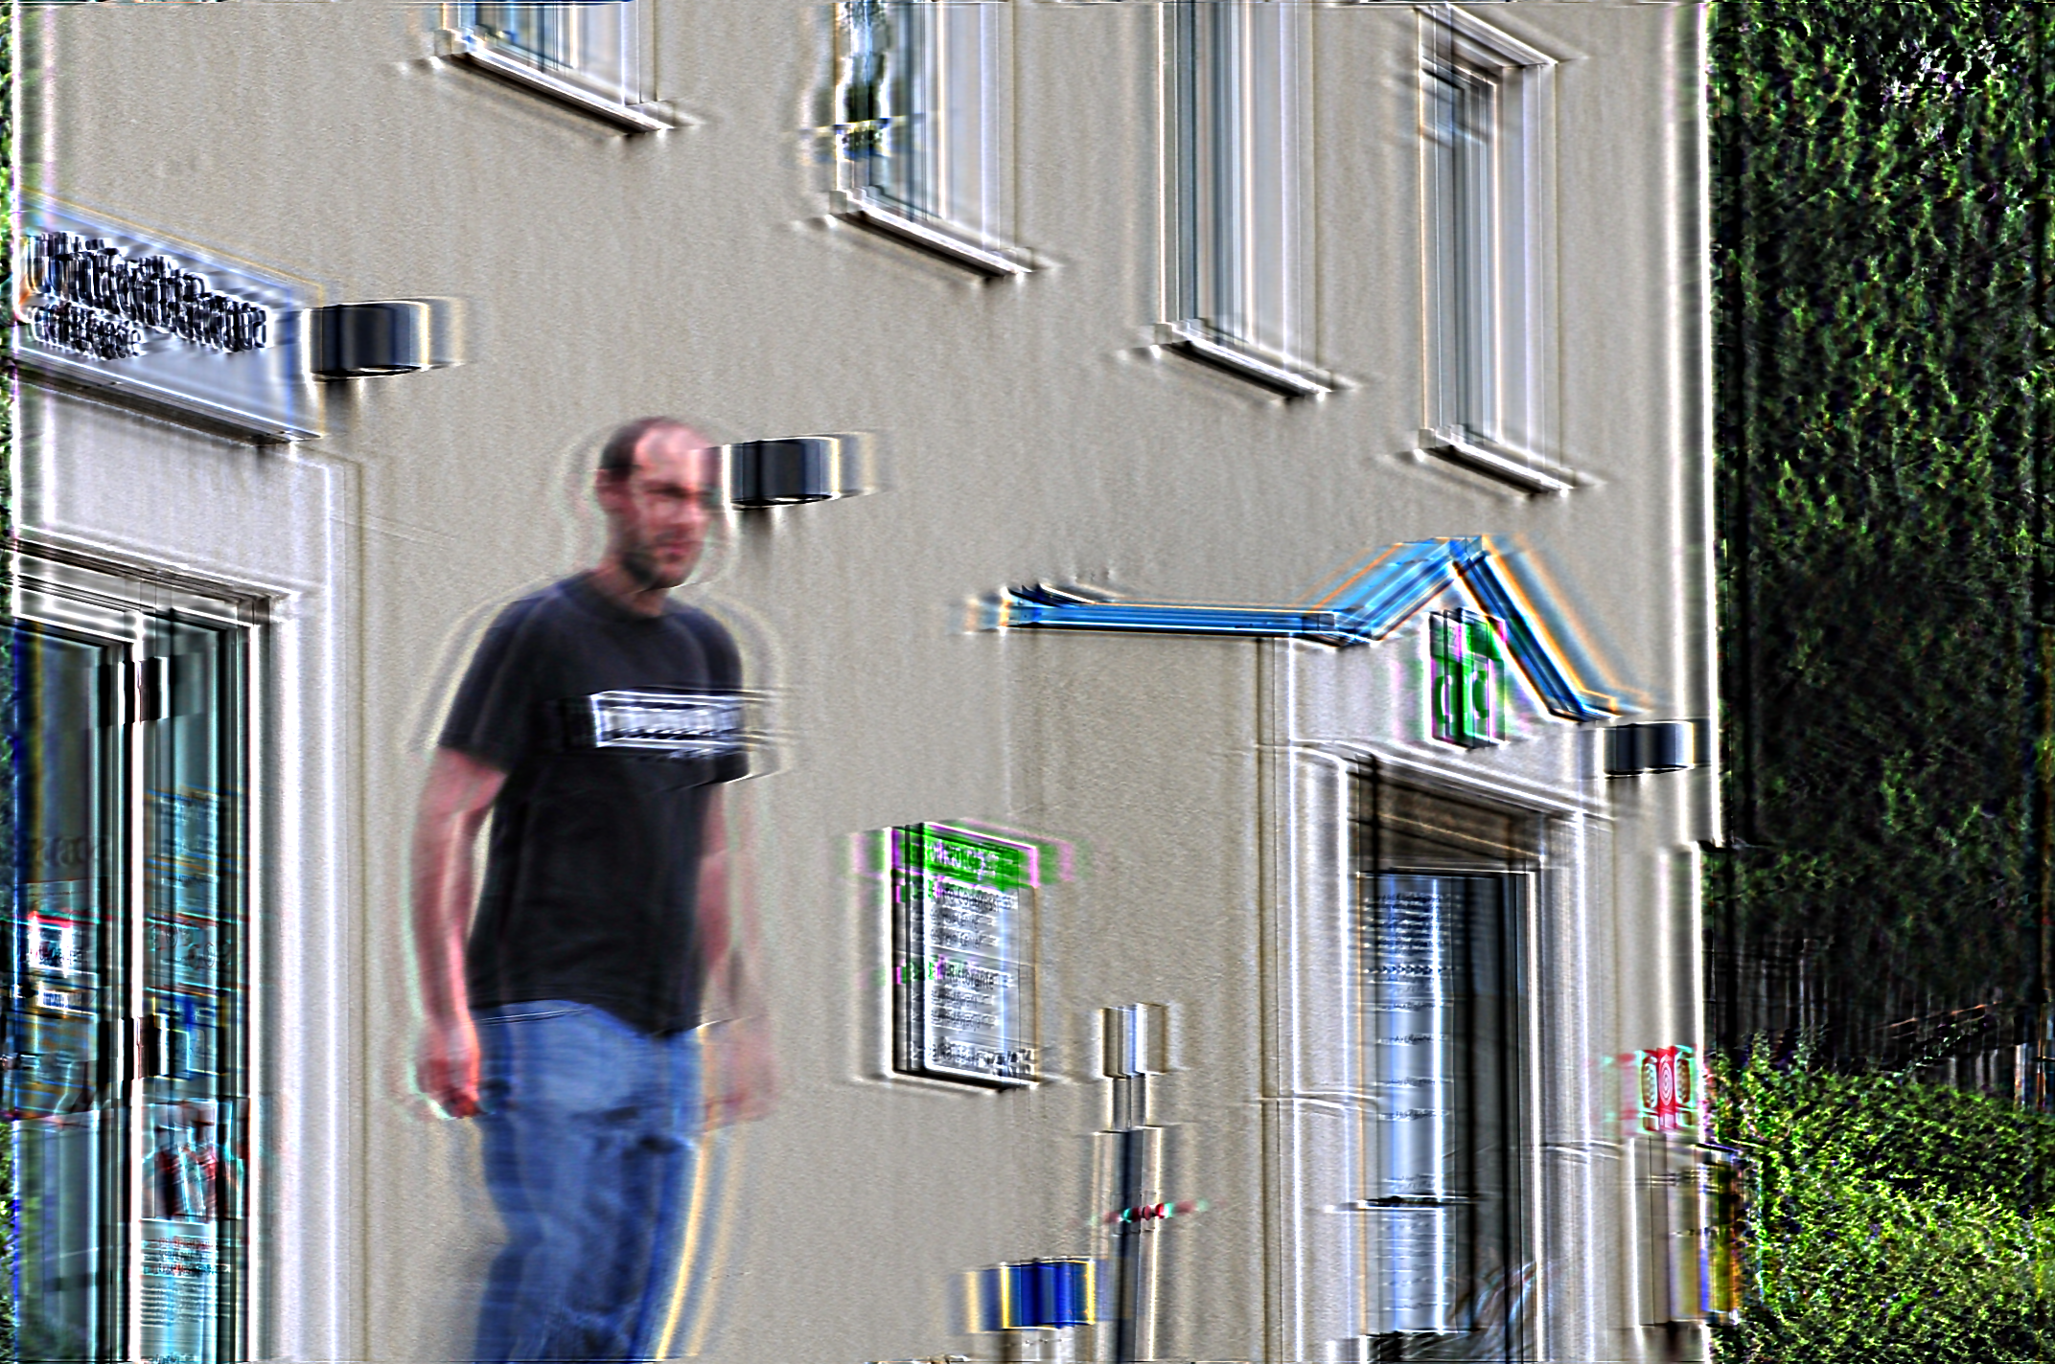
Figure 19 Final deblurred output for Image5.jpg.

2.6 Discuss and evaluate the step-by-step analysis and processing of Image6.jpg
Artefact diagnosis: Image5.jpg has the following artefacts: Directional motion blur. The edges are blurred in the same direction, thus reducing the contrast between the individual and background. This defect is characterized as being directional, unlike a defocus blur, and a motion point-spread function (MPSF) is a better model than a circular disk model (Gonzalez and Woods, 2018).
MATLAB processing steps: MATLAB processing is performed on the image to convert it to double precision, a motion point-spread function defined by fspecial('motion', 34, 8), and 10 iterations of Lucy-Richardson deconvolution. Then it sharpens with radius of 1.2 and amount of 0.8. A Canny edge mask is used to check the boundaries for high contrast, and in order to keep the important edges not smoothed out, bilateral filtering is applied in each channel to control the noise (Canny, 1986; Lucy, 1974; Richardson, 1972).
Critical evaluation: The resulting image's boundaries of objects are sharper and there is less of the smear than seen in the input. However, there is still some blur and possibly ringing due to the fact that there may be a small error in the motion path when compared with the assumed length and angle. In practice, the point-spread function is not exactly known, so this is to be expected. The output is thus a plausible improvement as it does not attempt to compensate for the original camera or subject motion completely but does help to improve edge clarity.
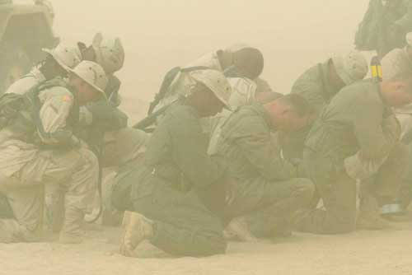
Figure 20 Input Image6.jpg showing haze and low contrast.

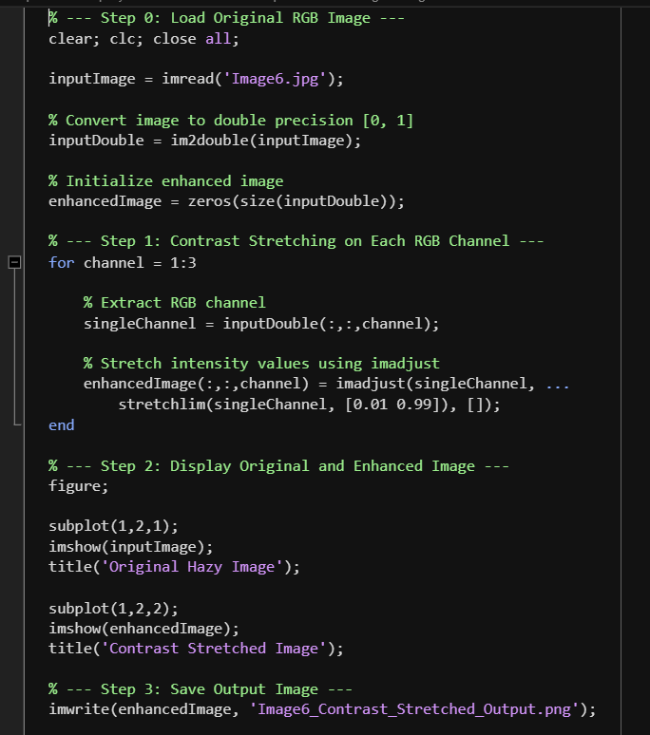
Figure 21 MATLAB code screenshot for Image6 channel-wise contrast stretching.

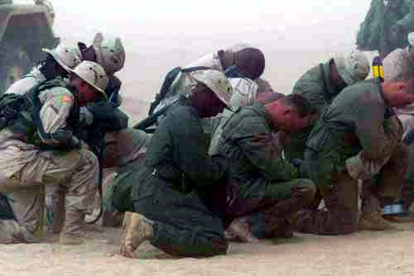
Figure 22 Contrast-stretched output for Image6.jpg.

2.7 Discuss and evaluate the step-by-step analysis and processing of image sequence
Diagnosis of Artefacts: Camera instability, low-light detail loss, small size of number-plates, local noise is present in the image sequence in the Vespa. The problem is that the sequence is not yet stable and a frame has not yet been decided on to be able to improve the plate. This is more complex than a still-image enhancement as time must be taken into account, and each frame must be aligned (Szeliski, 2022).
The script is designed to load and numerically sort the frames from the sequence, generate the original AVI film, and stabilise frames with the help of a template matching and a smoothed motion offset in MATLAB processing. After stabilisation, a cropping window is selected in frame 42 and fixed coordinates are used to crop the area of the plate. Histogram equalisation, CLAHE (value) channel, sharpening, 3x bicubic upscaling, non-local means denoising, contrast enhancement and gamma correction enhance the crop. It's a multi-stage workflow that involves temporal stabilisation and local plate enhancement (Buades, Coll and Morel, 2005; Zuiderveld, 1994).
Critical Evaluation: The stabilised frame has less disruption due to camera motion and the improved plate has a greater apparent resolution and contrast than the original extracted crop. This provides a stronger result since the stabilisation problem is removed from the plate-enhancement problem. The drawback is that if they're enhanced too strongly, they could add to the noise, and if the characters are small, they may produce artefacts around them. The output should thus be regarded as a better visual reconstruction, rather than a precise mathematical reconstruction of the original plate.
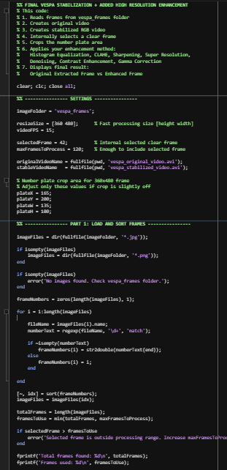
Figure 23 MATLAB code screenshot 1 for loading, sorting and preparing the Vespa frame sequence.

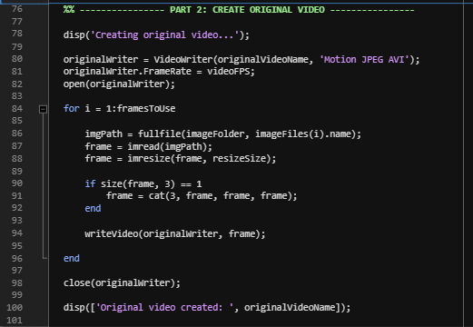
Figure 24 MATLAB code screenshot 2 for sequence processing and stabilisation setup.

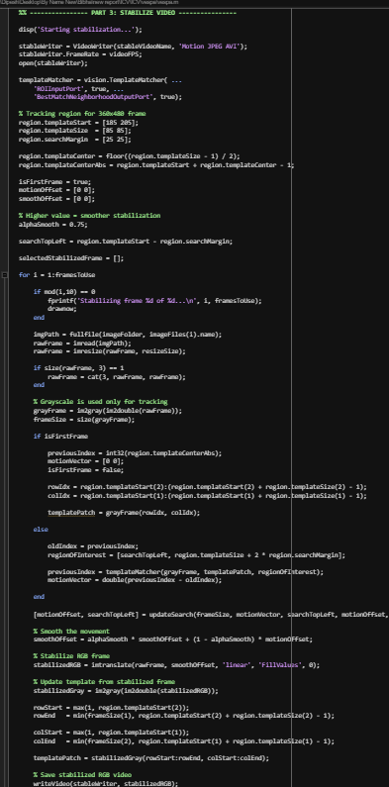
Figure 25 MATLAB code screenshot 3 showing template matching and stabilised-frame storage.

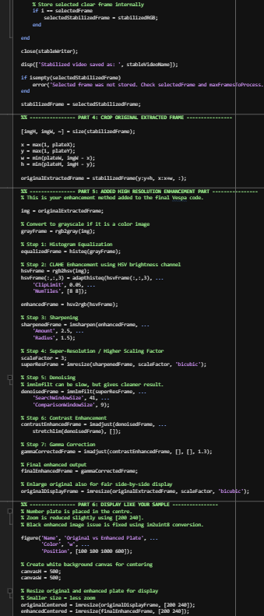
Figure 26 MATLAB code screenshot 4 showing cropped plate enhancement steps.

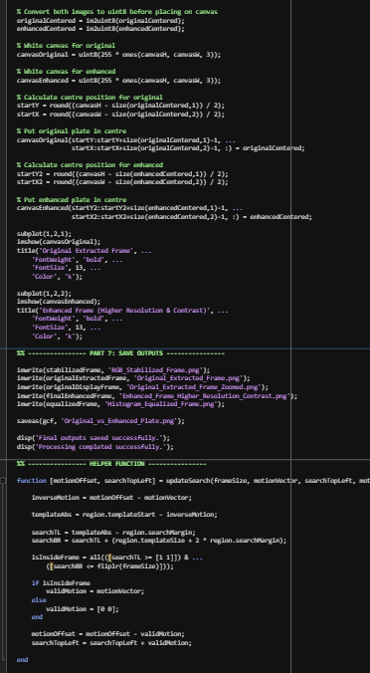
Figure 27 MATLAB code screenshot 5 showing output display, saving and helper function logic
.
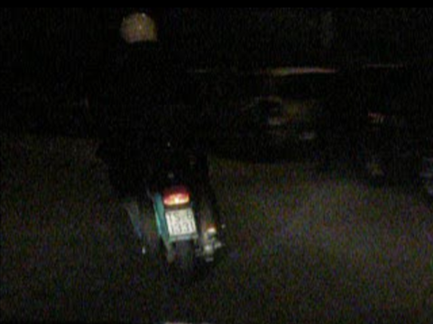
Figure 28 Stabilised RGB frame selected from the Vespa image sequence.

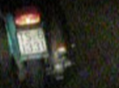
Figure 29 Original extracted number plate region from the stabilised Vespa frame.

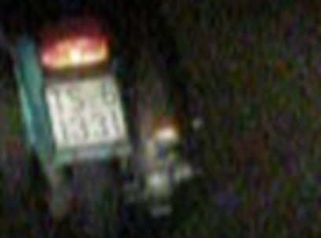
Figure 30 Zoomed original extracted Vespa plate area before final enhancement.

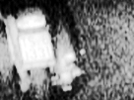
Figure 31 Histogram-equalised greyscale plate frame from the Vespa sequence.

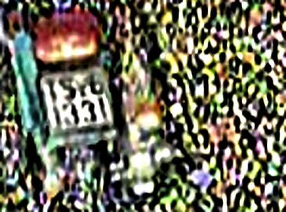
Figure 32 Higher-resolution contrast-enhanced Vespa plate output.

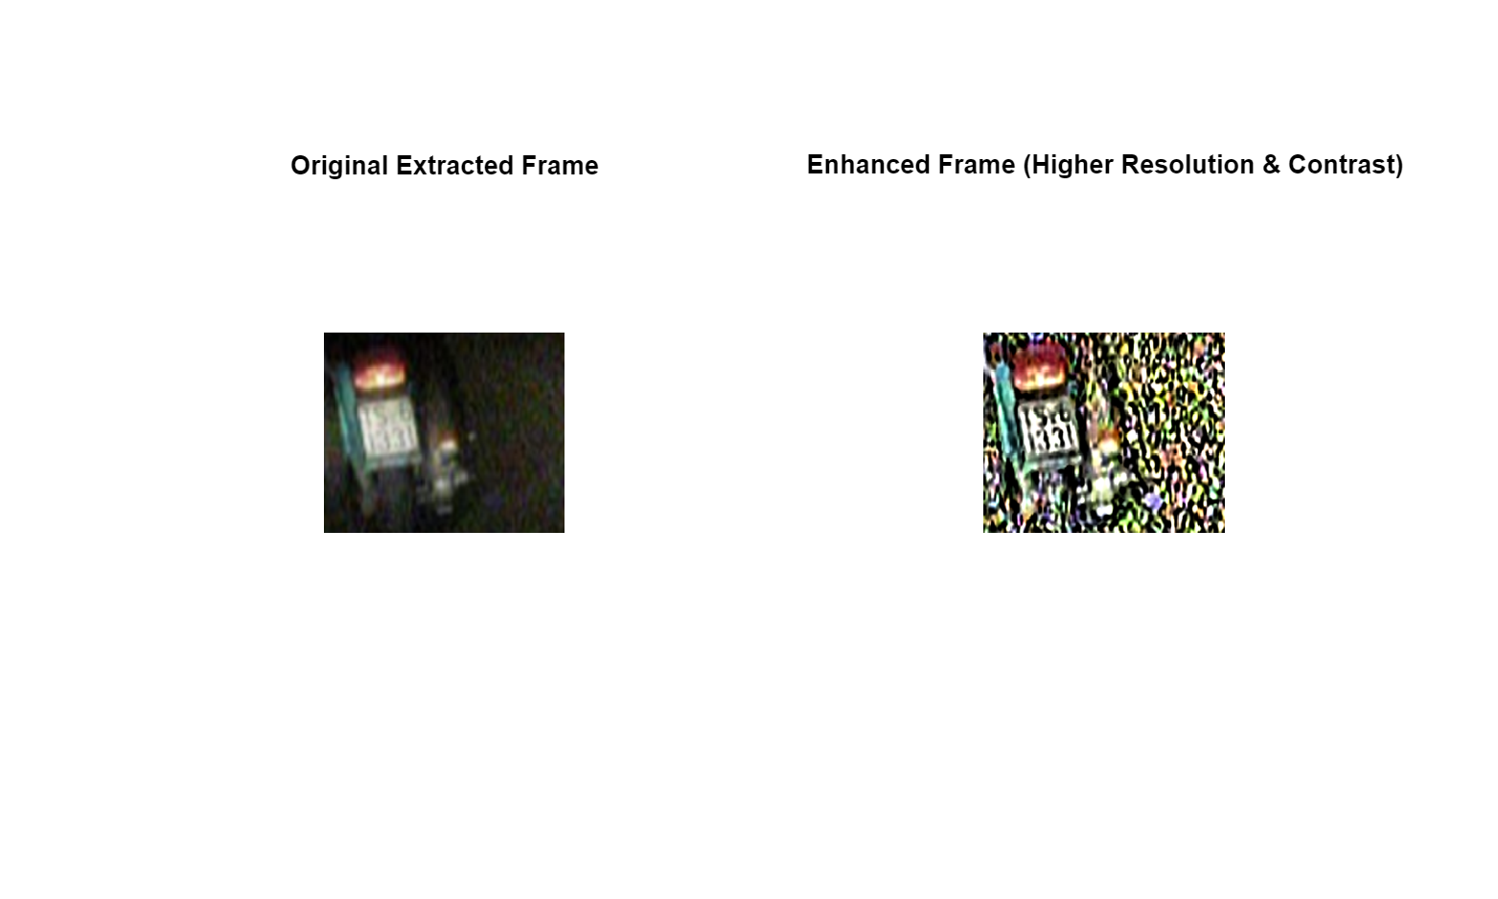
Figure 33 Final side-by-side comparison of the Vespa original extracted frame and enhanced plate.

2.8 Discuss and evaluate the step-by-step analysis and processing of video1.avi
Artefact diagnosis: video1.avi contains moving vehicle content: frame to frame change and number-plate visibility needs to be analysed. The motion part is not just an enhancement of still images, but a video processing, and the plate cut-out is small and low contrast. This task is then a combination of motion detection and local enhancement of a region of interest (Szeliski, 2022).
MATLAB processing steps: Reads frame 2 and frame 20 with VideoReader, converts these two frames to greyscale, double precision and computes the absolute difference between the two frames. The motion mask is obtained by using a threshold of 0.18 and smaller blobs under 80 pixels are removed using bwareaopen. The number plate is cropped out of frame 20 and subjected to four-times bicubic upscaling, sharpening and final intensity adjustment (MathWorks, n.d.-e; MathWorks, n.d.-a) to enhance it.
The results of critical evaluation: The motion mask is able to identify the changed regions between the selected frames successfully, thus the frame differencing method is appropriate for this short video. The increased plate output is beneficial when it comes to visibility, but the original crop size is still small, and there may be compression artefacts. The method is also suitable because it relies on an uncomplicated and clear motion analysis process prior to the specific improvement of the plate, thereby providing clear evidence that could easily be explained and reproduced.
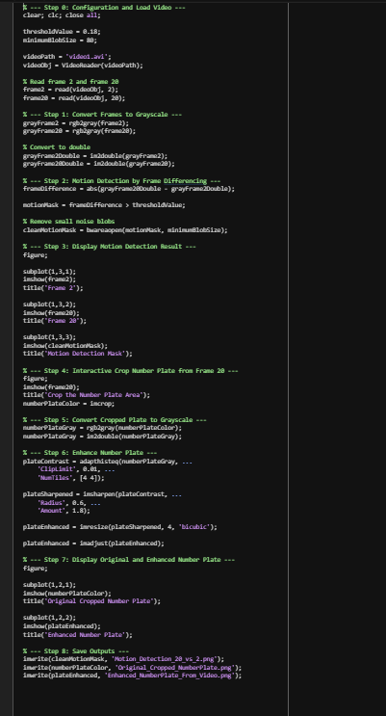
Figure 34 MATLAB code screenshot for video1.avi frame differencing and number plate enhancement.

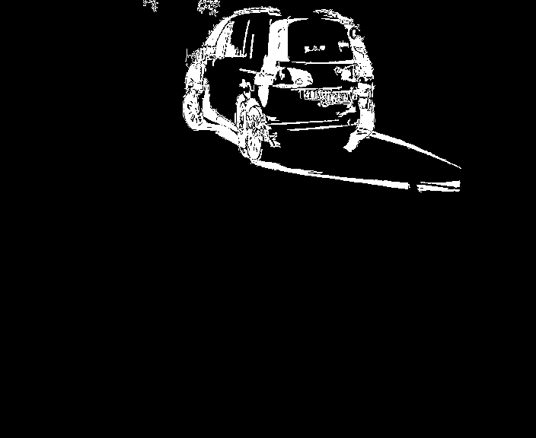
Figure 35 Motion detection output comparing frame 20 against frame 2.

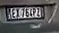
Figure 36 Original cropped number plate from video1.avi

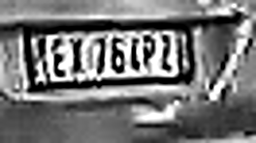
Figure 37 Enhanced number plate output from video1.avi.

2.9 Discuss and evaluate the step-by-step analysis and processing of video2.avi
Artefact diagnosis: video2.avi needs to be frame extracted prior to detailed plate enhancement. The chosen frame/0029 has a small area of plate which is low contrast and not easily readable in the original crop. The primary aspect of processing is then to select the appropriate frame, extract the section of interest (plate area), and enhance the contrast of the plate locally for examination.
MATLAB processing steps: The script makes a folder for the output, reads all the frames as PNGs with VideoReader and readFrame and then reads frame_0029.png so that it can be used for plate processing. The plate is cropped with drawrectangle and imcrop, scaled up by 3 times bicubic and converted to greyscale image before the enhancement using CLAHE and sharpening. The transformation from video frame to output – either the original or enhanced crop – can be shown directly by saving both original and enhanced crops (MathWorks, n.d.-e; Zuiderveld, 1994).
Critical evaluation: Enhanced frame 0029 plate crop has large size with high local contrast compared to original plate crop improving visual evaluation. The small source area and compression in the video, however, do not help to recover a lot of reliable information. It is an important evaluation period as upscaling and sharpening can help to make the characters easier to read, but it does not ensure exact recovery of the characters. The workflow is still valid as it shows the reproducible extraction, cropping, enhancement and saving of the frame.
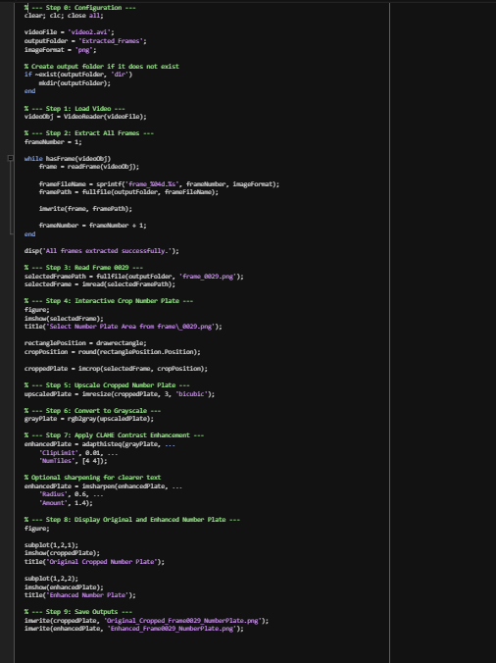
Figure 38 MATLAB code screenshot for video2.avi frame extraction and number plate enhancement.

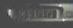
Figure 39 Original cropped plate from extracted frame 0029 of video2.avi.

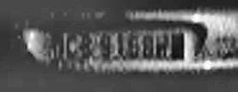
Figure 40 Enhanced number plate from frame 0029 of video2.avi.

Overall evaluation: Across the files of the coursework, the best performance is obtained by using the appropriate processing method to the visible defect: chromatic adaptation for colour cast, deconvolution for blur, CLAHE for local contrast, stabilisation for sequence motion and extracting frames from a video for video analysis. Significant technical limitations are also evident in the outputs: Interpolation will not create real detail and deconvolution relies upon an assumed "blur model," which can be problematic if it is incorrect, and contrast enhancement can introduce noise. A balanced evaluation of this will make the submission more useful/appealing, since it will show how to practically implement this in MATLAB as well as critical understanding of the theory of image processing.

3. References
Buades, A., Coll, B. and Morel, J-M. (2005) 'A non-local algorithm for image denoising', 2005 IEEE Computer Society Conference on Computer Vision and Pattern Recognition (CVPR'05), San Diego, CA, pp. 60-65. doi: 10.1109/CVPR.2005.38.
Canny, J. (1986) 'A computational approach to edge detection', IEEE Transactions on Pattern Analysis and Machine Intelligence, PAMI-8(6), pp. 679-698. doi: 10.1109/TPAMI.1986.4767851.
Gonzalez, R.C. and Woods, R.E. (2018) Digital Image Processing. 4th edn. New York: Pearson.
Jain, A.K. (1989) Fundamentals of Digital Image Processing. Englewood Cliffs, NJ: Prentice-Hall.
Lucy, L.B. (1974) 'An iterative technique for the rectification of observed distributions', The Astronomical Journal, 79, pp. 745-754. doi: 10.1086/111605.
MathWorks (n.d.-a) adapthisteq: Contrast-limited adaptive histogram equalization. Available at: https://www.mathworks.com/help/images/ref/adapthisteq.html (Accessed: 14 May 2026).
MathWorks (n.d.-b) chromadapt: Adjust image color balance by adapting colors to illumination. Available at: https://www.mathworks.com/help/images/ref/chromadapt.html (Accessed: 14 May 2026).
MathWorks (n.d.-c) deconvlucy: Deblur image using Lucy-Richardson method. Available at: https://www.mathworks.com/help/images/ref/deconvlucy.html (Accessed: 14 May 2026).
MathWorks (n.d.-d) imadjust: Adjust image intensity values or colormap. Available at: https://www.mathworks.com/help/images/ref/imadjust.html (Accessed: 14 May 2026).
MathWorks (n.d.-e) VideoReader: Create object to read video files. Available at: https://www.mathworks.com/help/matlab/ref/videoreader.html (Accessed: 14 May 2026).
Richardson, W.H. (1972) 'Bayesian-based iterative method of image restoration', Journal of the Optical Society of America, 62(1), pp. 55-59. doi: 10.1364/JOSA.62.000055.
Shapiro, L.G. and Stockman, G.C. (2001) Computer Vision. Upper Saddle River, NJ: Prentice-Hall.
Szeliski, R. (2022) Computer Vision: Algorithms and Applications. 2nd edn. Cham: Springer. Available at: https://szeliski.org/Book/ (Accessed: 14 May 2026).
Zuiderveld, K. (1994) 'Contrast Limited Adaptive Histogram Equalization', in Heckbert, P.S. (ed.) Graphics Gems IV. San Diego: Academic Press, pp. 474-485.

