Intelligent Agent Design for the N-Queens Problem

Table of Contents
1. Introduction 2
2. Problem domain analysis 2
3. Proposed intelligent agent design 3
4. Environment and interaction 4
5. Analysis of strengths, weaknesses and complexity 5
6. Ethical issues, limitations and improvements 6
7. Conclusion 6
References 7

1. Introduction
The N-Queens problem posits the question as to whether n queens can be laid down on an n x n chess board, without any two queens being in any row, column or diagonal attacking each other. Even though it started as a chess puzzle, it has become a historical AI benchmark since it focuses on the very fundamental challenge of intelligent search; a very large combinatorial space that is constrained by very specific constraints (Bell and Stevens, 2009; CSPLib, 2026). The task is also handy in the terms of agents, where the success is less reliant on noisy perception and more on state representation and rational action choice and search strategy adaptation with the increase in scale (Russell and Norvig, 2021; Poole and Mackworth, 2023).
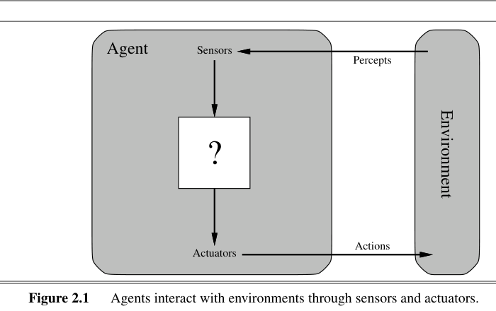
Figure 1 Generic agent–environment interaction underpinning the proposed N-Queens agent design
Source: Russell and Norvig (2021).

2. Problem domain analysis
The domain is most appropriate a constraint satisfaction problem. One queen can be associated with each column of a state and the row of that column is considered to be the value of the variable. An assignment is a complete assignment that has no row or diagonal conflicts. This representation cuts down the search space, although the size of the candidate assignments again increases exponentially with n, thus making the naive generate-and-test infeasible. Exact search studies demonstrated exponential growth in the straightforward backtracking, and subsequent studies demonstrated the related n-Queens Completion problem to be NP-complete and #P-complete (Stone and Stone, 1987; Gent, Jefferson and Nightingale, 2017).
The field thus raises a significant design problem: what is an efficient intelligent agent to navigate a hard search space? There are two key approaches that are proposed by existing solutions. Complete and interpretable, systematic approaches like backtracking and constraint propagation are however, expensive. Local-search schemes like min-conflicts repair bad states in an iterative manner, and can be very much more scalable when just one solution is needed (Minton et al., 1992; Sosic and Gu, 1994). This renders N-Queens much more appropriate to assess intelligent-agent architecture as opposed to brute-force calculation by itself.

3. Proposed intelligent agent design
A model based utility agent is the most appropriate design. A mere reflex agent is not powerful enough since a local perception like this queen is in conflict is not sufficient to decide on the most ideal next move. A goal based agent is preferable as it strives to achieve a zero conflict board, however, all non goal states are still treated too similarly. Practically, the agent will have to prioritize partial states based on their promisingness hence a utility-based design will be more appropriate (Russell and Norvig, 2021).
The current row assignment, the number of rows and the number of both diagonals are stored in the internal model. Based on these, the agent can determine the extent of conflict created by each queen and can determine the impact of the movement of any queen. The utility role that it plays should compensate legality and efficiency and punish conflict, unnecessary moves and restart cost. Theoretically, U(s) = -C(s)-aM-bR with C(s) being the count of attacking pairs, M being the count of moves and R being the count of restarts. Any cheaply obtained zero-conflict solution is the best.
The decision process is very simple. The initial complete assignment is the initial assignment made by the agent. Second, it picks a queen who is in conflict at hand. Third, it shifts that queen to the row in the same column which has the greatest utility, typically the fewest conflicts. To decrease cycling, ties are broken randomly and plateaus are forced by long plateaus, which cause random restart. This can also be considered a rational-agent version of the min-conflicts concept: at every step the agent selects the action with the best expected improvement, by its utility model (Minton et al., 1992; Sosic and Gu, 1994).
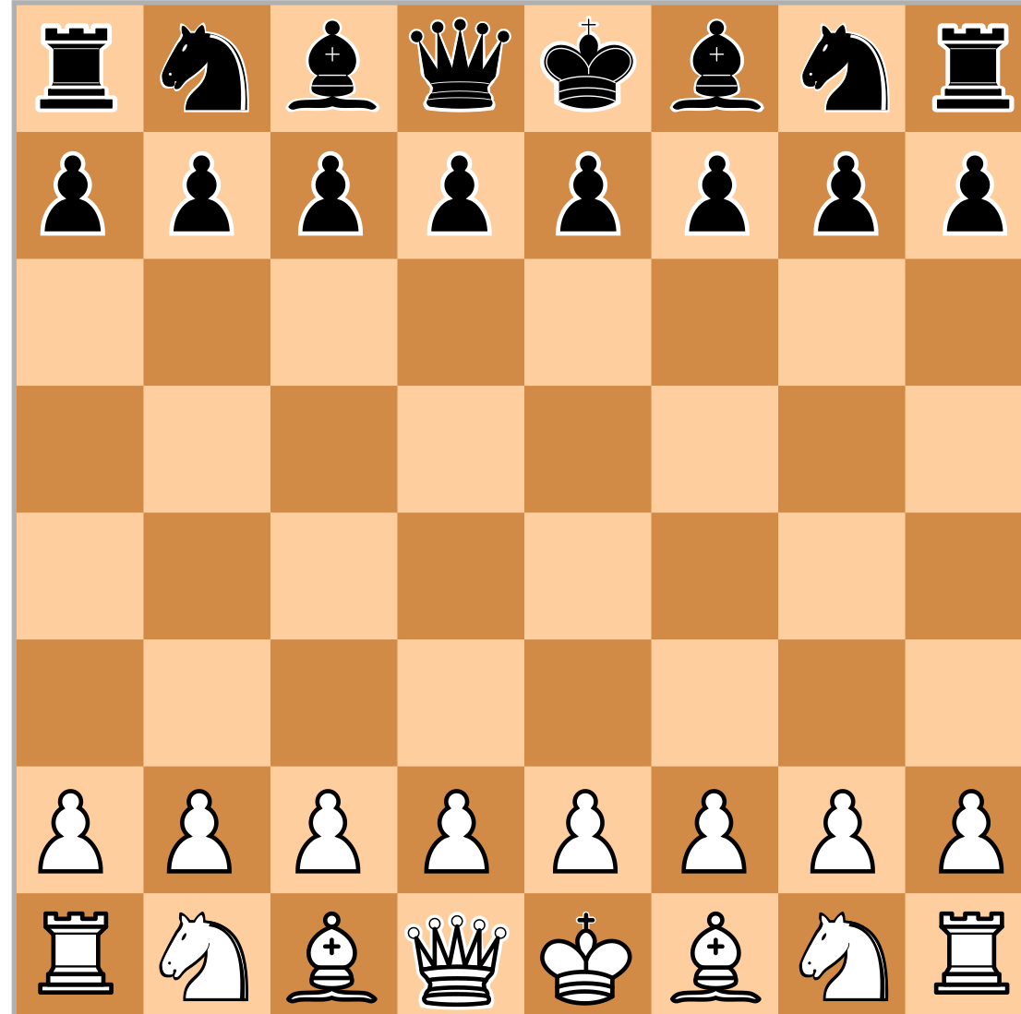
Figure 2 Chessboard representation used to conceptualise the N-Queens search space
Source: Wikimedia Commons (2010).

4. Environment and interaction
The N-Queens setting is completely observable, deterministic, static, discrete, single agent and known. It is also sequential and not episodic since each move will alter the search future. Such characteristics can turn to a model-based agent, as the agent is able to utilize precise internalized representation other than dubious estimation (Russell and Norvig, 2021; Poole and Mackworth, 2023). The performance measure in PEAS is a valid solution that has a low time and memory cost; the environment is the chessboard and its constraints; the actuators are queen-placement or queen-move actions; and the percepts are the board state and the number of conflicts. Practically, the agent will see the board as it is, and its conflict structure, and then it will update the internal model, make predictions about the result of the legal actions and implement the move with the most utility. The measure of performance of it ought to be both the correctness, and time, memory use and strength as n increases. A smart agent in this field then ought to be evaluated based on its ability to come up with a legitimate solution and a measure of how cost-effective it is in a familiar context.
Table 1 Environment classification for the proposed N-Queens agent.
Dimension | Classification and implication
World properties | Completely visible, deterministic, stationary, discrete and known; prediction can be made of the successor states.
Task structure | Single-agent and sequential; a move alters the search landscape in the future.
Performance measure | A good agent ought to optimize accuracy, speed, memory effectiveness and strength with an increase in n.

5. Analysis of strengths, weaknesses and complexity
Scalability is the key quality of the proposed agent. It operates on full candidate assignments as opposed to building a deep search tree of partial boards, as in exact search. This allows it to be effective when there is a need to determine a single solution in a short period of time. The low memory demand is a second strength. The agent requires O(n) space to assign rows and auxiliary counts of rows and diagonals to aid with the column assignment of O(n) queens.
The principal weakness is the incompleteness. Local search is not guaranteed to be successful on every run, and cannot be used to show unsatisfiability. The restriction is more relevant to more difficult versions like completion instances, which can be proven to be theoretically hard (Gent, Jefferson and Nightingale, 2017). The design is attracted due to complex analysis. To the best of a pure formulation of the game where there is a queen in every column, the worst-case search tree is exponential, and is often written as O(n!) when some pruning conditions are taken into account (Stone and Stone, 1987; San Segundo, 2011).
In comparison, the initial configuration is formed in O(n) time when the proposed agent is used. When there are fixed counts in maintaining the counts and every step of the repair scans all the n rows in the selected column, each step is O(n). In cases where the number of repair steps is increasing more or less in practice in a linear fashion, overall runtime is typically close to O(n 2 ), and O(n) space. This type of strong practical scaling is justified by empirical research into conflict-minimisation, and must not be confused with a general worst-case insurance (Minton et al., 1992; Sosic and Gu, 1994). The design is a logical trade-off thus: it is incomplete to gain speed and memory efficiency. The systematic CSP agent would only be desirable in situations where the task must have a demonstration, exhaustive enumeration or greater assurances.

6. Ethical issues, limitations and improvements
The N-Queens problem itself is not a highly ethical problem, however related intelligent agent architectures are extensively used in practice in areas like scheduling and resource allocation. The utility functions in such situations can be optimized to affect fairness and efficiency. Thus, the concept of transparency, robustness and responsible design should be taken into consideration even when developing agents in theory (European Commission High-Level Expert Group on AI, 2019; OECD, 2019; NIST, 2023).

7. Conclusion
The N-Queens problem is a wonderful field of study of intelligent agents since it is a rational search in a well-structured but computationally challenging field. The utility agent based on a model is the most powerful theoretical description as it can fully reflect the board and consider partial states and take actions that help to maximise the progress towards a legal configuration. Precise algorithms are still important to be complete but in the case of large examples a utility-directed local-search agent provides the more scalable and practically sensible answer. The case thus demonstrates that, intelligent performance is not only based on the algorithm that is applied, but how well the agent models its environment, the definition of utility and acting under computational constraint. It is not just limited to puzzles but also to bigger optimisation environments where the quality of the architecture of the agent influences the performance and accountability.

References
Bell, J. and Stevens, B. (2009) ‘A survey of known results and research areas for n-queens’, Discrete Mathematics, 309(1), pp. 1–31. Available at: https://doi.org/10.1016/j.disc.2007.12.043 (Accessed: 14 April 2026).
CSPLib (2026) Problem 054: N-Queens. Available at: https://www.csplib.org/Problems/prob054/ (Accessed: 14 April 2026).
European Commission High-Level Expert Group on AI (2019) Ethics Guidelines for Trustworthy AI. Brussels: European Commission. Available at: https://digital-strategy.ec.europa.eu/en/library/ethics-guidelines-trustworthy-ai (Accessed: 14 April 2026).
Gent, I.P., Jefferson, C. and Nightingale, P. (2017) ‘Complexity of n-Queens completion’, Journal of Artificial Intelligence Research, 59, pp. 815–848. Available at: https://doi.org/10.1613/jair.5512 (Accessed: 14 April 2026).
Minton, S., Johnston, M.D., Philips, A.B. and Laird, P. (1992) ‘Minimizing conflicts: A heuristic repair method for constraint satisfaction and scheduling problems’, Artificial Intelligence, 58(1–3), pp. 161–205. Available at: https://doi.org/10.1016/0004-3702(92)90007-K (Accessed: 14 April 2026).
National Institute of Standards and Technology (2023) Artificial Intelligence Risk Management Framework (AI RMF 1.0). Gaithersburg, MD: U.S. Department of Commerce. Available at: https://nvlpubs.nist.gov/nistpubs/ai/nist.ai.100-1.pdf (Accessed: 14 April 2026).
OECD (2019) Recommendation of the Council on Artificial Intelligence. Paris: OECD. Available at: https://legalinstruments.oecd.org/en/instruments/oecd-legal-0449 (Accessed: 14 April 2026).
Poole, D.L. and Mackworth, A.K. (2023) Artificial Intelligence: Foundations of Computational Agents. 3rd edn. Cambridge: Cambridge University Press.
Russell, S.J. and Norvig, P. (2021a) Artificial Intelligence: A Modern Approach. 4th edn. Hoboken, NJ: Pearson.
Russell, S.J. and Norvig, P. (2021b) ‘Figure 2.1: Agents interact with environments through sensors and actuators’, in Artificial Intelligence: A Modern Approach. 4th edn. Available at: https://aima.cs.berkeley.edu/4th-ed/pdfs/newchap02.pdf (Accessed: 14 April 2026).
San Segundo, P. (2011) ‘New decision rules for exact search in n-queens’, Journal of Global Optimization, 51(3), pp. 497–514. Available at: https://doi.org/10.1007/s10898-011-9653-x (Accessed: 14 April 2026).
Sosic, R. and Gu, J. (1994) ‘Efficient local search with conflict minimization: A case study of the n-queens problem’, IEEE Transactions on Knowledge and Data Engineering, 6(5), pp. 661–668. Available at: https://doi.org/10.1109/69.317698 (Accessed: 14 April 2026).
Stone, H.S. and Stone, J.M. (1987) ‘Efficient search techniques—An empirical study of the n-queens problem’, IBM Journal of Research and Development, 31(4), pp. 464–474. Available at: https://doi.org/10.1147/rd.314.0464 (Accessed: 14 April 2026).
Wikimedia Commons (2010) File: Chess board blank.svg. Available at: https://commons.wikimedia.org/wiki/File:Chess_board_blank.svg (Accessed: 14 April 2026).

