Kathmandu as a Destination Brand
A New Branding Strategy for Kathmandu, Nepal

Table of Contents
1. Introduction 5
2. Theoretical Background 5
2.1 Concept of Brand and Destination Branding 5
2.2 Integrated Branding Touchpoints 5
2.3 Aaker’s Brand Identity Model 6
2.4 Keller’s Customer-Based Brand Equity Model 6
2.5 Strategic Implications for Kathmandu 6
3. Evaluation of Current Branding Strategy 6
4. New Branding Strategy 10
4.1 New Brand Identity 10
4.2 Target Markets 10
4.3 Logo, Slogan and Visual Identity 11
4.4 Marketing Material Examples 12
4.5 Branding Communication Strategy 13
4.6 Implementation Plan 14
5. Conclusion 15
References 16
Appendices 18
Appendix A: Current branding evidence 18
Appendix B: SWOT analysis table 20
Appendix C: PESTLE analysis table 21
Appendix D: Competitor comparison table 23
Appendix E: Target market segmentation table 23
Appendix F: Proposed logo and visual identity notes 25
Appendix G: Marketing mock-up examples 27
Appendix H: Implementation plan table 28
Appendix I: Nine Thematic Dimensions Assessment 30
Appendix J: 6A Destination Analysis 31

1. Introduction
Kathmandu is the symbolic and the entrance to Nepal; the political capital, the entry point as well as the urban centre of a culturally rich valley which is listed among the seven monument zones by UNESCO. In spite of this importance, the destination image of Kathmandu is stronger in comparison to identified brand. Nepal Tourism Board through national tourism messaging focuses on Nepal -Lifetime Experiences, although Kathmandu is being marketed primarily as a heritage destination as opposed to an emotional city image. This difference is significant since Kathmandu has to compete with domestic destinations such as Pokhara and Bhaktapur, and other heritage cities of South Asian heritage that convey spiritual and cultural richness more effectively. In order to be competitive, Kathmandu needs to make its inherent heritage value an exciting emotional position, deal with urban issues that impact perception and use opportunities available like becoming a UNESCO Creative City of Film. This report will examine existing branding, theory, and offer a holistic destination branding strategy.

2. Theoretical Background

2.1 Concept of Brand and Destination Branding
A brand is more than a name or a symbol, it is a promise that is structured in a certain manner and makes sense in the mind of the audience. According to Aaker (1996), strong brands need a compact system of identity as compared to Keller (1993) definition of brand equity as the difference influence of brand knowledge on consumer response. The use of destination contexts complicates branding as places are not controllable products. They are residential and tourist destinations that are multi-layered in terms of the people living there, tourists, government, heritage institutions and operators. Destination branding must, therefore, be regarded as the strategic act of identity, experience and reputation rather than a promotion logo activity in its own right (Blain, Levy and Ritchie, 2005).

2.2 Integrated Branding Touchpoints
Moreover, destination branding needs to be consistent across various touchpoints, such as digital platforms, physical spaces and stakeholder communications. Fragmented strategy undermines brand recognition and recall, but integrated communications enhances awareness, credibility and long-term competitive advantage in markets that are becoming more and more saturated.

2.3 Aaker’s Brand Identity Model
There are two models that come in particularly handy with Kathmandu. To begin with, the Brand Identity Model by Aaker allows differentiating between core identity and extended identity. Its benefit is that it makes a decision between what has to be core, and what can change depending on the campaign. Kathmandu is important because Kathmandu has many definitions that contradict one another: sacred city, heritage city, creative city, gateway city and youth culture hub. The model proposed by Aaker can serve to support prioritisation, but its co-creation and contested character of city identities can be understated.

2.4 Keller’s Customer-Based Brand Equity Model
Second, the customer-based brand equity model by Keller is applicable since it has been based on the process of salience, imagery, judgements, feelings and resonance constructed in the memory of the audience (Keller, 1993). This is important in the industry of tourism where destinations are usually bought out of imagination than physically. Subsequent research on destination brand equity also puts an emphasis on awareness, image, quality and loyalty, and demonstrates that positioning congruence is important in the formation of stronger equity (Kladou et al., 2017; Rodriguez-Molina et al., 2019). In the case of Kathmandu, the most important issue that was outlined in the model of Keller is that awareness has a high level but the emotional and experience ladder is uneven.

2.5 Strategic Implications for Kathmandu
These frameworks taken together imply four implications on Kathmandu. The brand has to be based on the true local identity as opposed to the imported lifestyle images. It will have to establish equity by creating an equal stream of memory platforms. It should reflect symbolic elements - name, logo, slogan and visual motifs - on real experience, since brand elements can only create value when they convey a plausible identity (Kladou et al., 2017). Lastly, it should be able to strike a balance between tradition and modernity. A completely nostalgic brand would make Kathmandu look like a museum picture and too modern brand would sweep away living rituals and the stratified urban history that makes the city so special. This report also uses the Nine Thematic Dimensions Assessment in Appendix I to test whether the proposed Kathmandu brand is clear, distinctive, authentic and aligned across communication and visitor experience.

3. Evaluation of Current Branding Strategy
Kathmandu has now outstanding raw brand assets. Immediate international legitimacy is granted to it by UNESCO recognitio and the valley has a high concentration of large Hindu, Buddhist sites, which is unusual in terms of cultural density (UNESCO, 2026a). Nepal tourism system also provides visibility under the official Nepal Tourism Board site, which is multilingual and internationally oriented ( Nepal Tourism Board, 2026a). In 2024, Nepal had the entry of the 1,147,548 international tourists and India the USA, China and the UK were the most active source markets, and pilgrimage travel has risen in high demand along with the holiday travel, showing that Nepal has a range of experiences to provide (Ministry of Culture, Tourism and Civil Aviation, 2025). In terms of brand equity, Kathmandu thus has a good starting point in terms of salience.
Nevertheless, the present branding is still strategically poor on the city level. Kathmandu lacks an active foregrounded city logo, city slogan or narrative architecture making it a brand within Nepal brand. The Kathmandu official page is the descriptive and heritage-laden site that serves more as the destination information than the branded offer (Nepal Tourism Board, 2026b). The essence has not been distinctly chosen. Is it Kathmandu, more of a sacred place, historic, creative, cosmopolitan, or merely the opening to somewhere else?
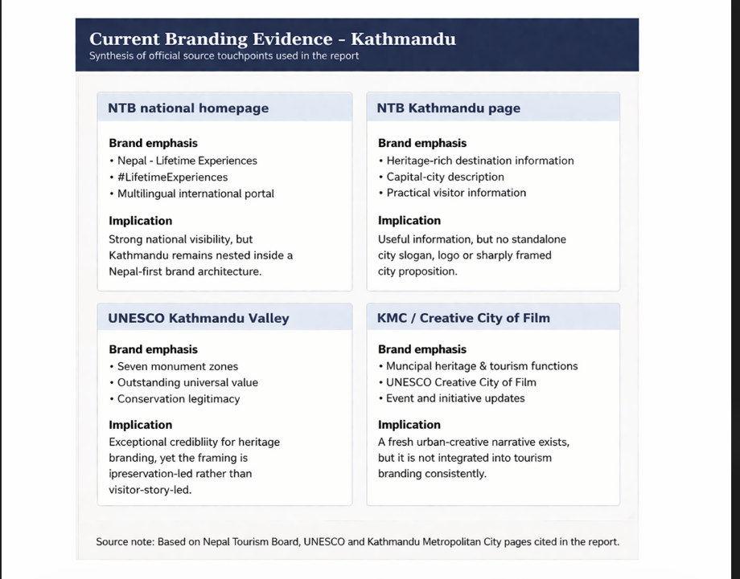
Figure 1 Current branding evidence of Kathmandu

Source: author synthesis based on Nepal Tourism Board, UNESCO and Kathmandu Metropolitan City materials cited in this report.
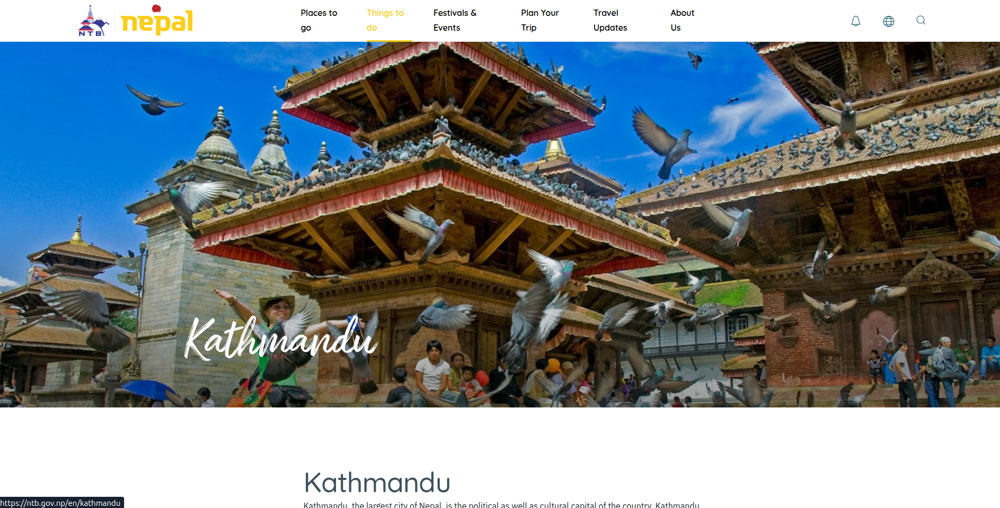
Figure 2 NTB Kathmandu landing page
Source: Nepal Tourism Board (2026b)

This confusion constrains the ability to remember. According to the model proposed by Keller, shallow equity is made when awareness does not generate organised imagery. Kathmandu reminds of temples, stupas, Thamel and old squares, but the emotional associations are of a mixed nature. To others the city is an indicator of mystery and spirituality; to others it is an indicator of dust and traffic jams and logistical pressure. As Karki et al. (2024) demonstrate, the process of heritage conservation in Kathmandu Valley is under pressure due to urbanisation, poor stakeholder coordination and poor sustainable promotion. These are not operational issues; they are brand issues since these influence judgement and emotions.
The position is explained in a short SWOT analysis. The strengths can be seen in the living heritage of the world, authenticity of the rituals, high concentration of the cultural experiences, and accessibility of the gateways. The fragmented messaging, inconsistent design towards the general public, the traffic and environmental stress, and the habit of promoting monuments without creating a consistent narrative are all weaknesses. Some of them are spiritual tourism, short-lengtheness video storytelling, domestic city-break travel, and the neglected UNESCO Creative City of Film label (UNESCO, 2024; Li and Zhang, 2023). These threats are heritage degradation, overtourism of some areas, a more defined leisure identity of Pokhara, clearer spiritual branding of Varanasi (Nepal Tourism Board, 2026d; Nepal Tourism Board, 2026e; District Varanasi, 2026).
On the whole, the existing strategy is one of the asset richness and brand insufficiency. Kathmandu is important, but it is not yet sharply positioned.

4. New Branding Strategy

4.1 New Brand Identity
The new brand identity that is proposed is Kathmandu as the living sacred city of stratified tales. The tactical concept is not just to market Kathmandu as a list of monuments, but as a location where ritual, craft, memory, movement and creativity are still alive in the day to day life in the urban center. The suggested brand personality is living heritage. This changes the city into a non-passive sightseeing experience into an active cultural experience.
It has the following core values: authenticity, reverence, craftsmanship, plurality, resilience and curiosity. It is creative and somewhat mysterious, its personality is soulful and complex, hospitable.
The given positioning is more solid than the existing one as it provides Kathmandu with a unique concept unlike generic national promotion and redefines perceived chaos as urban intensity instead of disorder. The city is not marketed as smooth, and pristine; it is marketed as multi-layered, and vital and purposeful. It is more real and consequently more believable. It also concurs with the reasoning of Aaker in explaining the core identity whilst permitting the long names like sacred mornings, artisan alleys, festival city and city of film to particular campaigns.

4.2 Target Markets
The target markets to be given priority should be selective as opposed to being universal. Segment one consists of domestic and diaspora Nepali urban travellers that are in search of pride, rediscovery and brief cultural escapes (Wassler, Wang and Hung, 2019). They should be messaged with the focus on rediscovering Kathmandu that is not about traffic and business.
Segment two will be Indian and wider SAARC pilgrimage and short-break travellers. Recent statistics of tourism in Nepal (2024) verify that the regional flows are still strong, and pilgrimage as a travel purpose is expanding (Ministry of Culture, Tourism and Civil Aviation, 2025). In this segment, Kathmandu is to preempt divine geography, ritualistic calendars, hassle-free tours and deferential hosting.
Segment three consists of long-haul culture heritage travellers of Europe, North America and Australia. To them, Kathmandu ought to be placed as a small world of inhabited civilisational experiences as opposed to a transitional place before trekking.
Segment four entails younger digital and creative travellers such as film, photography and design oriented travellers of South Asia, East Asia as well as global cities. The UNESCO Creative City of Film award is an opportune entry point between the past and the present and future of creativity (UNESCO, 2024). This group in particular is particularly sensitive to short-form video and creator-led discovery (Li and Zhang, 2023).

4.3 Logo, Slogan and Visual Identity
The new slogan is the following one: Kathmandu: Where Stories Still Breathe. The use of stories creates temples, shrines, festivals, craftsmen, courtyards and film culture; the use of still breathe creates continuity and vitality of the present.
There are three themes that should be combined to make the conceptual logo: a tiered pagoda roofline, a circular, mandala-shaped halo, the geometry of a traditional Newa window. All these convey religious architecture, spiritual light and artistry. The colour palette is to be based on the brick red, saffron gold, deep indigo and muted turquoise. The red brick used to depict the temple construction and the old city structure; the gold used as saffron is used to hint at ritual and warmth, the indigo adds depth and eveningness, and the turquoise brings freshness to be used digitally. A neat humanist sans serif should be used as text support to a luxurious serif wordmark. The whole sound must be civilized, modern and grounded as opposed to fancy-dress and excessive. The logo that is suggested here is a conceptual one, and it would need professional development before it can be adopted as an official one.
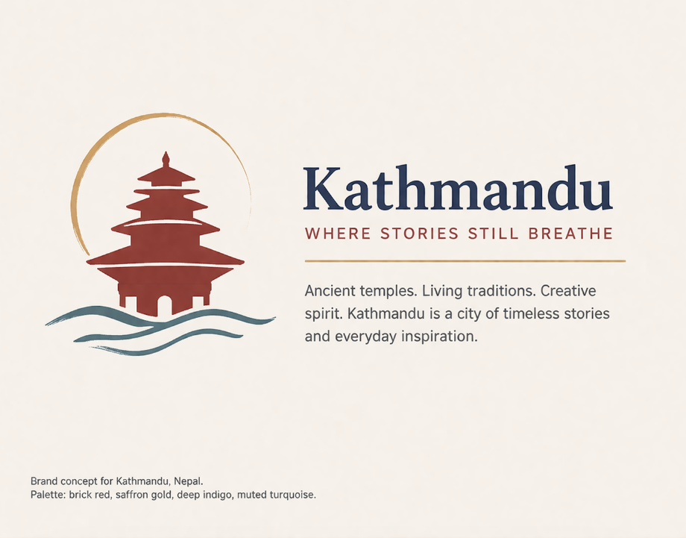
Figure 3 Proposed logo concept for Kathmandu
Source: author concept created for this report.

4.4 Marketing Material Examples
The brand must be developed into concrete materials as opposed to being abstract. The line Where Stories Still Breath could be used in a poster series with themed executions, like Sacred Dawn, Courtyard Craft, Festival Night and City of Many Paths over the poster series. The new website home page must have experience-oriented hero banner in the opening followed by the journey-based menu like Sacred Kathmandu, Creative Kathmandu, Taste Kathmandu and Beyond the Squares. The idea of a social media advertisement should be in the form of 20-30 seconds vertical reels with a full day in the city - prayer bells, street tea, wood carving and evening lamps - to create the emotional sequencing. Signage in airport welcome banners and heritage-district should be similar in colour, logo system and tone of voice such that the city can feel coherent since arrival.
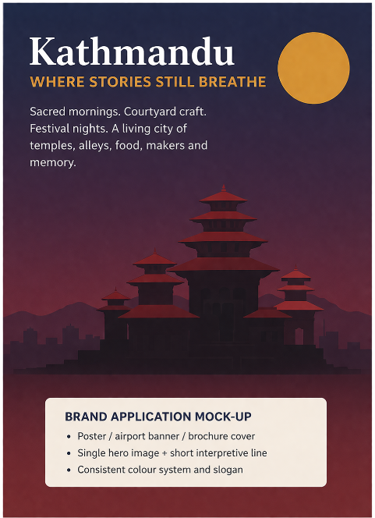
Figure 4 Example social media campaign mock-up

Source: author concept created for this report.

4.5 Branding Communication Strategy
Communication plan should have central brand discipline and decentralised storytelling. Nepal Tourism Board, Kathmandu Metropolitan City, heritage organizations, hotels, airlines and tour operators ought to adopt a common brand toolkit at the centre. The toolkit must be standardised in terms of the slogan, tone of voice, use of colours, description of the destination, style of photography and visitor etiquette message. In the absence of this layer of governance the fragmentation of messages will persist.
The content is to be based on living rituals, makers and craft, developed ways, neighbourhood discoveries, food culture, and creative city energy. The creator partnerships are supposed to focus on culturally literate photographers, filmmakers and travel storytellers and not on generic influencers. Hashtags to be used in the suggested campaign include: #StoriesStillBreathe, Living Kathmandu and SacredCityKathmandu.
The brand must have sustainability rather than be an addition to the brand. Texting should encourage good behaviour in the temple, dispersal beyond the hotspots that are crowded, hiring local guides, buying local crafts and movement that is not high impact where possible. This adds the element of authenticity and assists in matching the promise of heritage and the experience that sustains it. Consistency in signage, web design, social video communications and partner communications will help to build brand equity over time, by increasing recognition, trust and recommend.

4.6 Implementation Plan
The implementation should take three stages. Short term Kathmandu needs to do a city-wide brand audit, ensure there is governance of stakeholders, finalise an identity system, pilot a new web landing page and conduct a seasonal digital story telling campaign around one calendar of festival. In medium term, it must deploy templates of signage, airport and hotel collateral, neighbourhood itineraries, their creator partnerships and multi-lingual content packages in priority markets. The long-term strategy must be related to the product development: improved wayfinding, branded heritage trails, creative-city programming and frequent brand tracking. The 6A Destination Analysis in Appendix J also supports this implementation logic by linking the brand promise to attractions, accessibility, amenities, activities, available packages and ancillary services that shape the visitor experience.
The evaluation of success should be measured based on the indicators which are a combination of both marketing and experience: reach and engagement of branded content, share of voice, brand recall, sentiment, partner adoption of the visual identity, page dwell time on Kathmandu content, and qualitative feedback on clarity of destination promise. Visitor dispersal and satisfaction in the heritage districts should also be monitored where possible as the quality of experience is what maintains strong place brands not only through promotion but also through experience.

5. Conclusion
Kathmandu has no lack of meaning, Kathmandu has lack of destination definition. The city already boasts of superb cultural saturation, spiritual significance and world fame, but the present branding of the city is secondary to the larger Nepal brand and is not well organised on the city level. According to the identity logic by Aaker and brand equity point of view by Keller, this report has established that Kathmandu needs a more emotionally consistent, more coherent and more experience providing promise.
That coherence is provided in the proposed strategy - Kathmandu as a living sacred city where stories still breathe. It is more robust than the existing strategy since it transforms heritage into an unforgettable pledge, the symbolic identity with actual visitor experience, and it creates the room to communicate specifically to domestic, regional, long-haul, and creative-market segments. When adopted throughout the stakeholders, the rebrand would enhance the competitiveness of Kathmandu not by overlaying its image of heritage, but by ensuring that image is more unique, modern and reputable in the long run.

References
Aaker, D.A. (1996) Building Strong Brands. New York: Free Press.
Blain, C., Levy, S.E. and Ritchie, J.R.B. (2005) 'Destination branding: Insights and practices from destination management organizations', Journal of Travel Research, 43(4), pp. 328-338. doi: 10.1177/0047287505274646.
District Varanasi (2026) Tourism. Government of Uttar Pradesh. Available at: https://varanasi.nic.in/tourism/ (Accessed: 3 April 2026).
Karki, D., Dahal, R.K., Ghimire, B. and Joshi, S.P. (2024) 'Tourism and Tradition: Heritage Conservation Practices and Challenges Amid Mass Tourism in Kathmandu Valley', Interdisciplinary Journal of Innovation in Nepalese Academia, 3(2), pp. 58-85. doi: 10.3126/idjina.v3i2.73204.
Keller, K.L. (1993) 'Conceptualizing, measuring, and managing customer-based brand equity', Journal of Marketing, 57(1), pp. 1-22. doi: 10.1177/002224299305700101.
Kladou, S., Kavaratzis, M., Rigopoulou, I. and Salonika, E. (2017) 'The role of brand elements in destination branding', Journal of Destination Marketing & Management, 6(4), pp. 426-435. doi: 10.1016/j.jdmm.2016.06.011.
Li, Z. and Zhang, J. (2023) 'How to improve destination brand identification and loyalty using short-form videos? The role of emotional experience and self-congruity', Journal of Destination Marketing & Management, 30, 100825. doi: 10.1016/j.jdmm.2023.100825.
Ministry of Culture, Tourism and Civil Aviation (2025) Nepal Tourism Statistics 2024. Kathmandu: Government of Nepal. Available at: https://giwmscdnone.gov.np/media/pdf_upload/Nepal%20tourism%20statistics%202024_gdm4eag.pdf (Accessed: 3 April 2026).
Nepal Tourism Board (2026a) Nepal Tourism Board. Available at: https://ntb.gov.np/ (Accessed: 3 April 2026).
Nepal Tourism Board (2026b) Kathmandu. Available at: https://ntb.gov.np/kathmandu (Accessed: 3 April 2026).
Nepal Tourism Board (2026c) About Us. Available at: https://trade.ntb.gov.np/about-us/ (Accessed: 3 April 2026).
Nepal Tourism Board (2026d) Pokhara. Available at: https://ntb.gov.np/pokhara (Accessed: 3 April 2026).
Nepal Tourism Board (2026e) Bhaktapur. Available at: https://ntb.gov.np/bhaktapur (Accessed: 3 April 2026).
Rodriguez-Molina, M.A., Frias-Jamilena, D.M., Del Barrio-Garcia, S. and Castaneda-Garcia, J.A. (2019) 'Destination brand equity-formation: Positioning by tourism type and message consistency', Journal of Destination Marketing & Management, 12, pp. 114-124. doi: 10.1016/j.jdmm.2019.03.010.
UNESCO (2024) Kathmandu recognized as UNESCO Creative City. Available at: https://www.unesco.org/en/articles/kathmandu-recognized-unesco-creative-city (Accessed: 3 April 2026).
UNESCO (2026a) Kathmandu Valley. UNESCO World Heritage Centre. Available at: https://whc.unesco.org/en/list/121/ (Accessed: 3 April 2026).
Wassler, P., Wang, L. and Hung, K. (2019) 'Identity and destination branding among residents: How does brand self-congruity influence brand attitude and ambassadorial behavior?', International Journal of Tourism Research, 21(4), pp. 437-446. doi: 10.1002/jtr.2271.

Appendices

Appendix A: Current branding evidence
Table A1 summarises the main official touchpoints shaping Kathmandu's current brand architecture.
Source touchpoint | Evidence observed | Branding implication | Visual note
NTB national homepage | Refers to the national tourism architecture of Nepal, whereby the Nepal - Lifetime Experiences and the LifetimeExperiences can be seen, as well as the multilingual navigation. | Strong international visibility, but Kathmandu remains nested inside a Nepal-first umbrella brand. | Insert official homepage screenshot if required.
NTB Kathmandu page | Offers description of capital-city, heritage and destination information, no obvious system of city-level slogans and logos. | High informational value, weak standalone identity. | Insert Kathmandu landing page screenshot if required.
UNESCO Kathmandu Valley page | Boundaries the valley with the help of excellent universal value, monument zones and conservation significance. | Adds global credibility and heritage authority. | Insert UNESCO page capture if required.
Kathmandu Metropolitan City / Heritage touchpoints | Demonstrates the governance role of heritage-tourism, the presence of the city in terms of institutions. | Useful for legitimacy, but administrative rather than visitor-led in tone. | Insert KMC heritage page screenshot if required.
UNESCO Creative City of Film article | Brings a modern urban-inspired fiction which may be used to supplement the religious tradition. | Important repositioning asset that is currently underused in tourism storytelling. | Insert UNESCO article capture if required.

Figure 5 Current branding evidence board

Source: author synthesis based on official sources.

Appendix B: SWOT analysis table
Dimension | Kathmandu branding assessment
Strengths | UNESCO-protected living heritage; concentrated Hindu and Buddhist sites; high level of cultural authenticity; access of the gate; high concentration of year-long festival.
Weaknesses | Scattered city-wide communication; small isolated identity; poor signage and visitor interface; overcrowding and environmental stress; unbalanced digital narrative.
Opportunities | Expansion in pilgrimage and heritage tourism; local rediscovery tourism; video storytelling in the short form; UNESCO Creative City of Film capitalisation; curated neighbourhood tours.
Threats | Deterioration of heritage; spotting congestion; enhanced narrative rivalry by Pokhara, Bhaktapur and Varanasi; negative publicity by bad urban experience.

Appendix C: PESTLE analysis table
Factor | Implication for brand strategy
Political / Institutional | Brand delivery should be aligned between NTB, KMC, legacy agencies, tourist businesses and religious groups.
Economic | Kathmandu enjoys the advantages of gateway expenditure, accommodation, pilgrimage traffic and urban break business, however, the fluctuation of the budgets among markets demands differentiated communication.
Social / Cultural | Newa craftsmanship and multi-faith coexistence, as well as living rituals, are key brand equities; branding should be tactful and sensitive to community.
Technological | The growth of the brand will be based on enhanced mobile-first contents, multilingual information, social video and integrated digital wayfinding.
Legal / Heritage | The use of the brand in and around monuments and sacred spaces should be consistent with the conservation policies, etiquette and protection of heritage among visitors.
Environmental | Visitors take into account traffic, air quality and waste management, sustainability messages need to be accompanied by apparent operational enhancement.

Appendix D: Competitor comparison table
Destination | Core appeal | Current brand strength | Gap / opportunity for Kathmandu
Kathmandu | Living sacred city; layered heritage; ritual density; urban creativity | Very high intrinsic value but weak city-level articulation | Make identity clear on living heritage and coherent arrival to experience story telling.
Pokhara | Scenic leisure, lakes, mountain views, soft adventure | Clear and easy-to-grasp experiential promise | Kathmandu will not be able to compete with serenity, but must distinguish itself in the depth of sacredness and urban richness of culture.
Bhaktapur | Preserved medieval ambience; brick heritage; slower historic atmosphere | Strong authenticity and visual coherence | It would be wrong to try to appear cleaner Bhaktapur, Kathmandu must possess complexity, scale and ritual vitality.
Varanasi | Highly legible spiritual city brand centred on sacred geography and pilgrimage | Strong emotional and symbolic positioning | Kathmandu should simplify the identity of their own sacred-plural to be easier to read and remember.

Appendix E: Target market segmentation table
Segment | Profile / motivation | Desired message | Preferred channels
Domestic and diaspora Nepali urban travellers | Short stays, repeat trips, pride and rediscovery | Rediscover the capital beyond routine: food, festivals, neighbourhood stories | Instagram, TikTok, local media, event calendars
Indian and SAARC pilgrimage / short-break visitors | Regional access, religious motivation, multi-generational travel | Sacred routes, respectful hospitality, easy itineraries | Search, YouTube, travel agents, pilgrimage networks
Long-haul cultural heritage travellers | High-information planning; interest in history, architecture, food and urban culture | A compact world of living civilisational encounters | Official website, long-form editorial, guide partnerships
Young digital and creative travellers | Film, photography, design, social sharing, micro-discovery | Living heritage meets contemporary city energy | Reels, creator collaborations, short-form video, branded map content

Appendix F: Proposed logo and visual identity notes
Figure 6 Proposed logo concept

Source: author concept.
Element | Specification
Brand essence | Living heritage
Primary slogan | Kathmandu: Where Stories Still Breathe
Core motifs | Pagoda roofline, mandala halo, traditional Newa window geometry
Primary colours | Brick red, saffron gold, deep indigo, muted turquoise
Typography direction | Refined serif wordmark with humanist sans-serif support type
Brand tone | Soulful, intricate, credible, contemporary and rooted

Appendix G: Marketing mock-up examples
Figure 7 Poster / social campaign concept

Source: author concept.
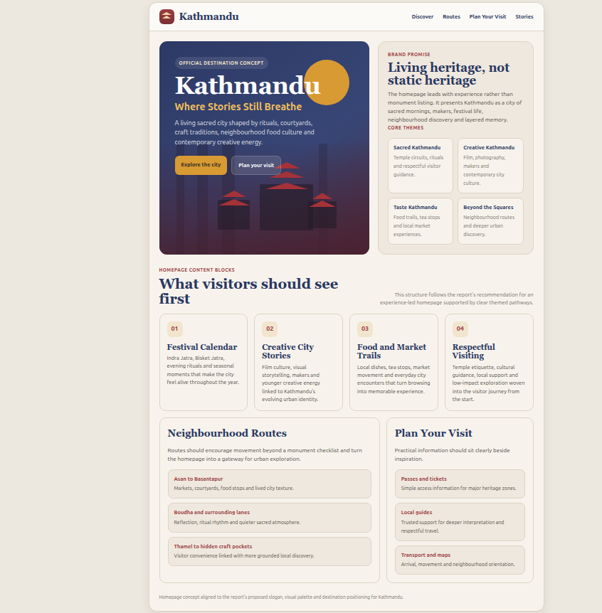
Figure 8 Homepage redesign concept

Source: author concept.

Appendix H: Implementation plan table
Phase | Timeframe | Key actions | Stakeholders | Expected outcomes | Indicators
Short term | 0-6 months | Brand audit; stakeholder steering group; finalise logo and style guide; pilot Kathmandu landing page; festival-based digital launch. | NTB, KMC, heritage bodies, hotels, agencies | Shared brand system established and first wave of consistent communication visible. | Toolkit completion; partner sign-up; campaign reach; engagement rate
Medium term | 1-2 years | Implement signage templates, airport signage, hotel materials, multilingual content, creator partnerships and neighbourhood routes narration. | NTB, KMC, airlines, hotels, guides, cultural organisations | Brand becomes recognisable across key touchpoints and more experience-led online. | Brand recall; dwell time; social share of voice; partner adoption
Long term | 3+ years | Link brand to product development: heritage trails, wayfinding upgrades, creative-city programming, annual brand tracking and sentiment review. | NTB, KMC, UNESCO-linked partners, private sector | Brand equity deepens through better experience quality and stronger differentiation. | Sentiment trend; visitor satisfaction; district dispersal; repeat recommendation

Appendix I: Nine Thematic Dimensions Assessment
To determine the uniqueness of the proposed identity, this appendix uses nine dimensions of destination-branding to Kathmandu to find out whether the proposed identity is experience-led, coherent, and distinctive. The evaluation associates the brand factors with impression, communication and physical delivery (Aaker, 1996; Keller, 1993; Blain, Levy and Ritchie, 2005).
Dimension | Kathmandu branding reading | Brand implication
Identity clarity | The suggested concept of a living sacred city will provide Kathmandu with better core identity than the existing positioning with heritages that are diffused and heavy. | Enhances the salience and recollection in the city level (Aaker, 1996; Nepal Tourism Board, 2026b).
Distinctiveness | Kathmandu is less competitive in terms of scenic composure and more of ritual intensiveness, stratified tales and city everyday sacredness. | Favors even greater distinction between Pokhara, Bhaktapur and Varanasi.
Authenticity | Its brand is based on the living rituals, craft traditions, neighbourhood texture and multi-faith heritage other than the artificial image of lifestyle. | Enhances trust and confidence in the brand in the long-term (UNESCO, 2026a; Kladou et al., 2017).
Emotional resonance | Where Stories Still Breath transforms monuments into the experience of promise of memory, continuity and atmosphere. | Assists to pass the consciousness to the emotional and touch point (Keller, 1993).
Visual coherence | The digital and physical touchpoints have a recognisable symbolic system that is developed using pagoda, mandala and Newa window patterns. | Enhances uniformity in terms of signage, web and campaign materials.
Experience alignment | Brand promises are attached with the actual experiences of the visitors like sacred mornings, Courtyard craft, food culture and festival nights. | Minimizes the distance between the picture and experience (Rodriguez-Molina et al., 2019).
Stakeholder fit | A common toolkit can be used to distribute the framework between NTB, KMC, heritage bodies, and the case of hotels and guides. | Endorses the concept of destination branding as opposed to the fragmented promotion (Blain, Levy and Ritchie, 2005).
Digital storytelling potential | The brand name is easily converted into short video content, creator stories and theme landing pages. | Matches current discovery behaviour in destination media (Li and Zhang, 2023).
Sustainability support | The brand promotes good manners, local artisanship, dispersal and heritage-sensitive tourism. | Secures the brand equity through the association between promotion and stewardship (Karki et al., 2024).

Appendix J: 6A Destination Analysis
This appendix evaluates the core offer branding of Kathmandu by relying on a 6A lens of destinations. All the elements are explained in branding terms such that operational characteristics help in image, meaning and destination equity.
6A element | Kathmandu branding reading | Branding implication
Attractions | The best symbolic resources of the brand are UNESCO monument zones, temples, stupas, festivals, craft traditions, and courtyards and craft traditions (UNESCO, 2026a). | The attractions should be branded as living heritage and not as isolated attractions.
Accessibility | The national tourism system gives Kathmandu an advantage of gateway and good visibility of travel ( Nepal Tourism Board, 2026a). | The messaging of arrival should be transformed into the city-level brand attachments.
Amenities | There are hotels, food, guide services and visitor information available but the branded interface has not been consistent across the touchpoints. | An integrated visual system would be able to make it look more coherent, and high-quality.
Activities | Rich layers of activity that offer storyable activities are pilgrimage, heritage walks, food discovery, neighbourhood exploration and creative-city experiences. | The activities must be offered in themed journeys that bring out the brand promise.
Available packages | Kathmandu is being sold as a stopover or circuit experience as opposed to an independent branded city experience. | Expertly-managed short-break and theme tours would enhance the recall and purchase.
Ancillary services | The backing experience to the brand is determined by governance, signage, etiquette advice, local guides and cultural organisations. | Credible destination branding requires a strong coordination on the part of ancillaries (Blain, Levy and Ritchie, 2005).

