Business Project Plan
RainyDay Café Operational Efficiency and Customer Satisfaction Improvement Project

Table of Contents
1. Project Scope Statement 4
2. Project Team 7
3. Project Resource and Task Allocation 9
4. Stakeholder and Communication Management 15
5. Project Budget 17
References 20
Appendix A: Benefits Realisation and Counter Workflow 22

List of Figures
Figure 1 Work Breakdown Structure Diagram. 7
Figure 2 3-Month Gantt Chart showing task sequencing from 9 February to 1 May 2026. 9

List of Tables
Table 1 RainyDay Café Current Operational Problem Map. 5
Table 2 Project Scope Summary 5
Table 3 Current vs Proposed Counter Workflow 6
Table 4 Proposed Matrix Project Team Structure. 6
Table 5 Project Team Roles and Responsibilities. 7
Table 6 Project Schedule from 9 February 2026 to 1 May 2026. 8
Table 7 RACI Matrix Table. R = Responsible, A = Accountable, C = Consulted and I = Informed. 11
Table 8 Stakeholder Power-Interest Grid. 12
Table 9 Communication Plan Table. 12
Table 10 Budget Summary Table. Total planned expense remains below £5,000. 13
Table 11 Benefits Realisation Table. 16

1. Project Scope Statement
The scope of this three month project from the 9 th Feb-1 st May 2006 is to improve the speed, throughput and stock efficiency at the Rainy Day Caf by focusing on symptoms that have been indicated in the brief: queuing time increase from 3 minutes peak to 8 minutes, counter congestion, staff handoff and stock wastage.
This is addressed by implementing Lean service analysis and redesign (SA&RD) 5S's, SOPs, par levels for stock and PDCA monitoring for the purpose of reducing wait, walk and handoff variability (Womack and Jones 2003; Slack, Brandon-Jones and Burgess 2022).
Table 1 RainyDay Café Current Operational Problem Map.
People | Limited staff training; staff confusion over roles; insufficient weekday staffing. | Process | Ad-hoc sandwich/coffee handoff; limited mise en place; no standard stock-check routine.
Place/Layout | Sandwich prep, coffee service and delivery share a counter; staff interactions. | Suppliers/Inventory | Fresh deliveries twice a week with risk of stockout, waste and inconsistent freshness of pastries.
Technology | Paper-based stock management leads to errors; lack of reorder awareness; panic-buying. | Customer Flow | Order and pick-up near the same place, creating confusion and congestion.
Combined effect: queues, congestion, stockouts, waste risk and lower satisfaction.

In-scope strategies include: defined order, coffee, sandwich, pickup and stock check areas; 5S storage; SOPs; low cost stock tracker; par levels and reorder points; adjusted delivery schedules; peak-time staff allocation; and split customer pickup signs.
Table 2 Project Scope Summary
Scope element | Draft content
Issues | Lines, crowds, out of stock and freshness issues.
Solutions | Lean/5S layout, SOP, tracker and signage.
Deliverables | Layout, SOP pack, tracker, training and handover pack.
Benefits | Improved service time, flow and customer experience.
Objectives | Faster service, no out of stock and SOP compliance.
Limits | 3 months, under £5,000, café remains open.

Table 3 Current vs Proposed Counter Workflow
Workflow aspect | Current state | Proposed state
Customer movement | Entrance -> single counter queue -> order/pay/prep/pickup cluster -> exit | Entrance -> menu point -> order/pay -> marked waiting lane -> separate pickup point -> exit
Staff movement | Sandwich, coffee and payment all done by baristas. | Designated areas: till/order, coffee, sandwich toaster, order shelf and inventory check.
Control method | Slight judgement and verbal passes. | Signage, tickets, prep list and scheduled inventory/freshness checks.
Operational impact | Overcrowding, jostling and varying service times. | No queue/backlog, better hand-offs and quicker progress for customers.
The project is set with three SMART goals to ensure it is measurable and attainable. First, by 1 May 2026, the café seeks to shorten average peak waiting time from around 8 minutes to 5 minutes or less over the pilot period (two weeks). This will be determined by three timing observations during peak times on weekdays. Second, by the end of May 2026, the number of stockouts for the priority sandwich fillings and pastries should be at least 50% less than the baseline in February, as measured by the daily inventory tracker and freshness log. Third, staff should adhere to the agreed standard operating procedures (SOPs) and updated role allocation with 90% compliance, using the observation sheets and staff training records. Clear and tangible objectives help manage and assess project performance (Lock, 2020).
The project scope is based on several assumptions. It is assumed that the café will operate throughout the project implementation, staff will take paid time off for training, suppliers will work with the project team to adjust their delivery schedule and the owner will support the low-cost improvements to signage, labels and storage. But the project scope does not include substantial structural works, new espresso machine, hiring more full-time staff and changes to the main food menu. This ensures project feasibility within the £5,000 budget, and in line with operational priorities (Maylor, 2010). It also promotes sustainability, as the café manager will be able to track the same performance indicators after the project.

2. Project Team
A light matrix team is suggested. A functional structure could hinder cross-functional change and a projectised structure is unviable for a small café with 4 full-time and 1 part-time employees. A matrix structure allows staff to work while providing the project manager with co-ordination of scope, schedule, risks and communications (Project Management Institute, 2021).
Table 4 Proposed Matrix Project Team Structure.
Café Owner / Sponsor
Approves budget, scope and supplier decisions
Project Manager / External Consultant
Plans, coordinates, controls, reports
Café Manager / Operations Lead  Daily implementation owner | Head Barista / Process Champion  Workflow and SOP lead | Supplier Representatives  Consulted on lead times and deliveries
Assistant Baristas  User representatives; pilot feedback | Part time Inventory and Training Support Assistant  Tracker, labels, training records | Customers  Feedback through observation and QR survey
Solid accountability: sponsor -> project manager -> internal leads |  | Dotted consultation: suppliers/customers

Table 5 Project Team Roles and Responsibilities.
Role | Responsibilities
Project Manager / External Consultant | Project plan, WBS, schedule, RACI, risks, communications, KPI report and handover. No consultant fee charged.
Café Owner / Sponsor | Approve scope, budget, supplier boundaries and final handover.
Café Manager / Operations Lead | Manage change of shift, controls and process.
Head Barista / Process Champion | Create process redesigns as SOPs, Visual Standards and coaching.
Assistant Baristas / User Representatives | Trials roles, record any problems and provide quality service.
Part-time Inventory and Training Support Assistant | Create stock tracker and label storage, document training and pilot experiences.
Supplier Representative | Advise on ordering and minimum quantities, freshness and delivery.

3. Project Resource and Task Allocation
The WBS breaks the improvement objective into work packages. The project diagnoses the problem, then buys the necessary material to fix it. Testing is PDCA-based (Deming, 1986).
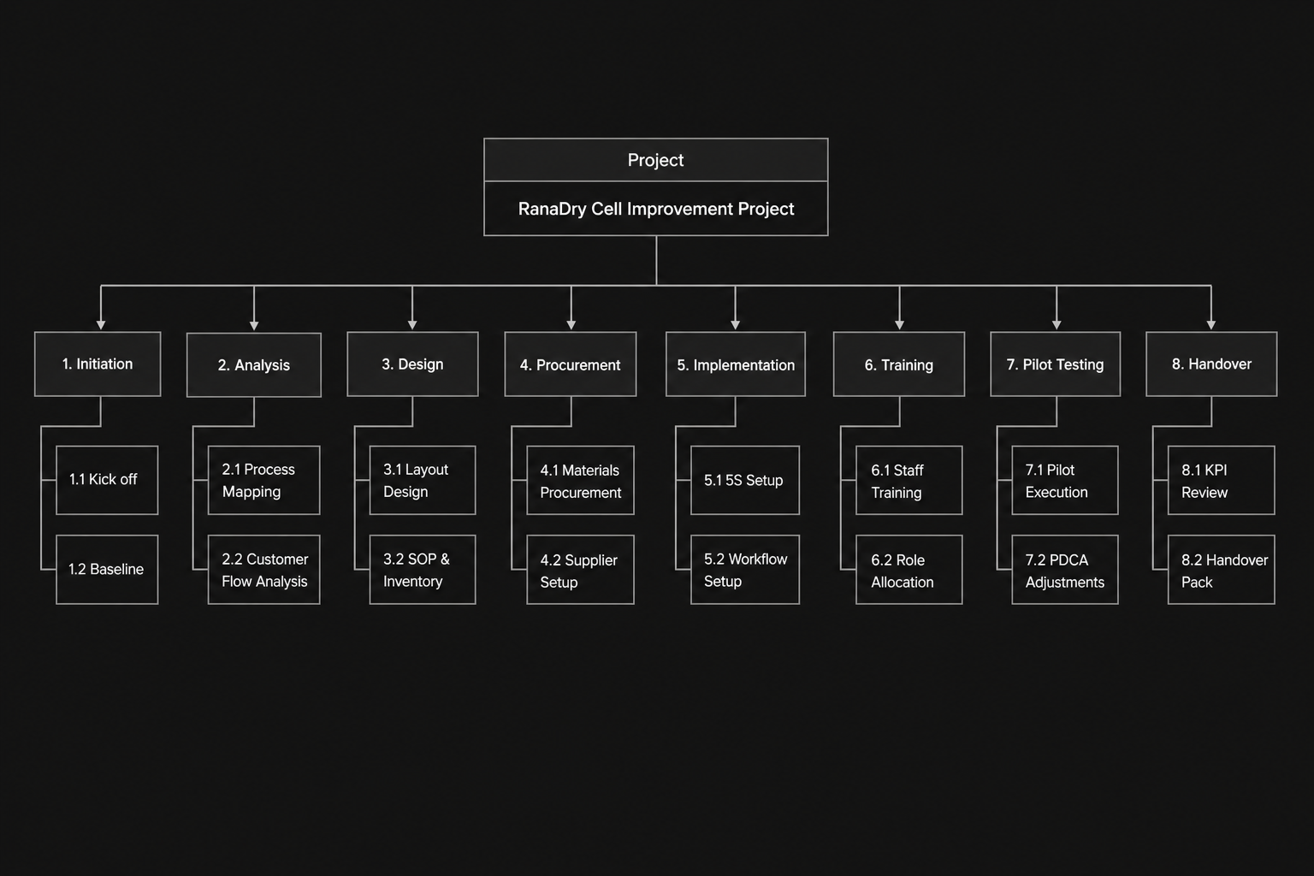
Figure 1 Work Breakdown Structure Diagram.

Table 6 Project Schedule from 9 February 2026 to 1 May 2026.
WBS code | Task | Start date | End date | Duration | Dependency | Owner
1.1 | Project kick-off, sponsor approval and project charter | 09 Feb 2026 | 10 Feb 2026 | 2 working days | None | Project Manager
1.2 | Data collection and risk register | 11 Feb 2026 | 13 Feb 2026 | 3 working days | 1.1 | Project Manager / Café Manager
2.1 | Current-state process mapping | 16 Feb 2026 | 20 Feb 2026 | 5 working days | 1.2 | Café Manager
2.2 | Customer-flow and bottleneck analysis | 23 Feb 2026 | 27 Feb 2026 | 5 working days | 2.1 | Project Manager
3.1 | 5S/Lean layout, station and role design | 02 Mar 2026 | 06 Mar 2026 | 5 working days | 2.2 | Head Barista
3.2 | Standard operating procedures, par levels and reorder points | 09 Mar 2026 | 13 Mar 2026 | 5 working days | 3.1 | Project Manager / Head Barista
4.1 | Supplies of signs, labels, storage and inventory tracker | 16 Mar 2026 | 20 Mar 2026 | 5 working days | 3.2 | Support Assistant
4.2 | Delivery audit with freshness trial with suppliers | 16 Mar 2026 | 20 Mar 2026 | 5 working days | 3.2 | Owner / Supplier Reps
5.1 | 5S backroom reset and labelling of storage areas | 23 Mar 2026 | 27 Mar 2026 | 5 working days | 4.1 | Café Manager
5.2 | Signage and segregation of pickups | 23 Mar 2026 | 27 Mar 2026 | 5 working days | 4.1 | Project Manager
6.1 | Staff training and SOP sign-off | 30 Mar 2026 | 03 Apr 2026 | 5 working days | 5.1, 5.2 | Head Barista
6.2 | Micro-scheduling and peak-hour role allocation | 30 Mar 2026 | 03 Apr 2026 | 5 working days | 6.1 | Café Manager
7.1 | Two-week pilot test | 06 Apr 2026 | 17 Apr 2026 | 10 working days | 6.1, 6.2 | Café Manager
7.2 | PDCA review and corrective adjustments | 20 Apr 2026 | 24 Apr 2026 | 5 working days | 7.1 | Project Manager
8.1 | KPI review, benefits review and handover | 27 Apr 2026 | 01 May 2026 | 5 working days | 7.2 | Project Manager

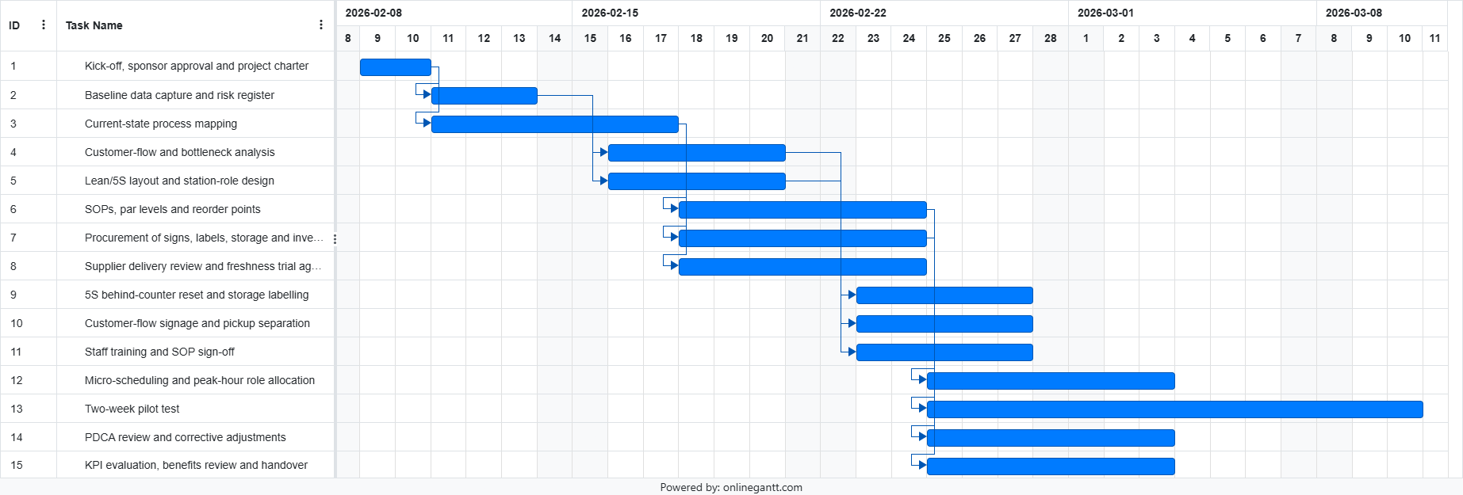
Figure 2 3-Month Gantt Chart showing task sequencing from 9 February to 1 May 2026.

Table 7 RACI Matrix Table. R = Responsible, A = Accountable, C = Consulted and I = Informed.
Activity | Project Manager | Café Owner/Sponsor | Café Manager | Head Barista | Assistant Baristas | Inventory/Training Support Assistant | Supplier Representative
Charter and scope approval | R | A | C | I | I | I | I
Diagnostic mapping and baseline data | A | I | R | R | C | C | I
Solution design and SOP drafting | A | I | R | R | C | C | I
Supplier delivery renegotiation | C | A | R | C | I | I | R
Procurement and inventory setup | R | A | C | C | I | R | C
Layout and 5S implementation | C | I | A/R | R | C | R | I
Training and SOP rollout | A | I | C | R | C | R | I
Pilot testing | C | I | A/R | R | R | C | C
Evaluation and handover | A/R | I | R | C | I | C | I

4. Stakeholder and Communication Management
The project alters staff practices, supplier practices and the customer experience, so stakeholder management is needed The plan prioritises those with high-power, but ethically engages staff and regular customers (Freeman, 1984).
Table 8 Stakeholder Power-Interest Grid.
 | Low interest | High interest
High power | Keep satisfied:  Fresh produce supplier; coffee bean roaster; pastry supplier | Manage closely:  Owner of Café; Café manager
Low power | Monitor:  Café customers; other cafes as contextual stakeholder | Keep informed and involve:  Manager barista; baristas; office staff; students; community residents

Table 9 Communication Plan Table.
Audience | Information need | Channel | Frequency | Owner | Purpose | Success measure
Owner | Budget, risks, milestones, KPI trend | Weekly dashboard/email | Weekly | Project Manager | Control scope and approve decisions | Decisions made within two working days
Café manager | Daily tasks, rota changes, pilot issues | Stand-up and tracker | Twice weekly | Project Manager | Operational coordination | Tasks completed by due date
Head barista | SOP details, station standards, coaching notes | Workshop and visual guide | Weekly during design/rollout | Café Manager | Translate design into practice | SOP sign-off achieved
Assistant baristas | Role allocation, training, feedback route | Briefing and feedback log | Before each pilot week | Head Barista | Protect staff confidence | No unpaid overtime; feedback captured
Customers: office workers/students/residents | Queue guidance and feedback request | Counter signage and QR survey | During pilot | Support Assistant | Improve service experience | Feedback response count and wait-time ratings
Suppliers | Delivery frequency, lead time and freshness needs | Email/call and meeting note | Weeks 6-7, then as required | Owner / Café Manager | Reduce stockout and waste risk | Trial delivery terms confirmed

5. Project Budget
The plan won't overwork staff since the plan has paid training and uses micro-scheduling rather than longer hours. Social sustainability is achieved through improved walk-through of customers and training. Sustainability is addressed by reducing food waste; par levels; freshness labels and re-usable laminated SOPs (Square, 2026).
Table 10 Budget Summary Table. Total planned expense remains below £5,000.
Budget item | Justification | Cost (£) | Cost source
Temporary inventory/training support assistant | 80 hours x £13.50 plus c.15% holiday/ admin fee for tracker, labels and training log | 1,242.00 | GOV.UK, 2026
Inventory/POS setup | Free Square POS software; optional reader/spreadsheet setup fee | 50.00 | Square, 2026
Staff paid training time | 5 staff x c.3 hours x £13.50 (rounded up); negates unpaid training | 250.00 | GOV.UK, 2026
Printed SOPs, laminated workflow guides | A4 laminating bags, printing, reusable information sheets | 120.00 | Staples, 2026
Queue and customer-flow signage | Floor stickers, signs and notices for counters | 120.00 | UK POS, 2026; Discount Displays, 2026
Pickup/order separation materials | Acrylic A4 sign holders, counter markers and affordable tape | 210.00 | Staples, 2026; XL Displays, 2026
5S storage materials | Storage containers, shelf labels, mini shelving and category labels | 520.00 | Ryman, 2026
Food-safety labelling and timers | Labels and timers for preparation and freshness | 180.00 | EurekaDirect, 2026; Food Safety Direct, 2026; Brother, 2026
Supplier delivery trial allowance | Performing trial of modified deliveries and waste tracking | 300.00 | Supplier negotiation allowance
Customer feedback QR materials | Google Forms/QR creation deemed free; table cards and other display items | 40.00 | Internal low-cost estimate
Contingency | c.10% for price fluctuations, delivery and replacements | 303.00 | Project estimate
Total planned expenses | Below the £5,000 ceiling; no consultant fee included. | 3,335.00 | Must be rechecked before submission
The plan avoids overworking staff by budgeting paid training and using micro-scheduling rather than simply demanding faster work. Social responsibility is addressed through clearer customer flow and staff training. Sustainability is addressed through food-waste reduction, par levels, freshness labels and reusable laminated SOPs.

References
Brother (2026) QL-700 high speed address label printer: supplies. Available at: https://store.brother.co.uk/devices/label-printer/ql/ql700 (Accessed: 25 April 2026).
Deming, W.E. (1986) Out of the Crisis. Cambridge, MA: MIT Press.
Discount Displays (2026) One Way System Floor Stickers 6 Pack. Available at: https://www.discountdisplays.co.uk/html/please-follow-one-way-system-floor-sticker.html (Accessed: 25 April 2026).
EurekaDirect (2026) Food Preparation Place Day Spot Labels On A Roll. Available at: https://www.eurekadirect.co.uk/Safety-Signage-Books-Labels/Safety-Signage/Safety-Signs/Safety-Labels/Food-Safety-Labels/Food-Preparation-Place-Day-Spot-Labels-On-A-Roll (Accessed: 25 April 2026).
Food Safety Direct (2026) Food/Digital Kitchen Timers. Available at: https://www.foodsafetydirect.co.uk/collections/catering-equipment-timers (Accessed: 25 April 2026).
Freeman, R.E. (1984) Strategic Management: A Stakeholder Approach. Boston: Pitman.
GOV.UK (2026) National Minimum Wage and National Living Wage rates. Available at: https://www.gov.uk/national-minimum-wage-rates (Accessed: 25 April 2026).
Project Management Institute (2021) A Guide to the Project Management Body of Knowledge (PMBOK Guide). 7th edn. Newtown Square, PA: Project Management Institute.
Ryman (2026) Really Useful Box office supplies. Available at: https://www.ryman.co.uk/office-supplies/really-useful-box (Accessed: 25 April 2026).
Slack, N., Brandon-Jones, A. and Burgess, N. (2022) Operations Management. 10th edn. Harlow: Pearson.
Square (2026) Square POS pricing and fees. Available at: https://squareup.com/gb/en/point-of-sale/pricing (Accessed: 25 April 2026).
Staples (2026a) Laminating pouches. Available at: https://www.staples.co.uk/office-stationery-retail/laminating-and-binding/laminating-pouchess/ (Accessed: 25 April 2026).
Staples (2026b) A4 sign holders. Available at: https://www.staples.co.uk/display-presentation/board-and-display-equipment/sign-holders/ (Accessed: 25 April 2026).
UK POS (2026) Floor Queue Stickers. Available at: https://www.ukpos.com/social-distancing-floor-queue-stickers (Accessed: 25 April 2026).
Womack, J.P. and Jones, D.T. (2003) Lean Thinking: Banish Waste and Create Wealth in Your Corporation. Revised edn. New York: Free Press.
XL Displays (2026) Queue Barriers, Retractable Barriers, Ropes and Stanchions UK. Available at: https://www.xldisplays.co.uk/categories/Queue-Barriers/ (Accessed: 25 April 2026).

Appendix A: Benefits Realisation and Counter Workflow
Table 11 Benefits Realisation Table.
Solution | Baseline issue | KPI | Target by handover | Business benefit
Lean workflow zones | Sandwich making and coffee brewing behind the counter. | Average peak wait | <=5 minutes | Improved speed and lunchtime competitiveness
5S storage and visual labels | Staff search for tools/stock in shared space | Observed staff collisions/search time | Reduced visibly during pilot | Smoother work and less stress
SOPs and role allocation | Impromptu procedures, and fudge-overs | SOP compliance | >=90% observed compliance | Reliable service quality
Inventory tracker, par levels and reorder points | Manual stock mistakes, stock-outs and excess stock | Stockout incidents | 50% reduction | Protected sales and lower waste
Supplier delivery renegotiation | Fresh deliveries twice a week and old pastries | Freshness/stockout log | Improved availability and freshness | Better customer perception
Separated pickup point and signage | Customers line up at counter | Queue/crowding observations | Clear movement and fewer counter blockages | Better experience and accessibility

