The Effect of Energy Costs on Business Profits in the UK Hotels and Similar Accommodation Industry

Executive Summary
The impact of energy prices on profit before tax for UK hotels and similar accommodation industry is analysed in this report for the period 2019-2024. It features a 20-firm panel which is derived from FAME accounts, annual Moodle energy-cost information and IBISWorld industry evidence. A series of descriptive statistics, visualisations and correlation and pooled OLS regression tests is conducted to investigate the relationship between higher energy costs and lower profitability. The outcome is more complex. Average hotel profit bounced back from the pandemic but was very unevenly distributed between firms, and energy costs have jumped significantly since 2021, and have reached a peak in 2023. Correlations are low and regression does not show any statistically significant negative energy-cost coefficient. That doesn't mean that energy costs are without consequence. Demand recovery, pricing power and firm scale and cost pass-through are hypothesized to contribute to observed profit as well. Energy shocks can be best viewed for hotels as margin pressure compared to the sector average which impacts less resilient operators more heavily than the average. This helps to inform decisions by managers in a sensible manner, based on evidence.

Table of Contents
Executive Summary 1
1. Introduction 2
2. Data Sources and Data Types 3
3. Alternative Data Sources 3
4. Summary Statistics and Data Visualisation 4
5. Correlation Analysis 7
6. Regression Analysis 9
7. Discussion 10
8. Conclusion 11
References 12
AI Use Statement 14

List of Figures
Figure 1 Annual Moodle energy-cost trend, 2019-2024 8
Figure 2 Normalised average profit and energy-cost pressure 8
Figure 3 Mean profit before tax versus energy cost (annual averages) 9
Figure 4 Mean profit before tax versus energy cost (annual averages) 9

List of Tables
Table 1 Summary statistics for complete observations 7
Table 2 Correlation matrix 10
Table 3 Pooled OLS regression output 11

1. Introduction
The selected industry is the UK hotels and similar accommodation SIC 55100 (FAME export). Hotels offer overnight lodging and services including cleaning and catering, front office and laundry. This renders the business vulnerable in terms of profitability to the levels of demand and operating costs. According to IBISWorld (2025; 2026), the UK hotel industry is a competitive service industry influenced by the level of hotel occupancy, room prices, flows of tourism and business travel. The studies on hotel-energy further reveal that electricity, heating and cooling usage and occupancy are major factors affecting the operation of the hotels (Deng and Burnett, 2002; Priyadarsini, Xuchao and Eang, 2009; Lai, 2016).
The coming years (2019-2024) are an economically unique time. Travel was extremely constrained in 2020 due to COVID-19 restrictions, followed by a differential recovery with the return of domestic tourism and corporate travel. Energy prices rose significantly from 2021, partly due to post-pandemic demand pressures and the war in Ukraine. There has been robust growth in the UK's non-domestic electricity prices and pressures on the sector, according to ONS (2025) and House of Commons Library (2026), and the cost of energy has now risen to be a significant cost burden, according to UKHospitality (2023). This results in an identification issue - energy price, demand, inflation and wages changed together. Evidence based on published data also highlights pass-through and productivity and heterogeneous firm adjustment (Ganapati, Shapiro and Walker, 2020; Fontagné, Martin and Orefice, 2024).
This report will seek to answer the question: how do the costs of energy impact on hotel profits in the UK and other accommodations? Profit before tax is used as the dependent variable because it captures overall accounting profitability before taxation, including the effects of operating performance and financing costs, and the total assets proxy for size/capacity of the firm. The analysis includes descriptions of the data sources and potential alternatives, descriptive statistics, charts, a correlation matrix and pooled OLS regression. Lastly, the results are shed some light upon by analysing the costs passed on and the intensity and productivity of energy use.

2. Data Sources and Data Types
Analysis of three complementary sources. The financial-statement data for 20 UK hotel companies were collected from 2019 to 2024 using first FAME (Bureau van Dijk, 2026) data. The terms used to describe the firm level variables are profit before taxation and total assets (both £000).
Profit before taxation was selected over operating profit because it captures the full cost burden including financing charges, which are material for asset-heavy hotel businesses with significant debt. Net income was rejected because tax treatment varies across firms and years, reducing comparability.
Secondly, values of energy costs per annum for the UK are available from the Moodle energy-cost file (York Business School, 2026). This is quantitative time-series data, and does not vary across firms within a year. This was then combined with the data set by year. Be careful with this structure; energy cost is not a utility bill for the individual firm, but rather whether or not the firm is under energy-cost pressure at the industry level is correlated with firm-level profit.
Third, IBISWorld's qualitative industry evidence illustrates the demand situation, competition and cost pressures. The multi-period data constitute a panel, covering multiple firms over six years. This mixed approach is supported by peer-reviewed studies of hotels that show that the energy use in these buildings depends on, among other factors, the number of rooms, building attributes and management practices, rather than on the price (Becken, Frampton and Simmons, 2001; Arenhart, Souza and Zanini, 2022; Arenhart et al., 2024). The information on profits is not missing, but was not imputed because there is a risk of losing traceability and the source auditability.

3. Alternative Data Sources
There were a number of alternative sources which could enhance a future study and minimise measurement error. Companies House accounts and notes to accounts would yield audited accounts, and may include information on rent, exceptional items or disclosures relating to energy. However, it has the disadvantage of not being as easy to access as FAME, as statements have to be manually extracted and formats differ between firms decreasing comparability. Companies House is not created to be used as a pre-packaged panel database, it's transparent.
Measurement would also benefit from energy data from the official datasets of DESNZ (2026) or ONS (2025). An annual series of the moodle might not have been as good as quarterly prices of non-domestic gas and electricity. The down side to this is that the national price still doesn't really show the actual tariff, length of the contract or hedging position of each hotel. A third alternative would be commercial benchmarking data, like STR, that would include occupancy, average daily rate and revenue per available room. These factors would significantly enhance the demand side controls, but would also be costly and not necessarily be the same as company accounts. The methodologically better information would permit the use of fixed-effects or panel models that would eliminate the omitted-variable bias due to inherent differences among firms.

4. Summary Statistics and Data Visualisation
The mean values must be viewed carefully for the reasons outlined in table 1. The mean value of profit before tax is -£869,000 and the median value of profit before tax is just -£83,000. A large gap means that the data is skewed to the left (or negative skew), which means most of the firms are near the break-even point or making moderate losses, while a few firms are making large losses. The level of concentration in the total assets is also very low. The average is £15.05m while the median is £4.32m, indicating that there is a range of small hotel businesses and asset-heavy business in the sample. The outlier levels of profit (-£12.45 million to £5.56 million) and assets (£16 to £135.70 million) have a significant impact on the summary measures.
The energy-cost series conforms with the usual pattern of macroeconomic series. As per figure 1, there is very slight decrease in the year 2020, slight increase in the year 2021, significant increase in the year 2022 and highest increase in the year 2023 followed by some relaxation in the year 2024. This is in line with ONS (2025). Figure 2 shows a comparison between the normalised average profit and the energy cost. Average profit comes to a standstill in 2020 and starts to rise once restrictions are lifted. The two series are impacted by different shocks as energy cost increases later. The literature for hotel-energy supports this interpretation as occupancy, climate, systems operating routines, and building systems are all factors the affect energy demand (Deng and Burnett, 2002; Priyadarsini, Xuchao and Eang, 2009; Lai, 2016).
Figures 3 and 4 are scatter plots. Figure 4 depicts the energy scatterplot that reveals there is a large spread in energy cost at each profit level, indicating that profitability can't be attributed only to energy costs. The size / profit scatter plot also indicates that there is only a weak correlation between size and profit. This is important because though there may be greater revenue potential in larger hotels, there is also a greater exposure of fixed costs, depreciation and financing costs. In summary, the descriptive evidence allows one to make a circumspect interpretation: pandemic recovery, demand recovery, prices, wage inflation and firm structure had a significant impact on hotel profits, which had also been affected by a significant increase in energy costs. Such a pattern leads to the necessity of the regression since it conceals large variations in firm specific characteristics and large outlier effects in general.
Table 1 Summary statistics for complete observations
Variable | N | Mean | Median | Std. dev. | Min | Max
Profit before tax (£000) | 114 | -869.19 | -83.39 | 2,474.37 | -12,451.00 | 5,563.10
Total assets (£000) | 114 | 15,053.71 | 4,318.82 | 28,019.65 | 15.98 | 135,697.39
Energy cost index/£ | 114 | 107,798.43 | 125,037.00 | 27,411.85 | 75,322.00 | 142,262.00

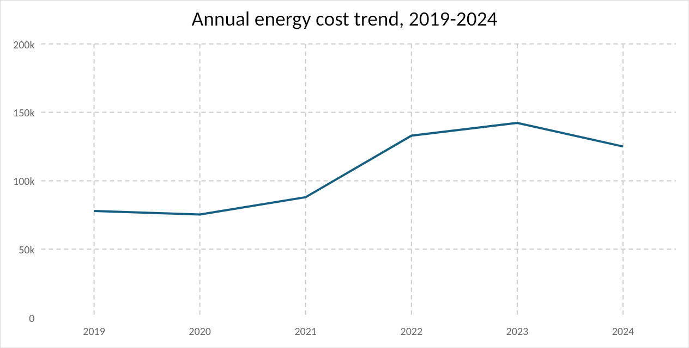
Figure 1 Annual Moodle energy-cost trend, 2019-2024
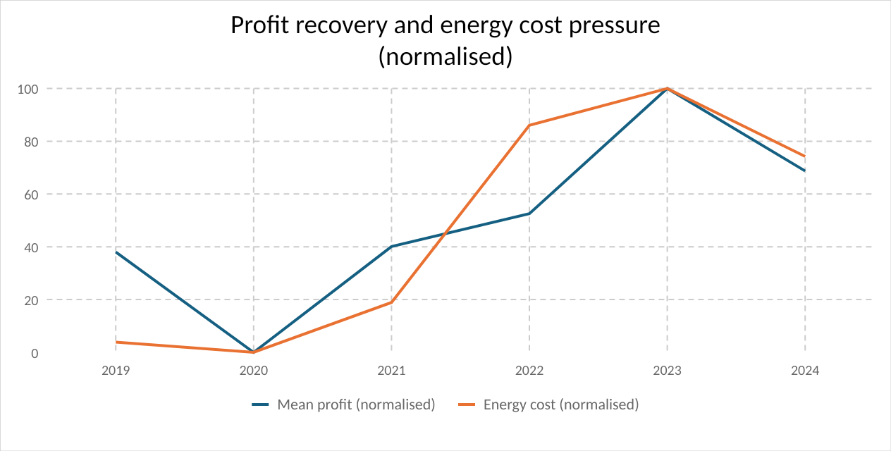
Figure 2 Normalised average profit and energy-cost pressure

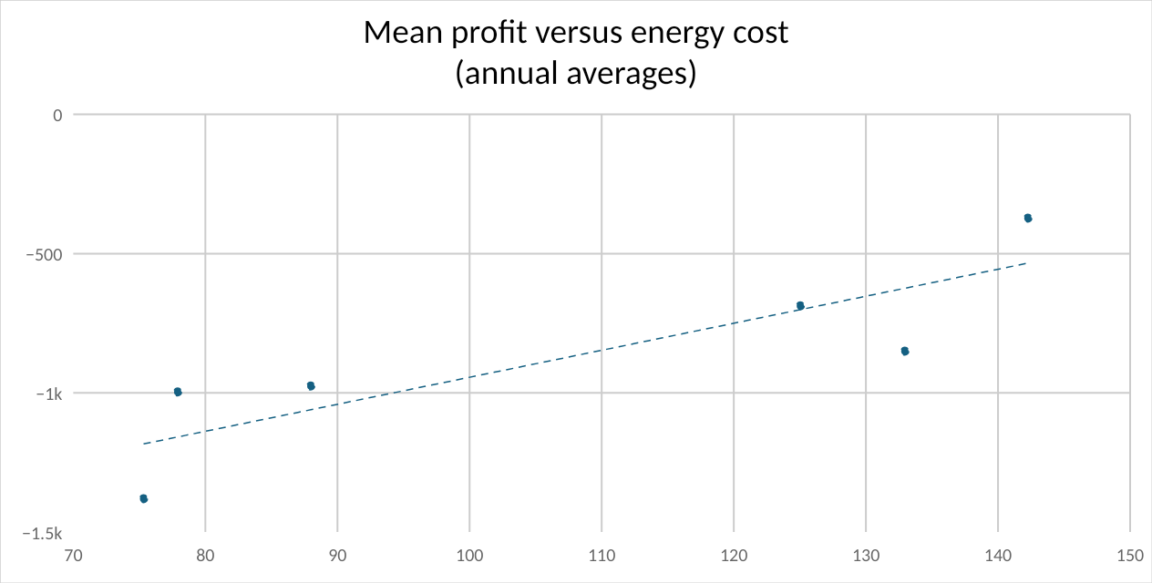
Figure 3 Mean profit before tax versus energy cost (annual averages)
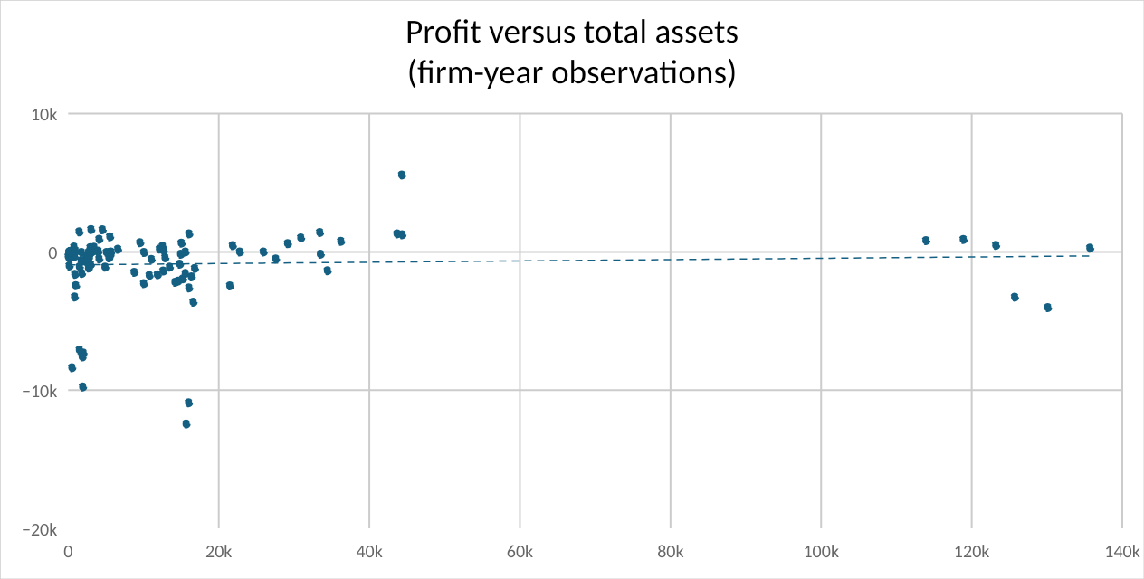
Figure 4 Mean profit before tax versus energy cost (annual averages)
Figure 4: Profit before tax versus total assets (firm-year observations)

5. Correlation Analysis
The weak correlation between variables at the pairwise level are reported in Table 2 and not at the firm level. The three variables (total assets, energy cost and profit) are not highly correlated, in particular there is a small positive correlation between profit and total assets (0.054), and between profit and energy cost (0.109). Such signs are not very indicative of the straightforward notion that higher energy costs would imply lower profits. This, however, is a possible reason as the energy shock happened during the demand recovery period when some hotels increased their prices and the occupancy rates increased. Correlation is descriptive, it does not control for demand, debt, management quality or disruption caused by the COVID-19 pandemic, and cannot directly show causation (Fontagné, Martin and Orefice, 2024).
Table 2 Correlation matrix
Variable | Profit before tax (£000) | Total assets (£000) | Energy cost (000s)
Profit before tax (£000) | 1.00 | 0.0540 | 0.1091
Total assets (£000) | 0.0540 | 1.0000 | 0.0399
Energy cost (000s) | 0.1091 | 0.0399 | 1.00

6. Regression Analysis
Assume that the estimated pooled OLS model is: Profit_it = β0 + β1TotalAssets_it + β2EnergyCost_t + ε_it.Suppose that the estimated pooled OLS model is: Profit_it = β0 + β1TotalAssets_it + β2EnergyCost_t + ε_it. The dependent variable is profit before tax because it captures overall accounting profitability before taxation, including the effects of operating performance and financing costs. To account for firm size, total assets is included, and energy cost indicates firm's annual cost pressure that is experienced at the level of the industry. The model is pooled because taught regression methods are being used in the assignment and the sample is small with annual data on energy used being shared across firms. The coefficient is scaled by 1,000 to be readable.
The total-assets coefficient of the regression model is positive but not statistically significant as presented in Table 3. This translates to a £1000 increase in assets being linked with only a £4.40 higher profit before tax, with energy cost being held constant, and a p-value of 0.599. Also, the energy-cost coefficient is positive though small. This is because a one unit increase in the scaled energy variable is accompanied by a rise in profit of £9670, although this isn't statistically significant as the p value is 0.258. The energy cost variable is the annual Moodle industry-level energy cost index (£), so a one-unit increase corresponds to a £1 rise in the index; the coefficient is therefore best read in terms of the £27,000–£142,000 range observed across the sample period rather than as a marginal unit effect. It's not that energy costs help increase hotel profits. Instead, the model does not yield direct negative effects since the price increases occurred at the time of the recovery from the downturn and firm-specific variation is the most salient feature of the sample, consistent with the studies that have been conducted on the topic and that have found heterogeneous cost pass-through and firm adjustment (Ganapati, Shapiro and Walker, 2020; Fontagné, Martin and Orefice, 2024).
Table 3 Pooled OLS regression output
Variable | Coefficient | Std. error | t-stat | p-value
Intercept | -1,977.61 | 950.01 | -2.08 | 0.0397
Total assets (£000) | 0.0044 | 0.0083 | 0.5268 | 0.5994
Energy cost (000s, Moodle value) | 9.67 | 8.51 | 1.14 | 0.2584

Model fit: n = 114; R-squared = 0.0144; adjusted R-squared = -0.0034.

7. Discussion
The results are best understood from economic mechanisms as well as signs of the coefficients. Hotels use less energy than heavy industry but energy is vital to their operations and hard to eliminate without impacting the guests' experience. Research on the energy consumption of accommodation has confirmed that occupancy, building systems, hotel class and hotel routines are factors that influence energy consumption (Becken, Frampton and Simmons, 2001; Deng and Burnett, 2002; Priyadarsini, Xuchao and Eang, 2009; Arenhart et al., 2024).
The main explanation is that of cost pass-through. But hotels can charge higher prices and apply a portion of the price hike to the consumer in markets with high occupancy or a strong brand name, or an appealing location. Pass through is constrained in less robust local markets as customers can choose as an alternative to more expensive lodging. This implies that the same energy shock can have different impacts on the margins of some firms – with some firms benefiting from demand recovery, and hiding the energy shock at the sample level. This is corroborated by evidence of pass through and firm adjustment (Ganapati, Shapiro and Walker, 2020; Fontagné, Martin and Orefice, 2024).
Consider the productivity effects as well. In reality, the potential efficiency savings from energy shocks can be realised through investment in efficiency, but the investment process is hampered by high hurdle rates, information gaps and organisational inertia (DeCanio 1993, Jaffe and Stavins 1994; Cagno et al., 2013; Sorrell, 2015). Smart heating control, LED light, benchmarking and environmental management system are some of the answers given by hotels for reducing their energy use (Bohdanowicz, 2005; Mensah, 2006; Bohdanowicz, 2006; Chan and Wong, 2006; Kahn and Liu, 2016). Having an asset base can support efficiency investment but also increases fixed-cost exposure. The managerial focus should therefore be on occupancy management, pricing discipline and operational efficiency rather than relying on demand recovery to sustain margins.

8. Conclusion
The statistical results of this report indicate there is no significant negative relationship between annual energy costs and profit before taxes for the sample of UK hotel companies in the 2019-2024 time period overall. Descriptive evidence provides support for a significant increase in energy prices since 2021 and the hotel industry's revival from the pandemic, though it is highly skewed. The correlation and regression results are also low, which suggests that the difference in the profit is not explained by the energy cost only.
The key message is that the cost of energy is not just a point-by-point cost driver of accounting profits, but, rather, as a pressure on margins. Occupancy recovery, rate increases and efficiency measures can sometimes compensate for these upgrades in cost; however, less robust firms may not be able to do so. The results are useful to managers for energy efficiency investment, pricing discipline and cost monitoring. Further research would benefit from direct utility bills and occupancy data and fixed-effects modelling to get a better estimate of the true profit impact. This would facilitate a causal interpretation and judgement.

References
Arenhart, R.S., Martins, T., Ueda, R.M., Souza, A.M. and Zanini, R.R. (2024) 'Energy use and its contributors in hotel buildings: a systematic review and meta-analysis', PLOS ONE, 19(10), e0309745. Available at: https://doi.org/10.1371/journal.pone.0309745 (Accessed: 14 May 2026).
Arenhart, R.S., Souza, A.M. and Zanini, R.R. (2022) 'Energy use and its key factors in hotel chains', Sustainability, 14(14), 8239. Available at: https://doi.org/10.3390/su14148239 (Accessed: 14 May 2026).
Becken, S., Frampton, C. and Simmons, D. (2001) 'Energy consumption patterns in the accommodation sector: the New Zealand case', Ecological Economics, 39(3), pp. 371-386. Available at: https://doi.org/10.1016/S0921-8009(01)00229-4 (Accessed: 14 May 2026).
Bohdanowicz, P. (2005) 'European hoteliers’ environmental attitudes: greening the business', Cornell Hotel and Restaurant Administration Quarterly, 46(2), pp. 188-204. Available at: https://doi.org/10.1177/0010880404273891 (Accessed: 14 May 2026).
Bohdanowicz, P. (2006) 'Environmental awareness and initiatives in the Swedish and Polish hotel industries: survey results', International Journal of Hospitality Management, 25(4), pp. 662-682. Available at: https://doi.org/10.1016/j.ijhm.2005.06.006 (Accessed: 14 May 2026).
Bureau van Dijk (2026) FAME: company financial statements database. Available at: https://www.bvdinfo.com/en-gb/our-products/data/national/fame (Accessed: 14 May 2026).
Cagno, E., Worrell, E., Trianni, A. and Pugliese, G. (2013) 'A novel approach for barriers to industrial energy efficiency', Renewable and Sustainable Energy Reviews, 19, pp. 290-308. Available at: https://doi.org/10.1016/j.rser.2012.11.007 (Accessed: 14 May 2026).
Chan, E.S.W. and Wong, S.C.K. (2006) 'Motivations for ISO 14001 in the hotel industry', Tourism Management, 27(3), pp. 481-492. Available at: https://doi.org/10.1016/j.tourman.2004.10.007 (Accessed: 14 May 2026).
DeCanio, S.J. (1993) 'Barriers within firms to energy-efficient investments', Energy Policy, 21(9), pp. 906-914. Available at: https://doi.org/10.1016/0301-4215(93)90178-I (Accessed: 14 May 2026).
Deng, S. and Burnett, J. (2002) 'Energy use and management in hotels in Hong Kong', International Journal of Hospitality Management, 21(4), pp. 371-380. Available at: https://doi.org/10.1016/S0278-4319(02)00016-6 (Accessed: 14 May 2026).
Department for Energy Security and Net Zero (DESNZ) (2026) Quarterly Energy Prices. Available at: https://www.gov.uk/government/collections/quarterly-energy-prices (Accessed: 14 May 2026).
Fontagné, L., Martin, P. and Orefice, G. (2024) 'The many channels of firm's adjustment to energy shocks: evidence from France', Economic Policy, 39(117), pp. 5-43. Available at: https://doi.org/10.1093/epolic/eiae011 (Accessed: 14 May 2026).
Ganapati, S., Shapiro, J.S. and Walker, R. (2020) 'Energy cost pass-through in US manufacturing: estimates and implications for carbon taxes', American Economic Journal: Applied Economics, 12(2), pp. 303-342. Available at: https://doi.org/10.1257/app.20180474 (Accessed: 14 May 2026).
House of Commons Library (2026) Hospitality: statistics and policy. Available at: https://researchbriefings.files.parliament.uk/documents/CBP-10333/CBP-10333.pdf (Accessed: 14 May 2026).
IBISWorld (2025) Hotels & Holiday Accommodation in the UK: industry data and analysis. Available at: https://www.ibisworld.com/united-kingdom/industry/hotels-holiday-accommodation/200252/ (Accessed: 14 May 2026).
IBISWorld (2026) Hotels in the UK: industry analysis. Available at: https://www.ibisworld.com/united-kingdom/industry/hotels/3375/ (Accessed: 14 May 2026).
Jaffe, A.B. and Stavins, R.N. (1994) 'The energy-efficiency gap: what does it mean?', Energy Policy, 22(10), pp. 804-810. Available at: https://doi.org/10.1016/0301-4215(94)90138-4 (Accessed: 14 May 2026).
Kahn, M.E. and Liu, P. (2016) 'Utilizing big data to improve the hotel sector's energy efficiency: lessons from recent economics research', Cornell Hospitality Quarterly, 57(2), pp. 202-210. Available at: https://doi.org/10.1177/1938965515619489 (Accessed: 14 May 2026).
Lai, J.H.K. (2016) 'Energy use and maintenance costs of upmarket hotels', International Journal of Hospitality Management, 56, pp. 33-43. Available at: https://doi.org/10.1016/j.ijhm.2016.04.011 (Accessed: 14 May 2026).
Mensah, I. (2006) 'Environmental management practices among hotels in the greater Accra region', International Journal of Hospitality Management, 25(3), pp. 414-431. Available at: https://doi.org/10.1016/j.ijhm.2005.02.003 (Accessed: 14 May 2026).
Office for National Statistics (ONS) (2025) The impact of higher energy costs on UK businesses: 2021 to 2024. Available at: https://www.ons.gov.uk/economy/economicoutputandproductivity/output/articles/theimpactofhigherenergycostsonukbusinesses/2021to2024 (Accessed: 14 May 2026).
Priyadarsini, R., Xuchao, W. and Eang, L.S. (2009) 'A study on energy performance of hotel buildings in Singapore', Energy and Buildings, 41(12), pp. 1319-1324. Available at: https://doi.org/10.1016/j.enbuild.2009.07.028 (Accessed: 14 May 2026).
Sorrell, S. (2015) 'Reducing energy demand: a review of issues, challenges and approaches', Renewable and Sustainable Energy Reviews, 47, pp. 74-82. Available at: https://doi.org/10.1016/j.rser.2015.03.002 (Accessed: 14 May 2026).
UKHospitality (2023) £7.3 billion bill increase looms for hospitality as energy support reduces. Available at: https://www.ukhospitality.org.uk/7-3-billion-bill-increase-looms-for-hospitality-as-energy-support-reduces/ (Accessed: 14 May 2026).
York Business School (2026) BME4007M Quantitative Methods for Business and Economics assignment brief and Moodle energy-cost dataset. York St John University.

AI Use Statement
I used ChatGPT mainly to brainstorm structure and check clarity.

