Business Report for Luxora Business Industry 2025
Luxora Business Report
BUS020C408S
Submission date: 9 April 2026
Anushka Kharel

Table of Contents
1. Introduction 3
1. Analysis for Metaverse marketing and customer experience personalisation Industry 3
1.1 An Overview of the Metaverse marketing and customer experience personalisation Industry 3
1.2 Linear Forecast of Productions for 2018 and 2027 5
1.3 Potential Expansion in the Retail Industry 6
1.4 Quality Assurance Conditions for Device Working 6
1.5 Costs of a New Device 7
1.6 Hypothesis Testing for the Possible Difference in Two Products 7
1.7 Pros & Cons Analysis 7
1.8 Customer Satisfaction 8
1.9 Initial SWOT Analysis about Possible Expansion 8
1.10 Summary 9
2. References 10
3. Appendices 11
Appendix A: Excel Workings and Formula Evidence 11
Appendix B: Additional Charts and Tables 12
Appendix C: Statistical and Financial Calculations 14

1. Introduction
Luxora is a digitally based fashion and lifestyle e-retailer where competitive model is based on fast market sensing, elastic production and close to customer demand to operational capacity. The concise introduces the company as a technology-driven retailer that delivers its services to its customers in over 150 countries making a significant use of digital platforms and responsive production (University of Roehampton, 2025).
The report assesses the metaverse marketing, customer experience personalisation, analyses consumer engagement data, forms forecasts, assesses the potential of the Middle East expansion, tests the reliability of the devices, reviews the loan affordability, conducts hypothesis testing on production output, reviews the case of personalisation in Singapore, summarises customer satisfaction outcomes provided in the supplied workbook, and concludes with a preliminary SWOT on the environmental impact of fast-fashion.

1. Analysis for Metaverse marketing and customer experience personalisation Industry

1.1 An Overview of the Metaverse marketing and customer experience personalisation Industry
The marketing report uploaded indicates that the future of digital marketing will be determined by a more personalised marketing, as well as more engaging spaces, such as the metaverse marketing. Though the number of marketers intending to expand into metaverse activity immediately was quite low, a significant number of them were ramping up investment in online events, real-time marketing and AI-supported content and automation. Meanwhile, customer experience personalisation was moving away not only the simple stuff (names, email content, etc.) but purchase-based and more sophisticated real-time. Effectively, marketing is shifting to less campaign-based and more context-based with value generated by being relevant, timely, and using customer data more effectively (Statista, 2025).
The marketing of metaverse is not the primary commercial focus yet, and it is an indicator of the significance of community-driven and interactive brand experiences. In the short term, product recommendation, retention and conversion can be enhanced by use of advanced personalisation. Nonetheless, the same report notes issues of data quality, privacy and cost, thus Luxora needs to consider personalisation as a controlled ability as opposed to a mere promotional instrument (Statista, 2025).
Task 2(a): Clustered bar chart on brand engagement failures
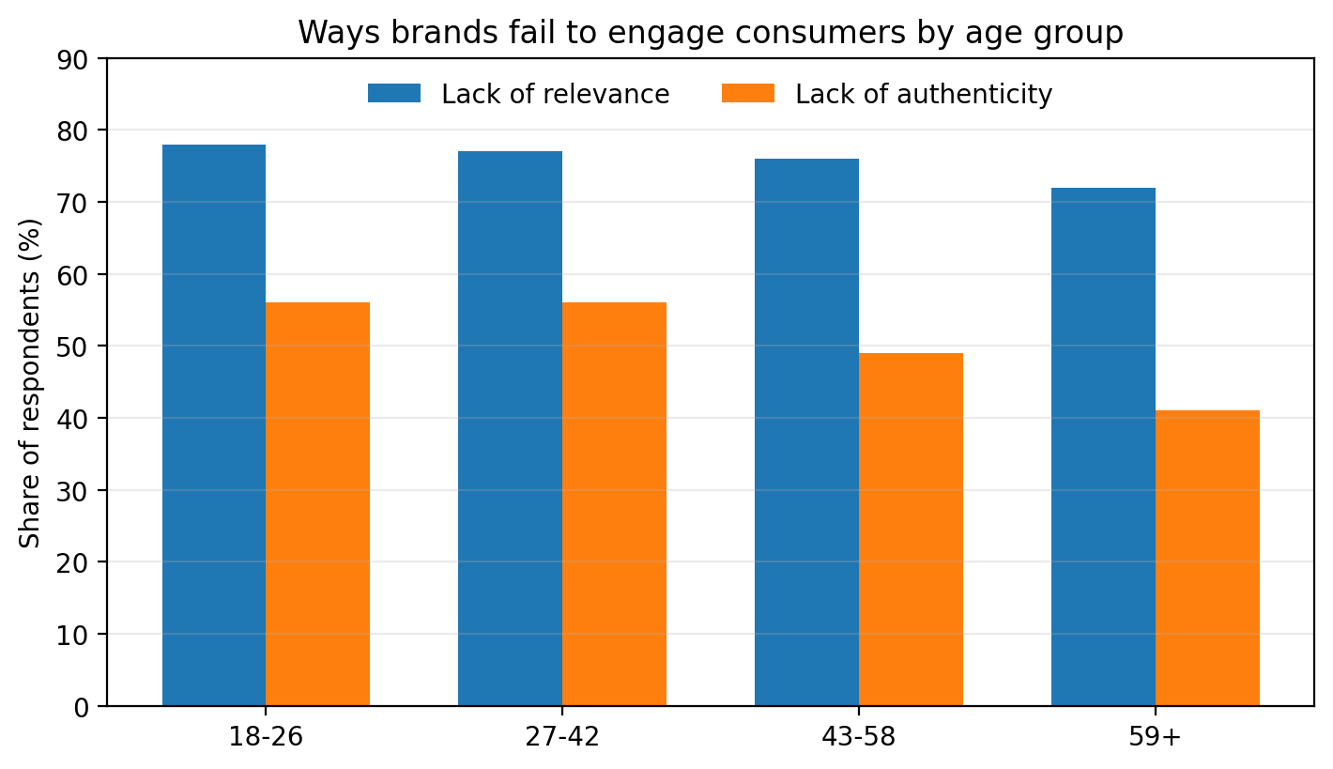
Figure 1: Ways brands fail to engage consumers by age group. Source: developed from data in Statista (2025).
72% and 78. The second problem is lack of authenticity which has a lower impact and is more precipitous on the older consumers. The dissimilarity between the two factors is least when it comes to older shoppers, indicating that older shoppers want both fit and sincerity, though to a smaller degree than authenticity, which younger groups are willing to tolerate, but not irrelevant message.
In the case of Luxora, the increased promotional activity should not be seen as the initial step towards better engagement, but rather audience matching. Leading to products, buying and context information ought to be utilized to enhance product suggestions, timing and channel selection. Another factor that the company requires is believable storytelling to ensure that the influencer content, sustainability claims and brand messages resonate with the shopping experience.

1.2 Linear Forecast of Productions for 2018 and 2027
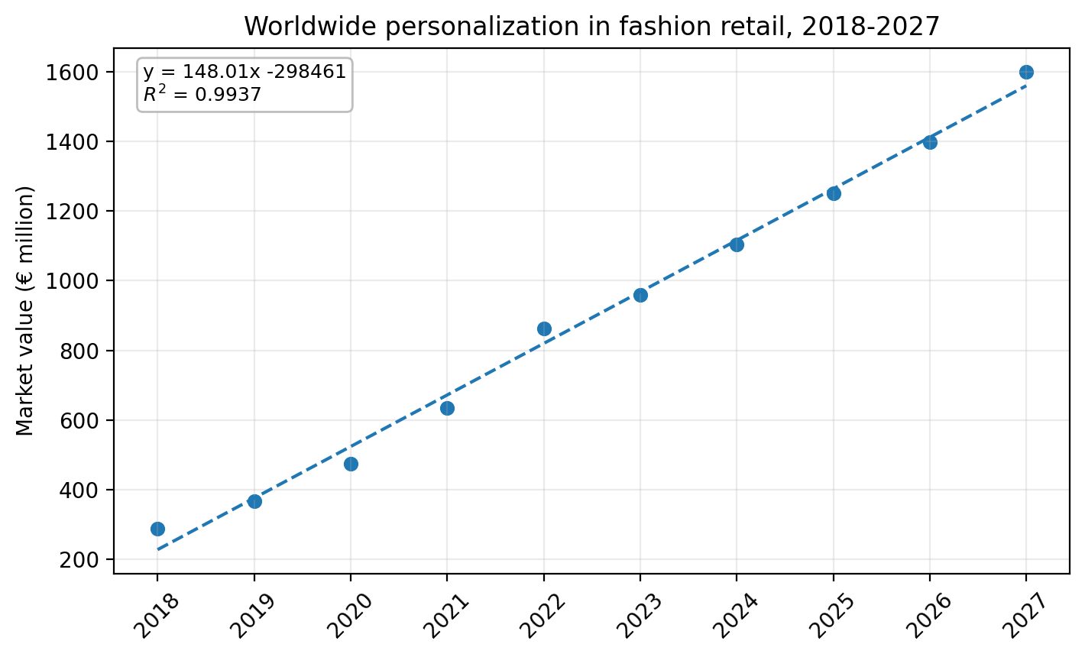
Figure 2: Scatter diagram with linear trendline for worldwide fashion personalisation market value, 2018-2027. Source: developed from University of Roehampton (2025).
The fitted line is y = 148.01x - 298,461 with R 2 =0.9937 indicating that nearly all the variation of the series can be explained by the linear model. The data rise from €288 million in 2018 to €1,600 million in 2027, and the line predicts a 2027 value of about €1,559.9 million.
In the case of Luxora, it means that personalisation is an ability to scale retail, and not a niche feature. Although the actual growth might not be completely linear, the trend of movement is heavily in an upward direction and justifies additional investment on data, recommendation systems and customer experience design.

1.3 Potential Expansion in the Retail Industry
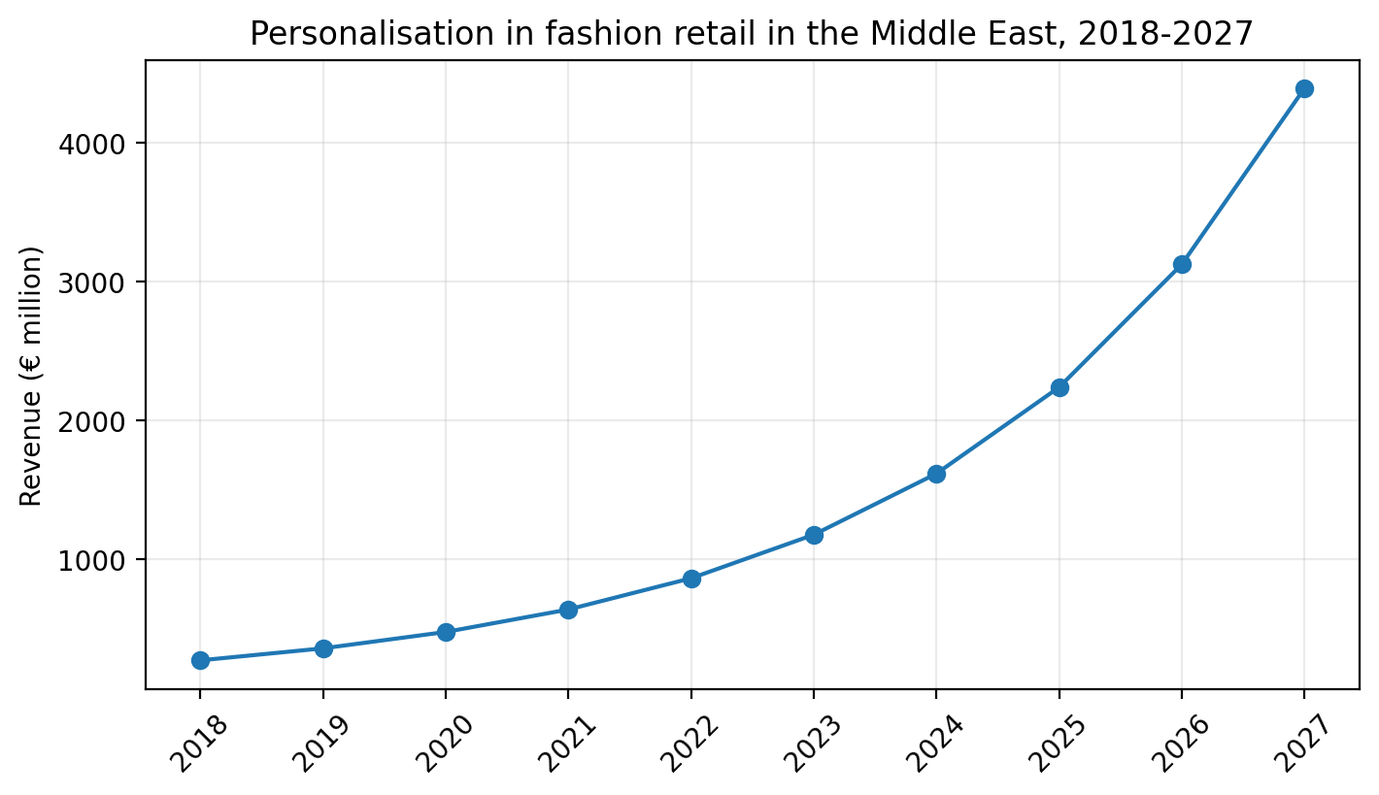
Figure 3: Personalisation in fashion retail in the Middle East, 2018-2027. Source: developed from University of Roehampton (2025).
grow to 4, 391.7 million in 2027 and the growth was projected to be starting with a basis of 270 million of the year 2018. It is over 16 times the increase, which amount to an implied compound growth rate of approximately 36.3 per annum. The growth rate improves after 2022 as well, which means that it shifts away to mass commercialization.
In case of Luxora, it is a promising regional potential. High-growth environment is appropriate to a retailer that has strengths in mobile commerce, broad assortment and quick responsiveness. Nevertheless, localisation of content, payments and fulfilment would be necessary in order to expand

1.4 Quality Assurance Conditions for Device Working
Luxora requires a 99.999% probability that at least one device remains operational. The new device has a failure probability of 0.25% (0.0025) and the older device 0.75% (0.0075). Assuming independent failures, the probability that both fail together is:
P(both fail) = 0.0025 × 0.0075 = 0.00001875.
Therefore:
P(at least one works) = 1 - 0.00001875 = 0.99998125 = 99.998125%.
This is very high, yet it is less than the needed level. The difference is -0.000875 percentage points, meaning that Luxora fails to comply with the given quality assurance standard. The existing system is robust, yet not resilient enough to accommodate the formal tolerance level in the firm, which justifies the need to upgrade or change the old equipment.

1.5 Costs of a New Device
Luxora is interested in funding a new device of up to £95,000 with monthly repayments and not exceeding 2,000. The monthly rate is calculated using the standard loan payment formula with an annual interest rate of 8% and monthly compounding rate: 0.006667. Noting the period of repayment would give one the minimum term that would adjust the payment to a budget of 58 months or an average of about 1980.34 per month. At 60 months payment is reduced to approximately £1,926.26.
The short notes are that the forecasts of profits are in the coming six years and therefore the reasonable limit is 72 months unless more data may be collected. That presents a plausible range of recommendations of 58-72 months. Practically, 60-72 months is the most obvious recommendation to management in case they want to use the usual whole-year terms since it allows to maintain the affordability without undue length of commitment.

1.6 Hypothesis Testing for the Possible Difference in Two Products
The significance level is not given in the brief hence a standard 5% two tailed test is assumed. Since the question is on whether the products have a similar mean weight of the packets, then the hypotheses are H0: μ1 = μ2 and H1: μ1 ≠ μ2.
A Welch two-sample t-test is suitable used due to the differences in sample sizes and standard deviates and the absence of the equal variances. For product 1, n1 = 40, mean = 250 g and s1 = 40 g. For product 2, n2 = 30, mean = 240 g and s2 = 15 g. The standard error is √(40²/40 + 15²/30) = 6.892, so t = (250 - 240)/6.892 = 1.451 with about 52.51 degrees of freedom. The p-value (two-tailed) is about 0.153.
The null hypothesis is not rejected since p > 0.05. In the sample evidence, the average fill amounts of the two products do not significantly differ. As far as business is concerned, the products are similar in terms of mean output, but it is evident that product 1 is more variable, thus less consistent.

1.7 Pros & Cons Analysis
Pros | Score / 10 | Cons | Score / 10
High risk of customer loss without personalisation in Singapore | 9 | Privacy and data-governance concerns | 7
Likely improvement in retention and repeat purchase | 8 | Budget and resource demands for execution | 7
Supports Luxora’s digital-first retail model | 8 | Difficulty of delivering personalisation at scale in real time | 6
Can strengthen relevance and customer loyalty | 7 | Risk of overpersonalisation reducing trust if poorly handled | 5
Total Pros | 32 | Total Cons | 25
Average Pros | 8.00 | Average Cons | 6.25
Table 1: Pros and cons of personalising the customer shopping experience in Singapore. Source: author evaluation using Statista (2025).
Table 1 uses a pros and cons approach to the question of whether Luxora needs to personalise customer shopping experience in Singapore. The best argument in its favour is that of demand-side pressure: the uploaded report indicates that 81% of surveyed consumers in Singapore were likely to switch to do not personalise the experience, the highest percentage in the countries displayed (Statista, 2025). This boosts strong retention, conversion and strategic fit scores. The key counterarguments include cost, sensitivity of privacy and the difficulty of real time personalisation.
The scores obtained in the completed table are a total pro score of 32 and a total con score of 25 with average scores of 8.0 and 6.25 respectively. Luxora then ought to make it personal in Singapore but in a moderate manner founded on open data utilisation and effective implementation discipline.

1.8 Customer Satisfaction
According to the uploaded Task 8 workbook, the average score of recent purchase (Q1) is 2.700, the overall average shopping experience score is 3.145 (the mean of Q2a and Q2b) and the average recommendation score (Q3) is 3.100. The overall shopping experience will thus be the best metric, whereas the recent purchase will be the worst.
These results indicate that Luxora is doing decent in terms of service experience but can do more to enhance purchase satisfaction and the probability of recommendation. There is one data note that is significant: there is one Q1 that is 5 in the workbook even though one of the scale notes is 1-4. Since the controlling source is the uploaded workbook, the observation has not been corrected.

1.9 Initial SWOT Analysis about Possible Expansion
Strengths | Weaknesses | Opportunities | Threats
On-demand and small-batch production can reduce excess inventory waste. | Fast-fashion business models remain associated with high material throughput. | Sustainable materials and circular services could differentiate Luxora. | Tighter regulation and public scrutiny may raise compliance and cost pressure.
Digital demand signals support more accurate stock planning. | Low-price positioning can conflict with sustainability expectations. | Better environmental disclosure can strengthen authenticity. | Reputational damage can spread quickly through social media.
Global digital reach enables faster communication of greener initiatives. | Supply-chain transparency may still be incomplete across partners. | Repair, resale and lower-impact packaging can add long-term value. | Resource scarcity and waste costs could erode margins over time.
Table 2: Initial SWOT analysis on fast-fashion environmental impact.
There is an initial SWOT analysis in environmental impact of fast-fashion presented in Table 2. The strengths of Luxora are that digital demand cues, flexibility in production and small-batches can decrease the overproduction and markdown waste. Nevertheless, the company continues to evolve in a rapid fashion industry where green marketing is subject to eager analysis. The video and the broader sustainability conversation connected to it illustrate vulnerabilities and risks regarding the use of resources, the generation of waste and the potential exposure to reputation in case of low prices were based on resource-consuming activities (Fast Fashion Environmental Impact, 2025; UNEP, 2022).
The implications of the SWOT strategically are that expansion in the future cannot be divorced of the environmental positioning. A chance to enhance materials, product information, packaging and circularity, can transform sustainability into an opportunity when Luxora provides it. Lack of improvement, on the contrary, may harm the trust just at the moment, when consumers are requiring more relevance and authenticity of the brands.

1.10 Summary
The market analysis indicates that fashion retail personalisation is growing at an alarming rate across the globe and more so in the Middle East and the engagement chart shows that relevance and authenticity are even stronger determinants of customer connection. The Singapore analysis supports the business argument, indicating that inability to personalise would result in loss of customers in an extremely sensitive market. The results of the customer satisfaction are satisfactory, in particular, regarding the shopping experience, yet they are not high enough to suggest the optimised proposition.
In its operations, the report further reveals that the growth decisions have to be backed by rigorous quantitative analysis. Luxora just misses its desired device reliability target, which further reinforces the argument to upgrade ageing equipment. The given budget allows financing a new device, provided that the term of the loan is 58 months or more, though 60-72 months would be the most reasonable. The hypothesis test, lastly, proposes that the two filling processes are similar in one, in terms of averages, but not in terms of variability. Altogether, Luxora ought to engage in data-driven personalisation and selective growth and enhance the production resilience and environmental responsibility.
A key theme in running through the findings is that the customer strategy and operations strategy at Luxora are interdependent. The increased personalisation enhances demand-side demands of speed, relevance and consistency; hence, the production system and financing decisions must be consistent to deliver on the promise in the market. It is specifically in the quantitative parts of the report that marketing ambition is transformed into operational feasibility.

2. References
Fast Fashion Environmental Impact (2025) YouTube video. Available at: https://www.youtube.com/watch?v=6AEr0tpTAMs (Accessed: 9 April 2026).
Statista (2025) Marketing personalization worldwide. [PDF] Module materials / uploaded report.
UNEP (2022) The environmental costs of fast fashion. Available at: https://www.unep.org/news-and-stories/story/environmental-costs-fast-fashion (Accessed: 9 April 2026).
University of Roehampton (2025) BDA Summative Assessment Brief 2025: Luxora Business Report. Module materials / uploaded brief.

3. Appendices

Appendix A: Excel Workings and Formula Evidence
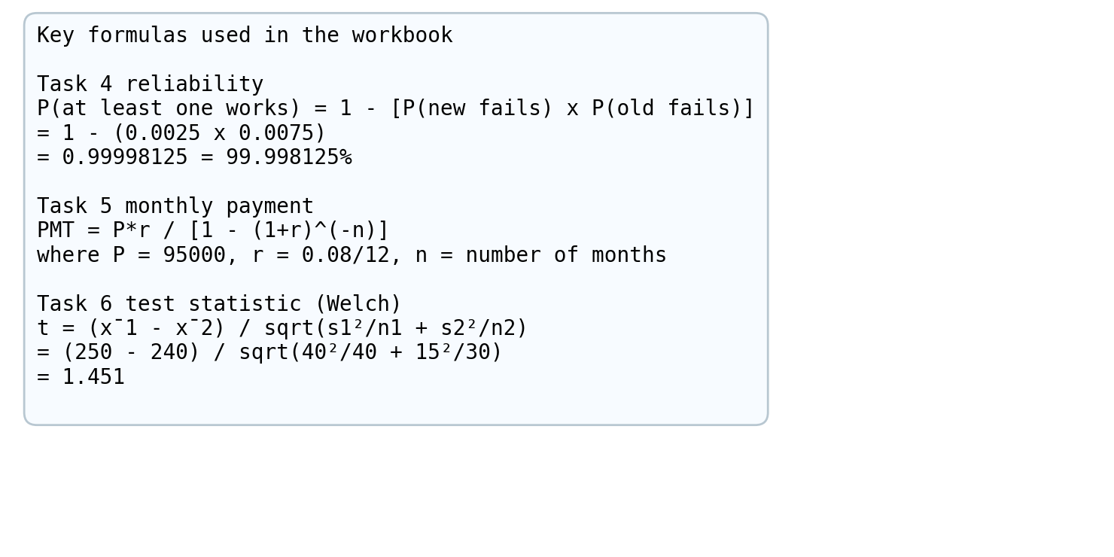
Figure A1: Key formulas used for reliability, loan payment and hypothesis testing.
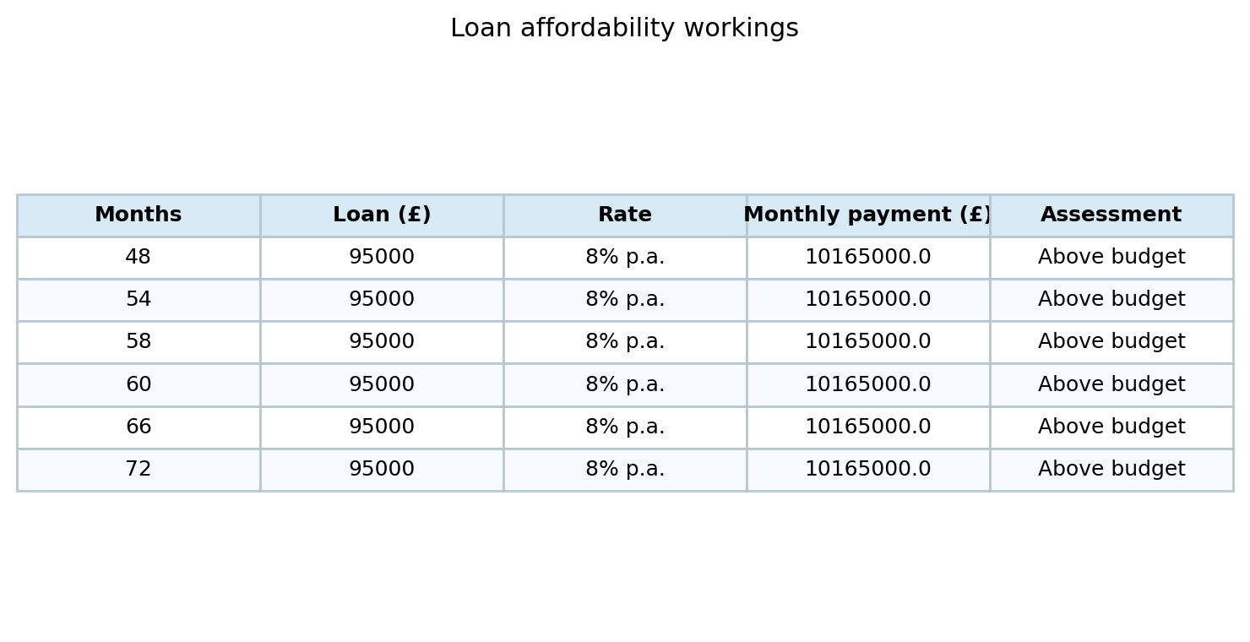
Table A1: Loan affordability workings for selected repayment periods.
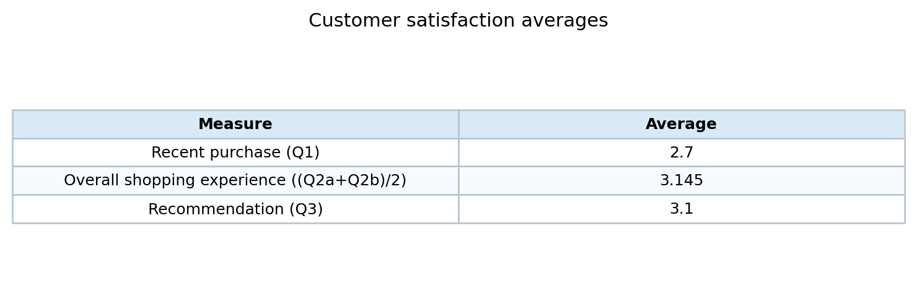
Table A2: Customer satisfaction averages derived from the uploaded workbook.

Appendix B: Additional Charts and Tables
Figure B1: Clustered bar chart reproduced from Task 2(a) working.
Figure B2: Scatter diagram and linear trendline reproduced from Task 2(b) working.
Figure B3: Middle East line chart reproduced from Task 3 working.

Appendix C: Statistical and Financial Calculations
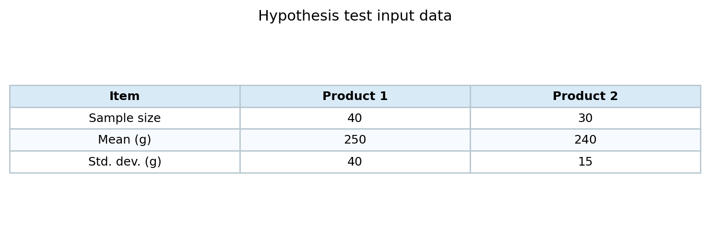
Table C1: Hypothesis test input values.

