Top-Down Fundamental Analysis and Optimal Two-Share Portfolio
Selected companies: ANZ Group Holdings Limited (ASX: ANZ) and CSL Limited (ASX: CSL)

Executive summary
This report examines an Australian equity investor who has a total portfolio of A$150,000, allocating funds between ANZ Group Holdings Limited (ASX: ANZ) and CSL Limited (ASX: CSL) in a top down fundamental and portfolio optimisation analysis. Global growth is moderate, inflation is still a problem and the RBA cash rate is at 3.60%, so it is important to be selective when it comes to stock exposure.
The suggested portfolio is 62% ANZ and 38% CSL. The higher allocation for ANZ is due to dividend income, less volatility, recent earnings improvement and upside from restructuring. CSL is added to the portfolio for diversification and recovery potential for global health care exposure, but has a lower weighting because of higher volatility, downgrades, restructuring risk and impairment concerns.
The expected return of the selected portfolio is 11.07%, the annualised risk is 11.40%, and the ratio of reward to risk is 0.66. This represents about A$93,000 in ANZ and A$57,000 in CSL or around 2,559 ANZ shares and 330 CSL shares at end-2025 prices. Overall, the portfolio is well diversified with a balance of income and banking exposure from ANZ and diversification and recovery upside from CSL, with the negative correlation between the two shares reducing risk.

Table of Contents
Executive summary i
1 Introduction 1
2 Top-down analysis of the investment environment 1
3 Industry and security analysis 3
4 Quantitative return, risk and expected return derivation 4
5 Portfolio construction and optimal allocation 7
6 Sensitivity analysis of optimal weights 9
7 Recommendation, implementation and monitoring 10
8 Conclusion 11
9 Reference List 12
10 Appendix A: Monthly adjusted price and return data 15

List of Figure
Figure 1 . Indexed adjusted-price performance, December 2023 = 100. 5
Figure 2 . Risk-return trade-off and selected maximum-utility portfolio 8

List of Tables
Table 1 Return and risk inputs 5
Table 2 Formal expected return derivation 7
Table 3 Portfolio alternatives and utility calculations 7
Table 4 Implementation of A$150,000 portfolio using end-2025 market prices 9
Table 5 Sensitivity of optimal weights to expected-return changes 9

Introduction
This essay is a top down fundamental analysis of an Australian equity investor who is allocating $A150000 amongst two shares listed on the Australian Stock Exchange (ASX): ANZ Group Holdings Limited (ASX:ANZ) and CSL Limited (ASX:CSL). The analysis begins at the macroeconomic level of the world economy and then continues with an analysis of the Australian economy, sector rotation and security selection before forming a two-share portfolio based on the expected return, volatility, correlation, reward-risk, and utility calculations. The investment date is assumed to be the end of 2025 and beginning of 2026, when the Reserve Bank of Australia lowered the cash rate to 3.60 per cent, but still had an inflation pressure problem (with inflation higher than the target level) (RBA, 2025a; ABS, 2026).
The investor profile is not a speculative one but is a moderately risk averse one. This is captured with a coefficient of risk aversion A = 4 in a utility function U = E(Rp) - 0.5Aσp², where E(Rp) represents expected return of the portfolio, and σp² represents the variance of the portfolio. ANZ selected on upside due to restructuring and income.ANZ is selected for upsides from restructuring and income in domestic banking. CSL is selected based on the diversification and recovery value in global healthcare, however, is limited due to recent downgrades, restructuring and impairment risk. This recommended portfolio is split 62 per cent for ANZ and 38 per cent for CSL with an expected return of 11.07 per cent, an annualised risk of 11.40 per cent and a reward-risk ratio of 0.66 on a cash rate of 3.60 per cent as the risk-free rate.

Top-down analysis of the investment environment
The top down approach starts with macroeconomic conditions as the discount rate, company earnings growth and risk appetite all influence equity valuations prior to deciding which companies to select (Bodie, Kane and Marcus, 2024). The conditions the world will face in 2026 won't be a crisis scenario like 2020, but it's not as easy as the high-liquidity days since the pandemic. Global growth is expected to reach 3.2 per cent in 2025 and 3.1 per cent in 2026, while unsettling issues such as trade fragmentation, policy uncertainty, fiscal weakness, and financial-market repricing could pose downside risks for global growth (IMF, 2025). This is the time period when equity returns may be positive but the expansion of the valuation may be selective as opposed to general.
The macro variables that are most important for this portfolio are inflation and interest rates. If inflation remains above the target, then central banks remain conservative in their measures to lower it as it is likely to bring back upward inflationary pressure. An increase in real rates leads to higher discount rates, lower price/earnings multiples and higher required equity risk premium. According to Damodaran (2025), the higher the uncertainty, the higher the macro risk and the higher the risk aversion of the investors, the higher will be the equity risk premium. In terms of companies, a higher equity risk premium is more appealing to companies with consistently solid cash flows, well-defined dividends and pricing power, but less desirable for companies with high leverage and/or long durations of growth, whose value is built on cash flows that are far into the future.
This world-wide tension is reflected in Australia. The RBA's November 2025 statement suggested that the monetary policy stance was continuing to be restrictive, due to the lack of full return to the target inflation band (RBA, 2025a). The annual CPI inflation rate is 3.8 per cent and the trimmed mean inflation rate is 3.3 per cent in December 2025, up from the RBA's 2-3 per cent target band (ABS, 2026). This leaves the economy in a late cycle environment, characterized by low rates which help households and asset prices, but slow to become expansionary, while sticky services and housing inflation holds the economy back. For ANZ, it is a double-edged sword as rates help margins, but cost-of-living stressed families make credit-risk sensitive. CSL's domestic rates have less direct impact, while discount rates worldwide and the demand for healthcare in the United States have an impact on its valuation.
Another diversified two-stock strategy is through sector rotation. When inflation is sticky, investors tend to shift to value and the companies that generate income and near term cash flow which helps ANZ banks. When growth growth is in sharp decline, however, the sectors with a defensive bias like healthcare tend to come back into favour as demand for plasma products and medicines is less cyclical. The best portfolio should thus be a collection of small bets, rather than one big bet. It should also seek to align itself to ANZ's ability to generate cyclical income, and CSL's overall characteristics of a global healthcare company, while also acknowledging that CSL's company-specific execution risk is not enough to warrant defensive selection.
There are also different channels for each security, at the global level. The primary macro risk for ANZ is related to Australian housing, business credit and wholesale funding costs – a scenario of ‘stagflation’ with high funding costs and increasing arrears. The factors which have a bigger impact on CSL are: US health care demand growth, Chinese albumin pricing, vaccine demand and the Australian dollar translation effect. This is a reinforcement of the diversification argument as the same macro event does not impact both earnings streams simultaneously and with equal impact.

Industry and security analysis
ANZ's business is diversified and its earnings are dependent on Loan Growth, Net Interest Margin, Deposit Competition, Credit Quality, Regulation & Capital Strength. In terms of cash profit, it has seen a decrease from A$6.725 billion in 2024 to A$5.787 billion in 2025, while the cash net interest margin (CET1 capital ratio) stands at 1.55 per cent (ANZ, 2025). These are indicative of a well capitalised bank but one with some short-term pressure on its earnings. Accordingly, the investment opportunity is hinged on dividend income and the quality of the franchise and measured operational improvement, not perfect past results.
This mixed opinion is reflected in the markets recently. ANZ's annual cash earnings declined 14 per cent as a result of margin pressure and one-off charges (Reuters, 2025a) and later it reported cash profits for the first-quarter of the FY2026 were up 19 per cent due to cost savings (Reuters, 2026a). ANZ is appealing for a moderately risk averse investor due to its relatively high dividend yield and lower volatility compared to CSL, and with its earnings monitoring system being a bit more evident, through NIM, arrears, cost to income and CET1. The primary concerns are the threat of further rate hikes, regulatory sanctions, mortgage market competition and Suncorp integration implementation and deteriorating home loan standards.
CSL is a world-class biopharmaceutical firm, whose revenue is spread over plasma derived therapies, vaccines and specialty pharmaceuticals. According to CSL's 2025 annual report, annual revenue was US$15.6 billion, over 100 countries in which CSL operates, and annual dividends were US$2.92 per share in 2025, with more than 29,000 employees working for CSL (CSL, 2025). Its enduring advantages include its ability to gather plasma in large volumes and process it for specialised applications, as well as having an international distribution network and access to the healthcare market, which thrives on consumers' income, but not necessarily in tandem with the economy. These attributes contribute to CSL's value in a two-share portfolio even in the wake of a challenging share price.
It's still got to be significant. The stock price drop is not driven by market volatility; it's due to execution risk. A restructuring plan with up to 3,000 job cuts and plans to spin off the vaccine business – with expected cost savings of an annual figure – were reported by Reuters (2025b) and Reuters (2025c), as was lower demand for vaccines in the United States and delays in the plans to spin off the vaccine arm. Capital Brief later reported that it would downgrade once again in FY2026, with expectations of being able to generate approximately US$15.2 billion of revenue, US$3.1 billion of NPAT, and US$5 billion of impairment costs (Capital Brief, 2026). CSL is thus of course not meant to be held as a low-risk asset anymore, but as an asset to be recovered and diversified.

Quantitative return, risk and expected return derivation
The risk and return evidence is for the month of December 2023 through December 2025. Adjusted prices are preferred as it takes into consideration dividend and corp action effects more appropriately as compared to raw closing prices. Annual returns are the percentage change in the adjusted price over the course of the year: (ending adjusted price / beginning adjusted price) - 1. Monthly returns are used to compute annualised risk, σannual = σmonthly x √12, which is the square-root of 12. This negative correlation between ANZ and CSL is significant as it means that diversification in a portfolio, according to the Markowitz Diversification Theory, 1952 (Markowitz, 1952) will lead to a decrease in variance.
Table 1 Return and risk inputs
Measure | ANZ | CSL | Interpretation
2024 return | 16.33% | -0.43% | ANZ outperformed; CSL was broadly flat.
2025 return | 33.90% | -37.47% | ANZ rallied while CSL sold off sharply.
Annualised risk, σ | 15.24% | 22.91% | CSL had materially higher volatility.
Correlation | -0.213 | -0.213 | Negative cross-correlation creates diversification benefit.
Forward expected return used | 10.50% | 12.00% | Derived through the blended model in Table 2.
Source: calculated from Digrin monthly adjusted prices and sources cited in the essay.
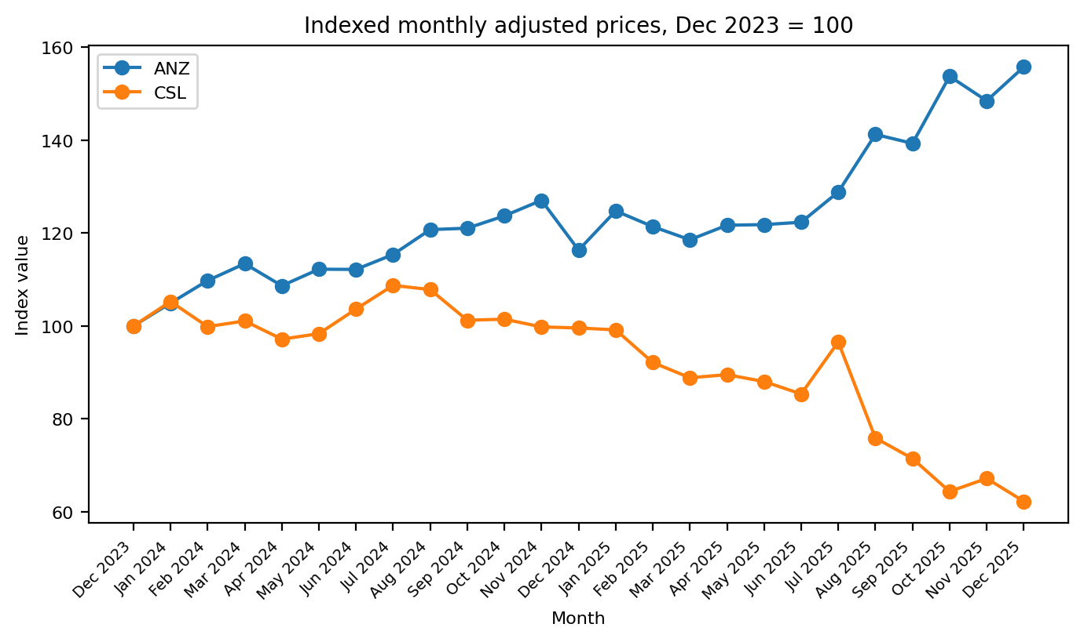
Figure 1 . Indexed adjusted-price performance, December 2023 = 100.
Source: calculated from Digrin (2026a, 2026b).
Expected returns are statistically calculated and not just based on past returns. The model is a hybrid approach since the CAPM model accounts for systematic market risk and dividend-growth and recovery assumptions account for stock-specific fundamentals. The CAPM part is E(Ri) = Rf + βi[E(Rm) - Rf] which was calculated in the following manner: Per cent risk free rate = 3.60, per cent equity risk premium = 6.00. The basic unit is based on dividend yield, sustainable earnings growth and a judicious valuation recovery allowance. Fundamental return is 60 per cent and CAPM is 40 per cent of the final input. This weighting may be warranted because both firms have catalysts which are unique to their respective companies and that this is not fully reflected in their market beta; nevertheless, CAPM does punish them for excessive optimism by Sharpe (1964) and by Damodaran (2025).
The blended model for ANZ is 10.50 per cent: 40 per cent of the CAPM estimate of the return of 8.10 per cent, and 60 per cent of the dividend-growth and restructuring return of 12.10 per cent. The model produces 40 per cent of the estimated CAPM return of 7.20 per cent, and 60 per cent of the CAPM estimate of the fundamental return of 15.20 per cent, for CSL, totaling 12.00 per cent. CSL's expected return is superior to ANZ's because the share price has priced in significant negative news whilst ANZ has considerable upside potential for recovery should the guidance stabilise, albeit with a lower weighting due to the significantly higher volatility/ downgrade risk of the share.
The expected-return inputs are thus not necessarily optimistic, but forward-looking. As the realised return in 2025 is quite high, ANZ's forecast is lower due to the lack of price momentum from history. The forecast by CSL is much lower than a full recovery as it assumes only a partial recovery. Academic reliability is important: the portfolio is not chosen by picking the one with the best historical performance, but rather by using a combination of the historical risk data and a clear forward valuation model.
Security | CAPM component | Fundamental component | Blended expected return
ANZ | Rf 3.60% + βadj 0.75 x ERP 6.00% = 8.10% | Dividend yield, sustainable growth and restructuring/re-rating return = 12.10% | 0.40(8.10%) + 0.60(12.10%) = 10.50%
CSL | Rf 3.60% + βadj 0.60 x ERP 6.00% = 7.20% | Dividend yield, normalised earnings growth and recovery allowance = 15.20% | 0.40(7.20%) + 0.60(15.20%) = 12.00%
Table 2 Formal expected return derivation
Source: author calculations using CAPM, dividend-growth and recovery assumptions.

Portfolio construction and optimal allocation
The portfolio is built based on the expected return, variance, standard deviation, a Sharpe style reward risk ratio and investor utility. E(Rp) = wANZRANZ + wCSLRCSL; for each portfolio. The variance of the random variable X is: σp2 = wANZ2σANZ2 + wCSL2σCSL2 + 2wANZwCSLρANZ,CSLσANZσCSL. Reward-risk is (E(Rp) - Rf) / σp. Utility is U = E(Rp) - 0.5Aσp², with A = 4. The risk free rate is the RBA cash rate of 3.60 per cent.
Table 3 Portfolio alternatives and utility calculations
ANZ / CSL weight | E(Rp) | σp | Reward-risk | Utility
0% / 100% | 12.00% | 22.91% | 0.367 | 0.0151
25% / 75% | 11.62% | 16.78% | 0.478 | 0.0599
50% / 50% | 11.25% | 12.33% | 0.621 | 0.0821
60% / 40% | 11.10% | 11.48% | 0.653 | 0.0846
62% / 38% | 11.07% | 11.40% | 0.655 | 0.0847
65% / 35% | 11.03% | 11.34% | 0.655 | 0.0846
75% / 25% | 10.88% | 11.64% | 0.625 | 0.0817
100% / 0% | 10.50% | 15.24% | 0.453 | 0.0586
Source: author calculations from Table 1 and Table 2 inputs.
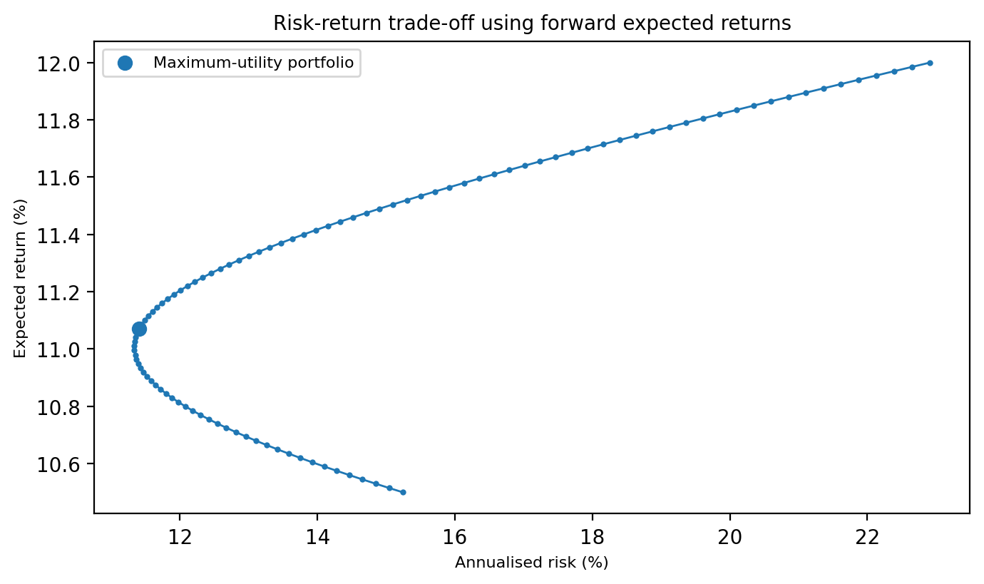
Figure 2 . Risk-return trade-off and selected maximum-utility portfolio
Source: author calculations.
The allocation on 1 per cent grid with the maximum utility is 62 per cent ANZ and 38 per cent CSL. The alternatives of rounded 60:40 and 65:35 portfolios are within the range of being very close, but the exact 62:38 portfolio is chosen because it provides the desired utility for the moderate risk aversion profile, while retaining material exposure to both shares. For the selected portfolio, E(Rp) = 0.62(10.50%) + 0.38(12.00%) = 11.07%. Variance equals 0.62²(15.24%)² + 0.38²(22.91%)² + 2(0.62)(0.38)(-0.213)(15.24%)(22.91%) = 0.0130, so σp = 11.40%. Reward-risk = (11.07% - 3.60%) / 11.40% = 0.655. Utility = 0.1107 - 0.5(4)(0.0130) = 0.0847.
The allocation is both economically and reasonably used. ANZ gets the heftier weight as it performs better recently, has lower volatility in the past and better income support. The weight of CSL is generally less than usual due to benefits of diversifying across the world in healthcare; however, the correction process of 2025 should warrant a risk discount. The negative correlation is particularly useful as while CSL can be volatile individually, combining it with ANZ has resulted in a portfolio risk that is lower than the weighted average of the two risks.
Table 4 Implementation of A$150,000 portfolio using end-2025 market prices
Security | Weight | Dollar allocation | End-2025 price used | Approx. shares | Cash used
ANZ | 62% | A$93,000 | A$36.34 | 2,559 | A$92,994.06
CSL | 38% | A$57,000 | A$172.65 | 330 | A$56,974.50
Cash residual | - | - | - | - | A$31.44
Source: author calculations.

Sensitivity analysis of optimal weights
This is mainly due to estimation risk; hence returns should be stress-tested. A sensitivity analysis confirms the recommendation but not it is binding. A 1 per cent drop in the expected return on ANZ leads the optimal ANZ weight to drop from 62 per cent to 59 per cent. The optimal ANZ weight would increase to 68 per cent if the expected return for CSL falls by 2 percentage points. Once CSL recovers by 2 percentage points, then the weight of the ANZ will drop to 56 per cent. The key takeaway is that the majority continues to be ANZ in all the scenarios analysed and the CSL share is between 32 per cent and 44 per cent. This is because this is not based on any single fragile point estimate.
Table 5 Sensitivity of optimal weights to expected-return changes
Scenario | ANZ expected return | CSL expected return | Optimal ANZ / CSL weight | E(Rp) | σp | Utility
Base case | 10.50% | 12.00% | 62% / 38% | 11.07% | 11.40% | 0.0847
ANZ -1 percentage point | 9.50% | 12.00% | 59% / 41% | 10.53% | 11.54% | 0.0786
ANZ +1 percentage point | 11.50% | 12.00% | 65% / 35% | 11.68% | 11.34% | 0.0910
CSL -2 percentage points | 10.50% | 10.00% | 68% / 32% | 10.34% | 11.35% | 0.0776
CSL +2 percentage points | 10.50% | 14.00% | 56% / 44% | 12.04% | 11.74% | 0.0928
Both -1 percentage point | 9.50% | 11.00% | 62% / 38% | 10.07% | 11.40% | 0.0747
Source: author calculations using the same risk, correlation and A = 4 inputs.
The sensitivity results also give some rules of implementation discipline. A major CSL downgrade should not be seen as a reason for a complete exit as the diversification benefit still continues but it would be a good reason to rebalance towards ANZ. On the other hand, if the guidance from the CSL firmens remains constant, and the recovery side case improves, the allocation of CSL could shift into the low 40 per cent. This is a dynamic portfolio: The allocation of 62:38 is not permanent, just the optimum that is in force at the moment.

Recommendation, implementation and monitoring
The advice is to allocate approximately A$93,000 to ANZ and A$57,000 to CSL with any leftover funds allocated to broking and rounding, and liquidity. If the expected return is realised at 11.07% then the net after tax and transaction cost return of this portfolio is around A$16,605. It is better than a 100 per cent ANZ portfolio since it helps to lessen the concentration of banking in any particular sector, and better than a 100 per cent CSL portfolio as CSL have high business-model, guidance and sentiment risk.
Monitoring should be done quarterly and rebalancing should take place if there is a difference of more than 10 percentage points from the target weight for any share or if fundamental triggers are breached. Net Interest Margin, Cost-to-Income ratio, CET1 capital and mortgage arrears, regulatory costs and restructuring benefit delivery are the key drivers for ANZ. The major catalysts of CSL are the FY2026 guidance, impairment updates, plasma margins, US demand for vaccines, China albumin pricing and permanent leadership appointment. At the macro level, the portfolio should be re-evaluated following the publication of each RBA meeting and CPI after the event as if there are renewed rate increases, this would impact the bank margin, credit quality and equity discount rates.

Conclusion
The bottom-up analysis provides an Australian equity environment of positive, but limited returns. The global growth is moderate, inflation is a policy issue and the 3.60 per cent cash rate should not be "easy money". If equity risk premiums are higher and a rotation towards the so-called cash cows, it pays to be selective in terms of exposure to companies that are resilient. The complementary exposures include: ANZ domestic financial leverage, dividend income and upside on restructuring while CSL is the global healthcare diversification and upside on the recovery value.
For a moderately risk averse investor, the optimal portfolios using formally derived forward returns are 62 per cent ANZ and 38 per cent CSL. The allocation has an average annual return of 11.07 per cent, a risk of 11.40 per cent and a reward-risk ratio of 0.66 and the maximum utility of the tested combinations. Sensitivity analysis indicates the portfolio will still be dominated by ANZ with reasonable forecasts and the weight of CSL will be adjusted as the evidence of recovery changes. The investment should be implemented with around 2,559 ANZ shares and 330 CSL shares and subsequently reviewed periodically against macro, sector and company-specific triggers with the aim of rebalancing.

Reference List
ABS (2026) Consumer Price Index, Australia, December 2025. Australian Bureau of Statistics. Available at: https://www.abs.gov.au/statistics/economy/price-indexes-and-inflation/consumer-price-index-australia/dec-2025 (Accessed: 12 May 2026).
ANZ Group Holdings Limited (2025) 2025 Annual Report. Available at: https://www.anz.com/content/dam/anzcom/shareholder/2025-annual-report/anz-2025-annual-report.pdf (Accessed: 12 May 2026).
Australian Government (2025) Mid-Year Economic and Fiscal Outlook 2025–26. Available at: https://budget.gov.au/content/myefo/index.htm (Accessed: 12 May 2026).
Bodie, Z., Kane, A. and Marcus, A.J. (2024) Investments. 13th edn. New York: McGraw Hill.
Capital Brief (2026) CSL downgrades FY26 earnings guidance after flagging impairment costs. Available at: https://www.capitalbrief.com/briefing/csl-downgrades-fy26-earnings-guidance-after-flagging-impairment-costs-62669ae9-fcf5-4854-affa-800674726311/ (Accessed: 12 May 2026).
CSL Limited (2025) 2025 Annual Report. Available at: https://investors.csl.com/annualreport/2025/ (Accessed: 12 May 2026).
Damodaran, A. (2025) Equity Risk Premiums (ERP): Determinants, Estimation, and Implications – The 2025 Edition. Available at: https://papers.ssrn.com/sol3/papers.cfm?abstract_id=5168609 (Accessed: 12 May 2026).
Digrin (2026a) ANZ Group Holdings Limited (ANZ.AX) price history. Available at: https://www.digrin.com/stocks/detail/ANZ.AX/price (Accessed: 12 May 2026).
Digrin (2026b) CSL Limited (CSL.AX) price history. Available at: https://www.digrin.com/stocks/detail/CSL.AX/price (Accessed: 12 May 2026).
IMF (2025) World Economic Outlook, October 2025: Global Economy in Flux, Prospects Remain Dim. International Monetary Fund. Available at: https://www.imf.org/en/publications/weo/issues/2025/10/14/world-economic-outlook-october-2025 (Accessed: 12 May 2026).
Markowitz, H. (1952) ‘Portfolio selection’, Journal of Finance, 7(1), pp. 77–91.
RBA (2025a) Statement on Monetary Policy – November 2025: Overview. Reserve Bank of Australia. Available at: https://www.rba.gov.au/publications/smp/2025/nov/overview.html (Accessed: 12 May 2026).
RBA (2025b) Statement on Monetary Policy – November 2025: Outlook. Reserve Bank of Australia. Available at: https://www.rba.gov.au/publications/smp/2025/nov/outlook.html (Accessed: 12 May 2026).
Reuters (2025a) ANZ CEO Nuno Matos vows to cut costs as bank faces margin pressure in 2026. Available at: https://www.reuters.com/business/finance/australias-anz-posts-lower-annual-profit-one-off-charge-margin-pressure-2025-11-09/ (Accessed: 12 May 2026).
Reuters (2025b) CSL to axe up to 3,000 employees and spin off vaccine arm; shares tumble. Available at: https://www.reuters.com/business/healthcare-pharmaceuticals/csl-axe-up-3000-employees-spin-off-vaccine-arm-shares-tumble-2025-08-19/ (Accessed: 12 May 2026).
Reuters (2025c) CSL delays spin-off, cuts profit outlook as US vaccination rates slide. Available at: https://www.reuters.com/business/healthcare-pharmaceuticals/australias-csl-delays-vaccine-division-spin-off-amid-us-market-volatility-2025-10-27/ (Accessed: 12 May 2026).
Reuters (2026a) ANZ Group cash profit jumps, shares hit record high on cost cuts. Available at: https://www.reuters.com/business/finance/anz-group-cash-profit-jumps-17-q1-lower-costs-2026-02-11/ (Accessed: 12 May 2026).
Sharpe, W.F. (1964) ‘Capital asset prices: A theory of market equilibrium under conditions of risk’, Journal of Finance, 19(3), pp. 425–442.
StockAnalysis (2026a) ANZ Group Holdings Limited (ASX: ANZ) stock price and overview. Available at: https://stockanalysis.com/quote/asx/ANZ/ (Accessed: 12 May 2026).
StockAnalysis (2026b) CSL Limited (ASX: CSL) stock price and overview. Available at: https://stockanalysis.com/quote/asx/CSL/ (Accessed: 12 May 2026).
Yahoo Finance (2026a) ANZ Group Holdings Limited (ANZ.AX) historical prices. Available at: https://uk.finance.yahoo.com/quote/ANZ.AX/history/ (Accessed: 12 May 2026).
Yahoo Finance (2026b) CSL Limited (CSL.AX) historical prices. Available at: https://uk.finance.yahoo.com/quote/CSL.AX/history/ (Accessed: 12 May 2026).

Appendix A: Monthly adjusted price and return data
The monthly adjusted prices are taken from Digrin (2026a, b). Monthly return is equal to price in the current month after adjusting for inflation, divided by price in previous month after adjusting for inflation, minus one. The monthly returns are used to calculate the annualised risk and correlation in the main essay.
Month | ANZ adjusted price | ANZ monthly return | CSL adjusted price | CSL monthly return
Dec 2023 | 23.33 | - | 273.74 | -
Jan 2024 | 24.48 | 4.93% | 288.12 | 5.25%
Feb 2024 | 25.61 | 4.62% | 273.35 | -5.13%
Mar 2024 | 26.46 | 3.32% | 276.70 | 1.23%
Apr 2024 | 25.35 | -4.20% | 265.98 | -3.87%
May 2024 | 26.18 | 3.27% | 269.18 | 1.20%
Jun 2024 | 26.17 | -0.04% | 283.71 | 5.40%
Jul 2024 | 26.92 | 2.87% | 297.65 | 4.91%
Aug 2024 | 28.17 | 4.64% | 295.19 | -0.83%
Sep 2024 | 28.24 | 0.25% | 277.11 | -6.12%
Oct 2024 | 28.86 | 2.20% | 277.75 | 0.23%
Nov 2024 | 29.64 | 2.70% | 273.18 | -1.65%
Dec 2024 | 27.14 | -8.43% | 272.56 | -0.23%
Jan 2025 | 29.11 | 7.26% | 271.44 | -0.41%
Feb 2025 | 28.32 | -2.71% | 252.22 | -7.08%
Mar 2025 | 27.66 | -2.33% | 243.23 | -3.56%
Apr 2025 | 28.39 | 2.64% | 245.04 | 0.74%
May 2025 | 28.42 | 0.11% | 241.00 | -1.65%
Jun 2025 | 28.54 | 0.42% | 233.67 | -3.04%
Jul 2025 | 30.06 | 5.33% | 264.33 | 13.12%
Aug 2025 | 32.95 | 9.61% | 207.73 | -21.41%
Sep 2025 | 32.50 | -1.37% | 195.64 | -5.82%
Oct 2025 | 35.87 | 10.37% | 176.19 | -9.94%
Nov 2025 | 34.64 | -3.43% | 183.89 | 4.37%
Dec 2025 | 36.34 | 4.91% | 170.42 | -7.33%

