FACULTY OF ENGINEERING, BUILT ENVIRONMENT & INFORMATION TECHNOLOGY
Bachelor of Information Technology (Hons)
TCS4494 Advanced Database
Coursework Submission

The History Project
  - Part 2: Database Implementation
Student Name
Module | TCS4494 Advanced Database
Semester | Jan-April 2026
Coursework Title | The History Project
Deliverable | Standalone Part 2 report (.docx)
Component | Database Implementation
DBMS | Oracle Database

Table of Contents
1. Introduction 3
2. Database Implementation 3
2.1 Oracle Database Implementation 3
2.2 Insertion Plan and Test Data Strategy 9
3. SQL Queries Selected from List A 16
A1 - Joining tables 16
A2 - ORDER BY 18
A3 - GROUP BY ... HAVING 19
A4 - Sub-queries 20
4. Detailed Evaluation of the Completed Work 21
5. Conclusion 22
References 23

Table of figures
Figure 1 Created tables: Teacher, Course, Student 5
Figure 2 Created Tables: Place, Tag, Person 6
Figure 3 Created Tables: historical_event and content_entry 7
Figure 4 Created Tables: feedback, entry_place, entry_person 8
Figure 5 Created Tables: entry_event, event_tag, event_person 9
Figure 6 Created Indexes 10
Figure 7 Inserted values into teacher, course, student 12
Figure 8 Inserted Values into place, tag, person 14
Figure 9 Inserted values into historical_event, content_entry and feedback 14
Figure 10 Inserted values into entry_place, entry_person and entry_event 16
Figure 11 Inserted values into entry_tag and entry_person 16
Figure 12 SQL statement for A1. 18
Figure 13 . Expected result produced by A1 on the populated dataset 18
Figure 14 SQL statement for A2 19
Figure 15 . Expected result produced by A2 on the populated dataset. 19
Figure 16 SQL statement for A3 20
Figure 17 . Expected result produced by A3 on the populated dataset 20
Figure 18 SQL statement for A4. 21
Figure 19 . Expected result produced by A4 on the populated dataset. 21

1. Introduction
The short story explains that it is a web-based history learning environment where the teachers build the courses, register students, give them homework in history and read the work submitted by the students. Students register and post text or link based historical information and teachers score each post out of a numerical value and remarks. The central issue with data is that multiple historical notions might be mentioned in each entry and in particular, people, places, dates and types of events. An effective design must then be in form of such that it facilitates flexible searching without causing duplication and update anomaly.
The database implemented in this report is up to that challenge by distinguishing between core business entities (teacher, course, student, content entry, feedback, place, person and historical event) and reusable reference data (tag) and associative structures that solve many-to-many relationships. The outcome is a scalable schema that is able to provide data integrity, maintainability and query performance.
The following report Part 2 is a standalone report that is devoted to practical implementation of the design of the database. It will translate the approved schema into an Oracle SQL, populate the data, respond to the set of queries needed, and assess the finished database solution based on the coursework brief.

2. Database Implementation

2.1 Oracle Database Implementation
The schema was realized in the Oracle-compatible SQL. The main data types of identifiers, names, dates and long-form entry text (NUMBER, VARCHAR2, DATE and CLOB) were chosen since they correspond to the data attributes. To enhance data integrity, primary keys, foreign keys, UNIQUE constraints and Check constraints were added. All standard SQL operations, such as table creation, INSERT statements, joins, ORDER BY, GROUP BY/HAVING and nested subqueries are all standard supported in Oracle (Oracle, 2023a; Oracle, 2023b; Oracle, 2023c).
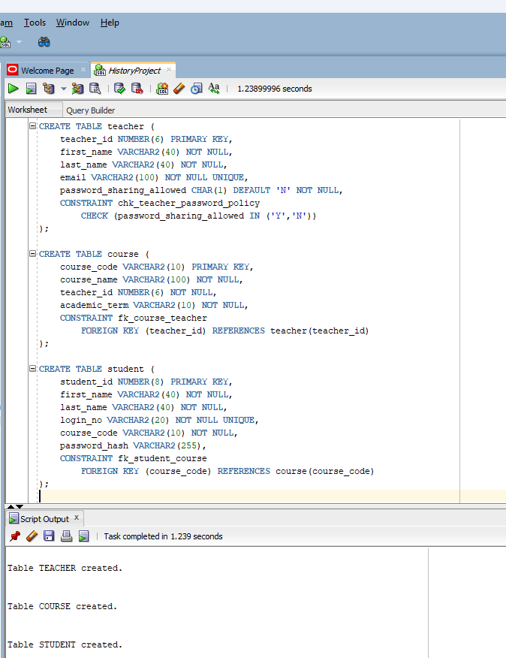
Figure 1 Created tables: Teacher, Course, Student

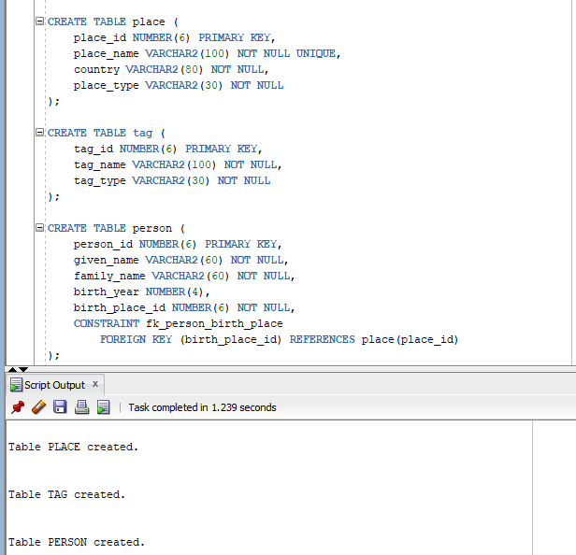
Figure 2 Created Tables: Place, Tag, Person

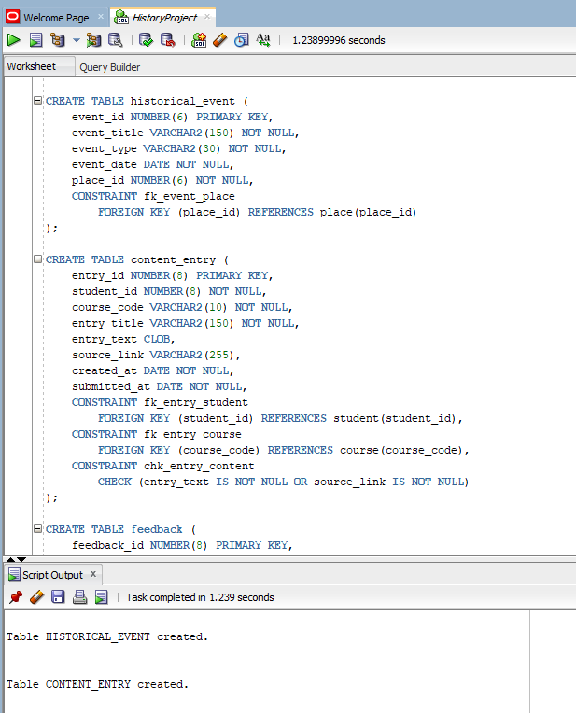
Figure 3 Created Tables: historical_event and content_entry
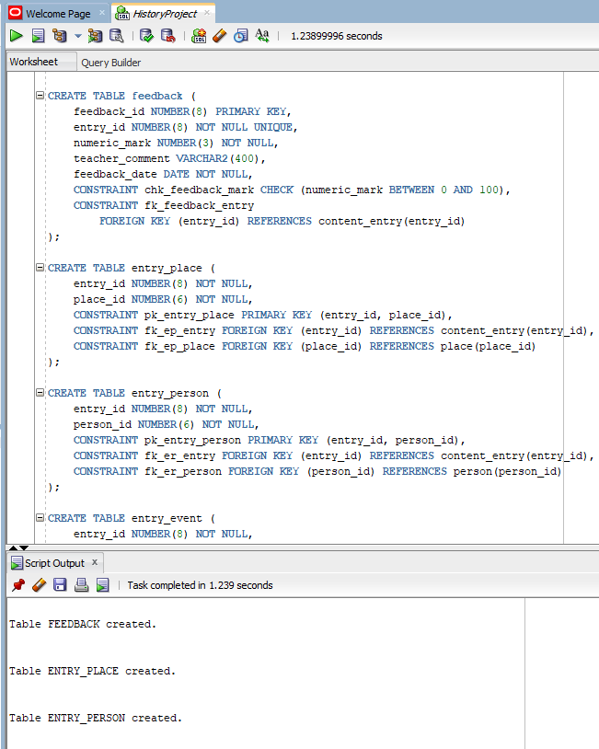
Figure 4 Created Tables: feedback, entry_place, entry_person
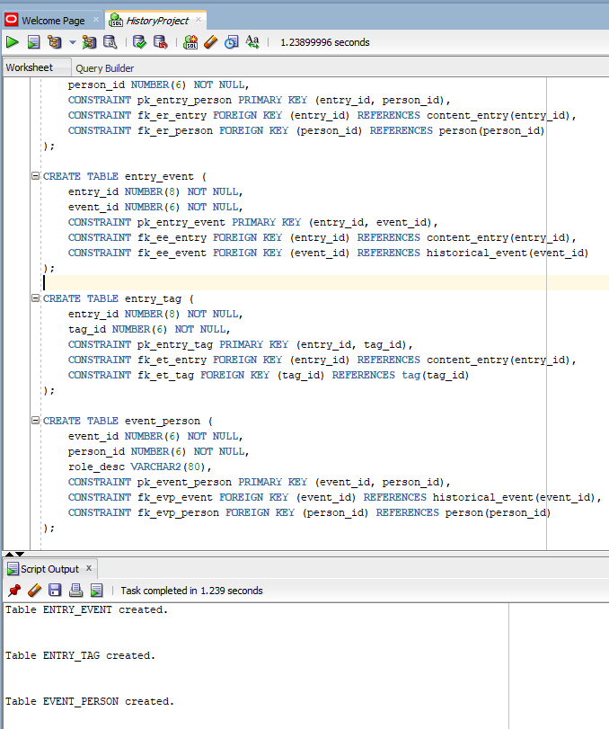
Figure 5 Created Tables: entry_event, event_tag, event_person
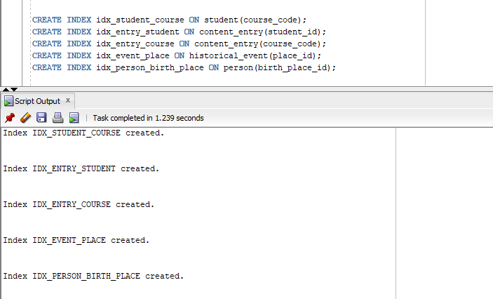
Figure 6 Created Indexes
Important robustness features include the password policy check on TEACHER, the numeric mark range check on FEEDBACK, the NOT NULL and UNIQUE constraints on identity fields, and the content-entry check that prevents empty submissions.

2.2 Insertion Plan and Test Data Strategy
A correct insertion order is essential because the schema contains several foreign-key dependencies. The loading plan used in this report is shown below.

Step | Tables | Reason
1 | TEACHER, PLACE, TAG | Independent parent/reference tables with no incoming foreign keys.
2 | COURSE, PERSON, HISTORICAL_EVENT | These depend on TEACHER or PLACE.
3 | STUDENT | Depends on COURSE.
4 | CONTENT_ENTRY | Depends on STUDENT and COURSE.
5 | ENTRY_PLACE, ENTRY_PERSON, ENTRY_EVENT, ENTRY_TAG, EVENT_PERSON | Associative tables depend on previously inserted parent rows.
6 | FEEDBACK | Depends on CONTENT_ENTRY and is loaded last because it represents teacher review.
To illustrate, the core tables were filled with at least ten rows and the junction tables were filled with the necessary amount of records to demonstrate the chosen queries. The dataset was purposely created to have overlapping places, people and events to ensure that joins, grouping and subqueries yield non-trivial results.
Identity-style rows with names of teachers, student login numbers, email addresses and text of feedback were initially pre-generated in an online data-generation workflow, then hand-curated to ensure that the resulting dataset was historically coherent. This curations was required since the queries chosen rely on significant overlaps between individuals, locations, events and tags as opposed to random values.
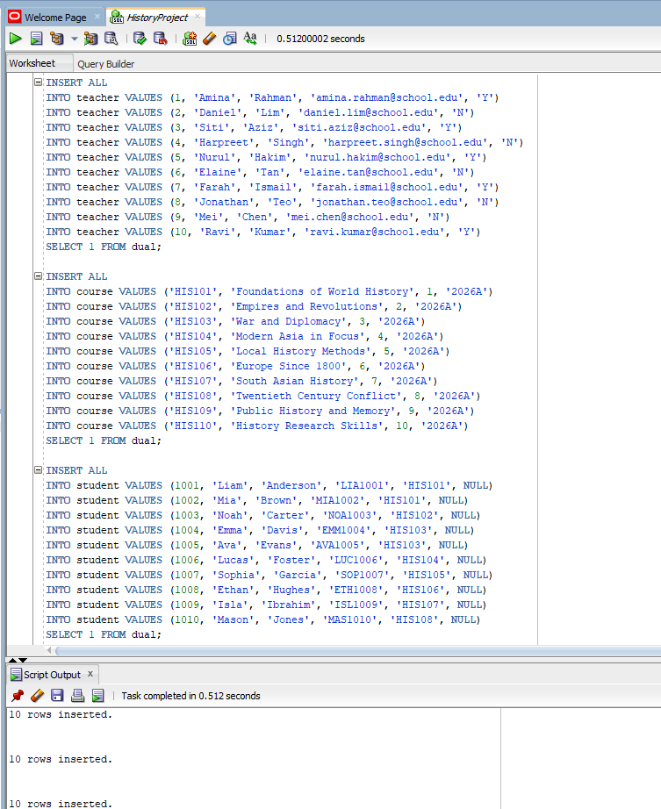
Figure 7 Inserted values into teacher, course, student
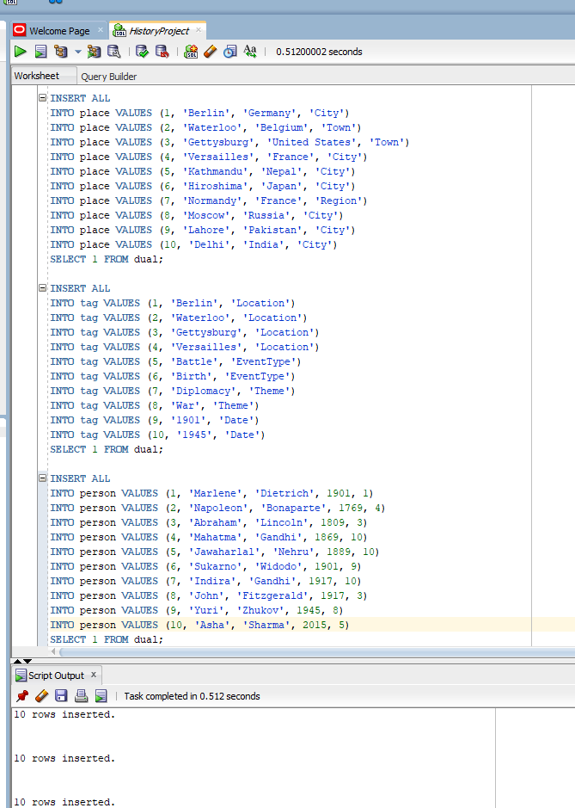
Figure 8 Inserted Values into place, tag, person
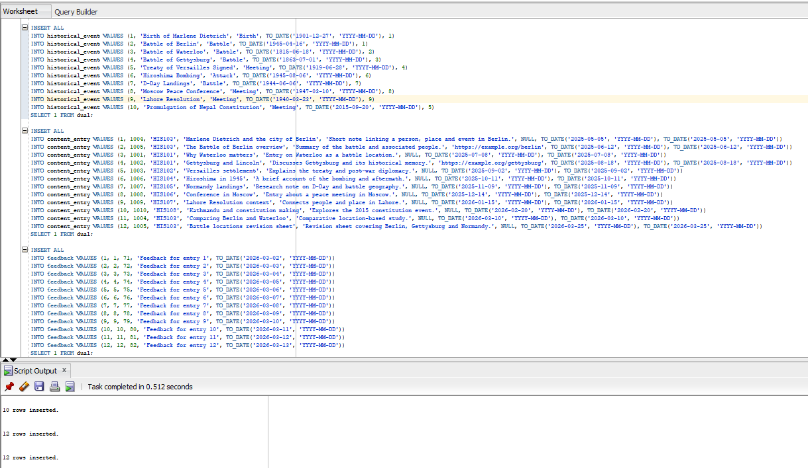
Figure 9 Inserted values into historical_event, content_entry and feedback
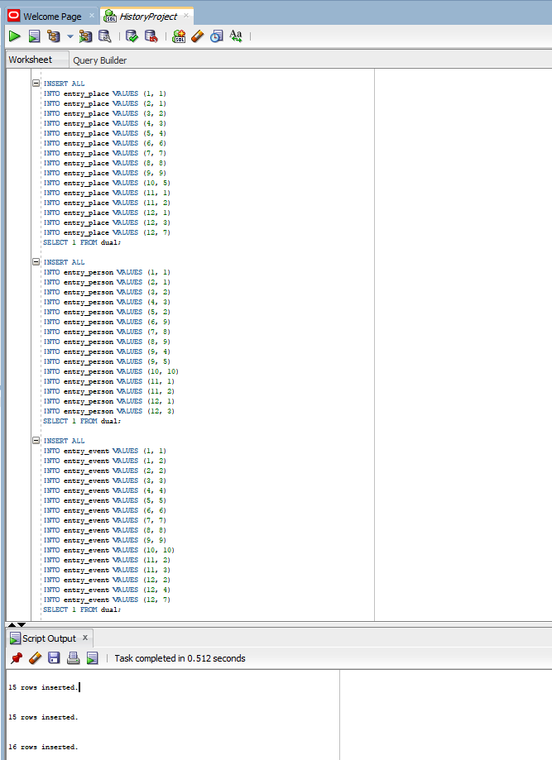
Figure 10 Inserted values into entry_place, entry_person and entry_event
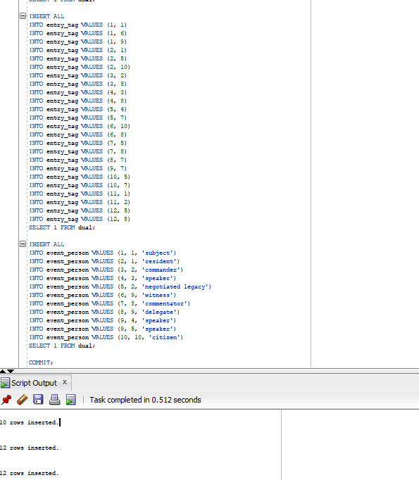
Figure 11 Inserted values into entry_tag and entry_person

Table | Record Count
TEACHER | 10
COURSE | 10
STUDENT | 10
PLACE | 10
TAG | 10
PERSON | 10
HISTORICAL_EVENT | 10
CONTENT_ENTRY | 12
FEEDBACK | 12
ENTRY_PLACE | 15
ENTRY_PERSON | 15
ENTRY_EVENT | 16
ENTRY_TAG | 24
EVENT_PERSON | 11

3. SQL Queries Selected from List A
The four queries implemented below have been selected to illustrate the necessary types of SQL: joins, ORDER BY, GROUP BY/HAVING and subqueries. Where the brief explicitly needed a value supplied by the user, it was implemented as a runtime prompt.

A1 - Joining tables
Purpose: Enumerate the students that have typed information about places.
This query is a combination of STUDENT, CONTENT_ENTRY, ENTRY PLACE and PLACE. The DISTINCT key eliminates unintentional duplication in which the student can make more than one reference to the same place at different records
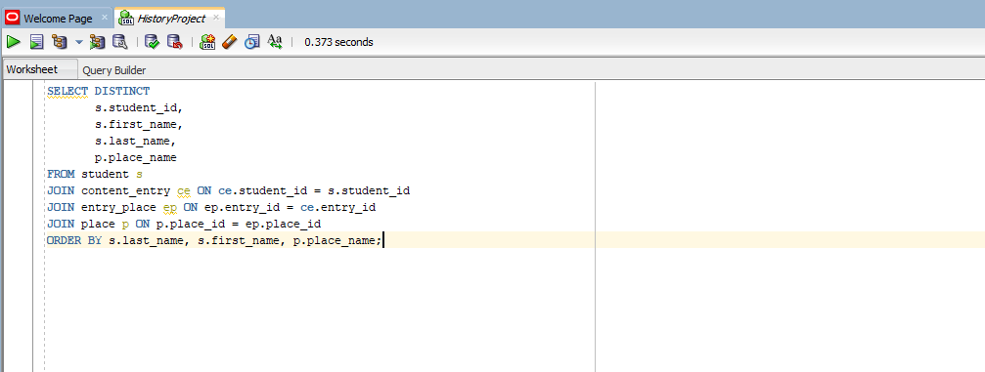
Figure 12 SQL statement for A1.
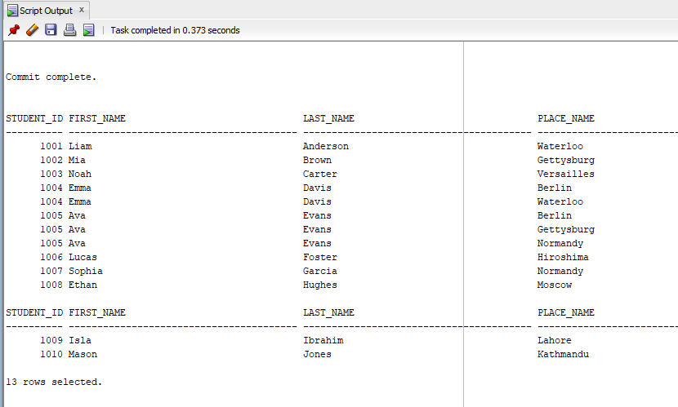
Figure 13 . Expected result produced by A1 on the populated dataset
Interpretation
The production proves that the database is able to trace back every place mentioned to the student that posted it on his/her content entry. This proves that the relationship between STUDENT, CONTENT_ENTRY, ENTRY_PLACE and PLACE is functioning properly and that the system can be trusted to recognize the students who have posted historical content on places. This can be significant to academic monitoring and assessment, as teachers should check student engagement, make sure that research topics are turned in and relate place-based content with the appropriate learner.

A2 - ORDER BY
Objective: Display events by a certain year that is keyed in at runtime and sorted by date of event.
The query takes in a runtime parameter as the year, and then orders the found events in ascending time order. It can be handy with a teacher who wishes to look at the historical activity on a yearly basis.
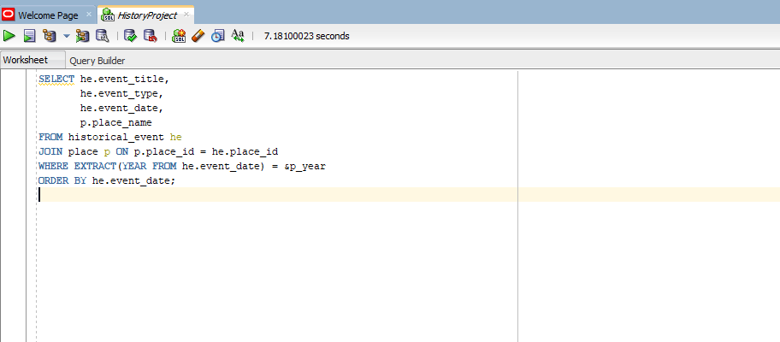
Figure 14 SQL statement for A2
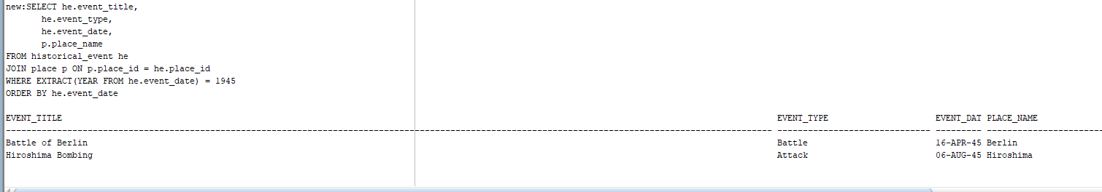
Figure 15 . Expected result produced by A2 on the populated dataset.
Interpretation
The outcome shows that the query is able to properly filter by the year entered by the user and display the events in chronological order. In the input year 1945, the output gives the list of the output by the date order of events: Battle of Berlin, then Hiroshima Bombing. This proves that the runtime parameter, as well as the ORDER BY clause, are working as expected and users can analyze historical events in a particular year in a concise way in a time-based order.

A3 - GROUP BY ... HAVING
Objective: Enlist the entries of students in a class, sorted by surname, of entries in the previous year.
The query will use course code as a query filter and a moving one-year window of date, which will group the records together by the surname and the HAVING will be used to only present the group which satisfies the given condition.
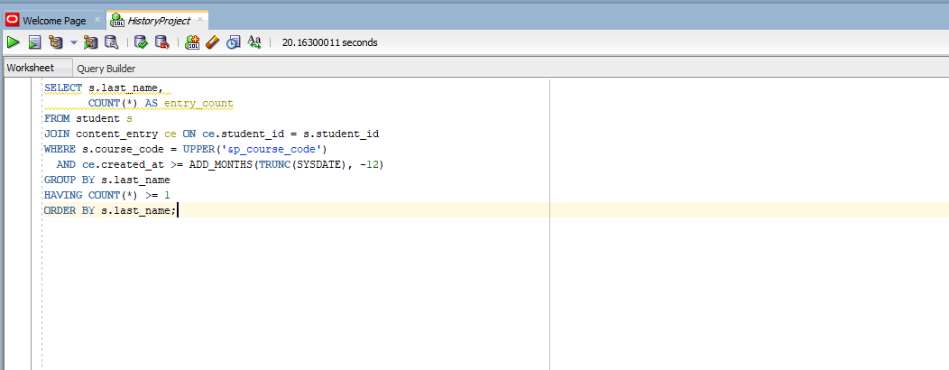
Figure 16 SQL statement for A3
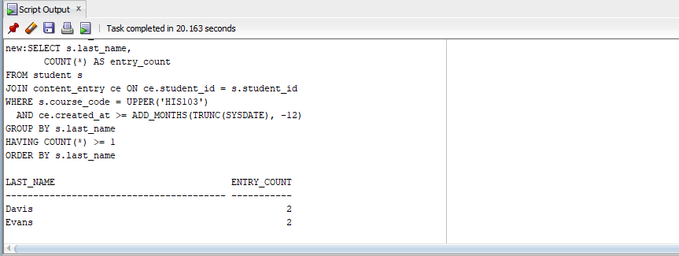
Figure 17 . Expected result produced by A3 on the populated dataset
Interpretation
The output is a confirmation that the query has the right filtering of the entries based on the course and time period and that it aggregates them based on the surname and the HAVING condition is used to only give out the qualifying groups. In course HIS103 last year, the outcome was that two students (Davis and Evans) with the surname submitted two entries. This shows that the logic of grouping and counting is operational and teachers can be able to determine how much student input there is in a classroom over a specified period.

A4 - Sub-queries
Objective: Find at least two locations where there is someone born, and a battle related to the same location.
This is accomplished with two nested subqueries: one of them finds places that present themselves as the place of birth of a person, and the other place finds battle events. The intersection is retrieved in the outer query.
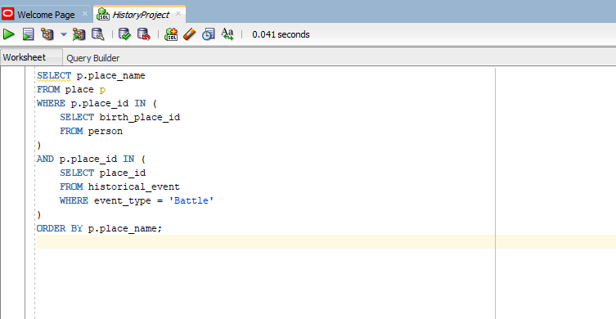
Figure 18 SQL statement for A4.
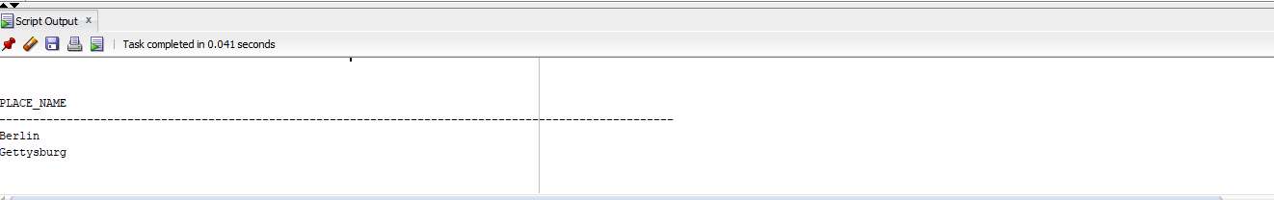
Figure 19 . Expected result produced by A4 on the populated dataset.
Interpretation
The output confirms that the query is correct and correctly gets the correct places that satisfy both of the conditions at the same time, in the sense that they are listed in the row of the person table as a birthplace and in the row of the historical_event table as the location of a battle. Berlin and Gettysburg (in the sample dataset) meet both of these criteria, proving that the subqueries and their intersection logic are working as expected. This is to make sure that the system is able to correctly retrieve locations which have a historical value in various ways.

4. Detailed Evaluation of the Completed Work
In general, the database can fulfill the functional requirements of the brief well. The modelling perspective has been the best where separation of student submissions and reusable historical reference data is concerned. That choice prevents duplication and enhances more searches and renders the schema extensible. As an example, the same location may have many records, may be a place of origin, it may even be the location of an event without being saved multiple times.
There is also a good level of implementation in terms of integrity. The design incorporates the primary keys and the foreign keys throughout, all many-to-many relationships are resolved explicitly and the validation rules are utilized in those cases where the business meaning is evident. They are: the mark-range check, password-sharing policy check, uniqueness of the login numbers and email address, and the rule against submitting empty content. These options will minimize bad data in the database level instead of depending fully on the web application.
Second strength is query suitability. The chosen queries are not artificial extensions, they are the extensions of the teaching use case. A1 helps track location-based work to individual pupils, A2 helps search by chronology, A3 helps report by class across time and A4 shows that the schema can be used to provide more powerful historical inferences using set-based logic and subqueries. Due to the normalisation of the schema, such queries are understandable and logically correct.
However, there are certain drawbacks. To begin with, the current model presupposes a single course being taken by students and a single place where the event is to take place. Students in a larger production system may have many classes in which they may be enrolled, and some events may be across location or date ranges. Second, a tag model is intentionally generic. This would assist with flexibility, although, a tighter controlled vocabulary or hierarchical taxonomy would enhance the consistency in searches. Third, passwords will be stored as a hash field in the data design; in a running application, salting, reset tokens, audit log and access-control roles would also be necessary to provide secure authentication.
The test dataset is sufficient to do coursework evaluation, but would have to be significantly bigger to do performance tuning. Additional Oracle capabilities might be introduced in production, such as sequences or identity columns to generate keys, indexes on high-frequency search columns, triggers to track audit trails, views to support teacher reporting and stored procedures to support common insert/update operations. These improvements can be achieved at the same platform due to the SQL capabilities in Oracle (Oracle, 2023a).
Overall, the work meets the criteria of the distinction level quite well as it shows a consistent modelling process, proper relational mapping, proper placement of foreign-keys, 3NF, and a sensible SQL implementation. The design is not only functional, but also defensible, extensible and to the educational use case. This is why it ought to do well in comparison with published marking scheme.

5. Conclusion
Part 2 converted the validated design into a working Oracle database implementation with a structured insertion plan, representative test data as well as four solutions to the required SQL queries in List A. The practical work done portrays good usage of constraints, relational joins, ordering, aggregation, subqueries and evaluation and proves that the database is not only applicable in coursework, but it can be further extended later.

References
Connolly, T. and Begg, C. (2015) Database Systems: A Practical Approach to Design, Implementation, and Management. 6th edn. Harlow: Pearson.
Oracle (2023a) SQL Language Reference 23c. Available at: https://docs.oracle.com/en/database/oracle/oracle-database/23/sqlrf/sql-language-reference.pdf
Oracle (2023b) Using Subqueries. Available at: https://docs.oracle.com/en/database/oracle/oracle-database/19/sqlrf/Using-Subqueries.html
Oracle (2023c) INSERT. Available at: https://docs.oracle.com/en/database/oracle/oracle-database/18/sqlrf/INSERT.html
Oracle (2018) Aggregate Functions. Available at: https://docs.oracle.com/en/database/oracle/oracle-database/18/sqlrf/Aggregate-Functions.html

