FACULTY OF ENGINEERING, BUILT ENVIRONMENT & INFORMATION TECHNOLOGY
Bachelor of Information Technology (Hons)
TCS4494 Advanced Database
Coursework Submission

The History Project
  - Part 1: Data Modelling
Student Name
Module | TCS4494 Advanced Database
Semester | Jan-April 2026
Coursework Title | The History Project
Deliverable | Standalone Part 1 report (.docx)
Component | Data Modelling
Work Type | Standalone coursework section

Table of Contents
1. Introduction 3
2. Assumptions and Design Decisions 3
3. Data Modelling 5
3.1 Conceptual Data Model 5
3.2 Physical Data Model 7
3.3 Normalisation Check 9
4. Conclusion 11
References 11

Table of Figures
Figure 1 Conceptual data model for The History Project. 6
Figure 2 Physical data model and relational mapping. 7

1. Introduction
The short outlines an online learning platform of history where the instructors will develop courses, enrol the students, set them history homework, and evaluate the work submitted by the students. Students post and add text-based or link-based historical information and the teacher marks and comments each post using numerical mark. The main data issue is that every record can concurrently touch on various historical concepts, particularly people, places, dates and event types. An effective design must thus be able to facilitate the flexible searching without causing duplication or update anomalies.
This report provides a database that overcomes that difficulty by differentiating between core business entities (teacher, course, student, content entry, feedback, place, person and historical event) and reusable reference data (tag) and associative structures which solve many-to-many relationships. The outcome is a scalable schema which supports data integrity, maintainability and query performance.
This is an independent Part 1 report on the coursework analysis and modelling phase of the coursework. It describes all the design assumptions, the rationale behind the entity and relationship structure and gives the physical relational mapping on which the implementation is to be built.

2. Assumptions and Design Decisions
Since the specification is deliberately open ended, the following assumptions were made to eliminate ambiguity and allow a solid implementation.
ID | Assumption | Design Rationale
A1 | One teacher owns one course in the submitted design. | According to the specification, a course is established by a history teacher and students are added. An accountability does not get obscured with more than one teacher per course, nor does the brevity of the course justify it.
A2 | Each student belongs to exactly one current course. | The brief is always about a course code being given to a student and the work against that course is recorded.
A3 | A student account is created before first login, but password_hash may be null until the first password is set. | This corresponds with the requirement that the pupils are requested to add a password when they are using it first.
A4 | Teacher-level policy controls whether password sharing is allowed. | According to the short statement this is at the discretion of the school/teacher. An indication of a teacher policy is thus stored.
A5 | A content entry must contain text, a source link, or both. | It helps avoid empty submissions, as well as retain the briefs' rule of text or links only.
A6 | A single entry may reference multiple places, people, events and tags. | History homework usually involves a number of interrelated ideas, necessitating M:N relationships.
A7 | Historical events occur at one primary location and on one event date. | This is enough to the chosen queries and makes the entity of the event brief.
A8 | A person has one recorded birthplace in this educational dataset. | This enables queries based on birthplace without causing an undue complication.
A9 | Each entry can receive at most one formal feedback record. | Each entry has a set of one numerical mark and comment described in brief.
A10 | The delivered schema targets 3NF and prioritises referential integrity over denormalised convenience. | This directly helps in the evaluation criteria on proper mapping, foreign keys and normalisation.
A11 | No shared USER supertype or additional sub-class hierarchy is implemented. | There are identifiers, permissions and business rules associated to teacher and student roles. The model will be much more straightforward by retaining them as distinct entities and will not lead to unnecessary generalisation.

3. Data Modelling

3.1 Conceptual Data Model
The conceptual ER model represented in figure 1 has a crow-s-foot interpretation. The entities only display the primary keys, as per the requirements of the brief. The model separates between core working entities and the past reference entities required to conduct searches and analysis.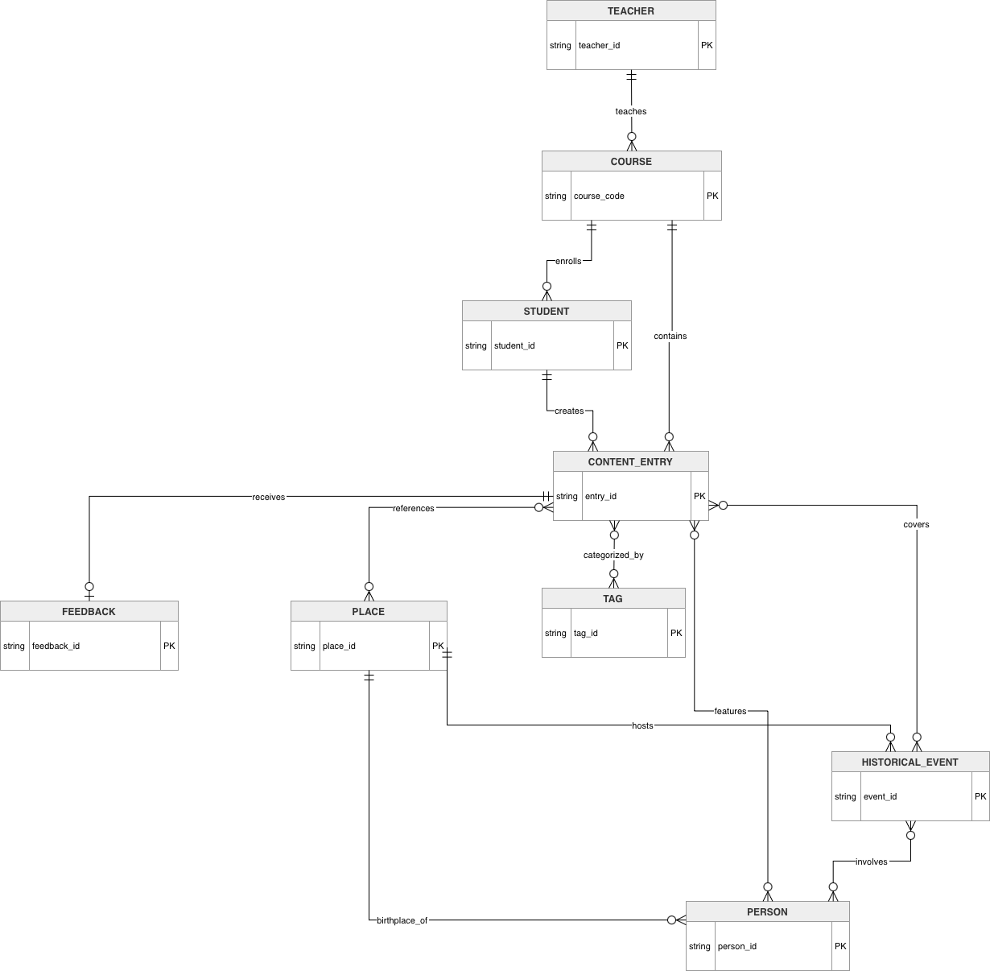
Figure 1 Conceptual data model for The History Project.
The cardinality options are not random. The teacher has numerous courses, a course has numerous students and a student is capable of making numerous content entries. A content entry may have many tags assigned, as well as may refer to many places, people and historical events, hence the four many-to-many links about CONTENT_ENTRY. The place entity is also the reference to the two entities, PERSON (birth place) and HISTORical event (event location).
It is a total participation as required by the business rule. An example is that each student has to be a member of a course, each item of content a member of a student and course and each historical event has to take place somewhere. The feedback is optional in terms of content entry since the entry can be made prior to the teacher marking it.

3.2 Physical Data Model
The conceptual model can be mapped to a relational schema that has 13 tables. ENTRY_PLACE, ENTRY_PERSON, ENTRY-EVENT and ENTRY-TAG resolve the many-to-many relationships, and EVENT-PERSON. The physical model containing primary keys, foreign key and data types are summarised in figure 2.
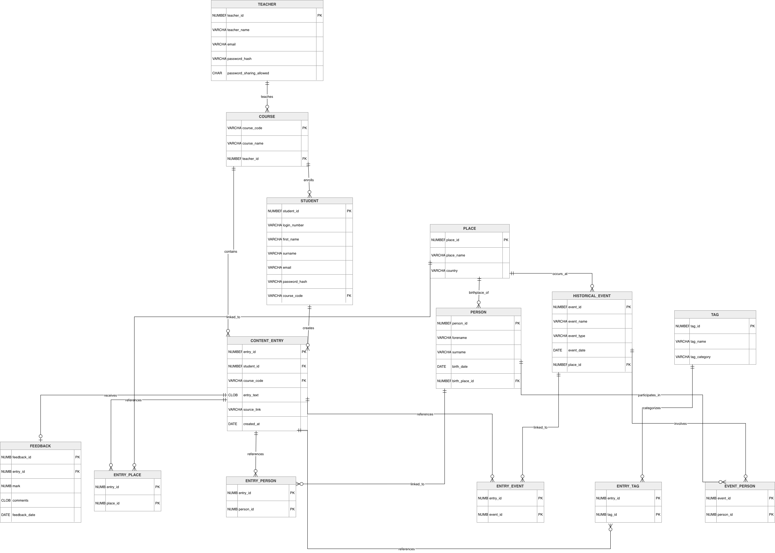
Figure 2 Physical data model and relational mapping.
Table 1 provides a concise data dictionary for the implemented tables.
Table | Primary Key | Main Foreign Keys | Purpose | Minimum Test Rows
TEACHER | teacher_id | - | Stores teacher account and password-sharing policy. | 10
COURSE | course_code | teacher_id | Stores courses created by teachers. | 10
STUDENT | student_id | course_code | Stores student identity, login number and course membership. | 10
PLACE | place_id | - | Stores standardised locations used by entries, people and events. | 10
TAG | tag_id | - | Stores reusable search tags and tag categories. | 10
PERSON | person_id | birth_place_id | Stores people referenced in historical content. | 10
HISTORICAL_EVENT | event_id | place_id | Stores event name, type, date and location. | 10
CONTENT_ENTRY | entry_id | student_id, course_code | Stores each student submission. | 12
FEEDBACK | feedback_id | entry_id | Stores mark and teacher comment for an entry. | 12
ENTRY_PLACE | entry_id, place_id | entry_id, place_id | Resolves entry-place M:N references. | 15
ENTRY_PERSON | entry_id, person_id | entry_id, person_id | Resolves entry-person M:N references. | 15
ENTRY_EVENT | entry_id, event_id | entry_id, event_id | Resolves entry-event M:N references. | 16
ENTRY_TAG | entry_id, tag_id | entry_id, tag_id | Resolves entry-tag M:N references. | 24
EVENT_PERSON | event_id, person_id | event_id, person_id | Resolves event-person M:N associations. | 11

3.3 Normalisation Check
The schema is constructed to meet with the Third Normal Form (3NF). To begin with, the atomic attributes are contained in every table thereby rendering the design to be 1NF. Second, each non key attribute is dependent upon the entire primary key; this is more than usual in the associative tables, where there is no non key attribute dependent on a subset of a composite key. Third, transitive dependencies have been eliminated by isolating the independent entities like PLACE, TAG, PERSON and HISTORical_event instead of replicating the information within the CONTENT entry.
Normal Form | Evidence in this design | Result
1NF | No repeating groups; all attributes are single-valued and atomic. | Achieved
2NF | Composite-key tables contain no partial dependency. | Achieved
3NF | Non-key attributes depend only on the key, the whole key and nothing but the key. | Achieved
This structure is therefore consistent with standard relational design guidance for eliminating redundancy and update anomalies (Connolly and Begg, 2015).

4. Conclusion
Part 1 defined a consistent data model of The History Project by putting the brief into a series of clear assumptions, an organized conceptual ER design and a relational physical model. The resulting schema settles the necessary many-to-many relationships, assigns foreign keys properly and shows adherence to 3NF, which provides a good basis on which to implement the database.

References
Connolly, T. and Begg, C. (2015) Database Systems: A Practical Approach to Design, Implementation, and Management. 6th edn. Harlow: Pearson.

