Canterbury Institute of Management (CIM)  ASSESSMENT COVER SHEET |  |  |  |  | 
- Personal Details
Student ID | Given Name(s) |  | Surname | Email Address
1. CIM11727 | Ranjana |  | Bhandari | ranjanabhandari26@gmail.com
2. CIM11728 | Asmita |  | Adhikari | CIM11728@ciom.edu.au
3. CIM11219 | Bibek |  | Kumar Pakhrin | tamangbibek192@gmail.com
4. CIM11617 | Nishan |  | Regmi | nishanregmi76@gmail.com
Campus | Canterbury Institute Of Management, Darlinghurst, Sydney
Course Title and Code | HOST303 Contemporary Issues in Tourism and Hospitality
Assessment Title | AT2 Group Written Report & Presentation
Due Date & Time | 11.59 pm Sunday, Week 10
Course Lecturer/Tutor Name: DR Andrew LE |  | Assessment Word Count (if applicable): 2331
- Student Declaration
By signing and submitting this cover sheet, I/we declare that:
- This assessment submission is my/our own work unless otherwise acknowledged (including the use of generative AI tools) and is in accordance with the Institute’s Academic Integrity and Honesty Policy available on the website.
- No part of this assessment has been submitted previously for advanced standing or academic credit in this or any other course.
- I/we certify that we have not given a copy or have shown a copy of this assessment item to another student enrolled in the course, other than members of this group.
- I/we are aware that the Lecturer/Tutor of this assessment may, for the purpose of assessing this assessment task communicate a copy of this assessment task to a plagiarism checking service to detect possible breaches of academic integrity, for example, plagiarism, recycling, cheating, contract cheating, or unauthorised use of generative AI (which may then retain a copy of the item on its database for the purpose of future investigation).
Signature: | RB |  | Date: | 9th April, 2026
Signature: | AA |  | Date: | 9th April, 2026
Signature: | BP |  | Date: | 9th April, 2026
Signature: | NR |  | Date: | 9th April, 2026

The Rise of Culinary Tourism:
Shaping the Future of the UAE F&B / Restaurant Sector

Country: United Arab Emirates (UAE)
Sector: Food and Beverage / Restaurant sector
Trend link: https://www.dubaidet.gov.ae/en/research-and-insights/-/media/files/faqs/gastronomy-report-2024-det.pdf

Executive Summary
Culinary tourism is becoming a strategic demand driver of hospitality destinations and in the United Arab Emirates (UAE) it is becoming a focal point of the future of the food and beverage (F&B) / restaurant industry. The recent data demonstrate that Dubai has been able to maintain high levels of visitation up until 2025 and 2026, and gastronomy offer gained popularity in the emirate thanks to the MICHELIN Guide, global rankings, and destination-focused campaigns (Dubai Department of Economy and Tourism [DET], 2025a, 2026a; MICHELIN Guide, 2025). The emergence of culinary tourism is important to the UAE restaurants since it alters the content of what tourists search, the amount that consumers will pay, and the criteria that they will apply to determine authenticity, sustainability, and service.
The report concludes that culinary tourism brings about growth prospects in terms of premiumization, destination branding and cultural differentiation, and exacerbates pressures in terms of consistency, labour capability, authenticity management and resource utilization. The most noticeable impacts occur across the five dimensions in provenance-led product quality, digitally mediated customer behaviour, staff upskilling and AI-assisted productivity, design-led servicescapes and more interpretive service encounters. It is best to create provenance and traceability into menus, invest in experience-driven digital discovery, apply AI to eliminate low-value administrative tasks instead of eliminating hospitality, create spaces that express local identity and circularity, and redesign story-based service rituals to translate Emirati and multicultural food culture to global guests.

Table of Contents
Executive Summary 2
1 Introduction 4
2 Findings and Analysis 4
2.1 Overall impact of the rise of culinary tourism on the UAE F&B / restaurant sector 4
2.2 Impact on service/product quality 5
2.3 Impact on customer expectations/behaviour 5
2.4 Impact on staff productivity 6
2.5 Impact on physical environment 7
2.6 Impact on service encounter 8
3 Recommendations 9
4 Conclusion 9
5 References 11

List of Figures
Figure 1 . UAE diners’ willingness to pay more for personalized restaurant experiences. 7
Figure 2 Old Dubai heritage setting used to market cultural food-tour experiences. 10

Introduction
Culinary tourism is defined as a type of tourism where food-related experiences are involved in destination selection, involvement and recall. It is most appropriately seen not as a niche activity in 2025/2026 but as a demand trend of the future, connected with the experience economy, a digital influence and the search of culturally distinctive consumption (Pine and Gilmore, 1999, Magdy and Hassan, 2025). In the case of hospitality, this trend has long-term sustainability consequences since it may enhance economic resilience, cultural conservation and destination competitiveness, and environmental and operational strains should growth be pursued without the ability, authenticity and resource discipline (Elkington, 1997; Chatzopoulou & Gorton, 2025).
In line with AT1, the UAE is still the country of interest in this report and the trend is only analyzed using the F&B / restaurant industry. This is to assess the role that the emergence of culinary tourism is playing in determining the sustainability of the sector using five dimensions; service/product quality, customer expectation and behaviour, staff productivity, physical environment and service encounter. It synthesises academic sources with government, industry and destination sources, basing the analysis on the 2024 DET gastronomy report as an indication of context but using more recent sources, 2025/2026, as the primary source of evidence.

Findings and Analysis

Overall impact of the rise of culinary tourism on the UAE F&B / restaurant sector
The emergence of culinary tourism is proving to be a strategically consequential attribute to UAE restaurants since food is now a fundamental tool that the destination uses in transforming visitation into spend, differentiation and repeat advocacy. In the first half of 2025, Dubai received 9.88 million overnight visitors and 19.59 million in 2025, respectively, and as a destination, gastronomy was listed as a reason to visit and invest internationally (DET, 2025b, 2026b). Simultaneously, the gastronomic status of Dubai got stronger due to the 2025 MICHELIN Guide, which included 119 restaurants with over 35 types of cuisine and provided the first three-starred restaurants of the city (MICHELIN Guide, 2025). Old Dubai food tours being ranked among Lonely Planet’s top ten for “A Fine Way to Dine” in 2026; included as part of the Dubai tourism department’s "A Fine Way to Dine" promotion in 2026; and the selection of Abu Dhabi as host to The World’s Fifty Best Restaurants 2026 (Government of Dubai Media Office, 2025; DET, 2026; The World’s Fifty Best Restaurants, 2026).
The opportunity is not just higher covers, in the Triple Bottom Line viewpoint. Culinary tourism has the potential to diversify revenue streams, transform local ideas and transform cultural foods into destination value. However, the dangers exist. The oversaturated restaurant industry in Dubai implies that the influx of visitors does not necessarily generate sustainable profitability, and authenticity may be undermined when the culinary identity is diminished to spectacle instead of presenting it in a representation by stakeholders (Associated Press, 2025; Chatzopoulou and Gorton, 2025). The sustainability of the sectors is thus reliant on whether restaurants can transform the increase in demand to unique, culturally plausible and operationally disciplined business models.

Impact on service/product quality
Culinary tourism increases the perceived quality level since the customers who patronize the restaurants not only base their assessment on taste, but also on authenticity, provenance, innovation, food safety and value congruence. The logic of SERVQUAL recommends that the issue of reliability and assurance is complicated when the guests anticipate not only perfect performance but also culturally significant menus (Parasuraman et al., 1988). Recent studies on gastronomy also indicate that the culinary value is enhanced when the quality of food is linked to authenticity, transparency, and environmental responsibility (Jung and Yoon, 2025; Vukolić et al., 2025). This in UAE changes quality management to rely solely on imported luxury to localized differentiation.
Gerbou in Dubai exemplifies this change. In the 2025 list of the World’s Greatest Places, TIME has recognised the restaurant as roughly 75 per cent of ingredients are sourced locally in the Emirates, the menu of the restaurant has refined Emirati food instead of showcasing it as a static heritage (Time, 2025). This is important since the culinary tourists are becoming more and more rewarding restaurants that are place transforming products. The service/product dilemma in the case of UAE operators is thus twofold: how to ensure the high quality of the services offered on the global market and at the same time incorporate locality, traceability and cultural integrity into the menu creation.
Best practice adaptation would involve provenance on menus, supplier narratives, and verifiable food-safety and allergen communication, and seasonal innovation, organized around local foods. Emirati producers and chefs should also cooperate with restaurants to ensure that the authenticity is co-created instead of being branded.

Impact on customer expectations/behaviour
The digitally discovered, socially verified and experience-based customer experience is being transformed into the restaurant demand by culinary tourism. And expectation-disconfirmation reasoning applies here, whereby the visitors come in with pre-established expectations, via platforms, influencers and destination marketing, and the experience on-site is determined to be more or less than that mediated promise. SevenRooms (2025) in the UAE discovered that almost all diners utilize online information to learn about new restaurants (99%), 74% of diners utilize social media to discover new restaurants and one in four diners discover restaurants through influencers. Scholarly sources also indicate that foodstagramming and foodie influencers have a direct impact on creative food-tourism involvement, visit intention and restaurant behaviour (Magdy & Hassan, 2025; Deng et al., 2025).

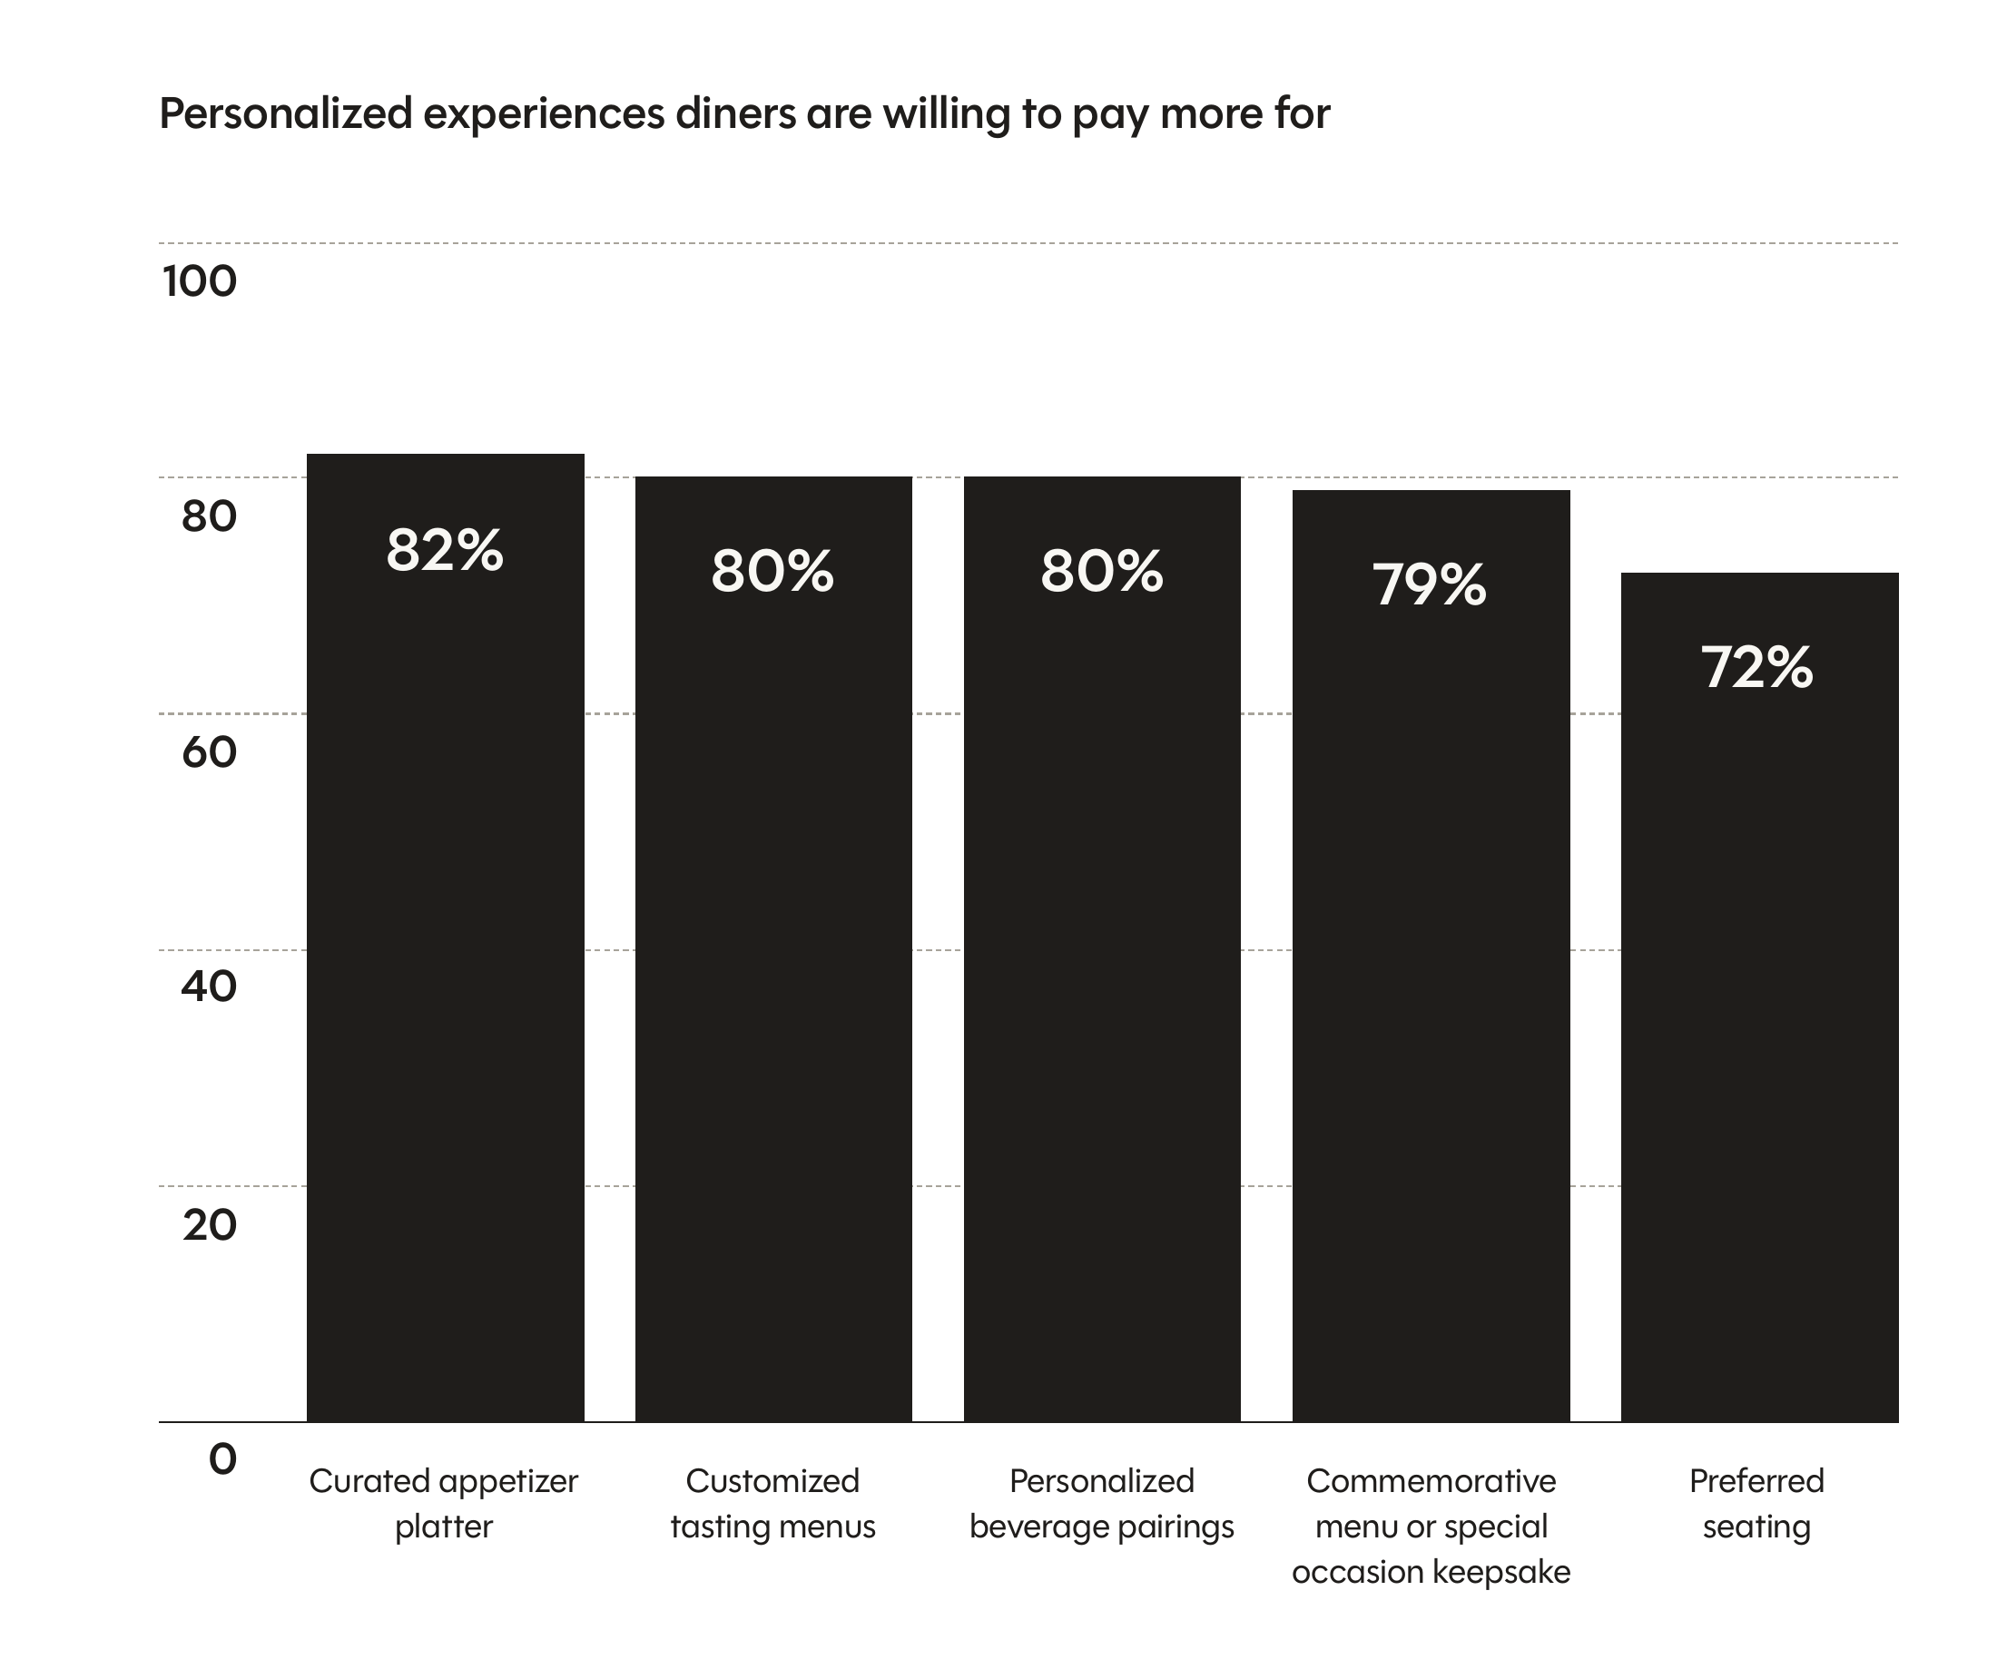
Figure 1 . UAE diners’ willingness to pay more for personalized restaurant experiences.
Source: SevenRooms. (2025). 2025 UAE Restaurant Industry Trends (p. 20). https://go.sevenrooms.com/rs/519-YNM-008/images/2025-UAE-Restaurant-Trends-SevenRooms.pdf
Figure 1 supports the connotation of this change which is premium. The UAE diners are not just window shopping to have meals; they can spend more to get crafted appetizers, tailor-made tasting menus and personalized beverage pairings. This implies that culinary tourists are demanding more immersion, personalization and experiences to share, as opposed to merely making a purchase. This behavioural shift is illustrated in the Old Dubai food tours where the food experience is packaged with exploration of heritage and storytelling layers and turned into a memory-filled cultural experience (Government of Dubai Media Office, 2025).
The suggestions regarding this dimension are managing the discovery and delivery simultaneously: restaurants need to invest in high-quality digital material, direct booking experiences, data-driven personalization and ethical influencer relationships that reflect the experience. Bookable micro-experiences (chef counters, tastings, pairings and neighborhood-led itineraries) should also be created by the operators, as culinary tourists are proving willing to part with money on experiences that look unique and intimate.

Impact on staff productivity
Culinary tourism enhances the intensity of labour as the product in the restaurant is made more interpretive, customized and multilingual. According to human-capital logic there is no way to reduce productivity in service settings to table turns only but it is also about the deployment of skills, the transfer of knowledge and the creation of value in the process of live interaction. SevenRooms (2025) reveals the tension in an evident way: 96 percent of the consumers in the UAE appreciate personal communication with the staff and the story behind the dish, but the operators indicate time pressure and inconsistency as an obstacle to personalization. At the same time, 87% of operators already utilize AI and all claim to be experiencing benefits, meaning that technology is becoming a necessity to eliminate low-value friction and not front-line hospitality (SevenRooms, 2025).
Task redesign is therefore a key determinant of productivity to UAE restaurants catering to culinary tourists. The personnel ought to spend fewer hours on repetitive reservation, messaging and review-management tasks and additional hours on clarification, cultural interpretation, and restoration. The policy agenda of the UAE Restaurant Group (2026) that prioritises building capabilities, sustainable initiatives and development of tourism clusters supports this orientation since the performance of the sector is viewed as an operational and ecosystem problem (UAE Restaurant Group, 2026).
Specific suggestions include AI to communicate with the guests before arrival, triage reservation and menu-storytelling, and investing in multilingual education, cultural awareness, and cultural intelligence. Measuring productivity by guest conversion, quality and sentiment of reviews, not merely percentage of labour cost to the restaurant should also be employed by restaurants since culinary tourism compensates enriched encounters and not necessarily faster encounters.

Impact on physical environment
The servicescape theory is used to explain why culinary tourism impacts more than interiors whereby the physical surroundings is used as a visible means in which brand meaning, sensory experience and destination identity is carried (Bitner, 1992). This is driving operators in the restaurant industry in the UAE to design which conveys place as opposed to generic luxury. Pan et al. (2025) suggest that the multisensory gastronomic spaces reinforce sustainable destination attraction since the cues around the space determine memory, values perception and responsible behaviour. This is particularly true in the UAE, as the restaurants are becoming more and more competitive as destination spaces.

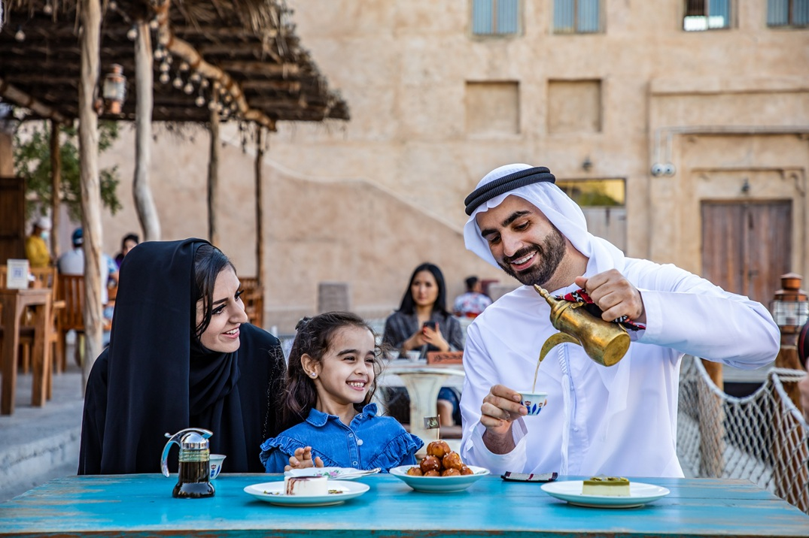
Figure 2 Old Dubai heritage setting used to market cultural food-tour experiences.
Source: Government of Dubai Media Office. (2025, October 22). Old Dubai food tours named among Lonely Planet’s top global experiences for 2026. https://mediaoffice.ae/en/news/2025/october/22-10/old-dubai-food-tours-named-among-lonely-planets-top-global-experiences-for-2026
Gerbou once again provides a good example of the UAE. The fact that it has been rated as one of the most beautiful restaurants in the world in 2025 indicates that design has now become a part of market value, and adaptive reuse, local material and Emirati visual references support the dining offer (Al-Khodairi, 2025). Figure 2 extrapolates the observation on the visitor side: the Old Dubai food-tour environment illustrates how built heritage, informal streetscape and vernacular atmosphere can increase authenticity and work to render food tourism legible prior to a dish being served. These cues are a sign of place to culinary tourists.
Restaurants are thus recommended to focus on adaptive reuse, locally resonant materials, visible elements of sustainability, layouts and designs that encourage storytelling, tastings and engagement between chefs and guests. It does not aim at themed adornment, but instead, logical placemaking that connects ambience, culture and operational sustainability.

Impact on service encounter
Culinary tourism shifts the service experience of functional exchange to cultural performance guided. According to service encounter theory and experience economy, value is co-created in the process of encounter, emotion and interpretation particularly when the guest is interested in meaning, in addition to consumption (Pine and Gilmore, 1999). This translates into employees in UAE restaurants being more demanded to clarify the ingredients, put dishes into context, tailor rituals, and overcome international cultural distance. Jung and Yoon (2025) demonstrate that the mediating role of the concept of perceived value on behavioural outcomes in gastronomic environments, whereas Luong and Nguyen (2025) demonstrate that the mediating role of gastronomic experiences in destination loyalty is achieved when food, image and engagement are linked.
The service implication is evident: storytelling is not an option anymore. A tasting menu at Trésind Studio, a sustainability-focused account at LOWE or a heritage-focused discussion on an Old Dubai tour all are based on human mediation to project cuisine into destination meaning. Once such an experience seems to be pre-determined, hurried or culturally superficial, the restaurant will not be performing as a culinary-tourism resource despite technically good food.
In this vein, operators must formalize story-of-dish, maintain high-touch greeting and farewell rituals and tie digital touchpoints to in-restaurant recognition in a way that it makes personalization feel seamless, as opposed to disjointed. In culinary-tourism market, authenticity will be either confirmed or lost in the encounter.

Recommendations
The discussion indicates that the UAE restaurant industry needs to react to culinary tourism by initiating a sustained action plan to sustainability as opposed to single marketing strategies. To start with, a provenance-based product approach, which connects menu engineering to local sourcing, traceability, food-safety guarantee and seasonal adjustment, should be embraced by the operators. This will safeguard quality as also enhance cultural and environmental credibility.
Second, restaurants need to redesign their marketing approach by abandoning the promo-based approach towards marketing to an experience-based approach to demand. On-site experiences that are well represented must be incorporated into digital discovery, direct bookings, customer relationship management, and collaboration with influencers to track its performance in terms of repeat visits, amount spent per visitor and quality of the reviews and not only in terms of reach.
Third, augmented productivity, rather than automated hospitality should be sought in the sector. Repetitive messaging of the guests need to be handled by AI, booking administration and retrieval of guest data by AI, whereas multilingual communication, cultural interpretation, upselling and recovery skills should be invested in as the workforce. This helps in safeguarding service depth and enhances efficiency.
Fourth, servicescape needs to be regarded as strategic infrastructure in the development of a restaurant. Local materiality, adaptive reuse, visible circular practices and layouts to conduct tastings or interact with the chef should be given priority since culinary tourists perceive the physical environment to be an aspect of authenticity.
Lastly, cluster-based collaboration should be scaled by the public and private stakeholders. UAE Food Cluster (Ministry of Economy and Tourism, 2026), DET campaigns, restaurant-group and culinary events initiatives need to work together to create local ideas, minimize food waste and enforce gastronomy facing the community. This will assist the industry to tap into visitor demand without compromising on the commercial, cultural and environmental pillars upon which sustainability is based.

Conclusion
Culinary tourism is defining the future of the UAE F&B / restaurant industry as it transforms what restaurants need to deliver and the way they need to generate sustainable value. The trend creates a chance based on destination branding, high experiences and cultural distinction, yet elevates the standard of genuineness, work ability, design integrity and work discipline. The most powerful implications can be seen in each of the five dimensions; product quality needs to be provenance-led, customer journeys experience-led, productivity technology-enabled, physical environments place-communicating, and service encounters translating cuisine into meaning. Culinary tourism can empower resilience in case the UAE restaurants react by integrating well-coordinated capability building and innovation.

References
Al-Khodairi, H. (2025, June 19). This Emirati restaurant has officially been selected for the World’s Most Beautiful Restaurants list 2025. Condé Nast Traveller Middle East. https://www.cntravellerme.com/story/this-emirati-restaurant-has-officially-been-selected-for-the-worlds-most-beautiful-restaurants-list-2025
Associated Press. (2025, July 3). Dubai’s booming restaurant scene is feeling the heat of high costs and high failure rates. AP News. https://apnews.com/article/9ed3b9ab9d12748880bfef889e4c5784
Bitner, M. J. (1992). Servicescapes: The impact of physical surroundings on customers and employees. Journal of Marketing, 56(2), 57-71. https://doi.org/10.1177/002224299205600205
Chatzopoulou, E., & Gorton, M. (2025). Authenticity, ethnic restaurants and the wider impact of tourism research. Annals of Tourism Research, 115, 104046. https://doi.org/10.1016/j.annals.2025.104046
Deng, B., Shi, C., & Wong, I. A. (2025). Can attractiveness and credibility characteristics of foodie travel influencers predict tourist followers’ attitude and behavior? A social influence perspective. Journal of Vacation Marketing. Advance online publication. https://doi.org/10.1177/13567667251386467
Dubai Department of Economy and Tourism. (2025a). Dubai gastronomy industry report 2024. https://www.dubaidet.gov.ae/en/research-and-insights/-/media/files/faqs/gastronomy-report-2024-det.pdf
Dubai Department of Economy and Tourism. (2025b, July 10). Tourism performance report January - June 2025. https://www.dubaidet.gov.ae/en/research-and-insights/tourism-performance-report-june-2025
Dubai Department of Economy and Tourism. (2026a, April 3). Dubai launches ‘Dubai, a fine way to dine’ culinary campaign. https://www.dubaidet.gov.ae/en/newsroom/press-releases/a-fine-way-to-dine
Dubai Department of Economy and Tourism. (2026b, February 9). Dubai welcomes 19.59 million visitors in third record year. https://www.dubaidet.gov.ae/en/newsroom/press-releases/dubais-tourism-industry-achieves-third-successive-record-breaking-year
Elkington, J. (1997). Cannibals with forks: The triple bottom line of 21st century business. Capstone.
Government of Dubai Media Office. (2025, October 22). Old Dubai food tours named among Lonely Planet’s top global experiences for 2026. https://mediaoffice.ae/en/news/2025/october/22-10/old-dubai-food-tours-named-among-lonely-planets-top-global-experiences-for-2026
Jung, H., & Yoon, H. H. (2025). Sustainable gastronomy as a driver of senior travelers’ experience, perceived value, and behavioral outcomes. Sustainability, 17(23), 10634. https://doi.org/10.3390/su172310634
Luong, T.-B., & Nguyen, D. T. A. (2025). Culinary involvement, cultural background, and culinary expertise: Interconnections between destination pull factors, culinary destination image, culinary experiences, and loyalty in Hanoi’s culinary tourism. Tourism and Hospitality Research. Advance online publication. https://doi.org/10.1177/14673584251330185
Magdy, A., & Hassan, H. (2025). Foodstagramming unleashed: Examining the role of social media involvement in enhancing the creative food tourism experience. Tourism and Hospitality Research. Advance online publication. https://doi.org/10.1177/14673584241311295
MICHELIN Guide. (2025, May 22). Two restaurants awarded three MICHELIN stars for the first time in Dubai at The MICHELIN Guide Ceremony 2025. https://guide.michelin.com/hk/en/article/michelin-guide-ceremony/three-michelin-stars-dubai-2025
Ministry of Economy & Tourism. (2026). Food sector. https://www.moet.gov.ae/en/food-sector
Pan, Q., Zhang, Q., Tian, J., Zhang, J., & Chen, Q. (2025). Embodied multisensory gastronomic experience and sustainable destination appeal: A grounded theory approach. Sustainability, 17(16), 7296. https://doi.org/10.3390/su17167296
Parasuraman, A., Zeithaml, V. A., & Berry, L. L. (1988). SERVQUAL: A multiple-item scale for measuring consumer perceptions of service quality. Journal of Retailing, 64(1), 12-40.
Pine, B. J., II, & Gilmore, J. H. (1999). The experience economy: Work is theatre and every business a stage. Harvard Business School Press.
SevenRooms. (2025). 2025 UAE Restaurant Industry Trends. https://go.sevenrooms.com/rs/519-YNM-008/images/2025-UAE-Restaurant-Trends-SevenRooms.pdf
The World’s 50 Best Restaurants. (2026, February 9). The World’s 50 Best Restaurants 2026 heads to Abu Dhabi. https://www.theworlds50best.com/stories/News/the-worlds-50-best-restaurants-2026-heads-to-abu-dhabi.html
Time. (2025, March 13). Gerbou: World’s greatest places 2025. https://time.com/collections/worlds-greatest-places-2025/7263114/gerbou/
UAE Restaurant Group. (2026, January 21). UAE Restaurant Group holds first board meeting of 2026 featuring briefing from the Ministry of Economy & Tourism. https://uaerg.ae/uae-restaurant-group-holds-first-board-meeting-of-2026-featuring-briefing-from-the-ministry-of-economy-tourism/
Vukolić, D., Radišić, M., Radišić, M., Pevac, D., Milošević, S., & Gajić, T. (2025). The role of food safety in sustainable gastronomic tourism: Insights from farm-stay tourist experiences. Agriculture, 15(18), 1966. https://doi.org/10.3390/agriculture15181966

