AWS Cloud Migration Plan for Horizon College
Task 1: Project Design Document
Role: AWS Cloud Architect Consultant

Table of Contents
1. Preliminary Assessment 3
2. Migration Plan 4
2.1 Governance, Compliance and Security Controls 4
3. Cost-Benefit Analysis 5
4. Risk Assessment 6
5. Timeline and Milestones 6
6. Conclusion and Future Recommendations 7
References 8
Appendix A: AI Use Declaration 10

List of Figures
Figure 1 Proposed AWS cloud architecture for Horizon College. 4
Figure 2 Gantt chart for the proposed 14-week implementation. 9

List of Tables
Table 1 Current-state issues and selected AWS services. 4
Table 2 Phased migration plan. 5
Table 3 . Indicative AWS operational cost estimate. 6
Table 4 Risk assessment matrix 8

1. Preliminary Assessment
Horizon College is presumed to be a medium-sized K-12 school having a single campus in Sydney, approximately 1,000 students, 120 staff and a small ICT team. Its current environment has a spreadsheet student enrolment or legacy database, individual learning and communication tools, paper archives and on-premise file servers. The business issues are: duplicated student records, less access by the parents, slowness in accessing the past records, poor disaster recovery and inconsistent permissions. The cloud architecture thus focuses on the controlled access, secure storage, scalable web services and auditable governance over an easy lift-and-shift of files. This analysis is based on the logic of readiness to the AWS Cloud Adoption Framework and the Amazon Web Services pillars of security, reliability, operational excellence, performance efficiency, cost optimisation and sustainability (Amazon Web Services, 2024; Amazon Web Services, 2026a).
The AWS Sydney Region is used by the target state to enhance data locality and low latency by Australian users. A custom VPC is allocated in two Availability Zones. The Application Load Balancer is located in the public subnets and the EC2 application servers and Amazon RDS are located in private subnets. Amazon S3 supports the digital archive with versioning, SSE-KMS encryption and lifecycle rules; staff, student and parent can access the digital archive via MFA with Amazon Cognito or federation with the school identity provider; IAM roles and least privilege; and auditability and recovery through CloudTrail, CloudWatch and AWS Backup. The architecture incorporates AWS recommendations regarding the use of the private networking, database availability, S3 encryption and IAM best practice (Amazon Web Services, 2026d; Amazon Web Services, 2026f; Amazon Web Services, 2026g; Amazon Web Services, 2026i).
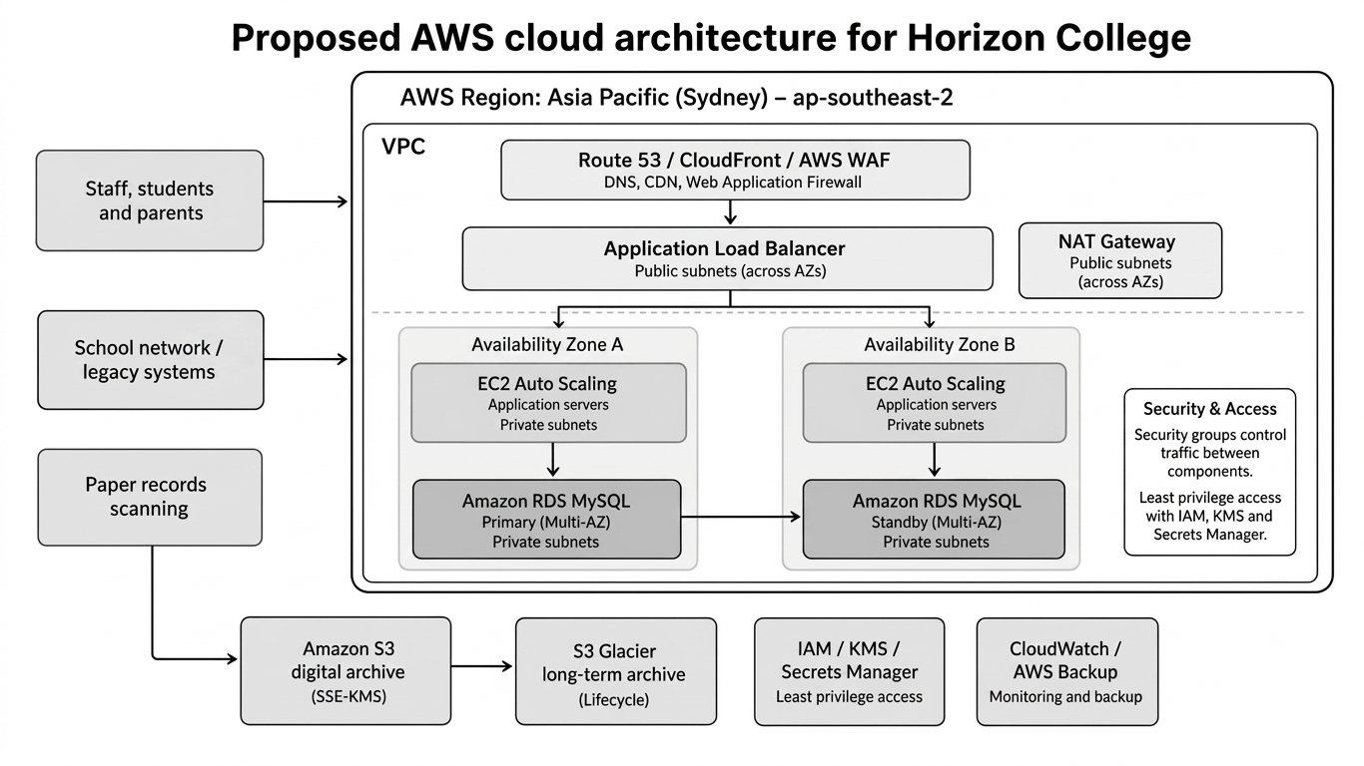
Figure 1 Proposed AWS cloud architecture for Horizon College.
Source: Author.

Table 1 Current-state issues and selected AWS services.
Current issue | AWS design response | Reason
Disconnected enrolment and records | Web portal on EC2 Auto Scaling, ALB and RDS MySQL | Centralises student data and supports controlled scalability.
Paper archives | S3 digital archive with metadata, versioning, SSE-KMS and lifecycle rules | Improves search, durability and retention control.
On-prem file server risk | S3, AWS Backup and private network access | Reduces single-site failure and supports remote access.
Weak access control | Cognito/federation, IAM roles, MFA and CloudTrail | Protects student data and records accountability.

2. Migration Plan
Migration must be done in a gradual fashion since education data contains ID information of minors and cannot be migrated in an unmanaged big-bang cutover. The evaluation stage catalogs apps, users, and file shares, paper record types, data owners, and retention policies and integrations. At this stage, the Horizon College must categorize data into public, internal, confidential and sensitive student data and determine which data to retire, retain, rehost, replatform or refactor, using the AWS 7Rs. Literature on cloud migration cautions that the failures tend to occur due to security, data-access, compliance, financial and management risks, and baselining and governance should come first before technical migration (Maniah et al., 2022; Amazon Web Services, 2026b).
The foundation stage makes individual production, test and logging accounts, a VPC, subnets, route tables, security groups, KMS keys, backup policies, the CloudTrail logging and cost tags. The next stage is the build stage that deploys the portal, enrolment workflows, RDS schema, S3 archive buckets and APIs. The process of data migration begins with enrolment record cleansing and deduplication followed by importing the structured data into RDS and scanning paper files into S3 with explicit metadata. The full cutover should be preceded by migrating a pilot group (e.g. Year 7 enrolments). The legacy systems are read-only to ensure business continuity, and nightly backups, a rollback plan and go-live weekend with stakeholder approval make sure that the business continues. This solution embraces the advantages of the cloud in learning and recognizes potential obstacles to cloud adoption like user training, privacy and continuity (Ali, Wood-Harper and Mohamad, 2018; Lahiri and Moseley, 2013).
Table 2 Phased migration plan.
Phase | Weeks | Main deliverables
Assess and baseline | 1-2 | Inventory, data classification, dependency map, risk register.
Set up AWS foundation | 3-4 | Accounts, VPC, IAM, logging, KMS, backup and budget alerts.
Build target services | 5-7 | Portal, RDS database, S3 archive, load balancer and security controls.
Migrate and validate data | 8-9 | Cleaned enrolment data, scanned archive pilot and reconciliation report.
Deploy and go live | 10-13 | UAT, training, DNS switch, rollback decision and production release.
Optimise | 14 | Monitoring review, cost tuning and post-implementation report.

2.1 Governance, Compliance and Security Controls
The governance along with compliance and security control are addressed through these controls: 2.1 Governance.
The process of governance will be steered by a small migration steering group that will include the principal or this representative, ICT manager, business administration lead, privacy officer and a representative of the teacher/parent. Records retention rules and incident escalation pathway should be accepted by the group before the production data is transferred and data classification scheme and access model are approved, as well as the criteria of cutover. To be compliant, Horizon College ought to capture the purpose of collecting each type of student and parent data, who may access it, how long it is stored as well as how to delete or correct any information. This is in line with the expectations of Australian Privacy Principle of open management, collection, use, disclosure, security, access and correction of personal information (Office of the Australian Information Commissioner, 2026).
The landing zone should be designed with security controls, as opposed to being added post go-live. MFA is used with staff and administrators, least-privilege IAM roles, S3 block public access, KMS-managed encryption key, private database subnets, no direct public access to RDS, vulnerability patching, centralised logs and immutable backups are all baseline controls. Administrative access must be by name, not shared and emergency access must be reviewed monthly. These measures are in line with AWS IAM guidance, shared responsibility model and emphasis on the Essential Eight on limiting administrative privileges, patching and MFA and regular backups (Amazon Web Services, 2026d; Amazon Web Services, 2026h; Australian Cyber Security Centre, 2023).

3. Cost-Benefit Analysis
The following estimate is approximate and should be confirmed in AWS Pricing Calculator prior to a purchase since prices are different depending on the location, usage and support plan (Amazon Web Services, 2026c). The initial year design based on a sensible first-year workload on a small production load consists of two EC2 instances behind an ALB, one RDS MySQL Multi-AZ database, 2 TB of S3 archive storage, monitoring, backups and modest outbound traffic. It costs more than a single virtual machine, yet is not going to recreate the same single point of failure that Horizon College already possesses. Monthly operating cost should be around US$530-US870 excluding tax, support and scanning labour (one time). Intelligent-Tiering and lifecycle policies can help in saving cost of the archives since old records cool down (Amazon Web Services, 2026e).
Table 3 . Indicative AWS operational cost estimate.
Cost item | Estimated monthly cost | Optimisation method
EC2, EBS and ALB | US$150-US$260 | Right-size instances; use Savings Plans after stable usage.
RDS MySQL Multi-AZ | US$180-US$260 | Start small; reserve capacity after baseline monitoring.
S3 archive and backup | US$80-US$130 | Use lifecycle, Intelligent-Tiering and retention policies.
Security, logging and data transfer | US$120-US$220 | Use budgets, tags, VPC endpoints and log retention rules.
Total | US$530-US$870 | Review monthly through Cost Explorer and budget alerts.

Availability, remote access and records governance are benefits worth the migration provided the school attaches importance to the same. It can save resources in server refreshing, server maintenance, manual search of records, handling and exposing of the backup media, and downtime exposure. Non-monetary rewards encompass parent access to the campuses when it is not in use, consistent security policy, less difficult reporting to the staff and recovery after the disturbance of the campuses. Tagged billing should be used to review the cost case quarterly to ensure that the school is able to relate spend to the enrolment, archive, portal and security functions.
It is also a matter of the cost-benefit case that deals with over-customisation. Standard authentication, database and storage patterns should first be used in the portal and only after it has been adopted successfully advanced features should be added. This helps avoid paying unused capacity and help to minimize the risk of support to a small ICT team. One-time project expenses such as the cost of scanning the archives, data cleansing, user training and any professional services, where appropriate, should be accepted independently of continuous costs of running the cloud system to help the school differentiate between the cost of migration investment and running cost.

4. Risk Assessment
Risks are not only technical, the greatest risks are related to student privacy, change management and governance. According to the AWS Shared Responsibility Model, the AWS is in charge of securing the cloud infrastructure whereas Horizon College is in charge of data classification, application configuration, identity, choice of encryption and user permissions (Amazon Web Services, 2026h). The controls must also correspond to the Australian Privacy Principles, as well as the Essential Eight and in particular, MFA, patching, limited administration and frequent backups (Office of the Australian Information Commissioner, 2026; Australian Cyber Security Centre, 2023).
Table 4 Risk assessment matrix
Risk | Likelihood / impact | Mitigation
Student data exposure through misconfiguration | Medium / High | Private subnets, S3 block public access, SSE-KMS, least privilege, WAF and access reviews.
Data loss or corrupt migration | Medium / High | Backup before migration, checksums, reconciliation reports and staged pilot migration.
Portal outage during cutover | Medium / Medium | Blue-green deployment, rollback window, DNS plan and RDS Multi-AZ.
Cost overrun | Medium / Medium | Budgets, tagging, instance right-sizing, lifecycle policies and monthly review.
Low adoption by staff or parents | Medium / Medium | Role-based training, quick guides, helpdesk support and pilot feedback.
Vendor lock-in and compliance gaps | Low / High | Document data export formats, retention rules, contracts and annual compliance review.

Not only documented but also tested, data protection. Prior to go-live, the ICT team is to restore a sample RDS backup, restores deleted S3 objects, check CloudTrail events of administrator work and test a simulated portal outage. School leadership should agree on recovery targets; e.g. the portal can have a recovery target of four hours during school days, whereas archive retrieval can accept a longer recovery time. This quantifies continuity and does not allow the school to think that being able to back up equals disaster recovery preparedness.

5. Timeline and Milestones
The 14 week schedule is feasible since it will allow time to do governance, build, migration, testing, training and controlled go live. The milestones include: approved baseline Week 2, secure AWS foundation Week 4, working prototype of portal Week 7, data migration pilot Week 9, UAT sign-off Week 11, cutover readiness Week 13 and stabilisation review Week 14. The Challenge Lab proof-of-concept can correlate to this timeline: S3 validates the concepts of archive hosting, EC2 validates the concepts of the portal, RDS validates the concepts of database migration, VPC validates the concepts of network segmentation, high availability validates the concepts of scaling, and infrastructure automation validates the concepts of repeatable deployment.
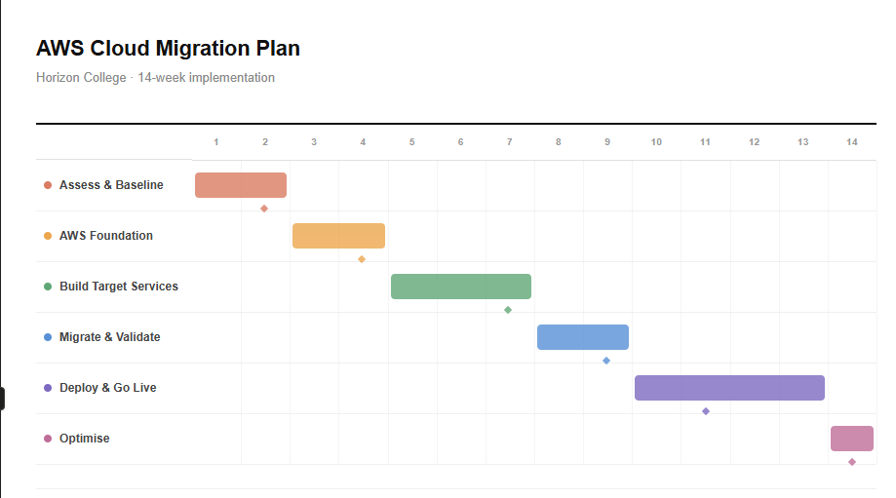
Figure 2 Gantt chart for the proposed 14-week implementation.
Source: Author.

6. Conclusion and Future Recommendations
The design provides Horizon College with a realistic AWS migration journey that will replace the isolated systems with a safe and sound enrolment database, digital archive and central portal. The primary suggestion is to migrate over time, design to secure student information, test disaster recovery prior to the go-live and do not over-provision during the initial term of operation. This can be enhanced by automated infrastructure via CloudFormation or Terraform, automation of retention of archives, quarterly Well-Architected review, analytics dashboard of the enrolment trends and a tested disaster recovery plan in a second location should it be demanded by the risk appetite of the school. After the initial full period of utilisation, these recommendations ought to be revisited to ensure that the actual login trends, volume of archive retrieval, support requests and AWS billing information can inform the subsequent optimisation process.

References
Ali, M.B., Wood-Harper, T. and Mohamad, M. (2018) ‘Benefits and challenges of cloud computing adoption and usage in higher education: A systematic literature review’, International Journal of Enterprise Information Systems, 14(4), pp. 64–77. doi: 10.4018/IJEIS.2018100105.
Amazon Web Services (2024) AWS Well-Architected Framework. Available at: https://docs.aws.amazon.com/wellarchitected/latest/framework/welcome.html (Accessed: 30 April 2026).
Amazon Web Services (2026a) AWS Cloud Adoption Framework. Available at: https://aws.amazon.com/cloud-adoption-framework/ (Accessed: 30 April 2026).
Amazon Web Services (2026b) About the migration strategies. Available at: https://docs.aws.amazon.com/prescriptive-guidance/latest/large-migration-guide/migration-strategies.html (Accessed: 30 April 2026).
Amazon Web Services (2026c) AWS Pricing Calculator. Available at: https://calculator.aws/ (Accessed: 30 April 2026).
Amazon Web Services (2026d) Security best practices in IAM. Available at: https://docs.aws.amazon.com/IAM/latest/UserGuide/best-practices.html (Accessed: 30 April 2026).
Amazon Web Services (2026e) How S3 Intelligent-Tiering works. Available at: https://docs.aws.amazon.com/AmazonS3/latest/userguide/intelligent-tiering-overview.html (Accessed: 30 April 2026).
Amazon Web Services (2026f) Protecting data with encryption. Available at: https://docs.aws.amazon.com/AmazonS3/latest/userguide/UsingEncryption.html (Accessed: 30 April 2026).
Amazon Web Services (2026g) Configuring and managing a Multi-AZ deployment for Amazon RDS. Available at: https://docs.aws.amazon.com/AmazonRDS/latest/UserGuide/Concepts.MultiAZ.html (Accessed: 30 April 2026).
Amazon Web Services (2026h) Shared Responsibility Model. Available at: https://aws.amazon.com/compliance/shared-responsibility-model/ (Accessed: 30 April 2026).
Amazon Web Services (2026i) Subnet route tables – Amazon Virtual Private Cloud. Available at: https://docs.aws.amazon.com/vpc/latest/userguide/subnet-route-tables.html (Accessed: 30 April 2026).
Amazon Web Services (2026j) Amazon EC2 On-Demand Instance Pricing. Available at: https://aws.amazon.com/ec2/pricing/on-demand/ (Accessed: 30 April 2026).
Amazon Web Services (2026k) Amazon S3 Pricing. Available at: https://aws.amazon.com/s3/pricing/ (Accessed: 30 April 2026).
Australian Cyber Security Centre (2023) Essential Eight maturity model. Available at: https://www.cyber.gov.au/business-government/asds-cyber-security-frameworks/essential-eight/essential-eight-maturity-model (Accessed: 30 April 2026).
Lahiri, M. and Moseley, J.L. (2013) ‘Migrating educational data and services to cloud computing: Exploring benefits and challenges’, Educational Technology, 53(1), pp. 20–30.
Maniah, Soewito, B., Gaol, F.L. and Abdurachman, E. (2022) ‘A systematic literature review: Risk analysis in cloud migration’, Journal of King Saud University – Computer and Information Sciences, 34(6), pp. 3111–3120. doi: 10.1016/j.jksuci.2021.01.008.
Office of the Australian Information Commissioner (2026) Australian Privacy Principles. Available at: https://www.oaic.gov.au/privacy/australian-privacy-principles (Accessed: 30 April 2026).

Appendix A: AI Use Declaration
Tool used: ChatGPT (OpenAI)
Purpose of use: AI was used to improve grammar, sentence structure, clarity and formatting.
Reason for use: To improve readability, professionalism, and ensure the report followed an appropriate academic and consultant-style format.
Declaration: AI was used only for editing and refining written expression. All technical analysis, AWS service selection, migration planning, cost estimation, risk assessment, architecture decisions, and final academic judgement were completed and verified by the student.
Example prompt used:
“Please check grammar, improve sentence clarity, and tell me how can I make this report sound more professional without changing the technical meaning.”

