Canterbury Institute of Management (CIM)  ASSESSMENT COVER SHEET |  |  |  |  | 
- Personal Details
Student ID | Given Name(s) |  | Surname | Email Address
1. CIM11219 | Bibek |  | Kumar Pakhrin | tamangbibek192@gmail.com
2.
3.
4.
Campus | Canterbury Institute of Management, Darlinghurst, Sydney
Course Title and Code | MGMT302 Strategic Management
Assessment Title | AT3 Group Written Report and Presentation
Due Date & Time | Written Report: 11.55 pm Sunday, Week 11
Course Lecturer/Tutor Name: |  | Assessment Word Count (if applicable): 2772
- Student Declaration
By signing and submitting this cover sheet, I/we declare that:
- This assessment submission is my/our own work unless otherwise acknowledged (including the use of generative AI tools) and is in accordance with the Institute’s Academic Integrity and Honesty Policy available on the website.
- No part of this assessment has been submitted previously for advanced standing or academic credit in this or any other course.
- I/we certify that we have not given a copy or have shown a copy of this assessment item to another student enrolled in the course, other than members of this group.
- I/we are aware that the Lecturer/Tutor of this assessment may, for the purpose of assessing this assessment task communicate a copy of this assessment task to a plagiarism checking service to detect possible breaches of academic integrity, for example, plagiarism, recycling, cheating, contract cheating, or unauthorised use of generative AI (which may then retain a copy of the item on its database for the purpose of future investigation).
Signature: | BP |  | Date: | 12th April, 2026
Signature: |  |  | Date:
Signature: |  |  | Date:
Signature: |  |  | Date:

Strategy Formulation Plan for Telstra
A Strategic Management Report

Executive Summary
Telstra has a structural strength but strategic tension in which it enters its Connected Future 30. The company enjoys scale, a dominant network, high market coverage and increasing digital infrastructural holdings, but its business is in a highly regulated and mature telecommunications industry where price war, customer loyalty, cyber threat and capital intensity can undermine competitive advantage unless proactively managed. The real question is thus not whether Telstra has assets, but can it convert network leadership to greater value growth without losing financial discipline and trust of the stakeholders.
The analysis concludes that the current business model of Telstra can deal with this challenge effectively as it is a combination of recurring connectivity revenues with enterprise solutions, as well as wholesale activities and infrastructure-based revenues. Its purpose, ambition and FY30 goals are also strategically aligned: they are all customer-focused and provide the company with directions on monetising the network and developing digital infrastructure. But SWOT analysis reveals that these ambitions can only be successful when Telstra simplifies and make compliance and trust stronger, as well as investing capital on the most profitable connectivity adjacencies.
It suggests a more focused connectivity leadership approach that is enabled by four priorities, namely: monetise network quality with premium and programmable connectivity; simplify and rebuild trust with transparent customer experience design; scale digital infrastructure and enterprise security through focused adjacency and partnerships; and drive implementation with disciplined operating leverage, AI-enabled efficiency and balanced-scorecard control.
Properly implemented, the suggested strategy will likely make retention stronger, contribute to the increase of higher-value revenue, increase the capital invested to executing it, minimize execution risk and solidify the status of Telstra as the connectivity and digital infrastructure provider of choice in Australia.

Table of Contents
Executive Summary 3
1 Introduction 5
2 Strategy Formulation Plan 5
2.1 Existing Business Model 5
2.2 Corporate Mission, Vision, and Goals 6
2.3 SWOT Analysis 7
2.4 Strategic Interpretation of SWOT 8
2.5 Functional-Level Strategies 9
2.6 Business-Level Strategy 10
2.7 Corporate-Level Strategy 11
2.8 Strategy Implementation 12
2.9 Monitoring and Control 13
3 Conclusion 13
4 Justification of Chosen Format 14
5 References 15

Introduction
Telstra is the biggest telecommunications and digital infrastructure corporation in Australia, which provides consumers, small businesses, enterprise and government customers with mobile, fixed, data, technology and infrastructure services (Telstra, 2025a). It indicated that at the end of FY25, it had 24.9 million retail mobile services in service with ACCC 2025 infrastructure snapshot also indicating the highest number of mobile sites among Australian network providers (ACCC, 2025b; Telstra, 2025a). Connected Future 30 is thus coming into the picture at a place of scale, but in an industry whose economics are becoming constrained.
This report evolves a strategy formation plan of Telstra in the modern Australian environment. It examines the business model of the company, its corporate mission, vision and goals, main internal and external factors and the strategic implications of the same. It, therefore, suggests interconnected functional, business and corporate strategies, implementation and monitoring suggestions.
The strategic formulation is particularly vital to Telstra at the moment due to the prevalence of competition, the transformation of the NBN environment, the emergence of new models of connectivity based on satellites and devices, the examination of consumer outcomes by regulators, and the centralization of cyber resiliency in the development of trust and value (ACCC, 2025a; Telstra, 2025a). Telstra must not merely be able to share, but to sustain quality of networks, data capability and infrastructure depth to achieve sustainable advantage.

Strategy Formulation Plan

Existing Business Model
The business model of Telstra can be defined as an integrated digital infrastructure and connectivity model. The company is able to generate value based on business model logic, which involves network assets, brand reach, technology capability and scale of distribution into a reliable connectivity, managed services and infrastructure access to various customer groups (Osterwalder and Pigneur, 2010; Teece, 2010). It has main customer groups, which include consumers, small and medium businesses, enterprise and government customers, wholesale partners and infrastructure users. The other complementary asset layers that Telstra works in are retail connectivity, enterprise solutions, wholesale network access, towers and fibre-based infrastructure.
Its value proposition varies across the segments but is based on a similar foundation of: reliable network quality, expansive coverage, reliable service, security and an ever more digital customer experience. Telstra is selling assurance to consumers and small businesses as well as selling voice and data. In the case of enterprise and government customers, value is realized through a combination of connectivity and managed technology, network capacity, security and solution integration. Telstra generates value chiefly based on recurring subscription and services revenues, and other revenues in hardware, wholesale deals, infrastructure revenues and long-term commercial deals (Telstra, 2025a).
This model influences the strategic choices of Telstra in two aspects. On the positive side, it provides the company with an acceptable resource foundation and several monetisation opportunities, which align with resource-based reasoning that assets that are valuable and hard to copy can be used to provide sustained advantaging (Barney, 1991). On the negative side, it is capital intensive and vulnerable to regulatory environment, changes in technology and demand of constant improvement in service delivery. In an advanced market, the model cannot count on the growth by sheer volume. Telstra has thus to monetise quality, minimise operating friction and selective growth of adjacencies where its assets generate economies of scope.

Corporate Mission, Vision, and Goals
Telstra has the goal of creating a connected future to ensure that everyone thrives, and its overall ambition as outlined in Connected Future 30 is to be the first choice of connectivity in Australia (Telstra, 2025a, 2025b). It creates a reasoning, which bridges the social relevance, customer value and shareholder outcomes: the notions of connectivity are introduced as the economic and social utility in the course of which Telstra can be able to justify the premium positioning, infrastructure investment and long-term development.
Telstra has a strong mission and vision in that it is operationalised by a definite strategic architecture. Telstra situates its strategy with three layers - customer engagement, network as a product, and digital infrastructure - with four enablers, including people and culture, technology leadership, sustainability and financial discipline (Telstra, 2025b). The targets that are accompanying are also tangible, such as greater advocacy and brand performance, yearly network enhancement, ongoing cash EBIT growth, mid-single digit cash earnings growth and a 10% underlying ROIC by FY30 (Telstra, 2025b).
On the whole, these business-level aspects are aligned with the competitive landscape and business model in a strategic manner. They understand that the future value will not be based on blind growth but improved customer economics, network monetisation and targeted infrastructure growth. The primary threat is executional: high-level goal statements can only generate value when they are converted into more specific propositions, disciplined capital deployment, trust-conserving behaviour and quantifiable business performance.

SWOT Analysis
Table 1 summarises the key internal and external factors affecting Telstra’s strategic position.
Strengths | Weaknesses
Leading network scale and performance | High capital intensity
Strong brand reach and large mobile base | Organisational and product complexity
Diversified earnings across multiple segments | Legacy systems and service friction
Proven execution in cost control and simplification | Trust and regulatory vulnerability
Opportunities | Threats
Monetise network leadership (premium, programmable connectivity) | Intense competition (Optus, TPG, MVNOs)
Expand digital infrastructure and enterprise security | Regulatory pressure and compliance scrutiny
AI-enabled customer and network optimisation | Technological disruption and new connectivity models
Growing demand for secure connectivity and fibre | Cyber risk, cost pressure and supply chain exposure

Strategic Interpretation of SWOT
The SWOT analysis brings out three strategic issues. The former is monetisation: Telstra has superiority of the network, but superior assets can only result in sustained advantage when it is translated into customer perceived value and price power. The second one is trust and simplicity: Telstra is unable to leverage its size in case regulatory inquiries, service intricacy or cover-up deals undermine customer advocacy. The third one is portfolio focus, not all the adjacent growth opportunities should attract capital in a mature market and therefore Telstra should prioritize those businesses where its assets, capabilities and partnerships complement each other.
Telstra should consider SO strategies to convert strengths in network and infrastructure into differentiated products, WO strategies to engage in digital simplification to rectify complexity, ST strategies to leverage scale and resilience to protect against competition, and WT strategies to enhance compliance and capital discipline where weakness and threat meet (Weihrich, 1982). That is, SWOT does not simply prescribe the diagnosis of the position of Telstra; it is the guidance of the strategic response to positioning towards greater value connectivity, cleaner performance and more discriminating growth.
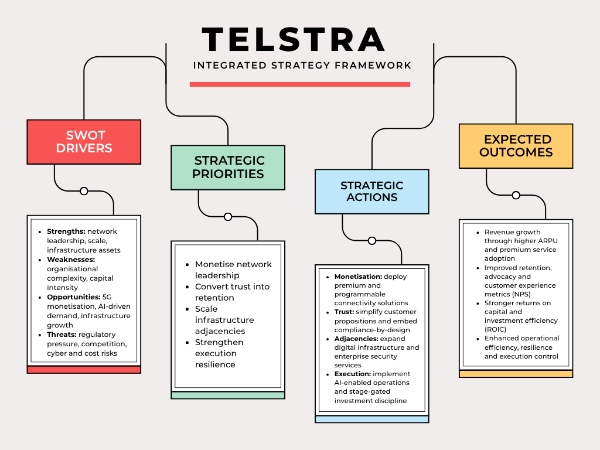
Figure 1 Telstra strategy map linking SWOT drivers, strategic priorities, actions, and expected outcomes
Note. Developed for this report from the analysis of Telstra’s corporate strategy, annual reporting and ACCC market evidence (ACCC, 2025a, 2025b; Telstra, 2025a, 2025b).
Figure 1 summarises how the SWOT analysis translates into strategic priorities, actions, and expected organisational outcomes.

Functional-Level Strategies
Functionally, Telstra is to line-up operations, customer management, technology, people and finance with the above three strategic issues.
The key priorities of operations and network strategy are reliability, automation and monetisation. Telstra must further invest in network quality, although future capex needs to be focused on commercialisable features like programmable bandwidth, quality-of-service controls, enterprise-grade security layers and fibre routes to meet the data demand in the AI era. This is desirable as opposed to capacity investment which is a necessity, yet invisible commercially. The advantage is that it will convert network advantage to revenue and retention more easily; the disadvantage is that it will enforce a more rigid prioritisation of less profitable projects.
Customer/marketing approach needs to be changed to a clear premium-value architecture rather than proliferated products. In the case of the consumer and small business markets, Telstra needs to streamline plan design, minimise unnecessary contacts, proactive service recovery and premium pricing based on reliability, safety and ease as opposed to abstract coverage claims. In the case of enterprise, its recommendation should focus on the outcome based bundling that involves connectivity and managed security assurance and service. This helps to advocate more and reduce churn, but it needs discipline to eliminate legacy offers, and temporary promotion clutter.
Cybersecurity and innovation strategy, digital capability are to be viewed as the growth engines, instead of the back-office functions. The strategy of Telstra already indicates AI-facilitated customer insights and technological leadership; it must now be transformed into real life applications like automating the network, predicting fault fixes, intelligent customer self-service and secure internet connectivity bundling to business customers (Telstra, 2025b). As a product feature and a trust mechanism, cybersecurity must be incorporated.
This change needs to be supported by people and culture strategy including reskilling in AI, cyber, and product management, enterprise solution selling and compliance-by-design. The incentives ought to be moderate between the financial results and the customer, resilience and conduct measures. Stage-gated investment also has to be enforced by finance and governance with specific hurdle rates and active portfolio review to ensure that strategic projects are evaluated based on cash EBIT contribution, return on invested capital and strategic fit.

Business-Level Strategy
Telstra can best adopt a differentiated connectivity leadership with selective value discipline as its business-level strategy. The lowest price should not be the main competitive tool in use by Telstra as it will be underutilising its best resources and it will erode margins. Rather, it ought to be competing by providing the most trusted, reliable and commercially useful connectivity experience in Australia in the consumer, business and enterprise segments and employ digital simplification and cost management to avoid making the premium operationally bloated.
This suggestion is in line with the logic of differentiation that Porter argues is sustainable when based on activities that competitors find difficult to imitate, and the resource-based perspective that advantage is brought about by unique assets and capabilities, as opposed to generic market presence (Barney, 1991; Porter, 1985). In the case of Telstra, the differentiators include network quality, resilience of the services, depth of infrastructure, ability to secure, reach to customers and brand salience. The strategic implication of this is that Telstra needs to defend premium positioning through its flagship brand, seek wholesale and secondary-brand channels to enter into value segments where necessary, and save scarce management attention to categories where differentiated connectivity can be economically advantages.
It is not just higher prices that are expected to be the organisational outcome. It has better customer lifetime value via reduced churn, enhanced advocacy, superior cross-sell to enterprise and digital infrastructure and enhanced resilience to commodity rivalry.

Corporate-Level Strategy
On corporate level, Telstra ought to consider focused adjacency growth as opposed to diversification which is not related. The portfolio must be structured around businesses that strengthen the business economics of connectivity: business leadership in retail, network monetisation, digital infrastructure and secure solutions, enterprise-grade. It involves further scaling InfraCo and Amplitel, further infrastructure and technology collaboration where capital or specialist know-how could be shared and increased enterprise service only when closely connected to the connectivity and network management capabilities of Telstra.
The strength of Telstra lies most where there is convergence between the ownership of infrastructure, customer relationship and technical capability. Instead, corporate development must be biased towards fibre and tower, satellite-ground ability, programmable network services and enterprise security as opposed to irrelevant digital business with poor synergies. Telstra ought to simplify, partner or recycle capital where assets or businesses fail to generate returns based on predetermined thresholds or where they are a distraction to the core. This strategy is already underway in the Telstra FY30 architecture, with its growth of digital infrastructure goals and a disciplined capital management (Telstra, 2025b).
Another corporate agenda is orchestration of the ecosystem. The AI-driven markets of the future, where cyber interdependence exists, are built on the concepts of partnerships and less on ownership. Telstra must thus carry on with alliances and co-investment frameworks in which they speed up ability, risk-or-expand access to development possibilities without watering down strategic authority. What should be the outcome is a more focused portfolio that is higher in long term payoff.

Strategy Implementation
Implementation needs to be in a phased programme and not a simultaneous change of all she needs to do. During the initial 12 months, Telstra must develop a strategy execution office reporting to the CEO and Board, turn the Connected Future 30 agenda into segment-level scorecards, simplify the architecture of the plan, find out which complexity is not core to the company and roll-out a small number of high-priority pilots within network-as-a-product and enterprise security. Remedial measures to compliance and building of trust must be done at an early stage since the execution credibility relies on this.
Between the first and third years, the emphasis is to be on scaled roll out. Automation of networks, predictive service operations and digital self-service enhancements must become a part of the regular processes. Sequencing of InfraCo against explicit return gates should be done and on a few infrastructure projects. Teams in business and enterprises need to be structured to have a more focused solution selling, with technical experts, and partner ecosystems. Reskilling AI and cyber and consultative sales, and finance should tighten post-investment review and capital reallocation should be delivered by HR.
Between years three and five, Telstra ought to streamline the portfolio and perfect monetisation models on the basis of the previous stages. The aim is to shift the network leadership as an engineering reality to network leadership as a commercial system repeat.
The primary obstacles include transformation fatigue, cross-functional silos, capex overruns, dependence and resistance of partners to the retiring legacy products. An approach to mitigate these risks includes evident executive sponsorship, focus prioritisation, well-defined responsibilities, gradual commitment of capital and open communication of trade-offs.

Monitoring and Control
Monitoring and control should be made a strategic control system, rather than a financial reporting process. A balanced scorecard is suitable as the success of Telstra is reliant on the connection between the financial performance and customer results, network performance, delivering innovation and risk management (Kaplan and Norton, 1992).
KPIs related to finances ought to entail the growth of cash earnings, ROIC underlying, operating leverage, capex efficiency and returns on strategic investments realised. KPIs to be used as customer measures are strategic NPS, episode NPS, churn, number of complaints and first-contact resolution. The Network Experience Index, outage rates and duration, digital resolution rates, activation lead times and cyber incident response performance should be incorporated into the network and operations KPIs. The growth KPIs should monitor the income of programmable or premium connectivity options, enterprise security and infrastructure income. The indicators of governance and conduct should include regulatory violations, privacy violations, audit measures and control remediation closure rate.
These should work by executive review on a monthly basis, quarterly strategy review by the Board and a yearly strategic refresh. There should be thresholds in order to take corrective action as opposed to passive reporting. Indicatively, when operating leverage is weakening and customer indicators are also declining, the management cannot afford to fall back to additional cost reduction but instead, it should re-evaluate the possibility that either the underinvestment or provide complexity that is disrupting the business model. It is a critical control logic since Telstra strategy will only work well when learning loops are quick enough to put it back on track before performance disparities would become structural.

Conclusion
The lack of assets is not the strategic challenge facing Telstra, but the need to transform these assets into growth of higher quality in a mature and challenging market. The report has revealed that the current business model, purpose and Connected Future 30 architecture of Telstra offers a good ground, though, unless the insights of the SWOT are converted into disciplined strategic decisions. The suggested solution is a well-coordinated strategy that is based on the differentiated connectivity leadership, trust-enhancing simplification, focusing infrastructure and enterprise adjacencies, and robust execution control.
Provided that Telstra makes such decisions disciplinarily, then it is likely to enhance advocacy, safeguard premium economics, bolster returns on capital and cement its part in the digital future of Australia. Commercially, the suggested plan assists Telstra to shift towards being a premier telco into the role of the most efficient connectivity and digital infrastructure organizer in the country.

Justification of Chosen Format
This type of report allows presenting the strategy formulation process in a clear and logical way as it connects the analysis (business model and SWOT) with strategic decisions and results. The integrated strategy map strengthens the communication process by providing a visual summary of the way in which the most important insights are turned into priorities, actions and more anticipated outcomes to increase clarity and understanding of stakeholders.

References
Australian Competition and Consumer Commission. (2025a). Communications market report 2024-25. https://www.accc.gov.au/system/files/communications-market-report-2024-25.pdf
Australian Competition and Consumer Commission. (2025b). Mobile infrastructure report 2025. https://www.accc.gov.au/by-industry/telecommunications-and-internet/mobile-services-regulation/mobile-infrastructure-report/mobile-infrastructure-report-2025
Barney, J. (1991). Firm resources and sustained competitive advantage. Journal of Management, 17(1), 99-120. https://doi.org/10.1177/014920639101700108
Kaplan, R. S., & Norton, D. P. (1992). The balanced scorecard - Measures that drive performance. Harvard Business Review, 70(1), 71-79.
Osterwalder, A., & Pigneur, Y. (2010). Business model generation: A handbook for visionaries, game changers, and challengers. Wiley.
Porter, M. E. (1985). Competitive advantage: Creating and sustaining superior performance. Free Press.
Telstra. (2025a). Annual report 2025. https://www.telstra.com.au/content/dam/tcom/about-us/investors/pdf-g/telstra-annual-report-2025-interactive.pdf
Telstra. (2025b). Our corporate strategy. https://www.telstra.com.au/aboutus/our-company/our-corporate-strategy
Teece, D. J. (2010). Business models, business strategy and innovation. Long Range Planning, 43(2-3), 172-194. https://doi.org/10.1016/j.lrp.2009.07.003
Weihrich, H. (1982). The TOWS matrix - A tool for situational analysis. Long Range Planning, 15(2), 54-66. https://doi.org/10.1016/0024-6301(82)90120-0

