Canterbury Institute of Management (CIM)  ASSESSMENT COVER SHEET |  |  |  |  | 
- Personal Details
Student ID | Given Name(s) |  | Surname | Email Address
1. CIM11727 | Ranjana |  | Bhandari | ranjanabhandari26@gmail.com
2. CIM9461 | Anchal |  | Datta | cim9461@ciom.edu.au
3. CIM13160 | Nalina |  | Sharma | CIM13160@ciom.edu.au
4. CIM10787 | Laksika |  | Jankhunthod | Cim10787@ciom.edu.au
Campus | Canterbury Institute of Management, Darlinghurst, Sydney
Course Title and Code | MGMT302 Strategic Management
Assessment Title | AT3 Group Written Report and Presentation
Due Date & Time | Written Report: 11.55 pm Sunday, Week 11
Course Lecturer/Tutor Name: |  | Assessment Word Count (if applicable): 2973
- Student Declaration
By signing and submitting this cover sheet, I/we declare that:
- This assessment submission is my/our own work unless otherwise acknowledged (including the use of generative AI tools) and is in accordance with the Institute’s Academic Integrity and Honesty Policy available on the website.
- No part of this assessment has been submitted previously for advanced standing or academic credit in this or any other course.
- I/we certify that we have not given a copy or have shown a copy of this assessment item to another student enrolled in the course, other than members of this group.
- I/we are aware that the Lecturer/Tutor of this assessment may, for the purpose of assessing this assessment task communicate a copy of this assessment task to a plagiarism checking service to detect possible breaches of academic integrity, for example, plagiarism, recycling, cheating, contract cheating, or unauthorised use of generative AI (which may then retain a copy of the item on its database for the purpose of future investigation).
Signature: | RB |  | Date: | 12th April, 2026
Signature: | AD |  | Date: | 12th April, 2026
Signature: | NS |  | Date: | 12th April, 2026
Signature: | LJ |  | Date: | 12th April, 2026

Strategy Formulation Plan for Woolworths Group

Executive Summary
Woolworths Group remains the leading full-line grocery retailer in Australia, but its recent strategic context has been defined by intense value competition, public scrutiny over pricing, supply-chain disruption, and the need to rebuild customer trust while defending margins. Current company disclosures show that Woolworths is responding by sharpening its food-led focus, simplifying the portfolio, improving retail execution, and leveraging loyalty, technology and AI capabilities to support long-term growth (Woolworths Group, 2025a, 2025b, 2026a). This report argues that Woolworths should not pursue a narrow low-price strategy. Instead, it should strengthen a hybrid value strategy in which trusted price, fresh-food differentiation, convenience and ecosystem advantages are mutually reinforcing. The SWOT analysis indicates that Woolworths’ scale, store network, supply-chain assets, own-brand capability, Everyday Rewards ecosystem and data infrastructure remain major strengths, while trust fragility, cost complexity and uneven group returns remain material constraints. The central recommendation is a strategy formulation plan built around four priorities: food-core focus, disciplined value leadership, omnichannel productivity, and selective ecosystem growth. These priorities are translated into coordinated functional, business and corporate strategies, followed by a staged implementation plan and balanced monitoring system. If executed well, the proposed strategy should improve customer advocacy, stabilise market share, lift productivity and returns, strengthen resilience, and support more sustainable long-term value creation for customers, team members, suppliers and shareholders.

Table of Contents
Executive Summary 2
1. Introduction 4
2. Strategy Formulation Plan 5
2.1 Existing Business Model 5
2.2 Corporate Mission, Vision, and Goals 6
2.3 SWOT Analysis 7
2.4 Strategic Implications from SWOT 8
2.5 Functional-Level Strategies 9
2.6 Business-Level Strategy 11
2.7 Corporate-Level Strategies 12
2.8 Strategy Implementation 13
2.9 Monitoring and Control 14
3. Conclusion 17
4. Brief Justification of Chosen Format 18
5. References 19

List of Figures
Figure 1 SWOT Matrix for Woolworths Group 9
Figure 2 Integrated Strategy Map for Woolworths Group 10

1. Introduction
The strategic importance of Woolworths Group is that it is situated at the core of household consumption in Australia, in terms of food supply chains and retail competition in the country. Its fundamental supermarket business is still the economic heart of the group, but the company now finds itself competing in a much more challenging environment than the one which supported its historical dominance. The consumer behaviour remains under the pressure of the cost of living, the regulatory environment in the food sector has become stricter, and people expect convenience, the availability of price information and the speed of its delivery when shopping online (Australian Bureau of Statistics [ABS], 2026; Australian Competition and Consumer Commission [ACCC], 2025; Woolworths Group, 2026a). Meanwhile, Woolworths has realized the necessity to reestablish trust, streamline the business and regain better performance in its Australian Food business (Woolworths Group, 2025a, 2025b).
This report develops a strategy formulation plan for Woolworths Group that connects analysis to action. The report consequently looks at the business model that the company has, deciphers its purpose, mission architecture and strategic goals, assesses the internal and external environments using SWOT, and then translates the results into functional, business level and corporate level strategy options. The latter sections are an elaboration of how the strategy ought to be put into action, followed up and revised. The general objective is to demonstrate how Woolworths can better leverage its current resources so as to provide a higher level of customer value, enhance its competitive edge and better organisational performance in the medium run.

2. Strategy Formulation Plan

2.1 Existing Business Model
The current business model of the Woolworths can be considered as an integrated business model of retail-and-services platform as opposed to an independent chain of supermarkets. The group will deliver value with a high-frequency food offer, anchored on fresh produce, everyday grocery, convenience and trusted value, and fulfilment assets. The offer is delivered via store, digital, fulfilment assets, loyalty infrastructure and adjacent services. Formal announcements focus on iconic retail brands, distribution and fulfilment services, a loyalty and rewards programme, retail media and data, technology and AI as key components of the business model and not support functions (Woolworths Group, 2025a). Scales, network density and data-rich customer relationships, physical and digital channels, and retail margins, higher-margin services and ecosystem monetisation are some of the ways of creating value in business-model terms (Foss and Saebi, 2017; Teece, 2018).
The architecture physically influences strategic choices that may arise in the future. First, it provides Woolworths with a defensible platform of an integrated value proposition that can not be easily duplicated at the same level by competitors. Second, it makes execution quality crucial: when availability, pricing clarity or service consistency fail, the model’s interdependence turns strengths into amplifiers of reputational damage. Third, the model suggests that the most plausible future growth will involve expanding the food core or capitalize on common data, logistics and customer access, but not when it diffuses the management attention on unrelated projects.

2.2 Corporate Mission, Vision, and Goals
Woolworths claims to be here on a mission to provide the best in convenience, value and quality to our customers and describes its meaning as creating better experiences together to have a better tomorrow (Woolworths Group, n.d.-a). Yet, its strategic priorities in the medium-term fulfill that role in practice: to be the first choice to the freshest Australian food, enhance returns in New Zealand Food and BIG W and develop complementary businesses and services (Woolworths Group, 2025a, 2025b). Its 2025 AGM reports also place sustainable growth in Woolworths Retail, complemented by greater growth in related businesses, as the path to mid-to-high single-digit EBIT growth and a target of doubling shareholder-return as the route to a doubling of its shareholder-return goals (Woolworths Group, 2025b).
These declarations are consistent with the business model since they focus on customer value, food leadership, leverage and disciplined returns ecosystem and not on an abstract aspiration. The implication of this is that they should be strategically formulated starting with the food core and not diversification as an end in itself. They also suggest that strategic fit is important: the purpose defines the breadth of stakeholders, the mission defines the value facing the customers, and the goals define the operating hierarchy in terms of which the allocation of resources should be evaluated (Grant, 2022).

2.3 SWOT Analysis
The resources which Woolworths has as its strengths are specific to its retail business in supermarket: scale, extensive network of stores and fulfilment, good brand recognition in fresh-foods, high number of loyal customers, and data and artificial intelligence, which are useful in planning, personalisation and monetisation (Barney, 1991; Woolworths Group, 2025a). The presence of such strengths explains why Woolworths will be able to balance price investment and service reach more than smaller competitors. Economics of own-brand also play in the favor of the company; official disclosure reveals that own-brand products offered by the company saved approximately 30% as compared to branded equivalents in FY2025, which enhances customer value and margin architecture (Woolworths Group, 2025a).
The lack of resources is not the weaknesses but performance frictions. Woolworths itself has recognised the necessity to restore customer confidence, streamline the business and be an even lower cost retailer with a differentiated food offer at its core (Woolworths Group, 2025a, 2026a). The 2025a research shows that the scale is no longer the sole surety of legitimacy due to the amount of public scrutiny of grocery pricing and a drop in trust of the grocery-sector since 2021 (Woolworths Group, 2025a). Execution is further inhibited by costs complexity, uneven returns in certain businesses, price sensitivity of margins as a result of price investment and even margin sensitivity. The opportunities are based on the conditions that leverage the best capabilities of Woolworths: the unchanging consumer concern with value, the growth of e-commerce and convenience, the increase in the retail-media economy, the growth of demand on traceability and sustainability of the food systems (ABS, 2026; Woolworths Group, 2026a). The threats are also quite material: the competition is still high, regulation in the food sector has increased, Food and Grocery Code has become compulsory, and the inflation, labour pressure, cyber risk and supply fluctuations still challenge large retail systems (ACCC, 2025; Woolworths Group, 2025a).
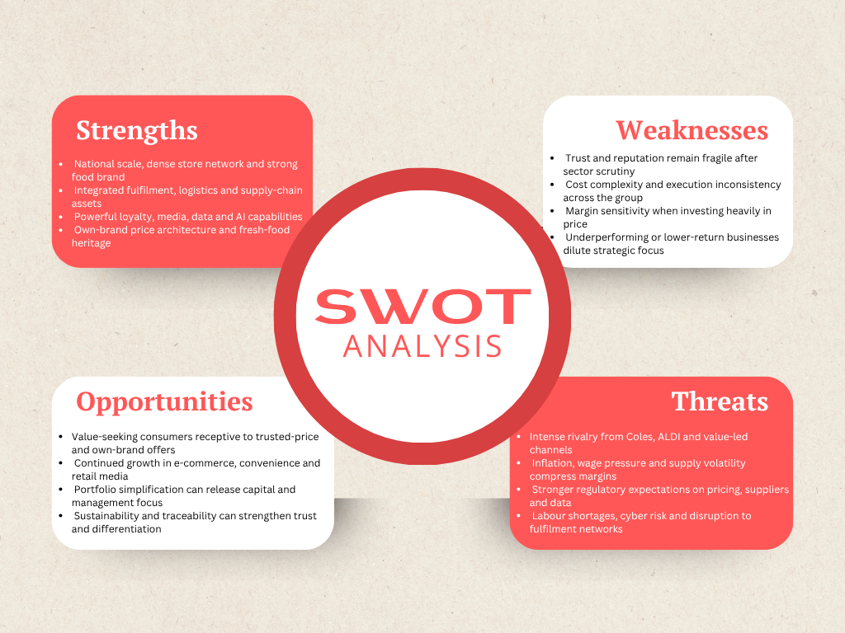
Figure 1 SWOT Matrix for Woolworths Group

2.4 Strategic Implications from SWOT
The SWOT analysis identifies four priorities: deepen food-core emphasis; value leadership more of a disciplined architecture than blanket discounting; make omnichannel convenience more productive; and streamline the portfolio and grow only complementary businesses that make the food ecosystem stronger or achieve attractive returns on shared capabilities.
This bridges analysis to choice: network reach, loyalty and data must be correlated with convenience and personalisation opportunities, whereas trust and complexity of costs must be executed in a more uncomplicated and transparent and better-governed manner.
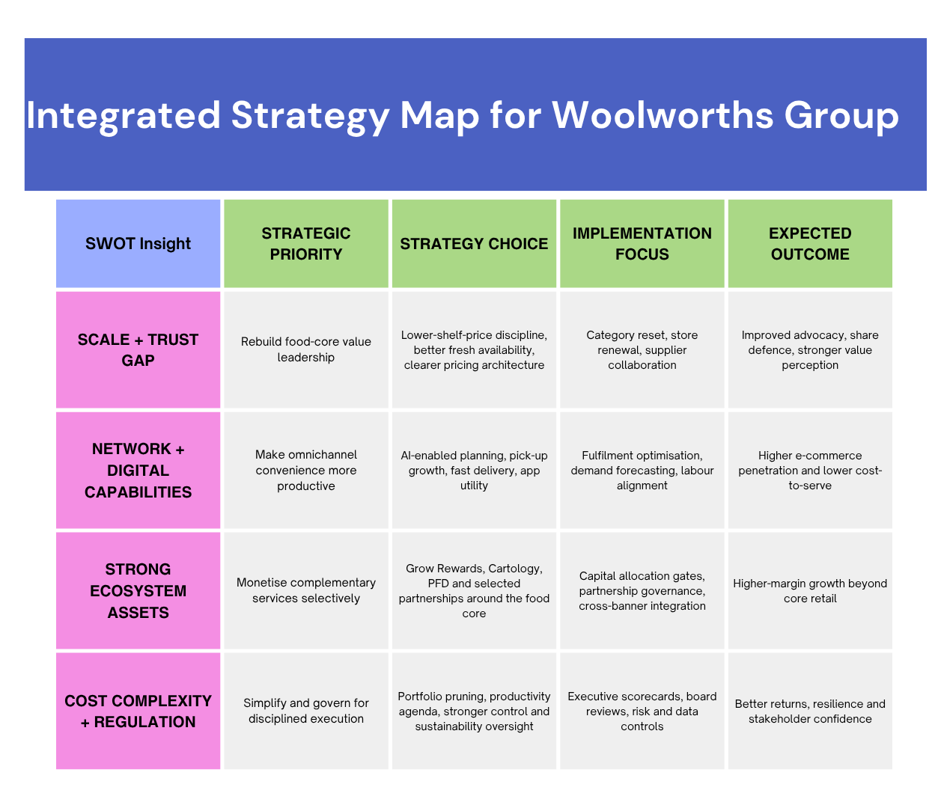
Figure 2 Integrated Strategy Map for Woolworths Group

2.5 Functional-Level Strategies
This is to be focused at the functional level, wherein operations and supply chain should consider a fresh-and-availability agenda. This implies network renewal, inventory visibility tightening and extending of direct sourcing and category-planning disciplines in fresh such that Woolworths emerges as a winner on quality and availability and waste reduction all at the same time. This type of approach is rational since freshness is one of the fundamental sources of differentiation whereas reliability in supply is a condition to be trusted value. It is a trade-off between capital intensity, and complexity of execution, but the payoff in terms of capability is less spoilage, and increased consistency of service.
The customer strategy and marketing should enhance value communication, as opposed to expanding the volume of promotion. Everyday value should be displayed through lower-shelf-price initiatives, unit-price openness, value-driven own-brand framework and individualised Rewards promotions, particularly in the case of cost-sensitive households. The disclosures by the company indicate that the engagement and value scores of Rewards go up when value is brought into the limelight and made more straightforward (Woolworths Group, 2025a, 2026a).
Technology and data strategy must shift towards digitisation to decision advantage. Woolworths is already considering AI as a store labour planning enabler, picking optimisation and digital customer experience (Woolworths Group, 2025a, 2026a). Selective scale, which is deployed where the AI enhances customer outcomes or labour productivity, but is accompanied by more robust privacy, cyber and governance controls, is therefore the strategic task. The implication in people management is the frontline capability development, as opposed to mere labour compression. New departments, internet fulfilment and store performance demand a more specific skills and incentives and local responsibility. Lastly, sustainability and finance must collaborate: capital must be directed towards projects that enhance cost-effectiveness, resiliency or consumer confidence in the food-system, whereas projects that are low-fit must bear increased hurdle rates or be dropped. That is, the same logic of competition should be reinforced by functional strategies, and not the separate silos optimised.

2.6 Business-Level Strategy
An integrated value strategy is the best business-level strategy that Woolworths can have: neither pure cost leadership, nor high-end differentiation, but a disciplined mix of trusted price and fresh-food advantage, convenience and omnichannel comfort. The framework of Porter is still helpful in this case since it helps to understand the risk of strategic vagueness; but now, in the modern grocery retailing, the scale leaders can use the low cost advantages and differentiated service attributes when they have the resources and systems to do it (Porter, 1985, 1996). The business model of Woolworths advocates the very approach. The combination of its dense store network, ability to own its own brands, supply-chain resources and Rewards ecosystem make it able to provide lower total shopping friction, not necessarily lower ticket prices.
Three mutually reinforcing mechanisms should then be used to maintain competitive advantage, first, the high-quality fresh-food delivery and product curation; second, reduced customer effort in stores, online services, pick-up and fast delivery; third, more data-driven personalisation, which increases the value of the basket and loyalty without sacrificing trust. This puts Woolworths in opposition to the limited focus of value of ALDI, and a more traditional imitation of the supermarket by integrating convenience and ecosystem into the value proposition.

2.7 Corporate-Level Strategies
On a corporate level, Woolworths ought to work towards related, capability-based portfolio management. The first one is to focus on simplifying the portfolio: capital and management focus should be on food-led core and businesses that are complementary and have a strategic adjacency. This is already a step Woolworths has taken in the right direction, as recent announcements of closing down the customer site of MyDeal and merging or selling off smaller businesses show that the company has already begun the process (Woolworths Group, 2025a, 2025b). The second one is selective ecosystem growth. PFD, Cartology, Rewards and some partnership-based propositions have the potential to generate group level value since they build on customer access, supplier relationships, logistics reach/data infrastructure, which the retail core already creates.
The third business strategy is the ability investment instead of irrelevant growth. Store renewal, fulfilment, digital architecture, cyber resilience, sustainability traceability and AI-enabled planning investments are best made at a group level since they are beneficial to a variety of businesses. The fourth direction is as strategy, not compliance, the sustainability integration. Emissions, waste, sourcing integrity and supplier behavior affect the cost, risk, legitimacy and customer trust at the portfolio level in a food retailer. Corporate strategy must thus give precedence to business and alliance that give the group a chance to enhance its long-term food-and-everyday-needs ecosystem.

2.8 Strategy Implementation
It should be implemented in a sequential manner in three horizons. During the initial 12 months, Woolworths ought to stabilise the fundamentals: entrench simpler operating designs, full supply-chain priority development, enhance price and range management, and stabilise customer confidence by means of more dependable value communication and store implementation. The CEO and the Woolworths Retail leadership must be accountable, with the assistance of the CFO, Supply-chain, digital and people leaders. During months 12-24, focus should be made to productivity and scaling: AI-enabled labour planning, fresh-sourcing redesign, more disciplined category resets, and enhanced Rewards and digital integration. During the 24-36 months, the emphasis should be on reaping portfolio benefits in terms of complementary business and growth of ecosystems driven by partnerships.
Resource allocation and change management are also important to successful implementation. The capital should be focused on those initiatives that will address several priorities simultaneously, which includes fulfilment automation, store renewal, cyber resilience, data platforms and frontline capability. Stage gates and post-investment reviews should be employed by the management in such a way that strategic projects are not transformed to inertia projects. The key risks are margin erosion due to unadhered price investment, store change fatigue, supplier pressure, and data-governance failures and the failure to realise productivity benefits. Implementation failure, according to Hrebiniak (2006), is usually indicative of coordination and accountability lapses as opposed to a bad intent. Woolworths must have a program office logic thus; there must be clearly defined owners, a discipline of milestones, a path of escalation and a decision of visible trade-offs when initiatives vie against each other to access the resources.

2.9 Monitoring and Control
Financial discipline should be coupled with strategic learning in the monitoring and control. Aggregate sales and EBIT are not sufficient as the two lagging indicators that Woolworths should use since they can conceal customer trust, labour capability or fulfilment economics value destruction. A more suitable system would be a balanced control system, which would tie customer, operational, financial and capability measures with the strategic priorities (Kaplan and Norton, 2004). Practically, this will entail monitoring market-share trend, value and new customer ratings, e-commerce infiltration, cost-to-serve, own-brand mixture, client loyalty involvement, CODB, ROFE, stockloss, safety measurements, food-waste redirection and chosen sustainability measures. New disclosures of the company already demonstrate the viability of such a dashboard with the help of such measures as VOC NPS, Rewards engagement, eCommerce penetration and safety outcomes (Woolworths Group, 2025a, 2026a).
The control is supposed to be of various rhythms. The executive reviews on monthly basis should review the operational and customer indicators, quarterly board reviews should review capital productivity, risk and strategic deviations and half year reviews should review whether the priorities of the portfolio are still valid. Corrective action should be pre-determined as opposed to being impromptu. Persistent share weakness should be used as an example, category-price resets should be used when economics of e-commerce are in bad shape, channel-mix or fulfilment redesign should be used when partnership or capital-allocation review is needed. This makes monitoring a passive reporting to an active strategy control.
Table 1. Monitoring and Control Dashboard
Strategic Area | Core KPI | Review Rhythm | Corrective Action Logic
Customer value | Comparable sales, market-share trend, Value-for-Money VOC, Group NPS | Monthly and quarterly | Escalate price, promotion and range resets if customer value or share weakens for two consecutive review periods
Omnichannel execution | eCommerce penetration, digital NPS, order accuracy, fulfilment cost-to-serve | Monthly | Rebalance channel mix, pick-up incentives and fulfilment labour if economics or service levels fall below plan
Productivity and returns | EBIT growth, CODB, ROFE, run-rate cost savings | Monthly and half-yearly | Pause low-return initiatives, reallocate capex, and tighten cost controls where returns lag
Loyalty and ecosystem | Active Rewards members, member engagement, Cartology revenue, partner attachment | Quarterly | Refresh member offers or partner mix when monetisation does not translate into customer value and repeat use
People, risk and sustainability | Team advocacy, TRIFR, stockloss, food-waste diversion, emissions indicators | Monthly and board quarterly | Trigger targeted capability, safety or supplier interventions when leading risk indicators deteriorate

3. Conclusion
Woolworths Group does not require a new identity per se, it requires a more disciplined and integrated application of the identity, assets and capabilities that it already has. This report has demonstrated that the company has a solid foundation of reinvigorated advantage on the basis of its food-led platform, scale in the supply-chain, loyalty ecosystem and data capacity, provided it develops strategy on a foundation of fit, as opposed to individual initiatives. The business model, in turn, is connected in the proposed plan to a system of strategic priorities consistent and coherent: the focus on food-core, the value leadership that is disciplined, the growth of the omnichannel and selective expansion of the ecosystems. These priorities are subsequently transferred into functional strategies, an integrated business-level strategy that is value-based and a corporate strategy with its focus on adjacency, simplification and leverage of capabilities. The control logic designed to implement and control is as important as the strategy selected. With a more stringent governance approach, more accountable and robust learning loops, Woolworths can likely enhance its customer advocacy, protect and expand its market share, increase returns and create a more robust retail system. The suggested plan of strategy formulation in that regard, is not merely competing more effectively in the present day, but is rather a way of regaining trust and establishing a more powerful sustainability agenda in the medium term.

4. Brief Justification of Chosen Format
The most suitable primary form of this assessment is a written report as this will enable the development of the strategic logic in a step-by-step manner: diagnosis, implication, choice, implementation and control. This is especially the case with Woolworths where the power of the recommendation lies in demonstrating how the conditions of the market, business-model realities and portfolio choices are related to each other and not on presenting individual recommendations. The most suitable complementary board deck would be a succinct PowerPoint deck to communicate with stakeholders outside the assessment. Slides would convert the report into visuals that are easy to understand by the executives, board members and non-specialists stakeholders as it would highlight priorities, investment decisions, milestones and KPI ownership. The integrated strategy map that is part of this report enhances understanding since the entire logic chain is condensed into only one visual model. That simplifies the interdependence of the SWOT insights, strategy decisions and anticipated results to comprehend and communicate.

5. References
Australian Bureau of Statistics. (2026, March 25). Consumer Price Index, Australia, February 2026. https://www.abs.gov.au/statistics/economy/price-indexes-and-inflation/consumer-price-index-australia/latest-release
Australian Competition and Consumer Commission. (2025, March 21). Supermarkets inquiry final report – February 2025. https://www.accc.gov.au/about-us/publications/serial-publications/supermarkets-inquiry-2024-25-reports/supermarkets-inquiry-final-report-february-2025
Barney, J. (1991). Firm resources and sustained competitive advantage. Journal of Management, 17(1), 99–120. https://doi.org/10.1177/014920639101700108
Foss, N. J., & Saebi, T. (2017). Fifteen years of research on business model innovation. Journal of Management, 43(1), 200–227. https://doi.org/10.1177/0149206316675927
Grant, R. M. (2022). Contemporary strategy analysis (11th ed.). Wiley.
Hrebiniak, L. G. (2006). Obstacles to effective strategy implementation. Organizational Dynamics, 35(1), 12–31. https://doi.org/10.1016/j.orgdyn.2005.12.001
Kaplan, R. S., & Norton, D. P. (2004). Strategy maps: Converting intangible assets into tangible outcomes. Harvard Business School Press.
Porter, M. E. (1985). Competitive advantage: Creating and sustaining superior performance. Free Press.
Porter, M. E. (1996). What is strategy? Harvard Business Review, 74(6), 61–78.
Teece, D. J. (2018). Business models and dynamic capabilities. Long Range Planning, 51(1), 40–49. https://doi.org/10.1016/j.lrp.2017.06.007
Woolworths Group. (2025a). Annual report 2025. https://www.woolworthsgroup.com.au/content/dam/wwg/sustainability/reports/f25/Woolworths%20Group%20Annual%20Report%202025%20.pdf
Woolworths Group. (2025b). Annual general meeting 2025 addresses and presentation. https://www.woolworthsgroup.com.au/content/dam/wwg/investors/agm/2025/2974752.pdf
Woolworths Group. (2026a). Half-year results announcement. https://www.woolworthsgroup.com.au/content/dam/wwg/investors/reports/f26/h26/3029540.pdf
Woolworths Group. (n.d.-a). Who we are. https://www.woolworthsgroup.com.au/au/en/who-we-are.html

