BARRIERS TO ACCESSING HEALTH CARE SERVICES AMONG SENIOR CITIZENS IN CHAPAGAUN, GODAVARI MUNICIPALITY, LALITPUR, NEPAL

A Thesis
Submitted to
Tribhuvan University
Faculty of Humanities and Social Sciences
Department of Sociology
NIMS College
For the Partial Fulfillment of the Requirement of
Master's Degree in Sociology

Submitted by
Shahil Maharjan
Exam Roll No. 75632019
TU Registration No. 6-2-710-358-2016

19th April, 2026

DECLARATION
I Shahil Maharjan (T.U. Regd. No.: 6-2-710-358-2016) declare that this thesis is my original work, which was prepared under the guidance of my supervisor and the title of this thesis is “Barriers to accessing health care services among senior citizens in chapagaun, godavari municipality, lalitpur, nepal”
I testify that this thesis has not been presented before with any institution to obtain any degree or diploma. Any information, which has been used in this thesis, has been appropriately recognized in the form of in-text citation and a reference list.
Date: ______
Place: Lalitpur, Nepal
Signature: ________
Shahil Maharjan


NIMS COLLEGE
Affiliated to Tribhuvan University

LETTER OF RECOMMENDATION
This is to confirm that Mr. Shahil Maharjan ( T.U. Regd. No.: 6-2-710-358-2016; Symbol No.: 75632019 ) has completed a thesis titled “Barriers to accessing health care services among senior citizens in chapagaun, godavari municipality, lalitpur, nepal” under my supervision and guidance
As far as I know, this thesis is an original piece of work done in partial compliance with the requirements of the Master Degree course in Sociology and is highly suggested to be submitted to the Department to be evaluated.
Mr. Deb Bahadur Gharti
(Supervisor)
Department of Sociology
NIMS College
Date: 19th April, 2026

NIMS COLLEGE
Affiliated to Tribhuvan University

LETTER OF APPROVAL
Date: ______
The thesis “Barriers to accessing health care services among senior citizens in chapagaun, godavari municipality, lalitpur, nepal” submitted by Shahil Maharjan (T.U. Regd. No.: 6-2-710-358-2016; Symbol No.: 75632019) has been discussed and recommended to award the Master Degree in the field of Sociology.
Evaluation Committee
Name | Designation | Signature
Mr. Deb Bahadur Gharti | Thesis Supervisor | _____________________
Mr. | External Examiner | _____________________
Mr. | Head of Department | _____________________

Department of Sociology
Nims College, Kumaripati, Lalitpur

ACKNOWLEDGEMENT
I would like to say how grateful I am to my thesis supervisor and the faculty members of the Department of Sociology, Nims College, who have provided me with academic guidance and support during the thesis process. I would like to thank senior citizens of Chapagaun, who would take part in this research and tell their stories and local health workers and leaders of communities who may give considerable insights into the reality of access to health services.
I also give credit to the support and understanding of my family and friends. Lastly, I am aware of the relevance of the policy commitments of the Government of Nepal regarding the right of old people, their health, and social protection, which offers an essential point of departure in a sociological investigation into the experience of growing old and receiving care.

ABSTRACT
The process of population ageing is gaining momentum and becoming the priority in health systems and social policy in most of the world, particularly in low- and middle-income nations where the burden of chronic diseases and disparities in access to services intersect (UNDESA, 2023). The population of older persons (those aged 60 years and older) in Nepal is an increasing proportion of the population, and that according to the census of 2021, population aged 60 and above was 2.97 million (10.2) in 2021 which is 10.2 times greater than in 1991 (10.2) (NSO, 2025). Although there are strong normative commitments, including the constitutional right of elderly citizens to special protection and social security and legal provision of free basic health services, the older adults commonly complain about their inconveniences regarding the transformation of the policy promises into the viable access (Constitution of Nepal, 2015; Public Health Service Act, 2018).
This thesis will analyze obstacles to receiving health care services amongst the elderly population in Chapagaun, a peri-urban area in the Godavari Municipality (Lalitpur, Nepal) where there are health facilities (an outpatient local hospital and emergency services) but older citizens might still experience financial, physical, informational, and institutional barriers (Godavari Municipality, 2021; Bajrabarahi Chapagaun Hospital, n.d.). The sociological model of the study is the Life Course Framework (cumulative advantage/disadvantage and linked lives), Intersectionality Theory (age in relation to gender, class, caste/ethnicity, and dependency), and the Behavioral Model of Health Service Utilization created by Andersen (predisposing, enabling, and need factors) (Ferraro and Shippee, 2009; Collins, 2015; Andersen, 1995).
This thesis is methodologically founded on a quantitative dominant mixed-method design. Patterns of service utilization, unmet need, and perceived barriers were reported in a cross-sectional survey of 90 senior citizens. These quantitative results were combined with 10 in-depth interviews with the senior citizens and 4 key informant interviews with the health and community stakeholders; the optional focus group discussion was not done due to mobility, hearing and comfort issues of the potential respondents. The combined results reveal that the lack of entitlement knowledge, poor affordability, transportation and waiting costs, and the unfinished practical value of the senior citizen allowance and NHIP remain a barrier to successful access. The thesis offers contextually relevant findings to make local governments, health planners, and service providers in peri-urban Nepal have more equitable and age-friendly health systems (WHO, 2020).

Table of Contents
DECLARATION i
LETTER OF RECOMMENDATION ii
LETTER OF APPROVAL iii
ACKNOWLEDGEMENT iv
ABSTRACT v
Chapter One Introduction 1
1.1 Background of the Study 1
1.2 Statement of the Problem 4
1.3 Purpose of the Study 5
1.4 Research Questions 6
1.5 Research Objectives 6
1.6 Significance of the Study 6
1.7 Limitations/Delimitations of the Study 7
1.8 Organization of the Study 7
Chapter Two Literature Review 8
2.1 Introduction to the Chapter 8
2.2 Conceptual Review 8
2.2.1 Defining senior citizens and older persons 8
2.2.2 Defining health care access 8
2.2.3 Barriers to accessing health care services 9
2.2.4 Affordability, availability, accessibility, and acceptability 10
2.2.5 Age-friendly services and geriatric responsiveness 10
2.3 Theoretical Review 11
2.3.1 Life Course Framework 11
2.3.2 Intersectionality Theory 11
2.3.3 Andersen’s Behavioral Model of Health Service Utilization 12
2.4 Empirical Review 13
2.4.1 International Studies 13
2.4.2 National Studies 13
2.4.3 Local/Context-Specific Studies 14
2.5 Review of Major Variables/Dimensions of the Study 15
2.5.1 Financial aspect (affordability and economic security) 15
2.5.2 Physical and geographic dimension (mobility, transportation, and accessibility of facilities) 16
2.5.3 Social and family aspect (linked lives, support and dependency) 16
2.5.4 dimension of cultural/social stratification (gender, caste/ethnicity, norms) 16
2.5.5 Institutional aspect (service organization, responsiveness, and age-friendliness) 16
2.5.6 Informational dimension (health literacy and awareness of entitlements) 17
2.5.7 Dimension of programme related (allowance and NHIP effectiveness in practice) 17
2.6 Research Gap 17
2.7 Conceptual Framework 18
2.8 Hypotheses / Propositions of the Study 20
2.9 Chapter Summary 21
Chapter Three Research Methods 21
3.1 Introduction to the Chapter 21
3.2 Research Philosophy and Approach 21
3.3 Research Design 22
3.4 Study Area / Research Setting 22
3.5 Population, Universe, and Sample 23
3.6 Sampling Techniques and Procedures 23
3.7 Sources and Nature of Data 24
3.7.1 Primary data 24
3.7.2 Secondary data 25
3.8 Data Collection Tools and Techniques 25
3.8.1 Structured questionnaire (survey on seniors citizens) 25
3.8.2 Guide to in-depth interview (senior citizens). 26
3.8.3 Schedule of key informant interviews. 26
3.8.4 Observation checklist 26
3.8.5 Justification of face-to-face techniques. 26
3.9 Data Collection Procedure 26
3.10 Methods of Data Processing and Analysis 27
3.10.1 Quantitative analysis 27
3.10.2 Operationalizing access as a product. 28
3.10.3 Qualitative analysis 28
3.11 Reliability and Validity / Trustworthiness of Data 29
3.12 Ethical Considerations 29
3.13 Chapter Summary 30
Chapter Four Data Analysis and Interpretation 31
4.1 Introduction to the Chapter 31
4.2 Background Characteristics of Respondents 31
4.3 Presentation, Analysis and Interpretation of Data by Objectives / Themes 35
4.3.1 Objective One: Perceptions and experiences of health care access 35
4.3.2 Objective Two: Major barriers faced by senior citizens 39
4.3.3 Objective Three: Role of old age allowance and NHIP 44
4.4 Discussion of Findings 47
4.5 Chapter Summary 48
Chapter Five Summary, Findings and Discussion, Conclusion & Implications 49
5.1 Introduction to the Chapter 49
5.2 Summary of the Study 49
5.3 Summary of Major Findings 50
5.4 Discussion of Findings 52
5.5 Conclusion 54
5.6 Implications of the Study 54
5.7 Recommendations 55
5.8 Areas for Further Research 56
References 57
Appendices 62
Annex 1: Survey Questionnaire (Senior Citizens) 62
Annex 2: Interview Schedule / Interview Guide (Health Workers & Community Leaders) 65
Annex 3: Consent Form 65
Annex 4: Statistical Tables Supporting Chapters 4 and 5 67
Annex 6: Inferential Tables and Hypothesis Testing Outputs 81

Abbreviations
ADB – Asian Development Bank
BHS – Basic Health Services
CBS – Central Bureau of Statistics (former name; now National Statistics Office)
CI – Cumulative Inequality
DoHS – Department of Health Services
FGD – Focus Group Discussion
FCHV – Female Community Health Volunteer
GESI – Gender Equality and Social Inclusion
HIB – Health Insurance Board
HIA – Health Insurance Act
HMIS – Health Management Information System
ICOPE – Integrated Care for Older People
IEC – Information, Education and Communication
KII – Key Informant Interview
LMIC – Low- and Middle-Income Country
MoHP – Ministry of Health and Population
NCD – Non-Communicable Disease
NDHS – Nepal Demographic and Health Survey
NHFS – Nepal Health Facility Survey
NHIP – National Health Insurance Program
NHRC – Nepal Health Research Council
NSO – National Statistics Office (Nepal)
OOP – Out-of-Pocket (health expenditure)
PHC – Primary Health Care
PHCRC – Primary Health Care and Resource Centre (Chapagaun)
SDGs – Sustainable Development Goals
TU – Tribhuvan University
UHC – Universal Health Coverage
UNDESA – United Nations Department of Economic and Social Affairs
UNFPA – United Nations Population Fund
WHO – World Health Organization

Chapter One Introduction

1.1 Background of the Study
The ageing of the population is among the most significant demographic changes of the twenty-first century, which have far-reaching implications on the health systems, social protection, and inequality (WHO, 2015). The United Nations stresses that the process of ageing is gaining momentum in most low-income settings in conjunction with endemic poverty and insufficient welfare capacity, which is more likely to push older adults out of the sphere of required services (UNDESA, 2023). The World Health Organization also contends that the health systems need to be restructured to move away from episodic models of acute care models to long-term and person-centred models that safeguard functional ability and manage chronic conditions, disability, and social care needs (WHO, 2015).
The elderly adulthood is usually related to an increased likelihood of chronic disease, multimorbidity, and functional impairment that could raise the frequency of contact with health services, as well as complicate the process of accessing them due to limited mobility and dependence (WHO, 2015; Dhungana et al., 2021). The UN Decade of Healthy Ageing (20212030) includes international frameworks that place the wellbeing of older persons in the context of rights and equity, that is, alongside the age-friendly service environment, it is necessary in terms of the social protection mechanism that minimizes financial hardship (WHO, 2020).
The issue of population ageing in Nepal is no longer an issue of the far future but a quantifiable and growing trend. According to the National Population and Housing Census 2021 thematic report on ageing, the population aged 60 years and above stood at 2,977,318 (10.2) in 2021; almost three times higher in absolute terms than it was in 1991, and the proportion just over fivefold as that of 1991 (5.8%). Such demographic transition is formed by the reduction in fertility, the rise in survival and the expansive structural adjustments in terms of households and intergenerational relationships (NSO, 2025).
The Nepalese also have a socially differentiated ageing. According to census-based results, differences in literacy between older adults and younger adults are vast in terms of gender of older individuals, with older women being significantly more prone to illiteracy than older men, which emphasizes how disparities experienced in the young age translate into old age (NSO, 2025). These disparities are important due to the fact that literacy and education determine health knowledge, system navigation, and interactional confidence in the clinical environments, thus, affecting the access to health care in sociologically patterned ways (Levesque et al., 2013).
The framework of health and social policy in Nepal has clear promises to older people. The Constitution of Nepal defines the basic rights regarding health and social protection and possesses a specific right of the senior citizens as respecting the special protection and social security of the State (Constitution of Nepal, 2015). To act upon the constitutional guarantees, the Public Health Service Act (2018) was adopted and it specifically promoted the right to free basic health services and emergency health services (Public Health Service Act, 2018). The Public Health Service Regulations (2020) also add that all citizens will obtain free introductory health services in the health institutions appointed (Public Health Service Regulations, 2020).
Besides rights-based obligations, Nepal has also implemented social protection initiatives that apply to the elderly members. The Census thematic report on ageing records that an old-age allowance was established in 1994 and put into effect as a monthly cash transfer, where eligibility age and benefit rates varied with time, which observes that in the mentioned period there was a minimum age requirement of 68 years and a monthly allowance of NPR 4,000 (NSO, 2025). The same report concludes that the Senior Citizens Act concludes that a senior citizen is a Nepali citizen who has attained the age of 60, thus giving a legal age of senior citizenship which is lower than the allowance eligibility age (NSO, 2025).
The social health insurance has also been a way through which Nepal is seeking health financing reforms. An organized overview of the National Health Insurance Program (NHIP) in Nepal indicates that the program has been rolled out nationwide in a legal and policy environment, comprising of a Health Insurance Act, and regulations and stipulations, and cites that NHIP has experienced problems such as low enrolment, attrition, and sustainability and governance (Khanal et al., 2023). The following limitations are important to older adults as chronic diseases and frequent service demands increase their susceptibility to out-of- pocket (OOP) spending, and older adults might face less sources of income to cover the expenses (Asian Development Bank, 2024).
Health demands of the aging population in Nepal are being predetermined by the presence of non-communicable diseases (NCDs) and risk factors. The national Survey on STEPS (2019) offers evidence on risk factors of NCD in Nepal in detail, which can support the general statements according to which chronic disease risks and cardiovascular risks are a significant public health concern (WHO and NHRC, 2020). The pattern of burden of chronic disease further highlights the significance of the policy of long-term care pathways and their importance in the context of an aging population as evidenced by national evidence on multimorbidity (Dhungana et al., 2021).
Nevertheless, the promises of policies do not necessarily have a direct relation with the experiences of access. The latest Nepal-specific studies have established obstacles to care access, including affordability issues, low acceptability and provider communication, and the lack of elderly-friendly service, and family support is commonly cited as an enabling factor that helps older adults to circumvent access barriers (Adhikari et al., 2024). Similar evidence based on research on elderly health service utilization in Nepal is that access could be limited due to geographic barriers and transport restrictions, especially with persons with chronic disease and mobility issues (Poudel et al., 2024). These results lead to the sociological policy-practice gap wherein the rights and programs are there but they fail to eliminate barriers equally, across social groups (Adhikari et al., 2024; MoHP, 2022).
This dissertation will be concerned with Chapagaun in Lalitpur as a setting of analytical interest. Chapagaun is located in the Godavari Municipality in the broader context of Kathmandu Valley, which is commonly perceived as peri-urban because of the nearness to urban core areas, as well as the localized nature of the limitation of infrastructure and services (Godavari Municipality, 2021). The local service environment encompasses an institutional health facility in Chapagaun (Bajrabarahi Chapagaun Hospital), which publicly lists outpatient, emergency, laboratory and inpatient services, and also mentions health insurance services ( Bajrabarahi Chapagaun Hospital, n.d.). Chapagaun being an appropriate location to understand the reasons why people of older age might still encounter hindrances even when they have care within geographic proximity compared to rural areas (Godavari Municipality, 2021; Bajrabarahi Chapagaun Hospital, n.d.).
Sociologically, it is not the very question of whether or not services are available, but how the access of older persons is framed by stratification, relationships in families, responsiveness of institutions, and awareness of rights. Older adults may be influenced by the life-course patterning of education and employment, household gender role divisions, disparity by caste and ethnicity, and how generations generate intergenerational support to seek health care and to have rights in practice (Gilligan et al., 2018; Collins, 2015).

1.2 Statement of the Problem
Nepal has put in place institutional and legal obligations aimed at achieving access to health and social protection with a constitutional right of older adults to special protection and social security and a legislative provision of free basic health services ( Constitution of Nepal, 2015; Public Health Service Act, 2018). Nevertheless, the access to health care among many older persons is still limited by the barriers that do not allow the affordability of timely and acceptable health care, which proves that there is a persistent gap between the official policy promises and the real life (Adhikari et al., 2024).
The situation is a multidimensional one. Conceptual literature on health care access focuses on the fact that access is not merely the availability of services; rather, it is determined by the factors of affordability, geographic accessibility, acceptability and fit between services and the needs and capabilities of the users (Penchansky and Thomas, 1981). At the primary level, in Nepal, though it is legally considered free, the elderly can incur OOP at the expense of diagnostics, medications, transport, follow-up visits, or personal services even in the situation when the state offers the services and the elderly cannot use them (Aryal, 2023; Acharya et al., 2016).
According to empirical studies in Nepal, several common barriers to older persons have been identified: affordability barriers, difficulty in provider-patient interactions, services that are elderly-friendly, and the role of family support in an enabling factor (Adhikari et al., 2024). Mixed-method studies in the rural Nepal reveal also that transportation and geography are constraining factors that inhibit access, and mobility and infrastructural constraints are crucial (Poudel et al., 2024). Although Chapagaun is not a rural mountain neighborhood, the peri-urban background provides the possibility of faced access constraints due to poor road surfaces, the lack of elder-friendliness transportation, and time cost of being a queue and inter-local facility-referral centers (Godavari Municipality, 2021).
Family relations and dependency are also structured to provide access barriers to older persons. Evidence through census demonstrates that a significant percentage of older persons reside with spouse/children or children, not to mention that an equally non-trivial percentage reside alone or only with spouse, and trends indicate that the percentages living alone or with spouse only are on the rise, a tendency that can increase risks of social isolation, and limit the amount of practical support available in terms of transport and decision-making (NSO, 2025). Such trends contribute to the unequal allocation of the resources of linked lives (time, care, money, and social capital), which, in turn, can become critical to whether an older individual can transform health needs into health service use (Gilligan et al., 2018).
Another aspect is that of policy initiatives which aim at lightening the financial burden. Old-age allowance and health insurance scheme of Nepal is aimed at enhancing social protection, although its practical impact may be weakened due to the implementation challenges, especially when it comes to older citizens who require recurrent services (NSO, 2025; Khanal et al., 2023). The critical assessment of NHIP focuses on the systemic problems, such as dissatisfaction with a compromised quality or lack of services where required and institutional issues related to claims, reimbursement, staffing, and governance (Khanal et al., 2023). The annual report of FY 2080/81 (2023/24) of Health Insurance Board also outlines the programmatic challenges, such as having problems with the timely examination and payments of claims, the lack of first service points where a person may be referred, and dissatisfaction of insured people, when there is a weak guarantee of quality services (Health Insurance Board, 2024).
The issue in Chapagaun is sociologically acute since there are health facilities, but the older population can still experience the barrier of affordability (in particular, medicines, diagnostics, and transportation), the barrier of information (lack of knowledge about entitlement or registration), the barrier of institutions (waiting lines, a requirement to be referred, a sense of disrespect or ageism), and the barrier based on gendered and classed dependency relationships (Adhikari et al., 2024; Levesque et al., 2013). The existence of institutional presence of Bajrabarahi Chapagaun Hospital, such as outpatient and emergency services and reported health insurance services, allows the possibility to study the policy-to-practice pathway as opposed to attributing the unmet need to the lack of facilities (Bajrabarahi Chapagaun Hospital, n.d.).

1.3 Purpose of the Study
The overall aim of the research is to explore the access to health care services by elderly in Chapagaun, Lalitpur, and define the practical barriers that elderly people have when seeking medical services with specific focus about the gap between the policy promises and the practicality (Constitution of Nepal, 2015; Public Health Service Act, 2018; MoHP, 2022).

1.4 Research Questions
The study is guided by the following questions of the research:
- What is their perception and experience of access to health care services among the senior citizens in Chapagaun?
- What are the greatest impediments to the accessibility of health care services by senior citizens in Chapagaun?
- To what extent do government programmes like senior citizen allowance and the National Health Insurance Program enhance the access of health care by senior citizens in Chapagaun?

1.5 Research Objectives
General objective:
To examine the accessibility of health care services among older adults in Chapagaun, Lalitpur and also determine the practical challenges that they encounter in accessing medical services.
Specific objectives:
- To investigate how the seniors perceive and experience in accessing health care services in Chapagaun, Lalitpur.
- To establish the significant obstacles that elderly people have in accessing health care services.
- To test whether government programmes like senior citizen allowances and health insurance can be used to enhance access to health care.

1.6 Significance of the Study
The present research holds a special place in at least four interdependent aspects. To begin with, the demographic trend that is changing to an ageing population in Nepal is quantifiable and accelerated, with the age group of 60+ years becoming over 10% of the national population, creating a policy and planning item on the health status and access to services among older persons (NSO, 2025). Second, the rights and policy promises of Nepal, including the constitutional protection of the elderly, free basic healthcare, and the development of geriatric health policies, provide a powerful normative framework, as evidenced recently, yet there are difficulties in their implementation and barriers to older users continue to affect them (Constitution of Nepal, 2015; Public Health Service Act, 2018; MoHP, 2022).
Third, the research fills a gap in the context. A lot of literature focuses on rural remoteness or indicators of the country level, yet peri-urban area such as Chapagaun is a different sociological space: it is close enough to urban areas to imply that it may be accessible, and it is still limited by the infrastructural features, unequal mobility and unequal responsiveness of institutions (Poudel et al., 2024; Godavari Municipality, 2021). Fourth, the research will add value to policy and practice; it will record lived experiences and barriers in a manner, which may inform the local government planning and service enhancement, consistent with the UN Decade of Healthy Ageing’s emphasis on creating age-friendly systems and reducing inequities (WHO, 2020).

1.7 Limitations/Delimitations of the Study
The research is confined in a geographical scope to Chapagaun and Lalitpur and hence the results may not be entirely applicable to the entire geographical location of Nepal, particularly the remote mountainous regions or big urban centers. Self-reported experiences and perceptions will be significant in the evidence base and may be affected by recall limitations, social desirability as well as health literacy differences. The constraints of time and resources can restrict sample size and depth, therefore, the study is planned to be feasible and analytically significant with mixed methods and triangulation.
Practical constraints are possible due to the fact that some of the older respondents may have mobility issues, literacy issues, hearing problems, or communication barriers, which can also inform participation, as well as form part of the phenomenon under research (i.e., the embodied barriers to access). Lastly, the research mainly focuses on the demand-side approach of the aged population, but a few key informant interviews will permit partial observation of the supply-side and community-based factors.

1.8 Organization of the Study
In this thesis, there are five chapters. In Chapter One, the background of the research, problem statement, objectives and significance are presented. Chapter Two summarizes a conceptual and theoretical literature review and comes up with a conceptual framework and hypotheses. Chapter Three describes the research methods, including design, sampling, tools, analysis and ethics. The research has been done in the field and four chapters have been analyzed, integrated and concluded with a conclusion based on the quantitative and qualitative results.

Chapter Two Literature Review

2.1 Introduction to the Chapter
This chapter summarizes the theoretical frameworks and conceptual hypotheses as well as factual material pertinent to the impediments to health care access among older adults with specific focus on Nepal and peri-urban settings. It develops an analytical framework which relates the evidence across the globe and the nation to the Chapagaun context and elucidates the role of access barriers as socially produced phenomena by life-course disparities, intersecting identities, and enabling structures (Levesque et al., 2013; Ferraro and Shippee, 2009; Collins, 2015).

2.2 Conceptual Review

2.2.1 Defining senior citizens and older persons
Yet the definition of older persons differs across the boundaries, yet the UN normally includes the age of 60 and above as a reference point. According to the census thematic report on ageing, Nepal, age 60 is also the threshold used to identify older persons in Nepal which is consistent with the legal definition of senior citizens in the Senior Citizens Act which defines a senior citizen as any citizen of Nepal who has attained the age of 60 years (NSO, 2025). In this thesis, the term senior citizens is applied to refer to the individuals that are of age 60 years or older, which is in line with the legal definition of senior citizens in Nepal and the orientation of this study regarding the rights and policy entitlements (NSO, 2025).

2.2.2 Defining health care access
The accessibility to health care is a multidimensional concept. One of the conceptualizations is a fundamental understanding of access as the extent of fit between clients and the health system and this is often defined in terms of the five A’s namely affordability, availability, accessibility, accommodation and acceptability (Penchansky and Thomas, 1981). The given method is especially beneficial when it comes to older patients since it reminds that there might be obstacles not only due to money and distance but also due to internal organizational structures (queues, hours, referral processes) and social interactions (communication, respect, ageism) (Penchansky and Thomas, 1981; Adhikari et al., 2024).
Another more recent and more popular framework takes access to be a process at the interface of health systems and populations where supply-side dimensions of accessibility (approachability, acceptability, availability/accommodation, affordability, appropriateness) are combined with demand-side abilities (to perceive, seek, reach, pay, and engage) (Levesque et al., 2013). The sociological significance of this process-oriented methodology lies in the fact that it can be used to observe how social position (education, gender, caste/ethnicity, family support) influences not only use, but also the ability to remain engaged in systems over time (Levesque et al., 2013; Collins, 2015).

2.2.3 Barriers to accessing health care services
Barriers are those factors that make individuals unable or slow to access, contact, get, or enjoy the assistance of health care. During the advanced stage of age, the obstacles tend to be compounding: mobility problems and poverty are compounded by low literacy and the necessity to have a companion, and systemic obstacles like insufficient geriatric responsiveness may increase stigma, fear, or resignation (Adhikari et al., 2024; Levesque et al., 2013).
In harmony with the access theory, the barriers in this thesis are arranged in three interaction levels:
- Distance, transport, physical accessibility of facilities, waiting time (Penchansky and Thomas, 1981; Poudel et al., 2024).
- Economic and programmatic obstacles (direct and indirect expenses, insurance services and functions, sufficiency of allowances, reimbursements and service package issues) (Khanal et al., 2023; Health Insurance Board, 2024).
- Social and institutional barriers (family dependency, gender norms, caste / ethnic discrimination, quality of communication, acceptability, ageism and perceived responsiveness) (Adhikari et al., 2024; Collins, 2015).

2.2.4 Affordability, availability, accessibility, and acceptability
Affordability is an issue that is about whether people can afford the indirect and direct cost of care without strain. OIP expenses may be maintained even in the environment, where a minimum of basic services are legally assured to be free, as in the case of drugs and tests being unavailable in the state facilities or when patients are referred to private services (Aryal, 2023; Acharya et al., 2016).
Availability: Availability is the extent to which services, personnel, medicines and infrastructure are available in adequate quantity and quality. Facility surveys and other health system assessments can be used to identify structural deficits that may turn into lived barriers, particularly in older persons requiring the continuity of chronic care (Aryal, 2023; Acharya et al., 2016).
Accessibility involves both the geographic and physical accessibility distance, means of transport, and accessibility of the facility environment and routes. The experiences of older adults in Nepal indicate that a significant limitation can be the transportation and geography, which supports the significance of mobility resources and family accompaniment (Poudel et al., 2024).
The concept of acceptability is defined by the acceptability of services in terms of their cultural and social acceptance and the respectful and comprehensible interactions. In Nepal, barriers to accessing care were reported as poor doctor communication and not finding elder-friendly services, and these factors might decrease trust and motivate not to use the service (Adhikari et al., 2024).

2.2.5 Age-friendly services and geriatric responsiveness
Age-friendly health services aim to make sure that older adults can safely and with dignity access services, such as physical (ramps, seating, signage), verbal (respectful communication), temporal (persisting with chronic illness), and referral (pathways) (WHO, 2015). The guidance of WHO on integrated care of older people focuses on the person-centred assessment and care paths, noting that the health system needs to adjust to the decreasing needs in intrinsic capacity and social support (WHO, 2017).
The Geriatric Health Service Strategy presented by MoHP (2022, unofficial translation) in Nepal is specifically aware of the fact that older adults are at higher risk of chronic conditions and multimorbidity with decreased functional capacity and the need to reduce barriers to accessing and using quality health services by older adults and enhance the family and community support systems (MoHP, 2022). The given strategy is a relevant policy context of this thesis since it recognizes that senior citizens have been deprived of health needs by institutional and service delivery capacity constraints and thus the policy-practice gap is not an academic assertion but an overt government issue (MoHP, 2022).

2.3 Theoretical Review
This thesis involves three complementary models, which are Life Course Framework, Intersectionality Theory, and the Behavioral Model created by Andersen. The two allow a sociological study of the relationship between structural inequality, identity, and institutional systems and health access of elderly populations under a peri-urban setting in Nepal (Ferraro and Shippee, 2009; Collins, 2015; Andersen, 1995).

2.3.1 Life Course Framework
The life course perspective highlights the theme that all health and wellbeing is constructed throughout the course of history and through the interaction between past, human agency, social institutions and related lives (Elder, 1994). One of the key notions that apply to the topic of ageing is cumulative advantage/disadvantage: inequalities in education, employment, and social status during the early years of life may accumulate and escalate as disparities in resources, health, and access to care in old age (Dannefer, 2003; Ferraro and Shippee, 2009).
Cumulative inequality can be used in the case of Nepali elderly people as it can work through the long-term dynamics of educational attainment (particularly among women), the informal or agricultural labour (no pension schemes), and disparities in access to land and property, which can have an impact on the health risk and the mobilization of resources to care (NSO, 2025; Ferraro and Shippee, 2009). The idea of linked lives is especially relevant to Nepal, where older individuals may not have access to it based on the time, money, and decision-making assistance of the family members; any alterations in the living conditions and migration may thus qualify as structural access shocks (Gilligan et al., 2018; NSO, 2025).

2.3.2 Intersectionality Theory
Intersectionality looks at the interaction between various axes of social differentiation, e.g. gender, race/ethnicity, class and other social positions, in creating distinct experiences of inequality instead of a cumulative effect (Crenshaw, 1989). Although intersectionality has emerged in legal and feminist literature, it has come to the center of the debate of health inequity since the interaction between systems of power and marginalization tend to influence health outcomes and access to health care (Collins, 2015; Hankivsky and Christoffersen, 2008).
There is an overlap between age and gender, class, caste/ethnicity, and rural /peri-urban location in Nepal. The dependence and communication with the providers, impacted by lower literacy and higher chances of being widowed, and social confidence and perceived discrimination, influenced by caste/ethnic hierarchies, may influence acceptability and engagement with care in older women (NSO, 2025; Collins, 2015). Intersectionality offers a lens through which the inequitable access consequences of a single policy (e.g. insurance or free care) can still be achieved since individuals are placed differently within social structures that impact knowledge, mobility, and power within clinical interactions (Collins, 2015; Hankivsky and Christoffersen, 2008).

2.3.3 Andersen’s Behavioral Model of Health Service Utilization
The Behavioral Model of Andersen conceptualizes health services use based on (a) predisposing factors (demographics, social structure, health beliefs), (b) enabling factors (resources at individual/family/community level) and (c) need factors (perceived and evaluations health need) (Andersen, 1995). The model especially is applicable to quantitative dominant mixed method studies since it helps quantify variables (e.g., insurance status, income, distance, chronic illness) but is socially sensitive to social structure and can help mobilize resources (Andersen, 1995).
In this thesis, the model by Andersen is applied as a framework that facilitates the linkage of life-course and intersectional conditions to manifested access outcomes (service utilization, unmet need, delays, satisfaction). As an illustration, enabling resources (income, literacy, family support) are affected by life-course socioeconomic disadvantage; meanwhile, intersectional gendered dependency may affect both predisposing patterns (health beliefs) and enabling resources (ability to reach and pay) (Andersen, 1995; Collins, 2015; Ferraro and Shippee, 2009).

2.4 Empirical Review

2.4.1 International Studies
Evaluations have demonstrated at the international level that older people experience the cumulative access barriers: financial barriers as a result of fixed or low income, physical barriers that are brought about by mobility and disability, and institutional barriers within the service design that do not match chronic care needs (WHO, 2015). The World Report on Ageing and Health by WHO contends that the current health systems have not been made to accommodate older populations and proposes the integration and person-based approach to care to enhance functional ability and reduce inequities (WHO, 2015).
According to the UN Decade of Healthy Ageing Plan of Action, the coordinated intervention is necessary to improve the access of older persons by focusing on health, social care, transportation, and community assistance, and older people themselves come in the centre of attention (WHO, 2020). This globalization of framing helps prove a major assumption of this thesis: barriers to access are not only the problem at the individual level but the product of institutional design and social support structures (Levesque et al., 2013).
The conceptual and empirical international access research also illustrates that the availability of the services should be coupled with the capacity of the patients to experience need, seek care, access services, pay without resource drainage, and use services over time-factors that are socially stratified (Levesque et al., 2013). These implications are very applicable in case of Nepal, where education and household support inequalities can rank these skills, particularly in the case of older women and those marginalized (NSO, 2025; Collins, 2015).

2.4.2 National Studies
An emerging literature source on health issues and access limitation of older persons is recorded in Nepal-based research. A qualitative study (conducted in central Nepal) provides essential barriers faced by older adults: lack of affordability, low acceptability and communication between older and physicians, and unfriendliness with older adults, and family support mitigates barriers in older adults (Adhikari et al., 2024). The result supports the sociological significance of interconnected lives and home dependence in determining the outcome of access (Gilligan et al., 2018).
Patterns of utilization among mixed-method studies and quantitative ones shed some more light on the determinants as well. A study on the health services usage among older adults in Pokhara finds the relation between enabling factors and utilization theory as well as it confirms the Andersen-type theories in which the enabling resource preconditions the service use (Karmacharya et al., 2022). The study of the rural elderly population in Gandaki Province indicates that geographical limitations and insufficient transportation means prevent access showing how mobile and geography determine service utilization despite high levels of need (Poudel et al., 2024).
Programmatic research studies of health insurance at the national level identify the existence of challenges in implementation that can indirectly influence the access of older persons. According to a systematic review of NHIP, there is low enrollment and high dropout, dissatisfaction of beneficiaries with quality of service or lack thereof, and systematic problems, including delayed reimbursement and institutional capacity (Khanal et al., 2023). These obstacles are important to older people due to the high level of chronic diseases as such individuals need permanent access to medications and follow-up, and disruptions are particularly detrimental to their health (Khanal et al., 2023; Asian Development Bank, 2024).
The policy analysis of the national health insurance policy in Nepal raises concerns about the policy implementation, which supports the idea that insurance plans cannot effectively cover the vulnerable population when governance, awareness, and provider payment systems are of low quality (Khanal et al., 2023). A study conducted by ADB also overviews the Nepal national health insurance program with specific attention to program design and implementation issues that are of concern when it comes to the financial protection and sustainability (Asian Development Bank, 2024).
Access to older persons is critically dependent on the context of their living arrangements nationally. The Census thematic analysis indicates that in 2021, 41.8% of the older persons lived with spouse and children, 24.1% with children, 14.3, with spouse only, and 4.4% alone, trends that show that some older adults might be deprived of everyday assistance in accessing services (NSO, 2025). This justifies the family support and dependency as a key factor of the barriers to access which is the focus of the study (NSO, 2025).

2.4.3 Local/Context-Specific Studies
The research that specifically addresses the data of senior citizens on the Chapagaun level is not observable in the freely available official sources, and this also belongs to the research gap that the research thesis will fill. But it is possible to define local institutional context by using municipal and facility documentation. The profile documents of Godavari Municipality indicate the existence of good inter-relationships with Kathmandu and other surrounding regions, such as health and care, which is how peri-urban dwellers could access services in local and urban institutions (Godavari Municipality, 2021).
In Chapagaun, Bajrabarahi Chapagaun Hospital openly mentions service provision (OPD, emergency, laboratory, IPD) and has a service link to the Health Insurance and informs that the institutional care is practically available in the area (Bajrabarahi Chapagaun Hospital, n.d.). It changes in favor of the thesis rationale: obstacles at Chapagaun might not be absolute lack of facilities, but rather a matter of affordability, transportation facilities, waiting time, institutional structure and awareness of what is due (Bajrabarahi Chapagaun Hospital, n.d.).
Chapagaun has also a place in the history of Nepal in community-based health programs. A community-based health insurance scheme review has mentioned a Primary Health Care and Resource Centre in Chapagaun, which suggests that local health financing schemes existed in the past (although not related to NHIP) (GIZ, 2012; Khanal, 2020). This history makes the research on the effectiveness and awareness of the use of health insurance, in this locality, more relevant, and the thesis focus on the existing government programs (allowance and NHIP) (Khanal et al., 2023; Health Insurance Board, 2024).

2.5 Review of Major Variables/Dimensions of the Study
This research paper is a study that considers the health care services as the outcome that is influenced by the interacting financial, physical, social, cultural, institutional, informational, and programmatic dimensions. These dimensions are conceptually and empirically appropriate.

2.5.1 Financial aspect (affordability and economic security)
The issues are financial obstacles (direct expenses (fees, medicines, diagnostics), indirect expenses (transport, food during visits, expenses of accompaniments). Although, in policy terms, free basic health care presumes a low risk of OOP, studies and reviews of policies discuss the existence of certain risks and barriers to implementation that may endanger vulnerable groups with insufficient protection (Aryal, 2023; Khanal et al., 2023). Another potentially empowering tool is the old-age allowance, which is only sufficient when the level of poverty in the household is high and the expense of chronic care maintenance remains high (NSO, 2025).

2.5.2 Physical and geographic dimension (mobility, transportation, and accessibility of facilities)
The lack of mobility and dependence of older persons poses an obstacle to the services even with geographic proximity. Nepal evidence indicates that transportation barriers are one of the prominent obstacles to the elderly population in most situations (Poudel et al., 2024). The barrier could be in the form of inaccessibility to elder-friendly transportation, irregular roads, or the necessity to have someone with them with them instead, not the utter remoteness (Poudel et al., 2024; Godavari Municipality, 2021).

2.5.3 Social and family aspect (linked lives, support and dependency)
The support of the family comes up as a strength that empowers the access of older persons. The qualitative evidence available in Nepal emphasizes the ease of overcoming the barriers when older adults are supported by their family, which can offer transport, money, and advocacy when interacting with a clinical provider (Adhikari et al., 2024). The Census data on living arrangements also indicates that there are older persons who are living alone or spouse-only, which may worsen areas of access (NSO, 2025).

2.5.4 dimension of cultural/social stratification (gender, caste/ethnicity, norms)
Intersectionality posits that the ability to be able to access things depends on gender and social position. The increased illiteracy of older women and the possible widowhood could influence knowledge, confidence, and dependency, and the caste/ethnic inequality could affect the sense of perceived discrimination and acceptability (NSO, 2025; Collins, 2015). These aspects can define not only utilization but also the attitude towards respect and quality in care relationships (Collins, 2015; Adhikari et al., 2024).

2.5.5 Institutional aspect (service organization, responsiveness, and age-friendliness)
The institutional barriers comprise long wait periods, lack of geriatric responsiveness, poor communication as well as inadequately age-friendly environments. Specifically, poor communication and absence of elderly-friendly services are the identified barriers associated with Nepal-based qualitative evidence (Adhikari et al., 2024). The policy strategy documentation of Nepal recognizes that the health requirement of the elderly is not fulfilled because institutional and service delivery capacity is weak, which supports the idea that institutional conditions are primary (MoHP, 2022).

2.5.6 Informational dimension (health literacy and awareness of entitlements)
This needs access to the ability to recognize need, cognize services and options, and find processes. This theory of patient-centred access underlines these specifications of access as its intrinsic component, not personal characteristics but social organization abilities, which are formed through the process of education and social support (Levesque et al., 2013). According to the FY 2080/81 annual report by the Health Insurance Board, the information and communication activities continue to work on awareness and enrollments which gives the implication that the deficit in the information implementation is still a feasible implementation issue (Health Insurance Board, 2024).

2.5.7 Dimension of programme related (allowance and NHIP effectiveness in practice)
Financial barrier interventions could not enhance access due to poor implementation. NHIP evaluation reports have shown systemic issues and dissatisfaction among the beneficiaries and annual reporting by the Health Insurance Board shows the presence of structural barriers and inter-tier coordination challenges that may contribute to service experience among older people (Khanal et al., 2023; Health Insurance Board, 2024).

2.6 Research Gap
There are four gaps connected to this research.
To begin with, the research gaps of the older-adult access in peri-urban areas, such as Chapagaun, are underrepresented relative to rural or distant national-level studies, although the peculiarities of the transformation of such a peri-urban environment and its social and infrastructural characteristics demand individual consideration ( Godavari Municipality, 2021).
Second, experience gap: the literature on the topic usually focuses on utilization rates, morbidity prevalence, or system documents, whereas the lived experience of older persons, particularly, in the context of dignity, acceptability, family dependency, and practical to navigate the entitlements are demanding more sociological consideration.
Third, policy-practice gap: Nepal has legal and policy undertakings towards senior citizens and free basic services and has developed geriatric strategies, but it is shown that the health needs of senior citizens are not fulfilled by capacity and implementation limitations; the local research is required to understand how such gap is manifested in the context of everyday seeking of care (Constitution of Nepal, 2015; Public Health Service Act, 2018; MoHP, 2022).
Fourth, lack of methodological overlap: the research tends to take either quantitative determinants or qualitative account. The quantitative-dominant mixed-method design allows generating evidence that is locally grounded in terms of the prevalence of barriers and also clarifying why the barriers are maintained due to lived experience and institutional processes.

2.7 Conceptual Framework
The framework conceptualizes the unlimited access theory (five A’s and patient-centred access), life-course and intersectionality approach, and the model proposed by Andersen. It presumes that access outcomes are influenced by explanatory factors (social position and resources), meditated by affordability, availability, accessibility, and acceptability as well as affected by policy/program functioning.
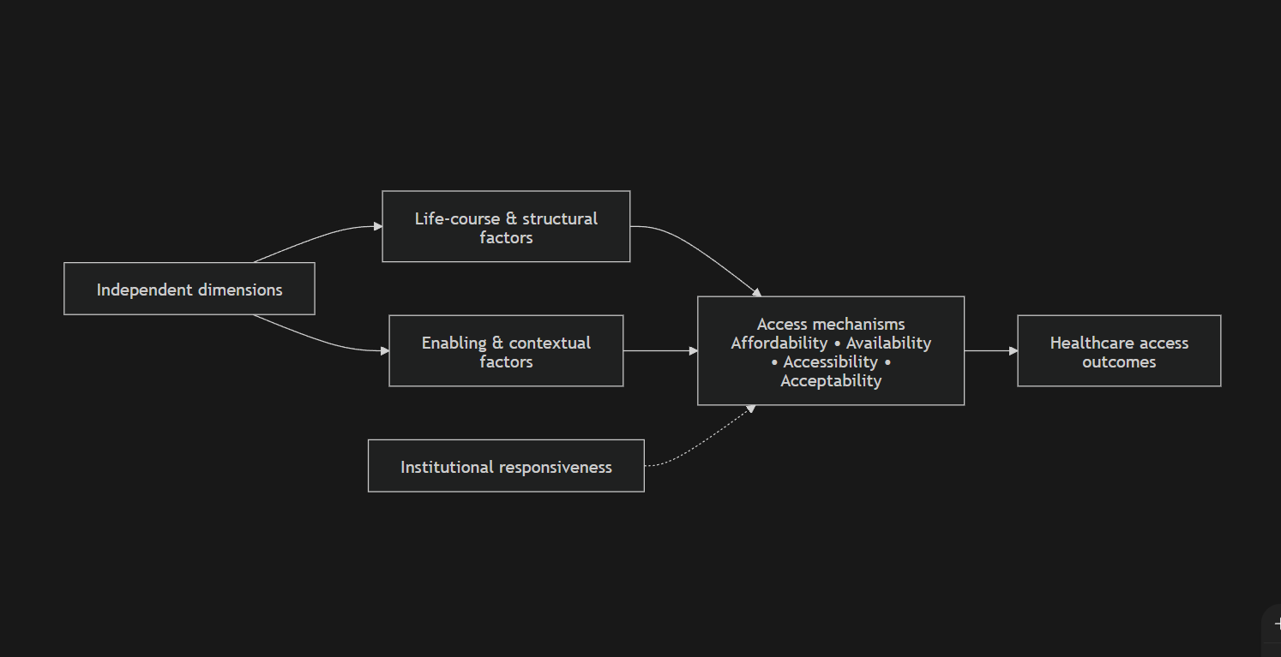
Figure 1 Conceptual framework: pathways shaping health care access among senior citizens in Chapagaun
EXPLANATORY / INDEPENDENT DIMENSIONS
------------------------------------
Life-course & structural factors:
- Education (literacy), work history, accumulated disadvantage
- Gendered roles, widowhood, caregiving histories
- Caste/ethnicity and social status
- Household wealth and income security
Enabling and contextual factors:
- Family support (transport, accompaniment, decision-making)
- Health insurance status (NHIP enrollment, renewal, usability)
- Senior citizen allowance receipt and adequacy
- Health literacy and awareness of rights/entitlements
- Transport availability and distance/time to facility
- Physical mobility, disability, chronic illness (need)
INTERMEDIATE ACCESS MECHANISMS
------------------------------
Affordability <-> Availability <-> Accessibility <-> Acceptability
(costs, OOP, (staff, (roads, (respect,
medicines, drugs, transport, communication,
insurance services) queues) age-friendliness)
INSTITUTIONAL RESPONSIVENESS (cross-cutting)
--------------------------------------------
- Elderly-friendly environment
- Communication and counseling
- Referral and first service point functioning
- Perceived quality and trust
OUTCOME / DEPENDENT DIMENSION
-----------------------------
Healthcare access among senior citizens
(measured as: utilization, delay/foregone care, unmet need,
satisfaction, continuity for chronic care)
This model aligns with the multidimensional access theory and allows operationalizing it through a mix of indicators (insurance status, distance, utilization) and mechanisms (acceptability, perceived disrespect, dependency) that appear to be experiential (Levesque et al., 2013).

2.8 Hypotheses / Propositions of the Study
Since the mixed-method design is quantitative-dominant, the survey part of the study involves hypotheses, and the qualitative analysis propositions lead the survey.
Hypotheses (quantitative element)
H1: A lower socioeconomic status among elderly people (poorer education and/or lower household economic status) results in a higher propensity of elderly people to report delayed or foregone care and greater perceived barriers to accessing care (Levesque et al., 2013; NSO, 2025).
H2: Female senior citizens will be more prone to informational barriers (low awareness of entitlements) as compared to male senior citizens, and dependency-related barriers (need for accompaniment) (NSO, 2025; Collins, 2015).
H3: Senior citizens who are not subscribers of NHIP (or incapable of utilizing insurance) tend to report more on the issue of affordability and unmet need (Khanal et al., 2023; Health Insurance Board, 2024).
H4: The barriers related to access to facilities and negotiating services are more likely to be reported by senior citizens living alone or in spouse-only households or have no available caregivers (NSO, 2025; Gilligan et al., 2018).
H5: Service need and increased likelihood of facing barriers (particularly waiting time, referral, repeated cost burden) are higher with greater burden of both chronic illness and mobility limitation (Poudel et al., 2022; Dhungana et al., 2021).
Propositions (qualitative component) Guiding.
P1: Institutional factors, including the availability of drugs, provider communication, and reimbursement / services package constraints mediate the perceived effectiveness of the senior citizen allowance and NHIP (Khanal et al., 2023; Health Insurance Board, 2024).
P2: The elderly do not perceive barriers to access as technical alone, but also as moral and relational phenomena (treated as a burden, ageism), having an impact on further help-seeking (Adhikari et al., 2024; Levesque et al., 2013).

2.9 Chapter Summary
This chapter identified that the access of health care to elderly citizens is a multidimensional and a socially organized course. It has discussed fundamental conceptual methodologies to access, three theoretical models (life course, intersectionality, Andersen), integrated international and Nepal-specific empirical data, and found gaps by centering on peri-urban Chapagaun. To conduct a quantitative-dominant mixed-method study conceptual framework and testable hypotheses were developed.

Chapter Three Research Methods

3.1 Introduction to the Chapter
This chapter explains how the researcher carried out the study to explore the barriers to the access of health care services by the senior citizens living in Chapagaun. It describes the research philosophy, design, study setting, sampling, tools, procedures, analysis, reliability/validity, and ethical safeguards, which makes the methodology coherent with the sociological framing and conceptual model of the thesis.

3.2 Research Philosophy and Approach
A pragmatic research philosophy will inform this study to the extent that this philosophy will give the researcher a reason to choose a method that best answers the research questions and that the complexity of social phenomena such as health care access need both numerical patterns and interpretative insights. The idea of pragmatism is suitable since the factors that limit access are both quantifiable (costs, distance, insurance enrolment) and qualitative (acceptability, dignity, family dependency) (Collins, 2015; Adhikari et al., 2024).
The research approach is a mixed-method approach that is quantitative in nature. The prevalence and distribution of barriers will be defined by the quantitative data, and the experience and interpretation of barriers and how programs and institutions contribute to the lived access will be articulated with the qualitative data.

3.3 Research Design
The research takes a cross-sectional quantitative survey study with a supplement of qualitative interviews and, where possible, one focus group discussion. The logic of mixed methods could be referred to as the explanatory sequential: the results of the survey will be used to select the qualitative respondents and themes to learn more about the observed trends.
This model is consistent with the model proposed by Andersen (measurable predisposing/enabling/need factors); it can be analyzed in accordance with sociological models highlighting cumulative inequality and overlapping identities, which can be quantified (in terms of stratified patterns) and qualitatively (in terms of dependency and dignity descriptions) (Andersen, 1995; Ferraro and Shippee, 2009; Collins, 2015).
The mixed-method design was achieved in implementation by conducting a survey of 90 senior citizens, 10 interviews with senior citizens in-depth, and 4 interviews with key informants who are local health and community stakeholders. The focus group discussion was optional and not done as a result of some of the potential eligible older individuals indicating a discomfort in being in a group setting and some have mobility or hearing impairments.

3.4 Study Area / Research Setting
The research is undertaken in Chapagaun, which is part of Godavari Municipality, Lalitpur District and Bagmati Province, Nepal. The peri-urban nature of Chapagaun is shown by its relations to Kathmandu Valley chains and limitations in infrastructure and the ability to move to some groups and populations, with aging individuals being among them (Godavari Municipality, 2021).
The local health service context is important to decipher access barriers. Bajrabarahi Chapagaun Hospital publicly identifies itself as being based in Chapagaun (Bagmati Province) and provides key services such as emergency, outpatient services, laboratory, inpatient services, and health insurance-related services which means that the institutionally-based health care is present in the locality (Bajrabarahi Chapagaun Hospital, n.d.). This environment is analytically useful as obstacles can be explored outside the physical lack of facilities and involving the quality and accessibility of services and benefits in ordinary living.

3.5 Population, Universe, and Sample
Target population (universe):
All the participants in Chapagaun over 60 years old and senior citizens during the study period, that is, all who met the older age qualifications of being an older person in Nepal (NSO, 2025).
Contextual population evidence:
Direct official ward-level older population figures for Chapagaun were not available No available official ward-level data on older population content in Chapagaun captured by accessible census web portals were available at the time of writing this thesis; and as such, this paper uses the best available Nepal-level and district/province contextual data and mentions this clearly. At the national level, the proportion of older people (60+) is 10.2 percent of the population, and census data revealed that the level of reliance on the family living conditions is high, meaning that household support is one of the most important enabling resources (NSO, 2025).
Sample strategy (quantitative and qualitative):
- Quantitative survey: around 90 older people.
- Interview with senior citizens: around 10 (maximum fluctuation) (Bajrabarahi Chapagaun Hospital, n.d.).
- Interviews with key informants: health workers, local leaders/community representatives, around 4.
- Focus group discussion (optional): 1 FGD of 6–8 senior citizens, only in case the participation is possible due to the mobility and comfort levels and the ethical protection can be ensured (NHRC, 2022).
The sample sizes will be sufficient to support a Master thesis yet allow triangulation and significant analysis of subgroups (e.g. gender distinction).

3.6 Sampling Techniques and Procedures
Quantitative sampling strategy.
The study line further reports convenience sampling, but to enhance the methodology defensibility without the unreasonable field effects, the current study direction narrows down to a more organized non-probability (assisted by a quota) household-based sampling method. This refinement has been determined by the fact that a complete sampling frame of senior citizens in Chapagaun might not be easily available but through systematic field techniques and quotas, bias can be minimized.
The sampling procedure in the survey will be as follows:
- Division of Chapagaun into clusters (toles/settlement) according to local information and the recommendations of ward/community leaders to eliminate the need to focus on the most approachable neighborhoods (Godavari Municipality, 2021).
- Set quotas so that there is representation in the significant categories of analysts likely to influence access: gender (approximately balanced), age categories (6079, 80+), at least caste/ethnicity categories where available have been reported locally (Collins, 2015).
- In each cluster, systematic household approach (e.g. every kth household versus screening all eligible senior citizens), and replacement rules in the event that no eligible participant is found, is used to minimize interviewer selection bias.
- This methodology is pragmatic and offers a stronger justifiable coverage compared to unstructured convenience per se and is identical to the emphasis on the thesis regarding social stratification and intersectional disparities (Levesque et al., 2013; Collins, 2015).
Purposive sampling which involves a maximum variation will be used to select the qualitative participants to make them diverse in terms of gender, age group, living arrangement (alone/spouse-only or living with children), health condition (presence of chronic illness), and insurance/allowance status (NSO, 2025). Key informants will be selected on the basis of their participation in service provision and community governance ( e.g., staff at the facility, leaders in the community).

3.7 Sources and Nature of Data

3.7.1 Primary data
- Senior citizens questionnaire completed in person through structured survey questionnaire.
- In-depth interviews with selected senior citizens.
- Service providers/community leaders through the key informant interview.
- Monitoring of service facility (accessibility, seating, signage, queuing facilities) in which the ethically appropriate and non-violent actions take place (WHO, 2017; MoHP, 2022).
- The focus group discussion was factored in during the design phase although this was not carried out due to the fact that some of the possible participants felt uneasy about a group discussion and some had mobility or hearing impairments.

3.7.2 Secondary data
- National policies and legal acts (Constitution, Public Health Service Act, geriatric strategy) (Constitution of Nepal, 2015; Public Health Service Act, 2018; MoHP, 2022).
- Ageing and other Census thematic and other official statistical or program reports (NSO, 2025).
- Peer-reviewed articles related to barriers to access among elderly and NHIP.

3.8 Data Collection Tools and Techniques

3.8.1 Structured questionnaire (survey on seniors citizens)
The questionnaire will be structured according to the thematic sections that will be congruent with the conceptual framework:
- Socio-demographic: (age, gender, marital status, education, caste/ethnicity, living arrangement), (NSO, 2025).
- Status and need (self-rated health, chronic conditions, mobility limitations, disability) (Poudel et al., 2022; Dhungana et al., 2021).
- Also access and in-use (recent visits, delayed care, need unmet, facility choice).
- Lastly, obstacles (quantified as affordability, availability, accessibility, acceptability; knowledge/awareness) (Penchansky and Thomas, 1981).
- Program exposure (receipt of old-age allowance; NHIP; enrolment, renewing, usability; perceived benefits).
- Upon-friendliness and responsiveness of service (communication, waiting, seating, respect) based on perceived age (Adhikari et al., 2024; MoHP, 2022).
Barrier domains conceptually take off the five-A’s and patient-centred access models to be comparative to the existing literature on access and to remain locally relevant (Penchansky and Thomas, 1981).

3.8.2 Guide to in-depth interview (senior citizens).
The interview questions will include: lived experiences of care seeking; decision-making processes; influence of family; queueing experiences, communication and respect; entitlement knowledge; and opinion of insurance and allowance effectiveness (Adhikari et al., 2024).

3.8.3 Schedule of key informant interviews.
Key informants will be questioned on: prevalent health issues of elderly; service patterns; referral routes; perceived obstacles; and institutional limitations on the implementation of elderly-friendly services and insurance-related services (MoHP, 2022).

3.8.4 Observation checklist
Features that can be related to age-friendliness (seating, signage, ramps/steps, queue arrangements) will be observed based on the priorities of international and Nepal policy on the elder-friendly services (WHO, 2017; MoHP, 2022).

3.8.5 Justification of face-to-face techniques.
Face-to-face procedures will be suitable since the elderly participants might have low literacy rates, might use oral communication more, and might need to be connected and supported; it is compatible with ethical principles that assert respect and supportive involvement of potentially vulnerable groups (NHRC, 2022).

3.9 Data Collection Procedure
Ethically informative procedure will be used in data collection:
- Preparation and permission: seek institutional permission with the Department of Sociology and the local administrative coordination and get the approval to work at the community level (NHRC, 2022).
- Development and translation of the tool: preparation of a questionnaire and guides in English and translated into Nepali (and other local languages, as necessary) with consideration of conceptual equivalence (not word-for-word translation) (Levesque et al., 2013).
- Pretesting/piloting: Test the survey on a small group of senior citizens in a similar environment to make the wording and order refined.
- Training: educate the enumerators to respectfully approach the older people in an interview, consent, and respond to distress or fatigue (NHRC, 2022).
- Fieldwork: carry out household-based survey interviews and arrange qualitative interviews in the locations of the participants, where the latter would feel comfortable and safe (home or isolated area) (Godavari Municipality, 2021; Bajrabarahi Chapagaun Hospital, n.d.).
- Data management: screening of the completed tools on a daily basis, storing the consent forms in a different place to the survey data, and anonymization of the interview transcripts (NHRC, 2022).

3.10 Methods of Data Processing and Analysis

3.10.1 Quantitative analysis
The results of the survey will be entered into SPSS (or similar) where they will be coded to be analyzed. The quantitative analysis will comprise:
- Descriptive statistics: frequencies, percentages, means where necessary (e.g. average time to facility, cost burdens).
- Cross-tabulations and bivariate tests (e.g., chi-square) touching upon the relationships between the outcomes of access (delay or unmet need) and the most important explanatory variables (gender, education, insurance status, living arrangement).
- In the event that it is possible given the sample size and distribution, constrained multivariate modeling (e.g., logistic regression using a few predictors) could be applied to investigate the relative role of enabling factors, which is informed by the Andersen model; otherwise, then a focus on robust descriptive and bivariate patterns will be applied to interpretation (Andersen, 1995).

3.10.2 Operationalizing access as a product.
Since the study is multidimensional, the access will be operationalized using a combination of indicators:
- Utilization (e.g. any visit under a specified period of recall)
- Delay/ foregone care through barriers.
- Reported unmet need (felt need and never sought or was not able to acquire care)
- Contentedness and perceived suitability/acceptability of services (Levesque et al., 2013)

3.10.3 Qualitative analysis
The audio-recorded interviews (qualitative and key informant) were transcribed and thematically analysed in an deductive-inductive model where consent was given. Due to the fact that the optional focus group discussion was not done, interview and key informant material alone were covered in the qualitative analysis.
- Access domain-based deductive coding (affordability, availability, accessibility, acceptability and abilities) and theoretical construct-based deductive coding (linked lives, cumulative disadvantage, intersectional vulnerability) (Levesque et al., 2013; Ferraro and Shippee, 2009; Collins, 2015).
- Inductive coding to reflect themes unique to the local area (e.g., experiences of queuing, ability to view entitlement as a stigma, ways of managing the service gaps) (Adhikari et al., 2024).
- To explain and elaborate quantitative patterns, qualitative findings will be relied upon, and this will be in line with the explanatory reasoning of mixed-method.

3.11 Reliability and Validity / Trustworthiness of Data
- Content validity: questionnaire domains are based on the developed access frameworks (five A’s; patient-centred access) and Nepal priorities regarding the policies towards senior citizens (WHO, 2017; MoHP, 2022).
- Pretesting: piloting will help to clarify ambiguous wording and make sure it is culturally appropriate (NHRC, 2022).
- Internal consistency: In any multi-item scale (e.g., perceived barriers scale), the alpha of Cronbach will be determined where suitable.
- Data quality checks: Double-entry checking of a sample number of surveys and logical checking (e.g. age vs allowance eligibility claims).
Qualitative trustworthiness
- Credibility: triangulation of interviews, significant people, and observation; repetitive questioning; and (where possible) a short-term participant validation of important interpretations (Adhikari et al., 2024).
- Transferability: detailed description of setting and the characteristics of the participants, which allows the other readers to evaluate the transferability to other peri-urban settings.
- Dependability and confirmability: having a record of coding actions and reflexive documents to minimize researcher bias following the best practices of qualitative research (Collins, 2015; Adhikari et al., 2024).

3.12 Ethical Considerations
The research will adhere to the ethical principles of respect to persons, beneficence, and justice, considering older people as one of the potentially vulnerable populations (NHRC, 2022). The ethical practices will be adhered to the national ethical principles of health research in Nepal that focus on informed consent, confidentiality, and sensitivity to social and cultural backgrounds (NHRC, 2022).
Such ethical protection measures are:
- Informed consent: the study participants will be provided with clear oral explanations of the study purpose, procedures, risks, benefits and the option of refusal and withdrawal without penalty; the consent will be signed or thumbprinted accordingly (NHRC, 2022).
- Voluntary participation: there is no coercion; particular attention is paid to the fact that the participation of family members should not be pressured (NHRC, 2022).
- Anonymity and confidentiality: use of codes (not names) in data sets; storing the consent forms separately; storing the recording is secure; anonymisation of the writing (NHRC, 2022).
- Less harm and exhaustion: the interviews will be arranged at convenient times; the interviewer can take a break; the interview can be interrupted in case the participant gets exhausted or upset (NHRC, 2022).
- Referral information: in case the participants complain about any urgent health issues or distress, the researcher will provide details on local health service, however, without any medical advice (NHRC, 2022).

3.13 Chapter Summary
In this chapter the quantitative-dominant mixed-method design was pragmatic and quantitative in nature to investigate the obstacles to health care access among elderly people in Chapagaun. The design theory is sound, practically plausible, and ethically cognizant of the vulnerabilities of older persons. It details sampling plan, instruments, process, analysis and measures of reliability/validity and validity.
This design was used in the completed study to conduct a survey of 90 senior citizens, 10 in-depth interviews and 4 key informant interviews. Focus group discussion was optional and not done due to the considerations of comfort and movement of the participants.

Chapter Four Data Analysis and Interpretation

4.1 Introduction to the Chapter
The chapter includes the analysis and interpretation of the quantitative and qualitative findings of the study of the barriers to the accessibility of health care services among senior citizens in Chapagaun, godavari Municipality, Lalitpur. It relies on survey information on 90 senior citizens, 10 in depth interviews with senior citizens and 4 key informant interviews. The quantitative analysis gives the background profile of the respondents, the experiences in accessing health services, the greatest obstacles and how the old age allowance and the National Health Insurance Program (NHIP) play a role in these obstacles whereas the qualitative analysis describes the way these obstacles are encountered in real life. The cross-tabulations and chi-square suggest that access varies by socioeconomic status, gender, living arrangement, insurance enrolment, mobility limitation, and chronic illness and the interview evidence is employed to understand these trends.

4.2 Background Characteristics of Respondents
The sample was comprised of a number of age groups. Nearly half, 48.9 percent, were aged 60–69, 35.6 percent were 70–79, and 15.6 percent were aged 80 years and above. This implies that the study included the young senior citizens as well as the old-old population, where the difference in the need of health and dependency in old age can be analyzed. The proportion of women (56.7 percent) and men (43.3 percent) is significant as gender tends to determine the level of health literacy and power to make decisions and trust in the ability to handle institutions (Collins, 2015; NSO, 2025).
It was socially heterogeneous in terms of caste and ethnicity: 30.0 percent Newar, 24.4 percent Tamang, 21.1 percent Brahmin/Chhetri, 14.4 percent other Janajati, and 10.0 percent Dalit. There were also various support situations which were demonstrated by marital status. Majority of the respondents were married (58.9 percent) with high percentage being widowed (18.9 percent), separated or divorced (12.2 percent) and unmarried (10.0 percent). The level of education was in general low. Over a third, 34.4 percent, had none at all, 23.3 percent were literate, none at all, 20.0 percent were primary, 14.4 percent were secondary and only 7.8 percent were bachelor level and higher. Low schooling is important as it influences the awareness, services navigation and benefits and procedures comprehension (Levesque et al., 2013; Andersen, 1995).
Occupational profile indicates economic vulnerability in the long-term. The most prevalent primary pre-retirement occupation (32.2 percent) was Agriculture, followed by small business (18.9 percent), service or teaching (15.6 percent), household work (15.6 percent), daily wage labour (10.0 percent) and retired formal job (7.8 percent). Most of the respondents thus lived their lives in low-protection or informal jobs, which restricts economic protection during old age. Data on living arrangements indicate that 45.6 lived with spouse and children, 31.1 with children only, 8.9 with spouse only, 8.9 with alone and 5.6 with relatives or others. Even though co-residence was prevalent, the presence of aged individuals residing on their own or with a spouse alone indicates some vulnerability whenever there is illness outbreak.
On the programme level, 51.1 percent indicated that they had the old age allowance and 53.3 percent were registered in NHIP. Nevertheless, renewed NHIP among the 41.1 percent was only done in the last year. This loophole indicates that the participation in the programmes is not a constant in practice. In general, background data indicate that population of the elderly in Chapagaun is socially stratified in terms of age, gender, education, occupation, support arrangements and the participation in programmes. The differences are key to subsequent understanding of access barriers.
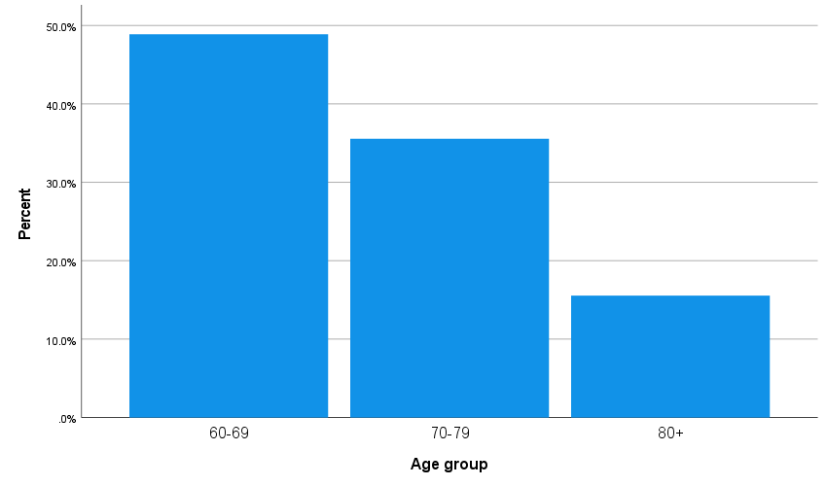
Figure 2 Age group distribution of respondents
Source: Field survey, 2026 (compiled from the statistical analysis file).
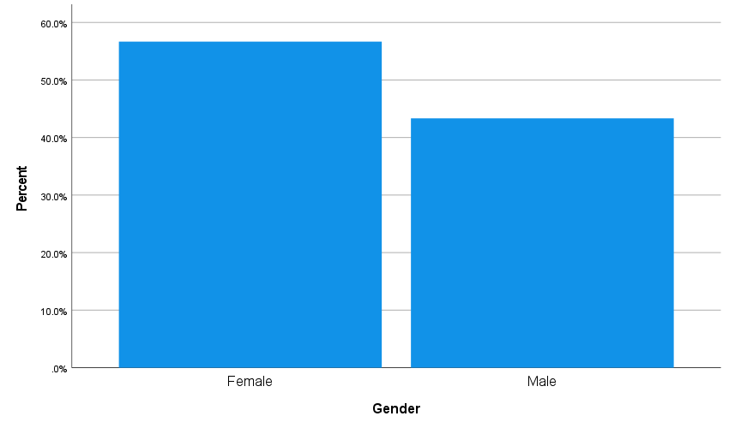
Figure 3 Gender distribution of respondents
Source: Field survey, 2026 (compiled from the statistical analysis file).
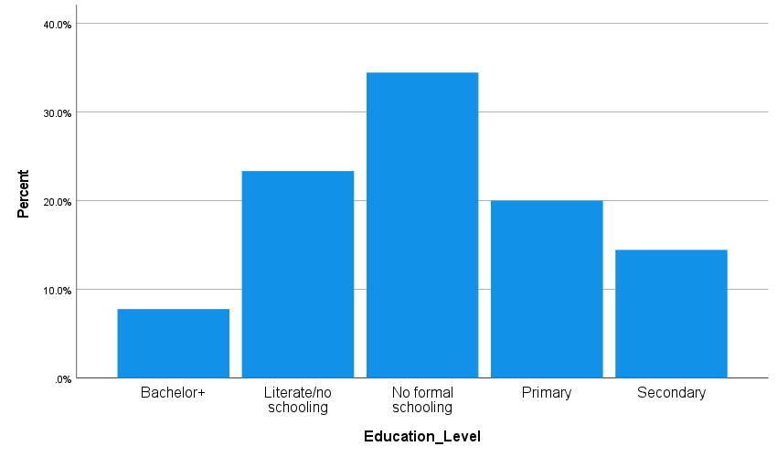
Figure 4 Education level of respondents
Source: Field survey, 2026 (compiled from the statistical analysis file).
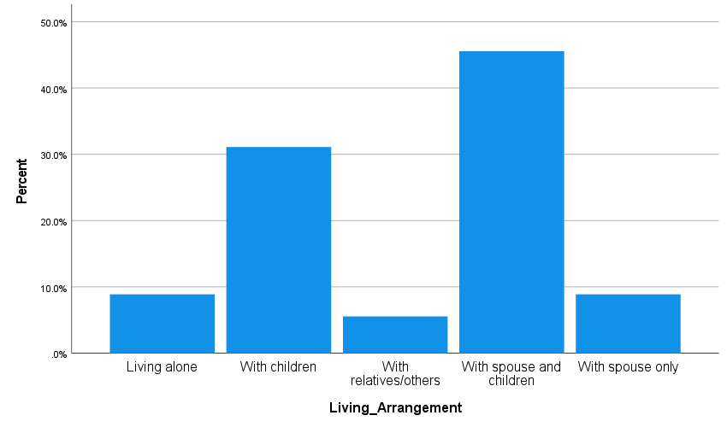
Figure 5 Living arrangement of respondents
Source: Field survey, 2026 (compiled from the statistical analysis file).
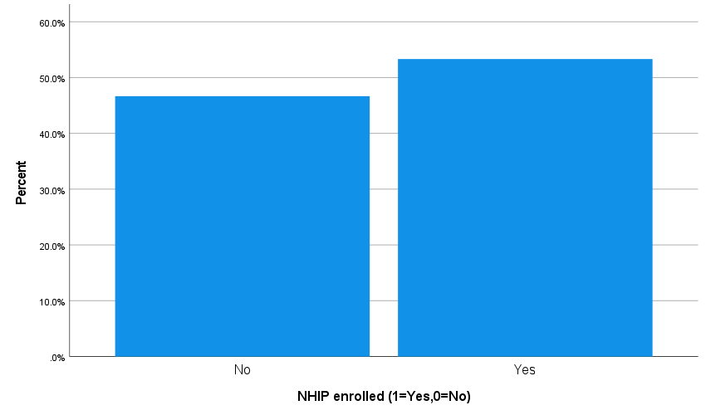
Figure 6 NHIP enrolment status of respondents
Source: Field survey, 2026 (compiled from the statistical analysis file).
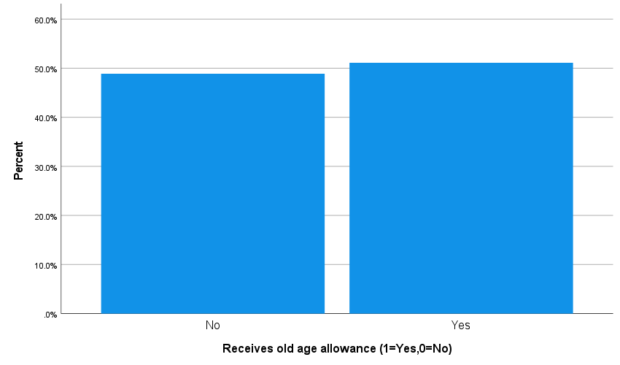
Figure 7 Receipt of old age allowance among respondents
Source: Field survey, 2026 (compiled from the statistical analysis file).

4.3 Presentation, Analysis and Interpretation of Data by Objectives / Themes

4.3.1 Objective One: Perceptions and experiences of health care access
The first objective explored health status, service use, disrupted access. Self-rated health depicts an ambivalent yet not very positive image. Even though 38.9 percent reported their health to be good and 7.8 percent very good, 36.7 percent were fair and 16.7 percent poor. Therefore, over 50 percent of the respondents were in the fair and poor category, which means that perceived health vulnerability in old age is high. This aligns with the bodies of literature that ageing is linked to chronic disease, multimorbidity, and a decreasing functional ability (WHO, 2015; Dhungana et al., 2021).
The chronic illness load was very great. The most frequent chronic condition that was reported was hypertension, with diabetes and arthritis/joint pain coming next. All in all, 78 respondents out of 90 had at least one chronic. This is also seen in service utilization: the average number of health visits during the past six months was 2.01 among individuals who had at least one chronic condition as compared to 1.00 among individuals who had no chronic illness. Chronic disease thus augmented the necessity to have recurrent interaction with health services and any obstacle was more decisive.
Access experience was also determined by mobility and dependency. Although 72.2 per cent of them answered in the negative that they were not limited in terms of mobility, 27.8 per cent of them answered in the affirmative that they were having difficulty in mobility. Similarly, 22.2 percent responded that they had to have someone to accompany them to a health visit. This implies that to a large minority it is not an individual act but rather relies on relational support in terms of access. Later in life, to access a facility, one might need money and transport, the time, care, and practical help of another person (Gilligan et al., 2018).
In terms of the use of the facilities, Bajrabarahi Chapagaun Hospital was the most frequently attended facility during the last visit with 44.4 percent of the respondents. An additional 15.6 percent attended a local health post or outreach service and 18.9 percent attended Patan Hospital or some other Kathmandu referral facility and 21.1 percent attended a private clinic or pharmacy. It means that local facilities play a significant role in the first contact care but still a significant number of them refer to the referral centres or private providers presumably due to the service limitation, lack of medicine, or belief in specialised care.
An indicator of strain is the cost and travel. The mean one way travel time was 22.27 minutes and the average cost of transport of the last visit was NPR 210.22. Even moderate travelling may be challenging to older individuals who are weak, painful or need to be accompanied by someone when they use the bus or train (Poudel et al., 2024). Mean waiting time during the final visit was 104.78 minutes with mean out-of-pocket spending being NPR 1,840.78. Such statistics imply that even in areas which have the services, care is still time-consuming and costly. The average rating of communication with provider (3.19 out of 5), respect with the provider (3.38), and family support of health care (3.57) shows that experience was mediocre and not very favourable.
The disrupted access is further reinforced by direct indicators of disrupted access. During the last 12 months, 37.8 percent had delayed care, 27.8 percent had forgone care and 52.2 percent said that they needed care but could not access it. One of the best findings of the study was that over half of the respondents reported that they had unmet need. It demonstrates that services do not necessarily translate into physical existence into effective access. Access should also be considered in terms of timeliness, affordability, and continuity and the capability of the user to go through the care pathway (Levesque et al., 2013). 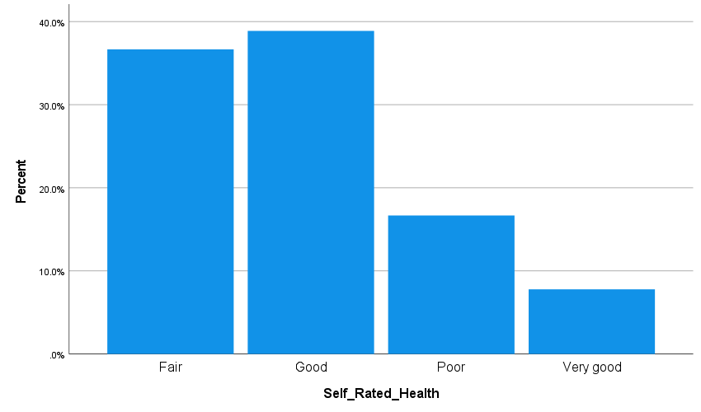
This trend was encouraged by qualitative results. The access was recurrently mentioned by the elderly interview participants as a process that hinged on pain, accompaniment, and the possibility of fulfilling registration and waiting. One of the respondents said, 'The hospital is not that far, however, when my knees are sore I cannot walk and I wait till my son is not busy and then I come with him (IDI-03). The other respondent associated chronic illness with recurring expense and effort: 'With pressure and sugar, I can never go to the doctor once; it is transportation, tests, medication each time round (IDI-07). Another key informant also noted that the aged patients tend to arrive late in the facility when none of the family members can come to fetch them (KII-02). Such stories serve to justify why even where facilities were geographically located there was still high need.
Figure 8 Self-rated health status of respondents
Source: Field survey, 2026 (compiled from the statistical analysis file). 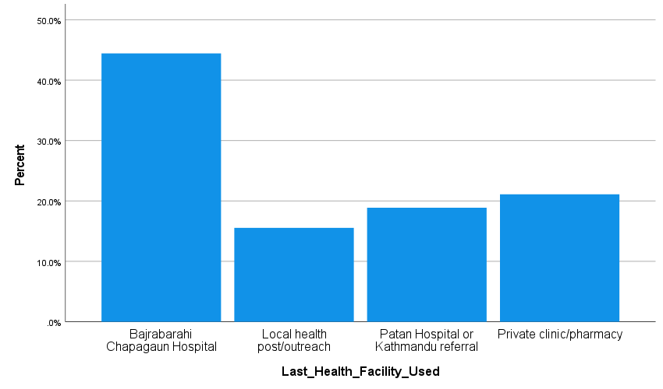
Source: Field survey, 2026 (compiled from the statistical analysis file). 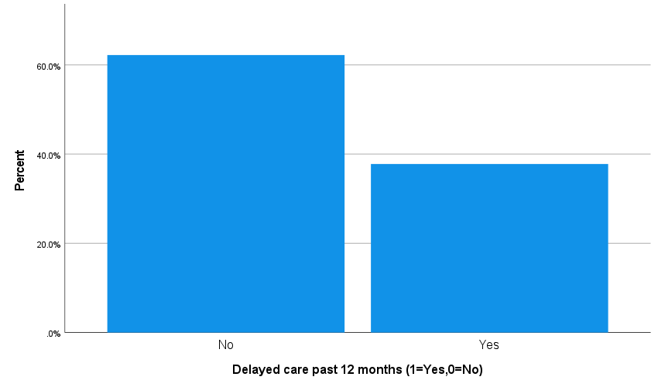
Figure 9 Respondents reporting delayed care in the past 12 months
Source: Field survey, 2026 (compiled from the statistical analysis file). 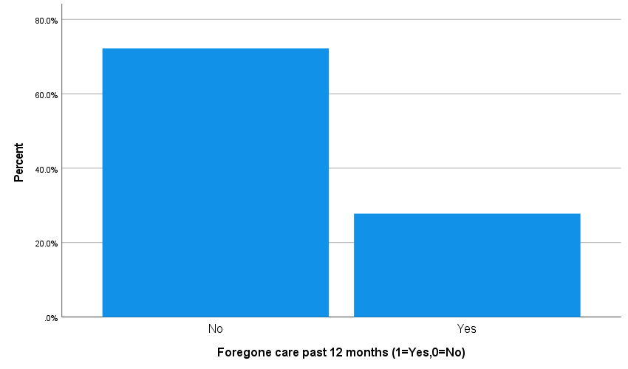
Figure 10 Respondents reporting foregone care in the past 12 months
Source: Field survey, 2026 (compiled from the statistical analysis file). 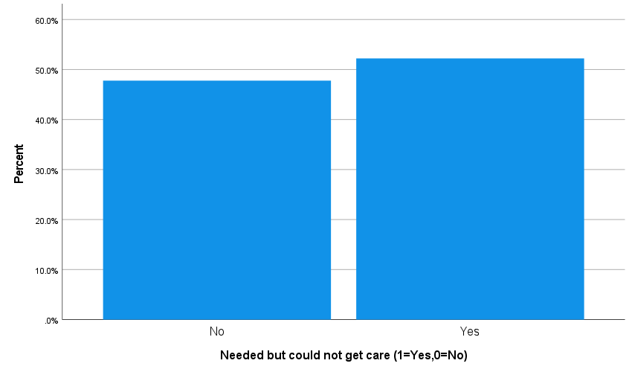
Figure 11 Respondents reporting unmet need for care
Source: Field survey, 2026 (compiled from the statistical analysis file).

4.3.2 Objective Two: Major barriers faced by senior citizens
The second aim was on the barriers which determined access in practice. Twenty-seven percent of the respondents, the highest percentage, chose low awareness of entitlements when they were asked to report the primary barrier that they encountered. It was then followed by affordability (17.8 percent) followed by transport or distance (15.6 percent), long waiting time (14.4 percent), poor communication or respect (7.8 percent), lack of accompaniment or family support (6.7 percent), medicine unavailability (5.6 percent), and only 1.1 percent reported minor or no major barrier. The ranking is significant as it demonstrates that informational, and not a strictly financial or geographical, barrier was at the top. The failure of older people to receive services is more likely not due to lack of such a service, but due to ambiguity of procedures, rights and entitlements (Levesque et al., 2013).
Indicators associated with availability are elaborated. When asked about the availability of medicines, 78.9 percent said yes and when asked about the availability of diagnostics, 67.8 percent said yes, at the final visit. They are the majority shares, though, it still implies that approximately one out of five did not find medicines and almost one out of three did not find diagnostics. These gaps may compel the old patients to repeat visits, to privately purchase or to a referral cost. On the same note, 70.0 percent of the respondents indicated the presence of seating of elderly patients at the facility leaving 30.0 percent without physical environment that is age sensitive. In the case of the old age group, sitting or standing on the floor is not an insignificant problem; it has a direct impact on the usability of the services.
Of interest were awareness data. Only 53.3 percent knew about free basic health services, 53.3 percent knew about the rights of senior citizens and only 31.1 percent knew about NHIP process. Therefore, the proportion of respondents, who properly comprehended the insurance process, was almost 7 out of ten. This contributes to the explanation of low knowledge of entitlements becoming the most common barrier. It also demonstrates that the gap in the supply of services is not the sole issue of policy-practice gap. There can be formal rights and programmes which however are not effective until the users are aware of the enrolment, renewal, referral procedures, and what services are covered.
The institutional and relational barriers to communication, respect, and family support in the descriptive ratings also indicate that there are relational and institutional barriers. These results corroborate the argument that there are layers of access barriers in old age. Others are material like cost, transport, medicine and diagnostics. The rest are organisational like the waiting time and the complexity in administration. Others are relational such as inadequate accompaniment, weak information, and provider interaction which might not be completely adjusted to older users (Penchansky and Thomas, 1981; Adhikari et al., 2024). 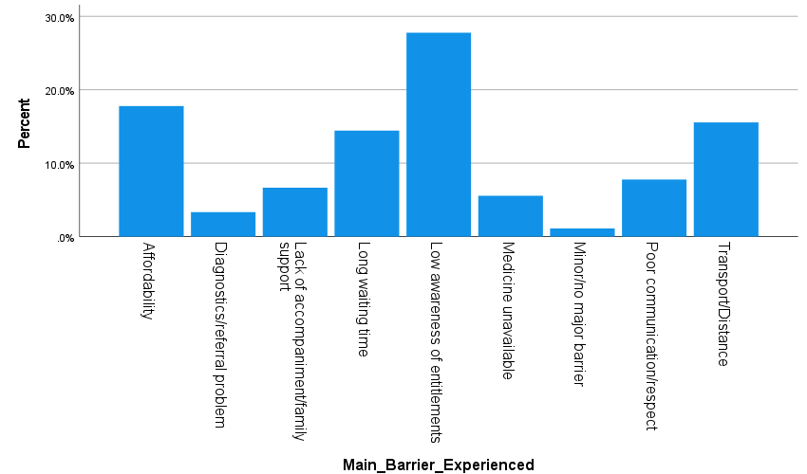
The interviews elucidated that lack of awareness of entitlements was characterized by the lack of understanding of the point of commencement of free services and the way insurance and referral processes are implemented in practice. Some of the participants indicated that they did not know the medicines or tests covered and the time the NHIP cards needed to be renewed. One of the respondents justifies this by saying that they hear that the services are free, but at the counter, they are not aware of what to request and what paper they require (IDI-01). Waiting and interpersonal treatment were also brought into the limelight: a few older individuals were embarrassed to ask questions more than once or felt they were treated as slow. One key informant has observed that a significant number of older patients come without all documents or a companion that prolongs the process and makes them feel frustrated (KII-03). This substantiates the survey results that the barriers are informational, organisational and relational, in addition to the financial ones.
Figure 12 Main barrier experienced by respondents
Source: Field survey, 2026 (compiled from the statistical analysis file). 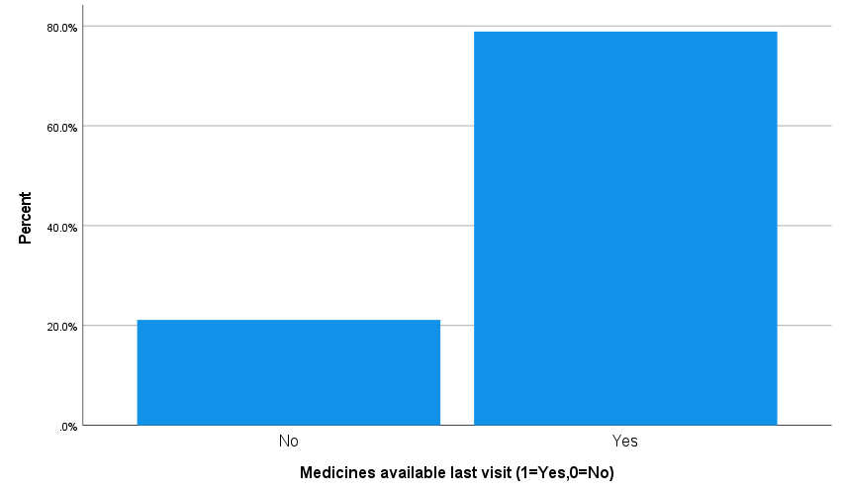
Figure 13 Availability of medicines at the last visit
Source: Field survey, 2026 (compiled from the statistical analysis file). 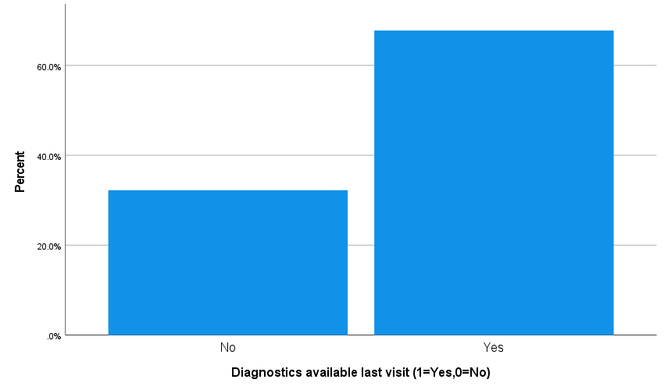
Figure 14 Availability of diagnostics at the last visit
Source: Field survey, 2026 (compiled from the statistical analysis file). 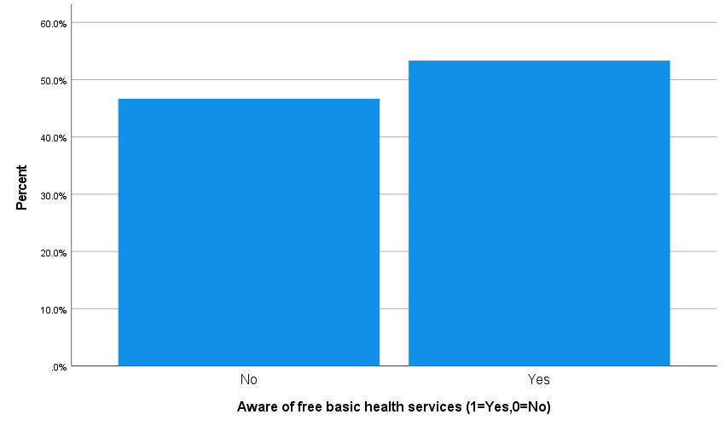
Figure 15 Awareness of free basic health services
Source: Field survey, 2026 (compiled from the statistical analysis file). 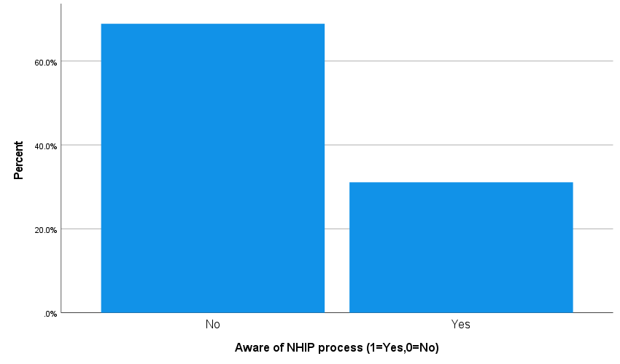
Figure 16 Awareness of the NHIP process
Source: Field survey, 2026 (compiled from the statistical analysis file). 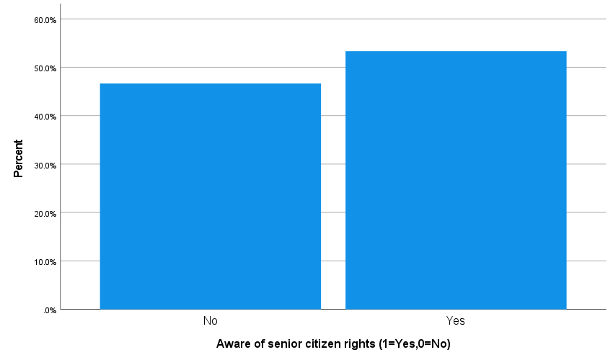
Figure 17 Awareness of senior citizen rights
Source: Field survey, 2026 (compiled from the statistical analysis file).

4.3.3 Objective Three: Role of old age allowance and NHIP
The third goal looked into the coverage and utility of the mechanisms of government support. Just over 50 percent of the respondents, 51.1 percent, said that they received the old age allowance and 53.3 percent of respondents were enrolled in NHIP. But, a mere 41.1 percent had renewed NHIP within the past year. Such disparity between enrolment and renewal is an indication that the participation is tentative and can be compromised by procedural difficulty, dissatisfaction or perceived lack of benefit.
The mean score of the respondents who rated NHIP usefulness was 3.21 out of 5 indicating moderate usefulness as opposed to strong satisfaction. The usefulness of old age allowance in health costs was less and it had a mean of 2.72 out of 5 amongst the recipients. The allowance does not seem to help fully considering the mean out-of-pocket cost per visit was NPR 1,840.78. It can help the marginal households, but it is not sufficient to remove financial pressure due to health.
There are also inferential findings that demonstrate that NHIP enrolment was not significantly related to unmet need or delayed care in this sample. The unmet need and delayed care were slightly higher among respondents who were not insured; however, this was not statistically significant. This is an indication that insurance is not the answer to overcome the larger framework of obstacles to senior citizens. When information is poor, there is no medicine or diagnostics, mobility or waiting time is high, then the practical impact of enrolment can be limited. 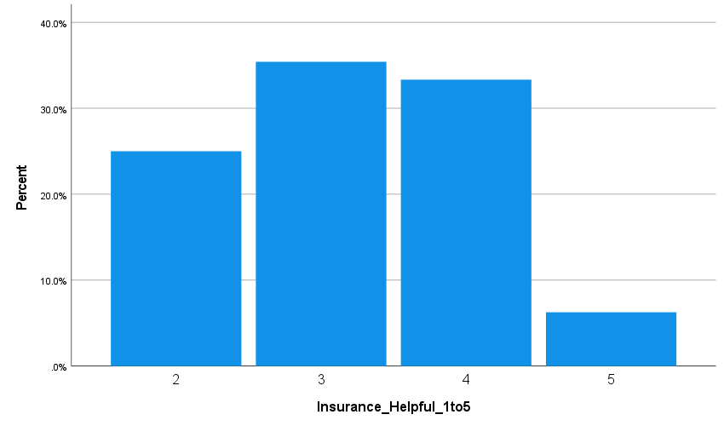
Qualitative data were indicative that both plans were considered to be beneficial yet inadequate. The old age allowance was reported by recipients to be used in transport or part of the medicine expenses as opposed to complete treatment expenses. One interviewee said, 'The allowance is useful in spending on little things, but a single sickness will exhaust it in a short time (IDI-09). In the case of NHIP, a number of the respondents enjoyed the presence of a card but complained of renewing, unspecified package restrictions, medicine shortages or getting referred. The case of a health worker also revealed that older patients are used to the card covering all costs and becoming discontent when the medicines or tests are not available at the initial point of service (KII-01). These stories can be used to understand why the programme enrolment, by itself, did not have a significant statistical correlation with delayed care or unmet need.
Figure 18 Perceived helpfulness of NHIP
Source: Field survey, 2026 (compiled from the statistical analysis file). 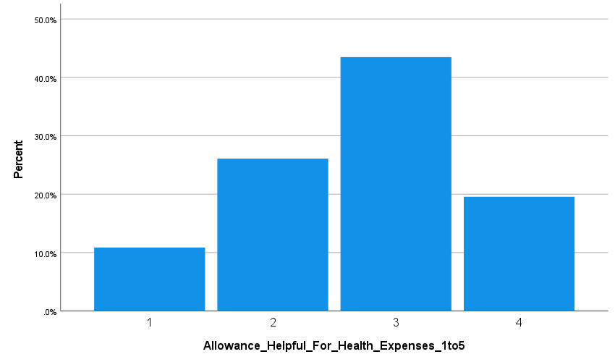
Figure 19 Perceived helpfulness of the old age allowance for health expenses
Source: Field survey, 2026 (compiled from the statistical analysis file). 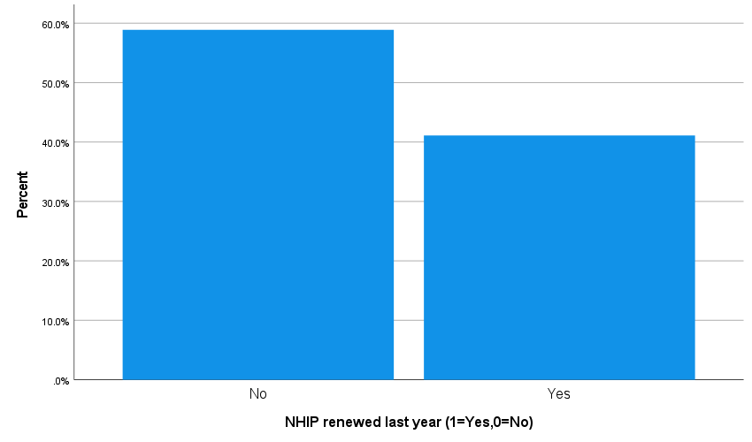
Figure 20 NHIP renewal status in the previous year
Source: Field survey, 2026 (compiled from the statistical analysis file).

4.4 Discussion of Findings
The findings presented in the chapter reveal that access to health care by senior citizens in Chapagaun is multidimensional and social. Many of the respondents use local facilities but the need is still not met. This substantiates the fact that utilisation by itself is not a sufficient indicator of access. Timeliness, continuity, affordability, dignity, and the user being able to interact with care over time are also crucial factors to effective access (Levesque et al., 2013).
There are certain major trends that are pointed out in the inferential analysis. With the socioeconomic hypothesis, an educational level did not influence significantly delayed care or unmet need, but the household income group had a significant impact on foregone care. The lowest income bracket recorded the highest foregone care and the highest income bracket recorded the lowest foregone care indicating that the material resources continue to have a potent influence on decision to forego treatment. According to the gender hypothesis, the awareness of the NHIP process among women compared to men was less, and men were more likely to require accompaniment, but none of these correlations was statistically significant. Nevertheless, the directional trend implies the gendered difference in information and reliance that should be considered in policies.
Results with regard to insurance were varied. There were no significant differences in enrolment in NHIP based on whether the need was met or not or delay, which implies that the benefits of the programme might be diluted by broader system issues, such as lack of awareness, renewal, lack of package visibility, and gaps in supply (Khanal et al., 2023; Health Insurance Board, 2024). The best outcome of the health status was the fact that mobility limitation was strongly linked with unmet need. It was significantly more likely that respondents of mobility limitation would report having a need to receive care but were not able to do so. This highlights the embodied aspect of access barriers and advocates age-friendly and person-centred service design (WHO, 2015; WHO, 2017; MoHP, 2022).
This interpretation is reinforced with the help of the qualitative material. Interviews indicated that older adults did not refer to barriers as being caused by single technical issues, they referred to them as being interconnected burdens of pain, dependence, uncertainty, and dignity. The need to pay children to ask them to accompany or ask them to provide money and not knowing what was paid and having to wait long queues when unwell made some of the participants procrastinate on taking care until the symptoms became severe. Key informants also attributed missed or delayed care to poor counselling regarding entitlement procedures and to the pragmatic lapses in the medicinal supply, seating, and queuing arrangements. The combination of the two is thus to propose that household resource constraints and institutional usability issues are the co-producers of policy-practice gap in Chapagaun.

4.5 Chapter Summary
The qualitative evidence of 10 in-depth interviews and 4 key informant interviews and the survey findings of 90 elderly people were analysed in this chapter. The respondents were socially diverse with low levels of education, high levels of informal work and low levels of coverage of programmes. The prevalence of chronic illness, frequent utilization of services (but often costly and time-intensive) and high need were common. The results of the survey and interviews were that the most significant barrier was the insufficient knowledge of the entitlements, then affordability, distance or transport and waiting. The qualitative data also indicated that the reliance on the family accompaniment, misunderstanding of the NHIP processes, and the feeling of prolonged queues or unavailability of medicines undermined the usefulness of the government programmes. Inferential analysis indicated low income to be significantly related to foregone care and mobility limitation significantly related to unmet need. Overall, the chapter demonstrates that the economic resources, health status, information, institutions and relational support interplay to define access to health care among the senior citizens of Chapagaun.

Chapter Five Summary, Findings and Discussion, Conclusion & Implications

5.1 Introduction to the Chapter
This chapter gives the general overview of the study, distillation of the important findings, the sociological explanation of the findings on a broader level, conclusion, implications and recommendations. It aids in moving the combined quantitative and qualitative results in Chapter Four into a broader context to demonstrate what they suggest about health care access among the elderly people in Chapagaun and other peri-urban setting of Nepal.

5.2 Summary of the Study
The thesis looked at the obstacles to access health care services in Chapagaun, Godavari Municipality, Lalitpur among senior citizens. It was informed by three aims: to understand how the elderly citizens perceive and experience access to health care, to determine the key barriers to access that they face, and to determine whether government programmes like the old age allowance and the National Health Insurance Program (NHIP) enhance the access. The prompt of the study was the population of Nepal has been rapidly ageing, the rights and protections granted to older citizens are written in law, and the ongoing issue that the promises of policy do not always result in effective care in real life (Constitution of Nepal, 2015; Public Health Service Act, 2018; MoHP, 2022).
The study was sociological in nature and utilised life course, intersectionality theory and the behavioural model of health service utilisation as the main analysis perspectives. These models proved to be helpful since they do not see access as the mere presence of services, but as the outcome of interaction between cumulative disadvantage, social position, enabling resources, health need, and institutional responsiveness (Andersen, 1995; Ferraro and Shippee, 2009; Collins, 2015). It was a quantitative-dominant mixed-method study (quantitative) in methodology. A structured survey was used to collect 90 elderly citizens as quantitative data which were analysed using frequencies, descriptive statistics, crosstabulations and selected chi-square tests. The data, in terms of qualitative data, were created using 10 in-depth interviews with the elderly citizens and 4 key informant interviews with the local health and community stakeholders and were thematically analysed. The optional focus group discussion was not implemented due to the discomfort that some of the older participants felt in a group and the mobility and hearing challenges of some participants.
Chapagaun was a key location to conduct the study since it is a peri-urban environment that has local health services, but there could be financial, informational, mobility-related, and institutional barriers to older persons. This enabled the thesis to look at the policy-practice gap in an environment that is neither geographically distant but nonetheless characterized by unequal access. The research thus adds to a more realistic perspective of the true experience of older individuals with health care systems in their daily lives.

5.3 Summary of Major Findings
The initial significant discovery is that of the social profile of the respondents. The surveyed elderly population was socially diverse yet characterized by the low level of educational achievement, a high number of informal jobs, and a range of household assistance. Over one-third were completely uneducated and many had spent the majority of their lifetime in agriculture, daily labour, household work or small business. There was a small minority that lived alone or with spouse only. These trends indicate that a good number of respondents had fewer economic and informational resources to rely on in their old age.
The second significant conclusion is that the need in health was great. Over fifty percent of the respondents considered their health to be fair or poor and chronic illness was prevalent. A majority of them had one or more chronic conditions particularly hypertension, diabetes, or arthritis or joint pain. Chronic illness respondents also indicated that they paid more attention to health visits as compared to non-chronic illness respondents. This implies that access here does not involve only occasional treatment but rather long term and repeated access to health services.
The third significant finding is that contact with service and contact difficulty of access co-existed. The use of the local facilities, particularly Bajrabarahi Chapagaun Hospital, was significant to service usage, yet most respondents continue to experience practical barriers. Waiting time was high, out-of-pocket cost was high and travel continued to be time and transport consuming. Most importantly, 37.8 percent had put off care, 27.8 percent had also skipped care and 52.2 percent of them said that they required care, but were unable to access it. The fact that the effective access was still poor even when certain services were physically accessible implies that there was a general lack of accessibility.
The fourth significant observation is related to the trend of barriers. A lack of awareness of entitlements turned out to be the most prevalent primary obstacle, then affordability, transport or distance, and long waiting time. Issues with availability also were still present, as there were respondents who reported a shortage of medicines, a shortage of diagnostics, and insufficient seating or age-sensitive seating. The level of awareness of free basic health services and the rights of senior citizens was only about half of the respondents whereas the NHIP process was significantly less. This demonstrates that not only were there economic and geographical barriers, but also informational, organisational, and relational barriers.
The fifth big discovery is connected with government programmes. There was coverage of the old age allowance and NHIP which was only slightly higher than half and NHIP renewal was less than enrolment. The rating of NHIP by the respondents was moderately helpful and that of old age allowance was quite helpful in meeting health expenses. This means the programmes will only partially support and not eliminate practical barriers to care. NHIP enrolment alone did not appear to have any significant effect on the delayed care or unmet need in this sample.
The last significant discovery is the one of the inferential analysis. The household income group was also found to be of great significance with regard to foregone care; the respondents in the lowest income group had a great probability of not seeking treatment as compared to the higher income group. Unmet need was found to be significantly related to mobility limitation: elderly individuals with mobility difficulty were far more likely to report that they needed care, but were unable to receive it. All other relationships including the education and unmet need, gender and awareness, NHIP enrolment and delay, and living arrangement and delayed care were not statistically significant, but some directional relationships were also interesting.
These statistical trends were well supported by the qualitative results. Participants of the interview tended to discuss access based on the accompaniment, the understandability of the procedures and the respectful attitude. They kept on explaining that it was not just the presence of a facility in the area, but whether an ill aged individual would be able to travel, wait, comprehend the process and receive the required medicine or test that day. Key informants also highlighted lack of clarity on NHIP processes, referrals, and the challenge posed to mobility-restricted older adults that come without assistance.

5.4 Discussion of Findings
The results are quite favourable to the thesis that the access to health care in the old age cannot be evaluated by the presence of the facility. Chapagaun is equipped with a local hospital and is near to urban referral services, but a high percentage of the elderly citizens still had delayed, foregone or unmet care. This confirms the usefulness of patient-centred model of access, which demonstrates that access is contingent on the fit between health systems and the capabilities of users to perceive the need, seek care, access services, incur costs, and remain involved in the treatment (Levesque et al., 2013). The awareness, affordability, mobility and waiting burden were the weak aspects in the same chain in this study.
Of particular importance is the great degree of unmet need. Over 50 per cent of the respondents said that they required care but were not able to get it. This is a grave consequence in a situation where older adults are already considered to be under protection and off-free/subsidised services (Constitution of Nepal, 2015; Public Health Service Act, 2018). The results are an indication that there is a large gap between policy and practice. This is not the first study on Nepal-based that has identified affordability issues, communication barriers, and the unavailability of elderly-friendly services as barriers to older adults, with family support being a facilitating factor (Adhikari et al., 2024; Poudel et al., 2024). The current research confirms these conclusions, but it puts a certain emphasis on informational exclusion especially. The most frequently reported barrier was low awareness of entitlements with awareness of the NHIP process being particularly low. The formal rights and programmes will thus be restricted in case the older people are not capable of comprehending how to utilize them.
The life course perspective is also supported by the results. Old age is severely linked to cumulative disadvantage by low education and informal employment experience and reliance on small household income. This is demonstrated by the great difference in the incidence of forsaken care between the lower and higher income earners: those with less economic means were far more likely to give up care when it was unaffordable. The social inequality thus influences the access to health care in old age even before the illness has struck (Ferraro and Shippee, 2009; Dannefer, 2003).
Intersectional thinking also is compatible with the findings. Even though not statistically significant, women were less knowledgeable about NHIP procedures and overall sample was stratified by gender, education, caste and ethnicity, and living arrangement. The social positions influence the confidence, mobility, information, and interaction with institutions (Collins, 2015; Hankivsky and Christoffersen, 2008). Such is the case of Andersen model that serves to explain the lack of care even with need. The factors of predisposition, enabling and need interacted in such a manner that prevented real utilisation in many instances (Andersen, 1995). This was highly manifested in the great correlation between mobility limitation and unmet need. More needy people were also at a disadvantage to access and utilize services and this justifies the need to offer more age-friendly and person-centred care (WHO, 2015; WHO, 2017; MoHP, 2022).
The results of the programme should also be interpreted. The old age allowance and NHIP were not in vain; they were considered to be somewhat beneficial. Yet, they could not be powerful enough to eradicate the larger system of obstacles towards senior citizens. There was poor coverage, poor renewal and incomplete insurance status did not have any significant effect on delayed care or unmet need. This aligns with broader issues in the literature regarding low enrolment, attrition, complexity of the procedures, and low trust in the insurance system in Nepal (Khanal et al., 2023; Asian Development Bank, 2024; Health Insurance Board, 2024). This means that the effectiveness of a programme needs to be evaluated not only by its legal existence or number of enrollees, whether the programme is effective, but on whether older people are able to comprehend, sustain and gain advantage of the programme in actual treatment contexts.
These results are also further sociological readings that are enhanced by the qualitative accounts. They unveil that barriers to access are encountered on both moral and relational platforms, and not only administrative. Some of the older participants were reluctant to ask questions over and over in case they were presumed to be a burden on the adult children to get them to pay the bus fares or because they were discouraged when they did not find the medicine after spending so much time waiting. This reinforces the idea that the access of older persons is influenced by the interrelated lives, by their location in the household support systems, and by the dignity/frustration induced within institutions. That is, it is the usability of care, rather than formal coverage, that matters.

5.5 Conclusion
This paper concludes that older adults in Chapagaun continue to experience chronic obstacles in accessing health care even though there is a presence of available services in the area and there are policy promises. It is not merely a matter of a deficiency of facilities. It is the partial transfer of formal rights and programmes into practice, usability. A large proportion of respondents had chronic disease, recurring need of care, and were somehow related to the public services but still had to wait, forgo treatment, and bear a high out of pocket cost, and had unmet need. The barriers that were the most significant were not confined to money and distance, but also the lack of awareness of the entitlements, long waiting period, incomplete access to medicine and diagnostics, and the difficulty because of mobility.
This study then concludes that health care access among the older citizens in Chapagaun is multidimensional, socially unequal and related. The respondents with less income had higher chances of not taking care and the ones who were not mobile had higher chances of being in need. To some degree, there was government programmes support, but respondents were not completely safeguarded against such obstacles.

5.6 Implications of the Study
There are theoretical implications, policy implications and practical implications of the study. Theoretically, it proves that life course, intersectional and enabling-resource perspectives are better approaches to understand ageing and health care access in Nepal. The issue of access is not purely medical, but also social, determined by education, level of income, support relations and physical ability.
On the policy level, the implications of the results are that the programmes targeting older persons should be considered based on how useful they are and not just based on their legal existence. The programme will not be effective at all when the beneficiaries do not know about it, are unable to navigate it or are unable to translate it into actual treatment. The implications of the findings at the level of service delivery are that the local facilities require more robust age-friendly arrangements, facilities, more understandable communication, manageable waiting systems, and continuity of the medicines and diagnostics. At the community level, the results indicate that outreach and accompaniment support is still needed, particularly among mobility-limited and low-income elderly individuals.

5.7 Recommendations
Following the results, a number of recommendations are suggested. To begin with, Godavari Municipality, local health and community health workers should intensify their information and counselling campaigns directly oriented against the older citizens and their family caregivers. Procedures related to free basic health services, rights of senior citizens and NHIP enrolment and renewal must be expressed in easy language, and repeated local outreach. As the lack of awareness on entitlements was the most prevalent barrier in this study, there is an urgent need to enhance information delivery.
Second, Bajrabarahi Chapagaun Hospital and other related facilities need to enhance the arrangement of age-friendly services. These must consist of dependable seating, easier registration and referral instructions, assistance to the weak elderly people as well as ways of minimizing waiting time. Even small organisational changes have the potential to make services more accessible to elderly patients with pain, fatigue or functional difficulty (WHO, 2015; WHO, 2017).
Third, senior citizens who are mobility-impaired ought to be offered special assistance. The elderly who do not travel easily alone should be looked into home based follow-up, community escort systems or volunteer arrangements on how to be accompanied. This group is in need of particular intervention as mobility limitation was highly linked to unmet need.
Fourth, there should be an economic protection. The continuation of medicines, diagnostics and transport to cause significant out-of-pocket cost even within a promise of protection policy environment should be reviewed by local authorities and national programme managers. The old age allowance is beneficial yet not enough, and the implementation of NHIP should be devoted to the simpler renewal, improved communication of benefits, and the more predictable services (Khanal et al., 2023; Asian Development Bank, 2024).
Fifth, family and community support ought to be considered as a component of the access system and not as a completely individual issue. Education campaigns, elderly associations, coordination at the ward level can enable family to be more responsive to assist older members to seek care.

5.8 Areas for Further Research
In this study, only one peri-urban area and one sample of the survey were considered. The replication of the study in future research can be done on the peri-urban, urban and rural regions to examine the differences in barriers to access by locale. The effects of interactions between gender, caste and ethnicity, income and chronic illness would be better to be tested on a larger sample and through a multivariate analysis. Greater depth qualitative studies might also be conducted to explore the reasons as to why older individuals are unaware of entitlements, perceptions of waiting and disrespect, and the effects of family dynamic in decision making of treatment as the years go by. Further studies on NHIP dropout, challenge of renewal and meaning of insurance to older people would also be a bountiful source of policy information.
Conclusively, to make health care more accessible to older members of the Chapagaun community, expanding the facilities and declaring rights is not enough. It involves ensuring that services become comprehensible, accessible, affordable, respectful and practically applicable to older people whose lives are framed by the accrued inequality and evolving support systems.

References
Adhikari, R., Shah, R. and Khanal, V. (2024) ‘Older people’s challenges accessing health services in central Nepal: a qualitative study using the domain of access framework’, BMC Health Services Research, 24, 1273. doi: https://doi.org/10.1186/s12913-024-11717-2.
Acharya, M. et al. (2016) ‘Free Essential Medicines Through Public Health Facilities in Nepal’, Value in Health, 19(7). doi: https://doi.org/10.1016/j.jval.2016.08.666.
Andersen, R.M. (1995) ‘Revisiting the behavioral model and access to medical care: does it matter?’, Journal of Health and Social Behavior, 36(1), pp. 1–10. Available at: https://pubmed.ncbi.nlm.nih.gov/7738325/ (Accessed: 25 March 2026).
Andersen, R. (1968) A behavioral model of families’ use of health services. Research Series No. 25. Chicago: Center for Health Administration Studies, University of Chicago. Available at: https://www.cabidigitallibrary.org/doi/full/10.5555/19702701913 (Accessed: 25 March 2026).
Aryal, K.K. (2023) ‘Free Basic Healthcare in Nepal: Can the Dream be Turned into Reality in the Pursuit of Universal Health Coverage?’, Journal of Nepal Health Research Council, 21(58), pp. i–ii. Available at: https://elibrary.nhrc.gov.np/bitstream/20.500.14356/2352/1/4922-Manuscript-32719-2-10-20230911.pdf (Accessed: 25 March 2026).
Asian Development Bank (2024) A Study on Nepal’s National Health Insurance Program. Available at: https://www.adb.org/sites/default/files/publication/965996/study-nepal-national-health-insurance-program.pdf (Accessed: 25 March 2026).
Bista, B. et al. (2021) ‘Prevalence of non-communicable diseases risk factors and their determinants: Results from STEPS survey 2019, Nepal’, PLOS ONE, 16(7), e0253605. doi: https://doi.org/10.1371/journal.pone.0253605.
Bajrabarahi Chapagaun Hospital (n.d.) Official website. Available at: https://bajrabarahihospital.bagamati.gov.np/ (Accessed: 25 March 2026).
Collins, P.H. (2015) ‘Intersectionality’s definitional dilemmas’, Annual Review of Sociology, 41, pp. 1–20. doi: https://doi.org/10.1146/annurev-soc-073014-112142.
Constitution of Nepal (2015) Constitution of Nepal 2072. Available at: https://ag.gov.np/files/Constitution-of-Nepal_2072_Eng_www.moljpa.gov_.npDate-72_11_16.pdf (Accessed: 25 March 2026).
Crenshaw, K. (1989) ‘Demarginalizing the intersection of race and sex’, University of Chicago Legal Forum. Available at: https://chicagounbound.uchicago.edu/cgi/viewcontent.cgi?article=1052&context=uclf (Accessed: 25 March 2026).
Crenshaw, K. (1991) ‘Mapping the margins: Intersectionality, identity politics, and violence against women of color’, Stanford Law Review, 43(6), pp. 1241–1299. Available at: https://blackwomenintheblackfreedomstruggle.voices.wooster.edu/wp-content/uploads/sites/210/2019/02/Crenshaw_mapping-the-margins1991.pdf (Accessed: 25 March 2026).
Dannefer, D. (2003) ‘Cumulative advantage/disadvantage and the life course: Cross-fertilizing age and social science theory’, The Journals of Gerontology: Series B, 58(6), pp. S327–S337. doi: https://doi.org/10.1093/geronb/58.6.S327.
Department of Health Services (DoHS) (n.d.) ‘The Public Health Service Act, 2075 (2018)’. Available at: https://dohs.gov.np/content/28/the-public-health-service-act--2075--2018-/ (Accessed: 25 March 2026).
Dhungana, R.R. et al. (2021) ‘Prevalence, pattern and determinants of chronic disease multimorbidity in Nepal: secondary analysis of a national survey’, BMJ Open, 11(7), e047665. doi: https://doi.org/10.1136/bmjopen-2020-047665.
Elder, G.H. Jr. (1994) ‘Time, human agency, and social change: Perspectives on the life course’, Social Psychology Quarterly, 57(1), pp. 4–15. doi: https://doi.org/10.2307/2786971.
Elder, G.H. Jr. (1998) ‘The life course as developmental theory’, Child Development, 69(1), pp. 1–12. doi: https://doi.org/10.1111/j.1467-8624.1998.tb06128.x.
Ferraro, K.F. and Shippee, T.P. (2009) ‘Aging and cumulative inequality: How does inequality get under the skin?’, The Gerontologist, 49(3), pp. 333–343. doi: https://doi.org/10.1093/geront/gnp034.
Gilligan, M., Karraker, A. and Jasper, A. (2018) ‘Linked lives and cumulative inequality: A multigenerational family life course perspective’, Journal of Family Theory & Review, 10(1), pp. 111–125. doi: https://doi.org/10.1111/jftr.12244.
Godavari Municipality (2021) Preparation of GPS Based Digital Profile of Godawari Municipality (Ward 10, 11, 12 & 13). Available at: https://godawarimunlalitpur.gov.np/sites/godawarimunlalitpur.gov.np/files/documents/godawari%20nagar%20profile%20%2C2078.pdf (Accessed: 25 March 2026).
GIZ / German Agency for International Cooperation (2012) Review of Community-based Health Insurance Initiatives in Nepal. Available at: https://p4h.world/wp-content/uploads/2013/06/Nepal_CBHI_GIZ_report.x73677.pdf (Accessed: 25 March 2026).
Hankivsky, O. and Christoffersen, A. (2008) ‘Intersectionality and the determinants of health: a Canadian perspective’, Critical Public Health, 18(3), pp. 271–283. doi: https://doi.org/10.1080/09581590802294296.
Health Insurance Board (2024) Annual Report FY 2080/81. Available at: https://giwmscdnone.gov.np/media/pdf_upload/Annual_Report_FY_2080_81_utqzyvx.pdf (Accessed: 25 March 2026).
International Labour Organization (ILO) (n.d.) Social health protection in Nepal. Available at: https://www.ilo.org/media/361536/download (Accessed: 25 March 2026).
Karmacharya, I. et al. (2022) ‘Health services utilization among older adults in Pokhara Metropolitan City’, Journal of Aging & Social Policy, 34(4), pp. 568–587. doi: https://doi.org/10.1080/08959420.2020.1851429.
Khanal, G.N. et al. (2023) ‘Evaluation of the National Health Insurance Program of Nepal: are political promises translated into actions?’, Health Research Policy and Systems, 21, 7. doi: https://doi.org/10.1186/s12961-022-00952-w.
Khanal, G.N. and Regmi, B. (2020) ‘Social protection in health: Characteristics and coverage of health insurance programme in Nepal’, Journal of Social Protection, 1, pp. 27–42. doi: https://doi.org/10.3126/jsp.v1i0.38209.
Kathmandu Post (2026) ‘List of free essential medicines to be revised’. Available at: https://kathmandupost.com/health/2026/01/09/list-of-free-essential-medicines-to-be-revised (Accessed: 25 March 2026).
Levesque, J.-F., Harris, M.F. and Russell, G. (2013) ‘Patient-centred access to health care: conceptualising access at the interface of health systems and populations’, International Journal for Equity in Health, 12, 18. doi: https://doi.org/10.1186/1475-9276-12-18.
Ministry of Health and Population (MoHP) (2022) Geriatric Health Service Strategy 2078/79 to 2086/87 (2021–2030). Available at: https://www.nhssp.org.np/Resources/GESI/Geriatric%20health%20service%20strategy%20English%20version%20-%202022.pdf (Accessed: 25 March 2026).
National Statistics Office (NSO) (2025) National Population and Housing Census 2021: Ageing Situation in Nepal (Thematic Report X). Available at: https://giwmscdntwo.gov.np/media/pdf_upload/Ageing%20Situation%20In%20Nepal%20for%20website%20final%20final_y9uaoo0.pdf (Accessed: 25 March 2026).
Nepal Health Research Council (NHRC) (2022) National Ethical Guidelines for Health Research in Nepal. Available at: https://nhrc.gov.np/wp-content/uploads/2022/04/National-ethical-guidelines-4-Aug-28-2022.pdf (Accessed: 25 March 2026).
Nepal Health Research Council (NHRC) (2019) Monitoring Synopsis of the Senior Citizens’ Care Centers. Available at: https://nhrcnepal.org/uploads/publication/Monitoring_Synopsis_of_the_Senior_Citizens_Care_Centers_2019-min.pdf (Accessed: 25 March 2026).
Penchansky, R. and Thomas, J.W. (1981) ‘The concept of access: definition and relationship to consumer satisfaction’, Medical Care, 19(2), pp. 127–140. doi: https://doi.org/10.1097/00005650-198102000-00001.
Poudel, K., Malla, D.K. and Thapa, K. (2024) ‘Health care service utilization among elderly in rural setting of Gandaki province, Nepal: a mixed method study’, Frontiers in Health Services, 4, 1321020. doi: https://doi.org/10.3389/frhs.2024.1321020.
Poudel, M. et al. (2022) ‘Morbidities, health problems, health care seeking and utilization behaviour among elderly residing on urban areas of eastern Nepal: a cross-sectional study’, PLOS ONE, 17(9), e0273101. doi: https://doi.org/10.1371/journal.pone.0273101.
Public Health Service Act (2018) The Public Health Service Act, 2075 (2018). Available at: https://bwcimplementation.org/sites/default/files/resource/NP_Public-Health-Service-Act-2075_EN.pdf (Accessed: 25 March 2026).
Public Health Service Regulations (2020) Public Health Service Regulations, 2020 (Unofficial English Translation). Available at: https://www.nhssp.org.np/Resources/HPP/Public%20Health%20Regulations%202020-%20Unoffical%20English%20Translation.pdf (Accessed: 25 March 2026).
United Nations Department of Economic and Social Affairs (UNDESA) (2023) World Population Ageing 2023: Challenges and opportunities of population ageing in the least developed countries. Available at: https://www.un.org/development/desa/pd/sites/www.un.org.development.desa.pd/files/undesa_pd_2024_wpa2023-report.pdf (Accessed: 25 March 2026).
World Health Organization (WHO) (2015) World report on ageing and health. Available at: https://www.who.int/docs/default-source/mca-documents/ageing/9789240694811-eng.pdf (Accessed: 25 March 2026).
World Health Organization (WHO) (2020) Decade of healthy ageing: baseline report. Available at: https://ifa.ngo/wp-content/uploads/2020/12/WHO-Decade-Baseline-Report-December-2020.pdf (Accessed: 25 March 2026).
World Health Organization (WHO) (2017) Integrated care for older people: guidelines on community-level interventions to manage declines in intrinsic capacity. Available at: https://www.who.int/publications/i/item/9789241550109 (Accessed: 25 March 2026).
World Health Organization (WHO) and Nepal Health Research Council (NHRC) (2020) Noncommunicable Disease Risk Factors: STEPS Survey Nepal 2019. Available at: https://www.who.int/docs/default-source/nepal-documents/ncds/ncd-steps-survey-2019-compressed.pdf (Accessed: 25 March 2026).

Appendices

Annex 1: Survey Questionnaire (Senior Citizens)
Title: Survey of the Barrier into the access of health care services among senior citizens in Chapagaun, Lalitpur Nepal.
Introduction (to be read aloud):
Namaste. My name is Sahil Maharjan. I am carrying out a research as a Masters thesis on the access of the seniors to health care services in Chapagaun. You are doing it on a voluntary basis. Your responses will remain anonymous and they will be utilized in the research study. You can drop any question or any time. This interview will last an approximate of 30-45 minutes. Do you agree to participate?
Section A: Socio-demographic Information
A1. Age (completed years): _
A2. Sex: ☐ Male ☐ Female ☐ Other
A3. Marital status: ☐ Married ☐ Widowed ☐ Separated/Divorced ☐ Never married
A4. Education level: ☐ No formal schooling ☐ Literate (informal) ☐ Primary ☐ Secondary ☐ Higher
A5. Main lifetime occupation (most years worked): ☐ Agriculture ☐ Wage labor ☐ Service/Govt ☐ Business ☐ Homemaker ☐ Other:
A6. Caste/Ethnicity (self-identified): ___
A7. Living arrangement (who do you live with most of the time?):
☐ Alone ☐ Spouse only ☐ Spouse and children ☐ Children ☐ Other relatives ☐ Other:
A8. Household economic situation (self-assessed): ☐ Very difficult ☐ Difficult ☐ Moderate ☐ Comfortable
A9. Main source of personal income now (if any): ______
Section B: Health Status and Need
B1. Self-rated health: ☐ Very good ☐ Good ☐ Fair ☐ Poor ☐ Very poor
B2. Do you have any diagnosed chronic disease? (multiple allowed)
☐ Hypertension ☐ Diabetes ☐ Heart disease ☐ Arthritis/joint pain ☐ Respiratory illness ☐ Kidney disease ☐ Other: _ ☐ None/Don’t know
B3. In the last 12 months, how often did you need to visit a health facility?
☐ None ☐ 1–2 times ☐ 3–5 times ☐ 6+ times
B4. Mobility limitation (walking/standing):
☐ None ☐ Mild ☐ Moderate ☐ Severe (need assistance)
B5. Do you need someone to accompany you to seek health care? ☐ Yes ☐ No
If yes, who usually accompanies you? ☐ Son/daughter ☐ Spouse ☐ Relative ☐ Neighbor ☐ Other: _
Section C: Health Service Utilization and Access
C1. Where do you usually go first when you are sick?
☐ Local hospital/health facility in/near Chapagaun ☐ Government hospital in city ☐ Private clinic/hospital ☐ Traditional healer ☐ Pharmacy ☐ Other: _
C2. In the last 12 months, did you ever delay seeking care even though you felt you needed it?
☐ Yes ☐ No
C3. In the last 12 months, did you ever not seek care at all despite feeling you needed it?
☐ Yes ☐ No
C4. Approximate one-way travel time to your usual facility: _ minutes
C5. Usual mode of transport: ☐ Walk ☐ Public vehicle ☐ Private vehicle ☐ Ambulance ☐ Other: ____
Section D: Barriers to Access (Perceptions)
(Answer: 1 = Not a barrier, 2 = Small barrier, 3 = Moderate barrier, 4 = Major barrier)
D1. Consultation fees or hidden costs
D2. Cost of medicines
D3. Cost of tests/diagnostics
D4. Transport cost
D5. Distance or difficult road/route
D6. Long waiting time / long queues
D7. Facilities not physically friendly (stairs, lack of seating, toilets)
D8. Lack of respectful treatment / ageism
D9. Difficulty understanding doctors’ explanations
D10. Lack of information about where to go
D11. Lack of family support/availability to accompany
D12. Drug shortages or delays in getting medicines
D13. Fear or discomfort in health facility environment
Section E: Awareness and Use of Government Programs
E1. Are you receiving the senior citizen allowance? ☐ Yes ☐ No ☐ Not sure
If yes: E1a. Is it helpful for health care costs? ☐ Very helpful ☐ Somewhat ☐ Not very ☐ Not at all
E2. Are you enrolled in the National Health Insurance Program (NHIP)? ☐ Yes ☐ No ☐ Not sure
If yes:
E2a. Have you used NHIP to receive health services in the last 12 months? ☐ Yes ☐ No
E2b. Main problems in using NHIP (multiple allowed):
☐ Don’t know procedure ☐ Service not available under insurance ☐ Facility did not accept easily ☐ Long process ☐ Referral problem ☐ Other: _
If no:
E2c. Main reason for not enrolling (multiple allowed):
☐ Not aware ☐ Too costly ☐ Too complicated ☐ Not useful ☐ No one to help enroll ☐ Other: _
Section F: Overall Assessment
F1. Overall, how easy is it for you to access health care when you need it?
☐ Very easy ☐ Easy ☐ Difficult ☐ Very difficult
F2. What is the single biggest barrier you face? ___
F3. What improvements would most help senior citizens in Chapagaun? ___

Annex 2: Interview Schedule / Interview Guide (Health Workers & Community Leaders)
Key Informant Interview Guide
Interview Guide Key Informant Interview.
- What do you regard as the most frequent health-related issues in elderly people in this community?
- Which are the primary obstacles to the provision of services among senior citizens (costs, mobility, family support, waiting time, communication, infrastructure)?
- To what extent are existing services (seating, priority queues, counseling time, referral support) elderly-friendly?
- What is the normal perception of the senior citizens concerning the ways they learn about their health, allowance, and insurance? What are the gaps?
- Practices (enrollment, renewal, acceptance, claims, referral): How does the National Health Insurance Program operate in Chapagaun (enrollment, renewal, acceptance, claims, referral)?
- What do older patients (medicines, tests, staff behavior, delays, problems with referrals) complain of most?
- What are the roles of local government and community institutions to the health access of senior citizens?
- What would be the realistic interventions that would enhance access (improvements that are age friendly, outreach, home-based support, awareness campaigns, transport arrangements)?

Annex 3: Consent Form
Informed Consent Form (For Senior Citizen Participants)
Entering into an agreement by a senior citizen participant requires the signature of the Informed Consent Form, which must be signed by a senior citizen participant or someone authorized to sign on their behalf (Prentkeman, 2003).
Title of the research: Obstacles to Health Care Service among elderly citizens in Chapagaun, Lalitpur, Nepal.
Researcher: Shahil Maharjan (Masters Degree Sociology, Nims College, Department of Sociology)
Purpose:
This is an invitation to take part in a research study concerning the access of senior citizens to health care services in Chapagaun and its challenges.
Procedures:
In case you say yes, you will be interviewed/surveyed after about 30-45 minutes. You are doing it on a voluntary basis.
Risks and Discomforts:
There is minimal risk. There are some questions that can be personal. You can drop any question or any time.
Benefits:
This research will not benefit you directly however, the research could contribute to better comprehension and preparation towards the health services of the senior citizens in the community.
Confidentiality:
In the thesis, your name will not be used. The information will be confidential. In case of audio recording, it will be under your permission.
Voluntary Participation:
Participation is voluntary. You are free to withdraw at any time without any adverse effects.
Consent Statement:
I have received the information presented. I agree to participate.
Participant Name: ____
Signature / Thumbprint: ___
Date: _____
Researcher Signature: _____
Date: __

Annex 4: Statistical Tables Supporting Chapters 4 and 5
All the following tables are copied and pasted as they are in the statistical analysis document that the researcher has given and have not altered their main contents.
Background Characteristics of Respondents - Frequency Tables
Age group
 |  | Frequency | Percent | Valid Percent | Cumulative Percent
Valid | 1 | 44 | 48.9 | 48.9 | 48.9
Valid | 2 | 32 | 35.6 | 35.6 | 84.4
Valid | 3 | 14 | 15.6 | 15.6 | 100.0
Valid | Total | 90 | 100.0 | 100.0

Gender
 |  | Frequency | Percent | Valid Percent | Cumulative Percent
Valid | Female | 51 | 56.7 | 56.7 | 56.7
Valid | Male | 39 | 43.3 | 43.3 | 100.0
Valid | Total | 90 | 100.0 | 100.0

Caste_Ethnicity
 |  | Frequency | Percent | Valid Percent | Cumulative Percent
Valid | Brahmin/Chhetri | 19 | 21.1 | 21.1 | 21.1
Valid | Dalit | 9 | 10.0 | 10.0 | 31.1
Valid | Janajati other | 13 | 14.4 | 14.4 | 45.6
Valid | Newar | 27 | 30.0 | 30.0 | 75.6
Valid | Tamang | 22 | 24.4 | 24.4 | 100.0
Valid | Total | 90 | 100.0 | 100.0

Marital_Status
 |  | Frequency | Percent | Valid Percent | Cumulative Percent
Valid | Married | 53 | 58.9 | 58.9 | 58.9
Valid | Never married | 9 | 10.0 | 10.0 | 68.9
Valid | Separated/Divorced | 11 | 12.2 | 12.2 | 81.1
Valid | Widowed | 17 | 18.9 | 18.9 | 100.0
Valid | Total | 90 | 100.0 | 100.0

Education_Level
 |  | Frequency | Percent | Valid Percent | Cumulative Percent
Valid | Bachelor+ | 7 | 7.8 | 7.8 | 7.8
Valid | Literate/no schooling | 21 | 23.3 | 23.3 | 31.1
Valid | No formal schooling | 31 | 34.4 | 34.4 | 65.6
Valid | Primary | 18 | 20.0 | 20.0 | 85.6
Valid | Secondary | 13 | 14.4 | 14.4 | 100.0
Valid | Total | 90 | 100.0 | 100.0

Living_Arrangement
 |  | Frequency | Percent | Valid Percent | Cumulative Percent
Valid | Living alone | 8 | 8.9 | 8.9 | 8.9
Valid | With children | 28 | 31.1 | 31.1 | 40.0
Valid | With relatives/others | 5 | 5.6 | 5.6 | 45.6
Valid | With spouse and children | 41 | 45.6 | 45.6 | 91.1
Valid | With spouse only | 8 | 8.9 | 8.9 | 100.0
Valid | Total | 90 | 100.0 | 100.0

Main_PreRetirement_Occupation
 |  | Frequency | Percent | Valid Percent | Cumulative Percent
Valid | Agriculture | 29 | 32.2 | 32.2 | 32.2
Valid | Daily wage/labor | 9 | 10.0 | 10.0 | 42.2
Valid | Household work | 14 | 15.6 | 15.6 | 57.8
Valid | Retired formal job | 7 | 7.8 | 7.8 | 65.6
Valid | Service/teacher | 14 | 15.6 | 15.6 | 81.1
Valid | Small business | 17 | 18.9 | 18.9 | 100.0
Valid | Total | 90 | 100.0 | 100.0

Monthly household income group
 |  | Frequency | Percent | Valid Percent | Cumulative Percent
Valid | 1 | 22 | 24.4 | 24.4 | 24.4
Valid | 2 | 43 | 47.8 | 47.8 | 72.2
Valid | 3 | 25 | 27.8 | 27.8 | 100.0
Valid | Total | 90 | 100.0 | 100.0

Receives old age allowance (1=Yes,0=No)
 |  | Frequency | Percent | Valid Percent | Cumulative Percent
Valid | 0 | 44 | 48.9 | 48.9 | 48.9
Valid | 1 | 46 | 51.1 | 51.1 | 100.0
Valid | Total | 90 | 100.0 | 100.0

NHIP enrolled (1=Yes,0=No)
 |  | Frequency | Percent | Valid Percent | Cumulative Percent
Valid | 0 | 42 | 46.7 | 46.7 | 46.7
Valid | 1 | 48 | 53.3 | 53.3 | 100.0
Valid | Total | 90 | 100.0 | 100.0

NHIP renewed last year (1=Yes,0=No)
 |  | Frequency | Percent | Valid Percent | Cumulative Percent
Valid | 0 | 53 | 58.9 | 58.9 | 58.9
Valid | 1 | 37 | 41.1 | 41.1 | 100.0
Valid | Total | 90 | 100.0 | 100.0

4.3.1 Objective 1 - Frequency Tables
Self_Rated_Health
 |  | Frequency | Percent | Valid Percent | Cumulative Percent
Valid | Fair | 33 | 36.7 | 36.7 | 36.7
Valid | Good | 35 | 38.9 | 38.9 | 75.6
Valid | Poor | 15 | 16.7 | 16.7 | 92.2
Valid | Very good | 7 | 7.8 | 7.8 | 100.0
Valid | Total | 90 | 100.0 | 100.0

Mobility limitation (1=Yes,0=No)
 |  | Frequency | Percent | Valid Percent | Cumulative Percent
Valid | 0 | 65 | 72.2 | 72.2 | 72.2
Valid | 1 | 25 | 27.8 | 27.8 | 100.0
Valid | Total | 90 | 100.0 | 100.0

Needs accompaniment for visit (1=Yes,0=No)
 |  | Frequency | Percent | Valid Percent | Cumulative Percent
Valid | 0 | 70 | 77.8 | 77.8 | 77.8
Valid | 1 | 20 | 22.2 | 22.2 | 100.0
Valid | Total | 90 | 100.0 | 100.0

Last_Health_Facility_Used
 |  | Frequency | Percent | Valid Percent | Cumulative Percent
Valid | Bajrabarahi Chapagaun Hospital | 40 | 44.4 | 44.4 | 44.4
Valid | Local health post/outreach | 14 | 15.6 | 15.6 | 60.0
Valid | Patan Hospital or Kathmandu referral | 17 | 18.9 | 18.9 | 78.9
Valid | Private clinic/pharmacy | 19 | 21.1 | 21.1 | 100.0
Valid | Total | 90 | 100.0 | 100.0

Travel_Mode_Last_Visit
 |  | Frequency | Percent | Valid Percent | Cumulative Percent
Valid | Ambulance | 6 | 6.7 | 6.7 | 6.7
Valid | Bus/Micro | 32 | 35.6 | 35.6 | 42.2
Valid | Family motorcycle | 15 | 16.7 | 16.7 | 58.9
Valid | Taxi/Auto | 17 | 18.9 | 18.9 | 77.8
Valid | Walking | 20 | 22.2 | 22.2 | 100.0
Valid | Total | 90 | 100.0 | 100.0

Delayed care past 12 months (1=Yes,0=No)
 |  | Frequency | Percent | Valid Percent | Cumulative Percent
Valid | 0 | 56 | 62.2 | 62.2 | 62.2
Valid | 1 | 34 | 37.8 | 37.8 | 100.0
Valid | Total | 90 | 100.0 | 100.0

Foregone care past 12 months (1=Yes,0=No)
 |  | Frequency | Percent | Valid Percent | Cumulative Percent
Valid | 0 | 65 | 72.2 | 72.2 | 72.2
Valid | 1 | 25 | 27.8 | 27.8 | 100.0
Valid | Total | 90 | 100.0 | 100.0

Needed but could not get care (1=Yes,0=No)
 |  | Frequency | Percent | Valid Percent | Cumulative Percent
Valid | 0 | 43 | 47.8 | 47.8 | 47.8
Valid | 1 | 47 | 52.2 | 52.2 | 100.0
Valid | Total | 90 | 100.0 | 100.0

4.3.1 Objective 1 - Descriptive Statistics
Descriptive Statistics
 | N | Minimum | Maximum | Mean | Std. Deviation
Health_Visits_Last_6_Months | 90 | 0 | 6 | 1.88 | 1.381
One_Way_Travel_Time_Min | 90 | 6 | 55 | 22.27 | 11.177
Transport_Cost_Last_Visit_NPR | 90 | 0 | 1910 | 210.22 | 378.726
Waiting_Time_Last_Visit_Min | 90 | 5 | 192 | 104.78 | 40.041
Out_of_Pocket_Cost_Last_Visit_NPR | 90 | 130 | 7710 | 1840.78 | 1446.404
Communication_With_Provider_1to5 | 90 | 1 | 5 | 3.19 | .898
Respect_From_Provider_1to5 | 90 | 2 | 5 | 3.38 | .712
Family_Support_For_Healthcare_1to5 | 90 | 1 | 5 | 3.57 | 1.039
Valid N (listwise) | 90

4.3.1 Objective 1 - Chronic Disease Burden (Multiple Response)
$Chronic Frequencies
 |  | Responses |  | Percent of Cases
 |  | N | Percent | Percent of Cases
Chronic conditionsª | Hypertension (1=Yes,0=No) | 43 | 26.1% | 55.1%
Chronic conditionsª | Diabetes (1=Yes,0=No) | 28 | 17.0% | 35.9%
Chronic conditionsª | Arthritis or joint pain (1=Yes,0=No) | 26 | 15.8% | 33.3%
Chronic conditionsª | Respiratory problem (1=Yes,0=No) | 15 | 9.1% | 19.2%
Chronic conditionsª | Heart disease (1=Yes,0=No) | 10 | 6.1% | 12.8%
Chronic conditionsª | Visual problem (1=Yes,0=No) | 21 | 12.7% | 26.9%
Chronic conditionsª | Hearing problem (1=Yes,0=No) | 22 | 13.3% | 28.2%
Total |  | 165 | 100.0% | 211.5%

4.3.2 Objective 2 - Frequency Tables
Main_Barrier_Experienced
 |  | Frequency | Percent | Valid Percent | Cumulative Percent
Valid | Affordability | 16 | 17.8 | 17.8 | 17.8
Valid | Diagnostics/referral problem | 3 | 3.3 | 3.3 | 21.1
Valid | Lack of accompaniment/family support | 6 | 6.7 | 6.7 | 27.8
Valid | Long waiting time | 13 | 14.4 | 14.4 | 42.2
Valid | Low awareness of entitlements | 25 | 27.8 | 27.8 | 70.0
Valid | Medicine unavailable | 5 | 5.6 | 5.6 | 75.6
Valid | Minor/no major barrier | 1 | 1.1 | 1.1 | 76.7
Valid | Poor communication/respect | 7 | 7.8 | 7.8 | 84.4
Valid | Transport/Distance | 14 | 15.6 | 15.6 | 100.0
Valid | Total | 90 | 100.0 | 100.0

Medicines available last visit (1=Yes,0=No)
 |  | Frequency | Percent | Valid Percent | Cumulative Percent
Valid | 0 | 19 | 21.1 | 21.1 | 21.1
Valid | 1 | 71 | 78.9 | 78.9 | 100.0
Valid | Total | 90 | 100.0 | 100.0

Diagnostics available last visit (1=Yes,0=No)
 |  | Frequency | Percent | Valid Percent | Cumulative Percent
Valid | 0 | 29 | 32.2 | 32.2 | 32.2
Valid | 1 | 61 | 67.8 | 67.8 | 100.0
Valid | Total | 90 | 100.0 | 100.0

Facility had elderly seating (1=Yes,0=No)
 |  | Frequency | Percent | Valid Percent | Cumulative Percent
Valid | 0 | 27 | 30.0 | 30.0 | 30.0
Valid | 1 | 63 | 70.0 | 70.0 | 100.0
Valid | Total | 90 | 100.0 | 100.0

Aware of free basic health services (1=Yes,0=No)
 |  | Frequency | Percent | Valid Percent | Cumulative Percent
Valid | 0 | 42 | 46.7 | 46.7 | 46.7
Valid | 1 | 48 | 53.3 | 53.3 | 100.0
Valid | Total | 90 | 100.0 | 100.0

Aware of NHIP process (1=Yes,0=No)
 |  | Frequency | Percent | Valid Percent | Cumulative Percent
Valid | 0 | 62 | 68.9 | 68.9 | 68.9
Valid | 1 | 28 | 31.1 | 31.1 | 100.0
Valid | Total | 90 | 100.0 | 100.0

Aware of senior citizen rights (1=Yes,0=No)
 |  | Frequency | Percent | Valid Percent | Cumulative Percent
Valid | 0 | 42 | 46.7 | 46.7 | 46.7
Valid | 1 | 48 | 53.3 | 53.3 | 100.0
Valid | Total | 90 | 100.0 | 100.0

4.3.2 Objective 2 - Descriptive Statistics
Descriptive Statistics
 | N | Minimum | Maximum | Mean | Std. Deviation
Communication_With_Provider_1to5 | 90 | 1 | 5 | 3.19 | .898
Respect_From_Provider_1to5 | 90 | 2 | 5 | 3.38 | .712
Family_Support_For_Healthcare_1to5 | 90 | 1 | 5 | 3.57 | 1.039
Valid N (listwise) | 90

4.3.3 Objective 3 - Frequency Tables
Receives old age allowance (1=Yes,0=No)
 |  | Frequency | Percent | Valid Percent | Cumulative Percent
Valid | 0 | 44 | 48.9 | 48.9 | 48.9
Valid | 1 | 46 | 51.1 | 51.1 | 100.0
Valid | Total | 90 | 100.0 | 100.0

NHIP enrolled (1=Yes,0=No)
 |  | Frequency | Percent | Valid Percent | Cumulative Percent
Valid | 0 | 42 | 46.7 | 46.7 | 46.7
Valid | 1 | 48 | 53.3 | 53.3 | 100.0
Valid | Total | 90 | 100.0 | 100.0

NHIP renewed last year (1=Yes,0=No)
 |  | Frequency | Percent | Valid Percent | Cumulative Percent
Valid | 0 | 53 | 58.9 | 58.9 | 58.9
Valid | 1 | 37 | 41.1 | 41.1 | 100.0
Valid | Total | 90 | 100.0 | 100.0

4.3.3 Objective 3 - Descriptive Statistics
Descriptive Statistics
 | N | Minimum | Maximum | Mean | Std. Deviation
Insurance_Helpful_1to5 | 48 | 2 | 5 | 3.21 | .898
Allowance_Helpful_For_Health_Expenses_1to5 | 46 | 1 | 4 | 2.72 | .911
Valid N (listwise) | 22

Annex 6: Inferential Tables and Hypothesis Testing Outputs
Chi-square results, crosstabulations, comparison statistics generated as a result of statistical analysis document.
H1: Access barriers and socioeconomic status.
Education_Level * Delayed care past 12 months (1=Yes,0=No) Crosstabulation
 |  |  | Delayed care past 12 months (1=Yes,0=No) |  | Total
 |  |  | 0 | 1 | Total
Education_Level | Bachelor+ | Count | 5 | 2 | 7
Education_Level | Bachelor+ | Expected Count | 4.4 | 2.6 | 7.0
Education_Level | Bachelor+ | % within Education_Level | 71.4% | 28.6% | 100.0%
Education_Level | Bachelor+ | % within Delayed care past 12 months (1=Yes,0=No) | 8.9% | 5.9% | 7.8%
Education_Level | Literate/no schooling | Count | 15 | 6 | 21
Education_Level | Literate/no schooling | Expected Count | 13.1 | 7.9 | 21.0
Education_Level | Literate/no schooling | % within Education_Level | 71.4% | 28.6% | 100.0%
Education_Level | Literate/no schooling | % within Delayed care past 12 months (1=Yes,0=No) | 26.8% | 17.6% | 23.3%
Education_Level | No formal schooling | Count | 18 | 13 | 31
Education_Level | No formal schooling | Expected Count | 19.3 | 11.7 | 31.0
Education_Level | No formal schooling | % within Education_Level | 58.1% | 41.9% | 100.0%
Education_Level | No formal schooling | % within Delayed care past 12 months (1=Yes,0=No) | 32.1% | 38.2% | 34.4%
Education_Level | Primary | Count | 12 | 6 | 18
Education_Level | Primary | Expected Count | 11.2 | 6.8 | 18.0
Education_Level | Primary | % within Education_Level | 66.7% | 33.3% | 100.0%
Education_Level | Primary | % within Delayed care past 12 months (1=Yes,0=No) | 21.4% | 17.6% | 20.0%
Education_Level | Secondary | Count | 6 | 7 | 13
Education_Level | Secondary | Expected Count | 8.1 | 4.9 | 13.0
Education_Level | Secondary | % within Education_Level | 46.2% | 53.8% | 100.0%
Education_Level | Secondary | % within Delayed care past 12 months (1=Yes,0=No) | 10.7% | 20.6% | 14.4%
Total |  | Count | 56 | 34 | 90
 |  | Expected Count | 56.0 | 34.0 | 90.0
 |  | % within Education_Level | 62.2% | 37.8% | 100.0%
 |  | % within Delayed care past 12 months (1=Yes,0=No) | 100.0% | 100.0% | 100.0%

Chi-Square Tests
 | Value | df | Asymptotic Significance (2-sided)
Pearson Chi-Square | 2.817ª | 4 | .589
Likelihood Ratio | 2.806 | 4 | .591
N of Valid Cases | 90

Monthly household income group * Foregone care past 12 months (1=Yes,0=No) Crosstabulation
 |  |  | Foregone care past 12 months (1=Yes,0=No)
 |  |  | 0 | 1
Monthly household income group | 1 | Count | 10 | 12
Monthly household income group | 1 | Expected Count | 15.9 | 6.1
Monthly household income group | 1 | % within Monthly household income group | 45.5% | 54.5%
Monthly household income group | 1 | % within Foregone care past 12 months (1=Yes,0=No) | 15.4% | 48.0%
Monthly household income group | 2 | Count | 34 | 9
Monthly household income group | 2 | Expected Count | 31.1 | 11.9
Monthly household income group | 2 | % within Monthly household income group | 79.1% | 20.9%
Monthly household income group | 2 | % within Foregone care past 12 months (1=Yes,0=No) | 52.3% | 36.0%
Monthly household income group | 3 | Count | 21 | 4
Monthly household income group | 3 | Expected Count | 18.1 | 6.9
Monthly household income group | 3 | % within Monthly household income group | 84.0% | 16.0%
Monthly household income group | 3 | % within Foregone care past 12 months (1=Yes,0=No) | 32.3% | 16.0%
Total |  | Count | 65 | 25
 |  | Expected Count | 65.0 | 25.0
 |  | % within Monthly household income group | 72.2% | 27.8%
 |  | % within Foregone care past 12 months (1=Yes,0=No) | 100.0% | 100.0%

Chi-Square Tests
 | Value | df | Asymptotic Significance (2-sided)
Pearson Chi-Square | 10.591ª | 2 | .005
Likelihood Ratio | 9.931 | 2 | .007
Linear-by-Linear Association | 8.201 | 1 | .004
N of Valid Cases | 90

H2: Gender and informational/dependency barriers
Gender * Aware of NHIP process (1=Yes,0=No) Crosstabulation
 |  |  | Aware of NHIP process (1=Yes,0=No) |  | Total
 |  |  | 0 | 1 | Total
Gender | Female | Count | 39 | 12 | 51
Gender | Female | Expected Count | 35.1 | 15.9 | 51.0
Gender | Female | % within Gender | 76.5% | 23.5% | 100.0%
Gender | Female | % within Aware of NHIP process (1=Yes,0=No) | 62.9% | 42.9% | 56.7%
Gender | Male | Count | 23 | 16 | 39
Gender | Male | Expected Count | 26.9 | 12.1 | 39.0
Gender | Male | % within Gender | 59.0% | 41.0% | 100.0%
Gender | Male | % within Aware of NHIP process (1=Yes,0=No) | 37.1% | 57.1% | 43.3%
Total |  | Count | 62 | 28 | 90
 |  | Expected Count | 62.0 | 28.0 | 90.0
 |  | % within Gender | 68.9% | 31.1% | 100.0%
 |  | % within Aware of NHIP process (1=Yes,0=No) | 100.0% | 100.0% | 100.0%

Chi-Square Tests
 | Value | df | Asymptotic Significance (2-sided) | Exact Sig. (2-sided) | Exact Sig. (1-sided)
Pearson Chi-Square | 3.157ª | 1 | .076
Continuity Correction^{b} | 2.393 | 1 | .122
Likelihood Ratio | 3.145 | 1 | .076
Fisher's Exact Test |  |  |  | .108 | .061
N of Valid Cases | 90

Gender * Needs accompaniment for visit (1=Yes,0=No) Crosstabulation
 |  |  | Needs accompaniment for visit (1=Yes,0=No) |  | Total
 |  |  | 0 | 1 | Total
Gender | Female | Count | 43 | 8 | 51
Gender | Female | Expected Count | 39.7 | 11.3 | 51.0
Gender | Female | % within Gender | 84.3% | 15.7% | 100.0%
Gender | Female | % within Needs accompaniment for visit (1=Yes,0=No) | 61.4% | 40.0% | 56.7%
Gender | Male | Count | 27 | 12 | 39
Gender | Male | Expected Count | 30.3 | 8.7 | 39.0
Gender | Male | % within Gender | 69.2% | 30.8% | 100.0%
Gender | Male | % within Needs accompaniment for visit (1=Yes,0=No) | 38.6% | 60.0% | 43.3%
Total |  | Count | 70 | 20 | 90
 |  | Expected Count | 70.0 | 20.0 | 90.0
 |  | % within Gender | 77.8% | 22.2% | 100.0%
 |  | % within Needs accompaniment for visit (1=Yes,0=No) | 100.0% | 100.0% | 100.0%

Chi-Square Tests
 | Value | df | Asymptotic Significance (2-sided) | Exact Sig. (2-sided) | Exact Sig. (1-sided)
Pearson Chi-Square | 2.909ª | 1 | .088
Continuity Correction^{b} | 2.102 | 1 | .147
Likelihood Ratio | 2.890 | 1 | .089
Fisher's Exact Test |  |  |  | .125 | .074
N of Valid Cases | 90

H3: NHIP and affordability/unmet need
NHIP enrolled (1=Yes,0=No) * Needed but could not get care (1=Yes,0=No) Crosstabulation
 |  |  | Needed but could not get care (1=Yes,0=No)
 |  |  | 0 | 1
NHIP enrolled (1=Yes,0=No) | 0 | Count | 17 | 25
NHIP enrolled (1=Yes,0=No) | 0 | Expected Count | 20.1 | 21.9
NHIP enrolled (1=Yes,0=No) | 0 | % within NHIP enrolled (1=Yes,0=No) | 40.5% | 59.5%
NHIP enrolled (1=Yes,0=No) | 0 | % within Needed but could not get care (1=Yes,0=No) | 39.5% | 53.2%
NHIP enrolled (1=Yes,0=No) | 1 | Count | 26 | 22
NHIP enrolled (1=Yes,0=No) | 1 | Expected Count | 22.9 | 25.1
NHIP enrolled (1=Yes,0=No) | 1 | % within NHIP enrolled (1=Yes,0=No) | 54.2% | 45.8%
NHIP enrolled (1=Yes,0=No) | 1 | % within Needed but could not get care (1=Yes,0=No) | 60.5% | 46.8%
Total |  | Count | 43 | 47
 |  | Expected Count | 43.0 | 47.0
 |  | % within NHIP enrolled (1=Yes,0=No) | 47.8% | 52.2%
 |  | % within Needed but could not get care (1=Yes,0=No) | 100.0% | 100.0%

Chi-Square Tests
 | Value | df | Asymptotic Significance (2-sided) | Exact Sig. (2-sided) | Exact Sig. (1-sided)
Pearson Chi-Square | 1.683ª | 1 | .195
Continuity Correction^{b} | 1.179 | 1 | .278
Likelihood Ratio | 1.689 | 1 | .194
Fisher's Exact Test |  |  |  | .212 | .139
Linear-by-Linear Association | 1.664 | 1 | .197
N of Valid Cases | 90

NHIP enrolled (1=Yes,0=No) * Delayed care past 12 months (1=Yes,0=No) Crosstabulation
 |  |  | Delayed care past 12 months (1=Yes,0=No)
 |  |  | 0 | 1
NHIP enrolled (1=Yes,0=No) | 0 | Count | 25 | 17
NHIP enrolled (1=Yes,0=No) | 0 | Expected Count | 26.1 | 15.9
NHIP enrolled (1=Yes,0=No) | 0 | % within NHIP enrolled (1=Yes,0=No) | 59.5% | 40.5%
NHIP enrolled (1=Yes,0=No) | 0 | % within Delayed care past 12 months (1=Yes,0=No) | 44.6% | 50.0%
NHIP enrolled (1=Yes,0=No) | 1 | Count | 31 | 17
NHIP enrolled (1=Yes,0=No) | 1 | Expected Count | 29.9 | 18.1
NHIP enrolled (1=Yes,0=No) | 1 | % within NHIP enrolled (1=Yes,0=No) | 64.6% | 35.4%
NHIP enrolled (1=Yes,0=No) | 1 | % within Delayed care past 12 months (1=Yes,0=No) | 55.4% | 50.0%
Total |  | Count | 56 | 34
 |  | Expected Count | 56.0 | 34.0
 |  | % within NHIP enrolled (1=Yes,0=No) | 62.2% | 37.8%
 |  | % within Delayed care past 12 months (1=Yes,0=No) | 100.0% | 100.0%

Chi-Square Tests
 | Value | df | Asymptotic Significance (2-sided) | Exact Sig. (2-sided) | Exact Sig. (1-sided)
Pearson Chi-Square | .244ª | 1 | .621
Continuity Correction^{b} | .076 | 1 | .783
Likelihood Ratio | .244 | 1 | .621
Fisher's Exact Test |  |  |  | .667 | .391
Linear-by-Linear Association | .241 | 1 | .623
N of Valid Cases | 90

Chi-Square Tests
 | Value | df | Asymptotic Significance (2-sided)
Pearson Chi-Square | 10.164ª | 8 | .254
Likelihood Ratio | 11.983 | 8 | .152
N of Valid Cases | 90

H4: Family support / living arrangement
Living_Arrangement * Needs accompaniment for visit (1=Yes,0=No) Crosstabulation
 |  |  | Needs accompaniment for visit (1=Yes,0=No) |  | Total
 |  |  | 0 | 1 | Total
Living_Arrangement | Living alone | Count | 6 | 2 | 8
Living_Arrangement | Living alone | Expected Count | 6.2 | 1.8 | 8.0
Living_Arrangement | Living alone | % within Living_Arrangement | 75.0% | 25.0% | 100.0%
Living_Arrangement | Living alone | % within Needs accompaniment for visit (1=Yes,0=No) | 8.6% | 10.0% | 8.9%
Living_Arrangement | With children | Count | 23 | 5 | 28
Living_Arrangement | With children | Expected Count | 21.8 | 6.2 | 28.0
Living_Arrangement | With children | % within Living_Arrangement | 82.1% | 17.9% | 100.0%
Living_Arrangement | With children | % within Needs accompaniment for visit (1=Yes,0=No) | 32.9% | 25.0% | 31.1%
Living_Arrangement | With relatives/others | Count | 3 | 2 | 5
Living_Arrangement | With relatives/others | Expected Count | 3.9 | 1.1 | 5.0
Living_Arrangement | With relatives/others | % within Living_Arrangement | 60.0% | 40.0% | 100.0%
Living_Arrangement | With relatives/others | % within Needs accompaniment for visit (1=Yes,0=No) | 4.3% | 10.0% | 5.6%
Living_Arrangement | With spouse and children | Count | 31 | 10 | 41
Living_Arrangement | With spouse and children | Expected Count | 31.9 | 9.1 | 41.0
Living_Arrangement | With spouse and children | % within Living_Arrangement | 75.6% | 24.4% | 100.0%
Living_Arrangement | With spouse and children | % within Needs accompaniment for visit (1=Yes,0=No) | 44.3% | 50.0% | 45.6%
Living_Arrangement | With spouse only | Count | 7 | 1 | 8

Chi-Square Tests
 | Value | df | Asymptotic Significance (2-sided)
Pearson Chi-Square | 1.808ª | 4 | .771
Likelihood Ratio | 1.761 | 4 | .780
N of Valid Cases | 90

Living_Arrangement * Delayed care past 12 months (1=Yes,0=No) Crosstabulation
 |  |  | Delayed care past 12 months (1=Yes,0=No) |  | Total
 |  |  | 0 | 1 | Total
Living_Arrangement | Living alone | Count | 5 | 3 | 8
Living_Arrangement | Living alone | Expected Count | 5.0 | 3.0 | 8.0
Living_Arrangement | Living alone | % within Living_Arrangement | 62.5% | 37.5% | 100.0%
Living_Arrangement | Living alone | % within Delayed care past 12 months (1=Yes,0=No) | 8.9% | 8.8% | 8.9%
Living_Arrangement | With children | Count | 16 | 12 | 28
Living_Arrangement | With children | Expected Count | 17.4 | 10.6 | 28.0
Living_Arrangement | With children | % within Living_Arrangement | 57.1% | 42.9% | 100.0%
Living_Arrangement | With children | % within Delayed care past 12 months (1=Yes,0=No) | 28.6% | 35.3% | 31.1%
Living_Arrangement | With relatives/others | Count | 4 | 1 | 5
Living_Arrangement | With relatives/others | Expected Count | 3.1 | 1.9 | 5.0
Living_Arrangement | With relatives/others | % within Living_Arrangement | 80.0% | 20.0% | 100.0%
Living_Arrangement | With relatives/others | % within Delayed care past 12 months (1=Yes,0=No) | 7.1% | 2.9% | 5.6%
Living_Arrangement | With spouse and children | Count | 26 | 15 | 41
Living_Arrangement | With spouse and children | Expected Count | 25.5 | 15.5 | 41.0
Living_Arrangement | With spouse and children | % within Living_Arrangement | 63.4% | 36.6% | 100.0%
Living_Arrangement | With spouse and children | % within Delayed care past 12 months (1=Yes,0=No) | 46.4% | 44.1% | 45.6%
Living_Arrangement | With spouse only | Count | 5 | 3 | 8
Living_Arrangement | With spouse only | Expected Count | 5.0 | 3.0 | 8.0
Living_Arrangement | With spouse only | % within Living_Arrangement | 62.5% | 37.5% | 100.0%
Living_Arrangement | With spouse only | % within Delayed care past 12 months (1=Yes,0=No) | 8.9% | 8.8% | 8.9%
Total |  | Count | 56 | 34 | 90
 |  | Expected Count | 56.0 | 34.0 | 90.0
 |  | % within Living_Arrangement | 62.2% | 37.8% | 100.0%
 |  | % within Delayed care past 12 months (1=Yes,0=No) | 100.0% | 100.0% | 100.0%

Chi-Square Tests
 | Value | df | Asymptotic Significance (2-sided)
Pearson Chi-Square | 1.005ª | 4 | .909
Likelihood Ratio | 1.067 | 4 | .900
N of Valid Cases | 90

Living_Arrangement * Needed but could not get care (1=Yes,0=No) Crosstabulation
 |  |  | Needed but could not get care (1=Yes,0=No) |  | Total
 |  |  | 0 | 1 | Total
Living_Arrangement | Living alone | Count | 4 | 4 | 8
Living_Arrangement | Living alone | Expected Count | 3.8 | 4.2 | 8.0
Living_Arrangement | Living alone | % within Living_Arrangement | 50.0% | 50.0% | 100.0%
Living_Arrangement | Living alone | % within Needed but could not get care (1=Yes,0=No) | 9.3% | 8.5% | 8.9%
Living_Arrangement | With children | Count | 14 | 14 | 28
Living_Arrangement | With children | Expected Count | 13.4 | 14.6 | 28.0
Living_Arrangement | With children | % within Living_Arrangement | 50.0% | 50.0% | 100.0%
Living_Arrangement | With children | % within Needed but could not get care (1=Yes,0=No) | 32.6% | 29.8% | 31.1%
Living_Arrangement | With relatives/others | Count | 1 | 4 | 5
Living_Arrangement | With relatives/others | Expected Count | 2.4 | 2.6 | 5.0
Living_Arrangement | With relatives/others | % within Living_Arrangement | 20.0% | 80.0% | 100.0%
Living_Arrangement | With relatives/others | % within Needed but could not get care (1=Yes,0=No) | 2.3% | 8.5% | 5.6%
Living_Arrangement | With spouse and children | Count | 22 | 19 | 41
Living_Arrangement | With spouse and children | Expected Count | 19.6 | 21.4 | 41.0
Living_Arrangement | With spouse and children | % within Living_Arrangement | 53.7% | 46.3% | 100.0%
Living_Arrangement | With spouse and children | % within Needed but could not get care (1=Yes,0=No) | 51.2% | 40.4% | 45.6%
Living_Arrangement | With spouse only | Count | 2 | 6 | 8
Living_Arrangement | With spouse only | Expected Count | 3.8 | 4.2 | 8.0
Living_Arrangement | With spouse only | % within Living_Arrangement | 25.0% | 75.0% | 100.0%
Living_Arrangement | With spouse only | % within Needed but could not get care (1=Yes,0=No) | 4.7% | 12.8% | 8.9%
Total |  | Count | 43 | 47 | 90
 |  | Expected Count | 43.0 | 47.0 | 90.0
 |  | % within Living_Arrangement | 47.8% | 52.2% | 100.0%
 |  | % within Needed but could not get care (1=Yes,0=No) | 100.0% | 100.0% | 100.0%

Chi-Square Tests
 | Value | df | Asymptotic Significance (2-sided)
Pearson Chi-Square | 3.849ª | 4 | .427
Likelihood Ratio | 4.062 | 4 | .398
N of Valid Cases | 90

H5: Chronic illness / mobility
Mobility limitation (1=Yes,0=No) * Delayed care past 12 months (1=Yes,0=No) Crosstabulation
 |  |  | Delayed care past 12 months (1=Yes,0=No)
 |  |  | 0 | 1
Mobility limitation (1=Yes,0=No) | 0 | Count | 44 | 21
Mobility limitation (1=Yes,0=No) | 0 | Expected Count | 40.4 | 24.6
Mobility limitation (1=Yes,0=No) | 0 | % within Mobility limitation (1=Yes,0=No) | 67.7% | 32.3%
Mobility limitation (1=Yes,0=No) | 0 | % within Delayed care past 12 months (1=Yes,0=No) | 78.6% | 61.8%
Mobility limitation (1=Yes,0=No) | 1 | Count | 12 | 13
Mobility limitation (1=Yes,0=No) | 1 | Expected Count | 15.6 | 9.4
Mobility limitation (1=Yes,0=No) | 1 | % within Mobility limitation (1=Yes,0=No) | 48.0% | 52.0%
Mobility limitation (1=Yes,0=No) | 1 | % within Delayed care past 12 months (1=Yes,0=No) | 21.4% | 38.2%
Total |  | Count | 56 | 34
 |  | Expected Count | 56.0 | 34.0
 |  | % within Mobility limitation (1=Yes,0=No) | 62.2% | 37.8%
 |  | % within Delayed care past 12 months (1=Yes,0=No) | 100.0% | 100.0%

Chi-Square Tests
 | Value | df | Asymptotic Significance (2-sided) | Exact Sig. (2-sided) | Exact Sig. (1-sided)
Pearson Chi-Square | 2.979ª | 1 | .084
Continuity Correction^{b} | 2.200 | 1 | .138
Likelihood Ratio | 2.925 | 1 | .087
Fisher's Exact Test |  |  |  | .095 | .070
Linear-by-Linear Association | 2.946 | 1 | .086
N of Valid Cases | 90

Mobility limitation (1=Yes,0=No) * Needed but could not get care (1=Yes,0=No) Crosstabulation
 |  |  | Needed but could not get care (1=Yes,0=No)
 |  |  | 0 | 1
Mobility limitation (1=Yes,0=No) | 0 | Count | 36 | 29
Mobility limitation (1=Yes,0=No) | 0 | Expected Count | 31.1 | 33.9
Mobility limitation (1=Yes,0=No) | 0 | % within Mobility limitation (1=Yes,0=No) | 55.4% | 44.6%
Mobility limitation (1=Yes,0=No) | 0 | % within Needed but could not get care (1=Yes,0=No) | 83.7% | 61.7%
Mobility limitation (1=Yes,0=No) | 1 | Count | 7 | 18
Mobility limitation (1=Yes,0=No) | 1 | Expected Count | 11.9 | 13.1
Mobility limitation (1=Yes,0=No) | 1 | % within Mobility limitation (1=Yes,0=No) | 28.0% | 72.0%
Mobility limitation (1=Yes,0=No) | 1 | % within Needed but could not get care (1=Yes,0=No) | 16.3% | 38.3%
Total |  | Count | 43 | 47
 |  | Expected Count | 43.0 | 47.0
 |  | % within Mobility limitation (1=Yes,0=No) | 47.8% | 52.2%
 |  | % within Needed but could not get care (1=Yes,0=No) | 100.0% | 100.0%

Chi-Square Tests
 | Value | df | Asymptotic Significance (2-sided) | Exact Sig. (2-sided) | Exact Sig. (1-sided)
Pearson Chi-Square | 5.427ª | 1 | .020
Continuity Correction^{b} | 4.385 | 1 | .036
Likelihood Ratio | 5.587 | 1 | .018
Fisher's Exact Test |  |  |  | .033 | .017
Linear-by-Linear Association | 5.366 | 1 | .021
N of Valid Cases | 90

Report
Health_Visits_Last_6_Months
Has at least one chronic condition | Mean | N | Std. Deviation
0 | 1.00 | 12 | .853
1 | 2.01 | 78 | 1.400
Total | 1.88 | 90 | 1.381

